Christopher Montgomery

Professor James Outen

Time Series Analysis

Measuring the Effect of the US-China Trade Dispute on US Soybean Exports: An Intervention Analysis

This paper adopts an intervention analysis design to measure the price and export quantity effects of a Chinese tariff announcement on American soybeans. The paper finds significant evidence of declines in Chinese imports of US soybeans following the tariff announcement, providing further support for traditional tariff theory. Estimates of the tariff announcement effect on US soybean prices and exports to the world, while negative, were found to be statistically insignificant. This finding suggests reductions in Chinese import demand were covered by increased imports from other countries. However, the limited number of post-intervention observations raise questions regarding the internal validity of the model proposed in this paper.

*Introduction*

On April 4, 2018, the Chinese government announced its intentions to levy a 25% import tariff on American soybeans effective on July 7, 2018. While the Chinese tariff threat does not represent the beginning of trade tensions between the United States and China, its announcement represented a significant escalation in the dispute between the world’s two largest economies. In 2017, China imported 13.9 billion dollars in American soybeans, representing nearly 58% of all American soybean exports.[1] China’s soybean tariff announcement and implementation has become a major topic of discussion in American media.[2] China’s tariff announcement has raised significant welfare concerns for farmers, whose crop planting decisions were made prior to the Chinese tariff announcement.

In addition to significant social policy implications, the Chinese soybean tariff represents an opportunity to study the effects of a tariff placed by a large importer on a highly fungible, marketized commodity. In this case, tariff theory would suggest that the implementation of a tariff by a large country importer reduces exports and prices of affected products from the exporting country. However, efficient market hypotheses suggest that, in markets with sufficiently low adjustment costs, a large country import tariff has limited effects on trade volumes and prices. In such cases, the implementation of a tariff results in a re-routing of trade rather with zero net effects.

This paper proposes an intervention analysis methodology to measure the effect of China’s April 4, 2018 tariff announcement on American soybean prices and exports. It applies best fitting (S)ARIMA models with post intervention dummy and interaction terms to total three US soybean export time series including total exports, exports to China, and exports to the European Union. In the analysis of this paper features a model fit for 1 month US soybean price futures.

*Literature Review*

Trade theory is clear concerning the effects of an import tariff on import quantitates and prices. Ad valorem tariffs levied on imported goods effectively act as taxes in which a share of the burden falls on importing firms in the form of an import duty.[3] This increase in import prices incentivizes importing firms to find substitutes including similar products or perfect substitutes exporters not subject to tariff treatment. In aggregate, importing firms shift demand away from the tariffed products, resulting in a net decrease in imports of the tariffed commodity. The extent to which imports decline is a function of the price elasticity of demand of the importing firms and the tariff rate. Importers with high price elasticities of demand, such as commodities importers, are more greatly affected by a tariff compared to importers with low price elasticities, such as luxury goods importers.

Net export and price effects of a tariff on affected exporting firms are ambiguous. Both are determined by the ability of tariffed exporters to adjust and find trade partners in third country markets. In the case of a fungible commodity like American soybeans, tariff adjustment costs could be negligible and result in a complete reallocation of trade with zero net-export and price effects. In such a case, downward pressure on prices resulting from the decline in demand for imports from the tariff levying country is counteracted by increased import demand from other countries.

One special trade theory case suggests negative net export and price effects for exporting firms facing a tariff duty. This model, called “optimal tariff theory,” demonstrates that an importing country with a significant world market share and high price elasticity of demand could force exporters to reduce the prices in the fact of a tariff.[4] In this case, third country markets are too small in terms of market power to make up for a decline in import demand from the tariff levying country. As a result, exporters facing a tariff from a large importer must lower their prices to continue exporting to the tariff levying country.[5] While the large country case results in a decline in export firm prices received, the effect of a large country tariff on affected firms’ net export quantities can be ambiguous.

This paper adds to the literature by providing an empirical case study to the above trade theory. The below analysis tests the applicability of optimal tariff theory to the US-China trade dispute while empirically demonstrating net export and price effects of a Chinese tariff on American soybeans. Results from this paper concerning net welfare affects for US soybean producers can provide significant insights for policy makers as the US-China trade dispute continues.

*Data*

US soybean export data were gathered from the Foreign Agricultural Service’s *Export Sales Reporting* database (ESR). ESR contains weekly export volumes of American soybeans to individual partner countries from 1999 through November 2018.[6] Net exports, as well as soybean exports to the United States top two trading partners, China and the European Union, were isolated for analysis. Each series was aggregated to monthly data to better model seasonal trends. Author’s analysis found optimal seasonal model fits with export data aggregated to quarterly. However, doing so would reduce post-intervention observations below the number required for meaningful analysis.

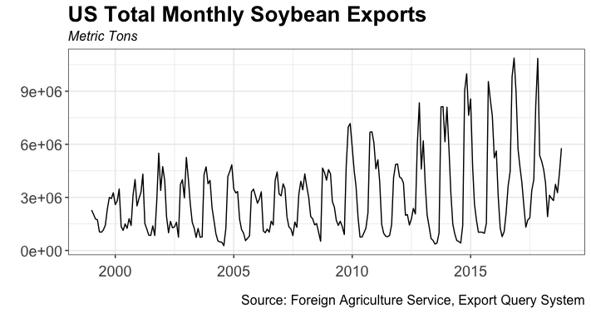

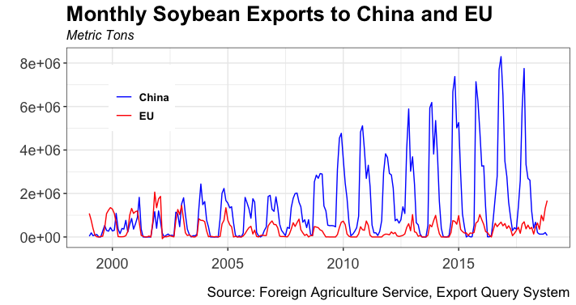

In addition to the above export series, American soybean prices were included for analysis. Continuous one month soybean futures contracts were gathered from the Chicago Board of Trade, the main market for American soybeans.[7]

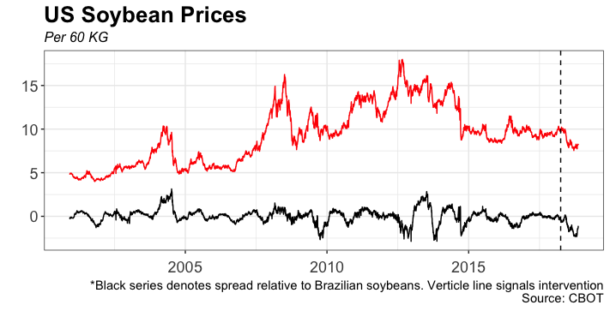

The below table summarizes the four series analyzed in this paper. Monthly export time series each contained 239 observations, with results from Augmented Dickey Fuller and Phillips-Perron tests each rejecting the null hypothesis, thus signaling stationarity. Daily soybean price data were likewise found to be non-stationary. This finding is intuitive, as asset prices are typically best fit by non-stationary random walk models. Visual inspection of ACF and monthly boxplots of each series indicated the presence of annual seasonal trends in each of the export series. Subsequent ARIMA Box and Jenkins confirm the presence seasonality, as discussed below.

|  |  |  |  |  |  |
| --- | --- | --- | --- | --- | --- |
| Series | Observations | Frequency | Stationary | Seasonality | |
| Total Exports | 239 | Monthly | Yes | | Yes |
| Exports to EU | 239 | Monthly | Yes | | Yes |
| Exports to China | 239 | Monthly | Yes | | Yes |
| Soybean Prices | 4336 | Daily | No | | No |

*Methodology*

This paper relies on an intervention analysis design to demonstrate the effects of China’s tariff on American soybean exports. The analysis features a standard intervention analysis regression specification shown below:

where:

= US soybean prices or exports at time *t*

autoregressive process of lag polynomial A

= coefficient of an intervention dummy term where = 1 post-intervention

= moving average process with a lag polynomial B

In accordance with the intervention analysis procedure put forth by Enders, the author first utilized Box and Jenkins techniques to induce stationarity and determine best fitting ARIMA models for exports and price series.[8] Seasonal ARIMA models were fit to monthly export data to induce a better fit. Best fitting (S)ARIMA specifications for each series were subsequently applied to the entirety of each series, with the addition of intervention dummies as exogenous regressors. Resulting model coefficients were then used to determine the effect of the Chinese soybean tariff on each series.

*Results*

The below table describes the results of the best fitting pre-intervention models for each time series. Best fitting ARIMA models were determined by a two-step process. First, the programming function “auto.arima,” featured in the Forecast package in R, was used with each series to isolate the 3 best fitting models determined by lowest AIC values. Residual autocorrelation functions for each model were then inspected to determine the presence of significant residual autocorrelation. Low AIC models with the least amount of residual autocorrelation were selected as best fitting for each series.

|  |  |  |  |
| --- | --- | --- | --- |
| **Series** | **ARIMA Model** | **AIC** | **Residual Autocorrelation** |
| Exports to China | (1,0,0)(0,1,2)[12] | 6469 | Yes- L7; L11; L23 |
| Exports to EU | (2,0,3)(1,1,2)[12] | 5995 | Yes – L22 ; L23 |
| Total Exports | (2,0,3)(1,1,2)[12] | 6614 | Yes - L23 |
| 1 Month Futures | (0,1,0)(0,0,0) | -2799 | Yes – L7 ; L13; L23; L25 |

As the above table shows, significant residual autocorrelation was present in each of the selected export model fits. Theory would suggest an expectation of residual autocorrelation with 1-2 lags give ACF plots with 95% confidence intervals and 24 lags. In addition, significant residual autocorrelation occurs at lags near seasonal intervals. This finding suggests the export SARIMA models are failing to adequately model seasonal patterns. Aggregating export data to quarterly levels, which better correct for fluctuations in soybean growing and harvest seasons, could induce a better SARIMA fit. However, the author has elected to analyze monthly soybean export series, as aggregating to quarterly would limit each series to only one post-intervention observation. Residuals plot and ACF of the soybean price series suggests the presence of conditional heteroscedasticity, in which case a GARCH process could provide a better fit.[9]

Following the above analysis, the above pre-intervention models were applied to the entirety of each export and price series. Each full series model also included an intervention dummy beginning with China’s April 4, 2018 announcement of a tariff on US soybean imports. Different model specifications were attempted, including phased introduction of intervention dummies and the inclusion of an interaction term between intervention dummies and time since the initial intervention date. The below tables summarize the findings for each series featuring the author’s preferred intervention model featuring intervention and post-intervention time terms.

**Model: US Soybean Exports to European Union**

|  |  |  |  |  |
| --- | --- | --- | --- | --- |
| **Coefficients** | **Estimate** | **Std. Error** | **t value** | **p-value** |
| Intervention | 95,133 | 176,094 | .54 |  |
| Intervention * Time | 126,334 | 40,529 | 3.12 |  |
| AIC = 6216 | | | | |

**Model: US Soybean Exports to China**

|  |  |  |  |  |
| --- | --- | --- | --- | --- |
| **Coefficients** | **Estimate** | **Std. Error** | **t value** | **p-value** |
| Intervention | 926,483 | 589,290 | 1.57 |  |
| Intervention * Time | -1,030,895 | 136,685 | -7.54 |  |
| AIC = 6731 | | | | |

**Model: Total US Soybean Exports**

|  |  |  |  |  |
| --- | --- | --- | --- | --- |
| **Coefficients** | **Estimate** | **Std. Error** | **t value** | **p-value** |
| Intervention | 473746.6 | 779934.8 | . 61 |  |
| Intervention * Time | -445532.7 | 193901.9 | -2.29 |  |
| AIC = 6862 | | | | |

**Model: US Soybean Prices (Per 60kg)**

|  |  |  |  |  |
| --- | --- | --- | --- | --- |
| **Coefficients** | **Estimate** | **Std. Error** | **t value** | **p-value** |
| Intervention | -0.2408 | 0.1721 | -1.40 |  |
| Intervention * Time | -0.0104 | 0.0142 | -.73 |  |
| AIC = -2975.29 | | | | |

The above results support the theorized effects of China’s tariff announcement on American soybeans. While each series’ intervention coefficients representing the initial tariff announcement effect was statistically insignifcant, all intervention coefficients were of the expected sign. In addition, the post-intervention interaction terms with time were found to be statistically significant and of the expected sign for each of the export series. The post-intervention time interaction term for the US soybean price series was statistically insignificant, but of the expected sign.

The results of the intervention analysis show that the initial effects of China’s soybean tariff announcement on export levels were limited. Total export levels as well as export levels to China and the European Union did not change significantly in the month immediately following the tariff announcement. This finding can likely be explained by the fact that the soybean shipments often require weeks before final export. It is also plausible that directly after the tariff announcement, Chinese import firms expected to be able to purchase and recover American soybeans prior to the tariff taking effect, resulting in a zero or even positive initial post-intervention effect on Chinese soybean demand.

Statistically significant post-intervention interaction terms with time show export effects of China’s tariff have increased over time. In the wake of the tariff announcement, US soybean exports to the European Union have increased significantly while soybean exports levels to China have witnessed a significant decline. In aggregate, total US soybean exports have declined following China’s tariff announcement. This demonstrates increased US exports to non-Chinese soybean importers have not sufficiently counteracted the decline in demand from Chinese importers following the tariff announcement.

Regression results from the soybean price series are less conclusive. Theory suggests that the global decline in demand for US soybeans will place downward pressure prices. While, both intervention and the post-intervention time interaction coefficients were negative, neither proved statistically significant. This could suggest that increases in demand from non-Chinese importers may have buoyed soybean prices, preventing more noticeable declines in prices.

**Robustness Checks**

ACF plots for each of the full series specifications yielded no changes in residual autocorrelation when compared to pre-intervention models. Nevertheless, significant residual autocorrelation persisted in the full series specifications. Regarding the export series, the significance of residuals surrounding the half year and 2-year lag suggest a poor seasonal model fits. This finding is rather intuitive, as the true seasonal data generating process, soybean planting and harvest seasons, occur sporadically and often spill over between monthly periods.[10] As such, aggregating export data to the quarterly level could produce a greater seasonal model fit and reduce residual autocorrelation. However, doing so would limit export series to one post-intervention observation occurring during the low export season, and likely create poor estimates of intervention effects.

In addition to concerns regarding the seasonal fit of the 3 export series analyzed, visual inspection of the residuals plots for both China and total export series suggest potential heteroscedasticity.[11] Including additional exogenous regressors could reduce heteroscedasticity in the two series. Future specifications should consider adding an exogenous regressor representing Chinese GDP growth to better model China’s import demand for soybeans. Considering China represents the United States largest soybean export destination, including Chinese GDP as an exogenous regressor in the total soybean export series will likely induce a better model fit as well.

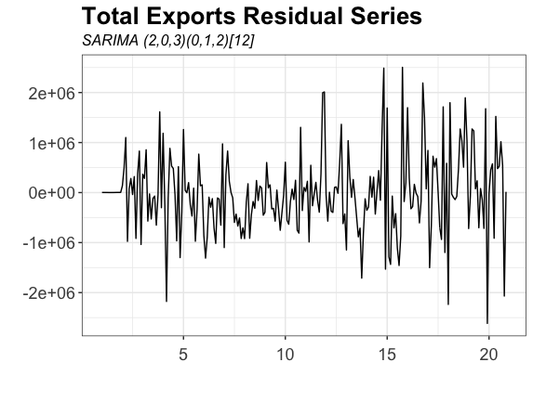

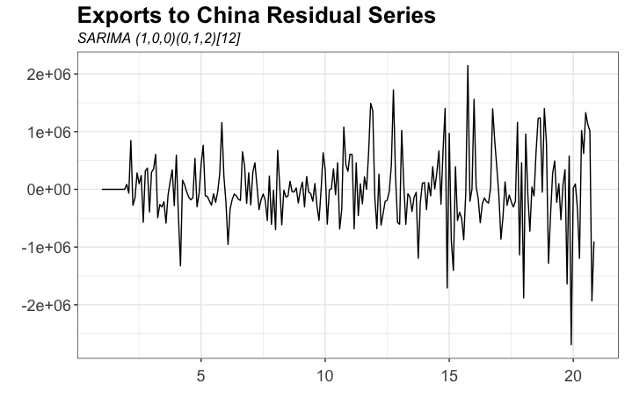

**Conclusion**

The above analysis demonstrates that the aggregate effects of China’s tariff announcement on American soybean imports resulted in a net decline in American soybean exports. This magnitude of decline export decline appears to have grown over time, suggesting that demand for soybeans from the rest of the world is not sufficient to counteract reduced Chinese demand. In addition, evidence suggests that the soybean price effects of China’s tariff announcement were less severe than discussed in popular media.

In addition to the above economic analysis, China’s soybean tariff raises significant political economy questions. Ultimately, uncertainty remains as to whether the negative welfare affects associated with China’s tariff will translate to significant voter dissatisfaction among American farmers, a highly-mobilized constituency. As such, it is unclear for how long China’s soybean tariff will persist moving forward.

1. Author’s calculation from Foreign Agriculture’s Global Agricultural Trade System (GATS)
2. For example, Google search data show the highest relative search frequency for the term “soybeans” since 2005 occurred in July 2018, the month in which China’s soybean tariff was implemented. <https://trends.google.com/trends/explore?date=2010-11-10%202018-12-10&geo=US&q=soybean>
3. For an introductory analysis on tariff theory, see Krugman, Paul. Obstfeld, Maurice. *International Economics: Theory and Policy.* Pearson. 2009
4. Broda, Christian. Limao, Nuno. Weinstein, David. “Optimal Tariffs and Market Power: The Evidence.” *The American Economic Review.* 2008
5. Humphrey, Thomas. “Classical and Neoclassical Roots of the Theory of Optimum Tariffs.” *Federal Reserve Bank of Chicago.* 1987.
6. Measured in metric tons.
7.
8. Enders, Walter. *Applied Econometric Time Series 4th Edition.* Wiley. 2015.
9. For the sake of simplicity and paper time and length constraints the author has elected to leave a GARCH fit for future analysis.
10. Typically, American soybean growing season occurs between May and July while harvesting occurs between October and December. Seasons vary based on annual climate. <https://www.farmcreditknowledgecenter.com/Farm_Credit_Knowledge_Center/media/Images/Soybean-Planting-Harvesting-and-Stages.pdf>
11. For the sake of space, only the residuals plot for the total export model is shown. See appendix for source code regarding additional residuals plots.