HumanCare WorldWide
Backend Setup & Reference Guide

1. What This Document Covers
This document explains, in plain language, how the HumanCare WorldWide backend (the server that will power the mobile app, patient portal, and vendor portal) is built today: what tools and languages it uses, how its files are organised, and how the login system works end to end. Diagrams are included throughout so each part can be explained without needing to read code.

2. Languages & Tools Used
The backend is being built with a small, proven set of tools — chosen to keep the project simple enough for a solo developer to maintain, while still being solid enough for a production medical-transport application.
Layer | Choice | Why
Language | JavaScript (Node.js) | No build/compile step; simpler for a solo developer than TypeScript.
Runtime | Node.js v24 | Runs our JavaScript server code.
Web framework | Express 5 | Handles incoming web requests and routing.
Database | MySQL (local install) | Stores all patient, vendor and request data.
ORM (DB toolkit) | Prisma 6.19 | Defines the data model and talks to MySQL safely.
Login tokens | JWT (JSON Web Tokens) | Proves who is logged in on every request, without a server-side session.
Password / code hashing | bcrypt | Passwords and OTP codes are never stored in readable form.
Cross-app access | CORS | Lets the future mobile/web app call this API safely.
Configuration | dotenv (.env file) | Keeps secrets and settings out of the codebase.

Deliberately not used yet (planned for later):
- Redis — would speed up rate-limiting and manage a retry queue for Bitrix24 sync. Skipped for now; a simple database check does the same job for the OTP cooldown at this scale.
- TypeScript — dropped in favour of plain JavaScript for simplicity.
- Docker — not installed on this machine; MySQL runs natively on Windows instead.

3. How the Pieces Fit Together
At a high level, the app on a patient's or vendor's phone talks to our backend server, which is the only thing that talks to the database directly. Two outside services will be connected later: an SMS/email provider (to actually deliver OTP codes) and Bitrix24 CRM (to sync service requests as leads).
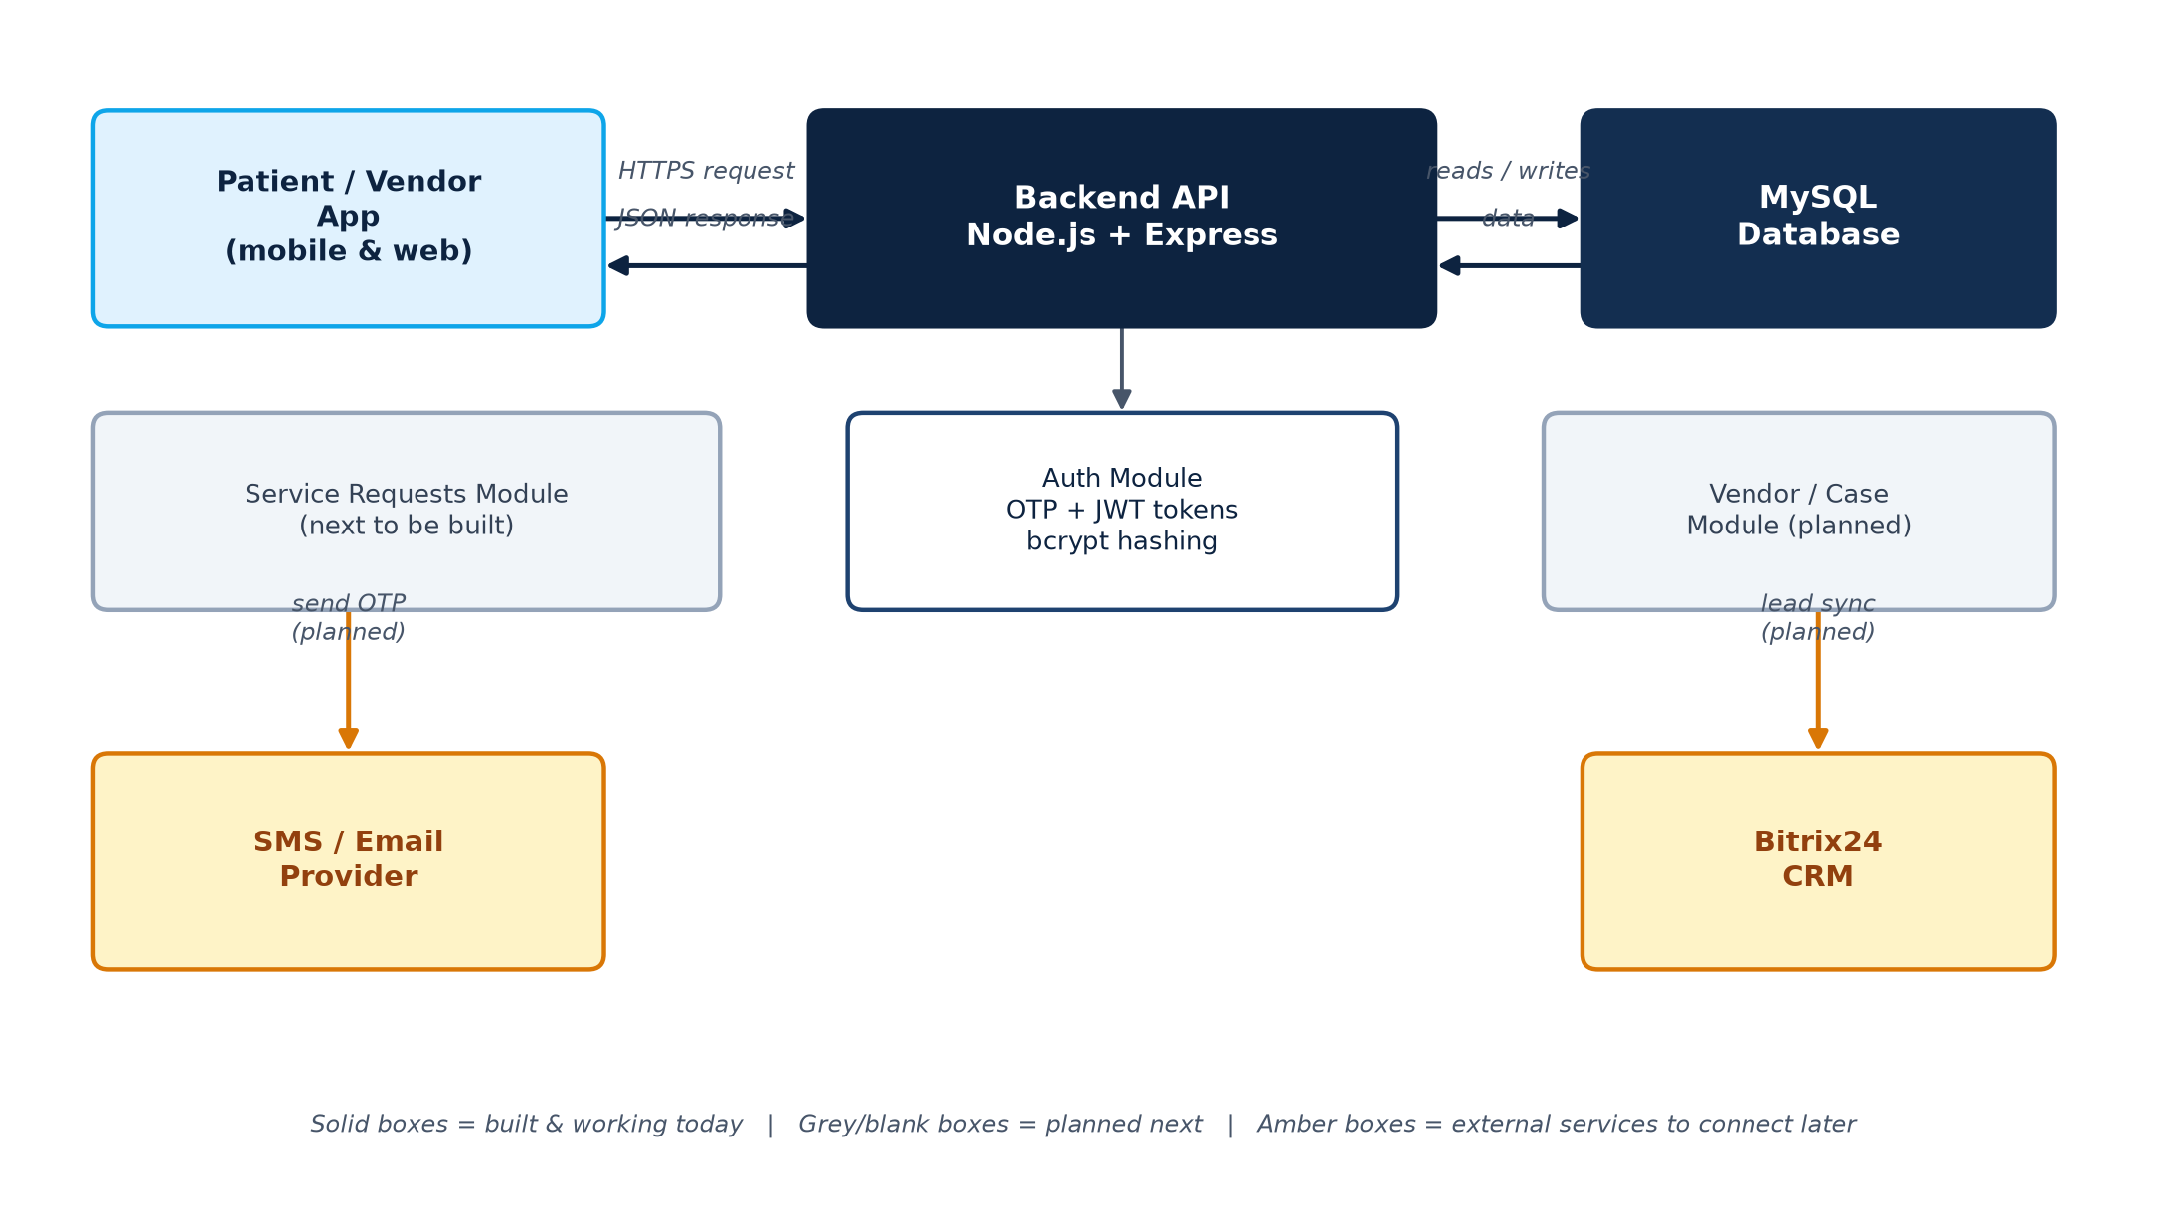
System architecture — solid boxes are built and working today; grey and amber boxes are planned next.

4. Project Folder Structure
The project is organised so that each feature area (like “auth”, and later “requests” or “vendors”) has its own small, self-contained folder. This keeps things easy to find as more features are added.
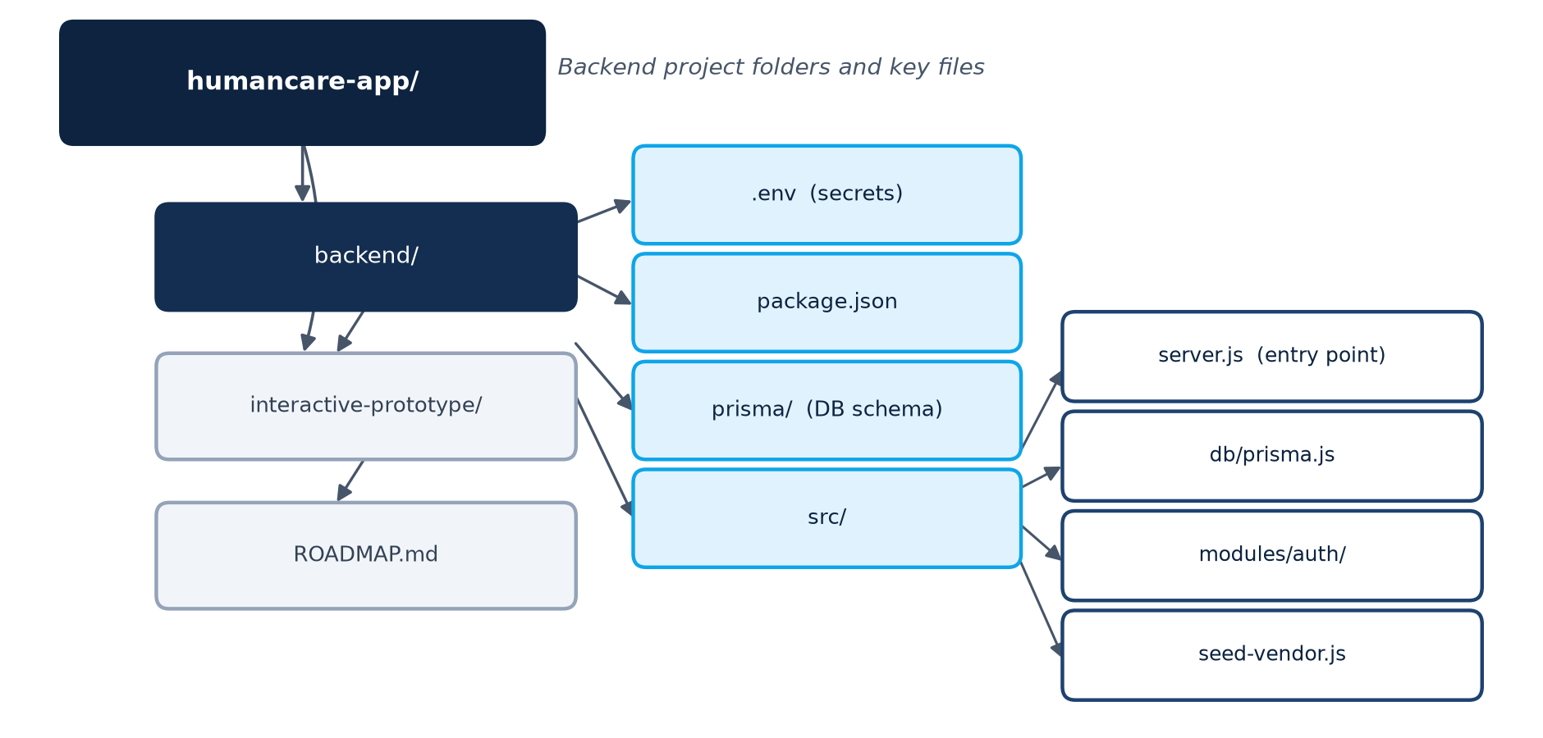
Backend project folders and key files.

Why each feature folder has three files:
- routes — “which web address triggers this?” (e.g. POST /auth/otp/request)
- controller — “what does this request need, and what do we send back?”
- service — “what is the actual logic?” — reusable, and doesn't know about the web at all.
This same three-file pattern will be repeated for every future feature area (service requests, vendor case management, notifications, Bitrix24 sync), so the codebase stays predictable as it grows.

5. Database Tables (Current)
Defined in a single schema file and applied to MySQL via one migration:
Table | Purpose
users | Patients — created automatically the first time someone verifies their mobile OTP.
otp_codes | One-time login codes for patients and vendors, stored only as hashes, with expiry.
vendors | Partner companies (insurance, TPA, government, corporate).
vendor_users | Individual login accounts belonging to a vendor company.
service_requests | A patient's request for a service, with a unique tracking reference and status. Table exists; the endpoints to create/list these are being built next.

Local environment setup (.env)
The server reads its configuration from a local, never-committed .env file: a database connection string, two JWT secret keys, and the port number. The database connection uses a dedicated, limited-privilege MySQL account created specifically for this app — the shared MySQL root login is never used day to day.

6. How Login Works Today (Step by Step)
The login system (“Auth Module”) is the first part of the backend that has been fully built and tested against a real database. Both patients (by mobile number) and vendors (by email + password) sign in using a one-time code (OTP) sent after their first check, plus a 30-second cooldown to stop the same code being requested over and over (which would waste money on SMS).
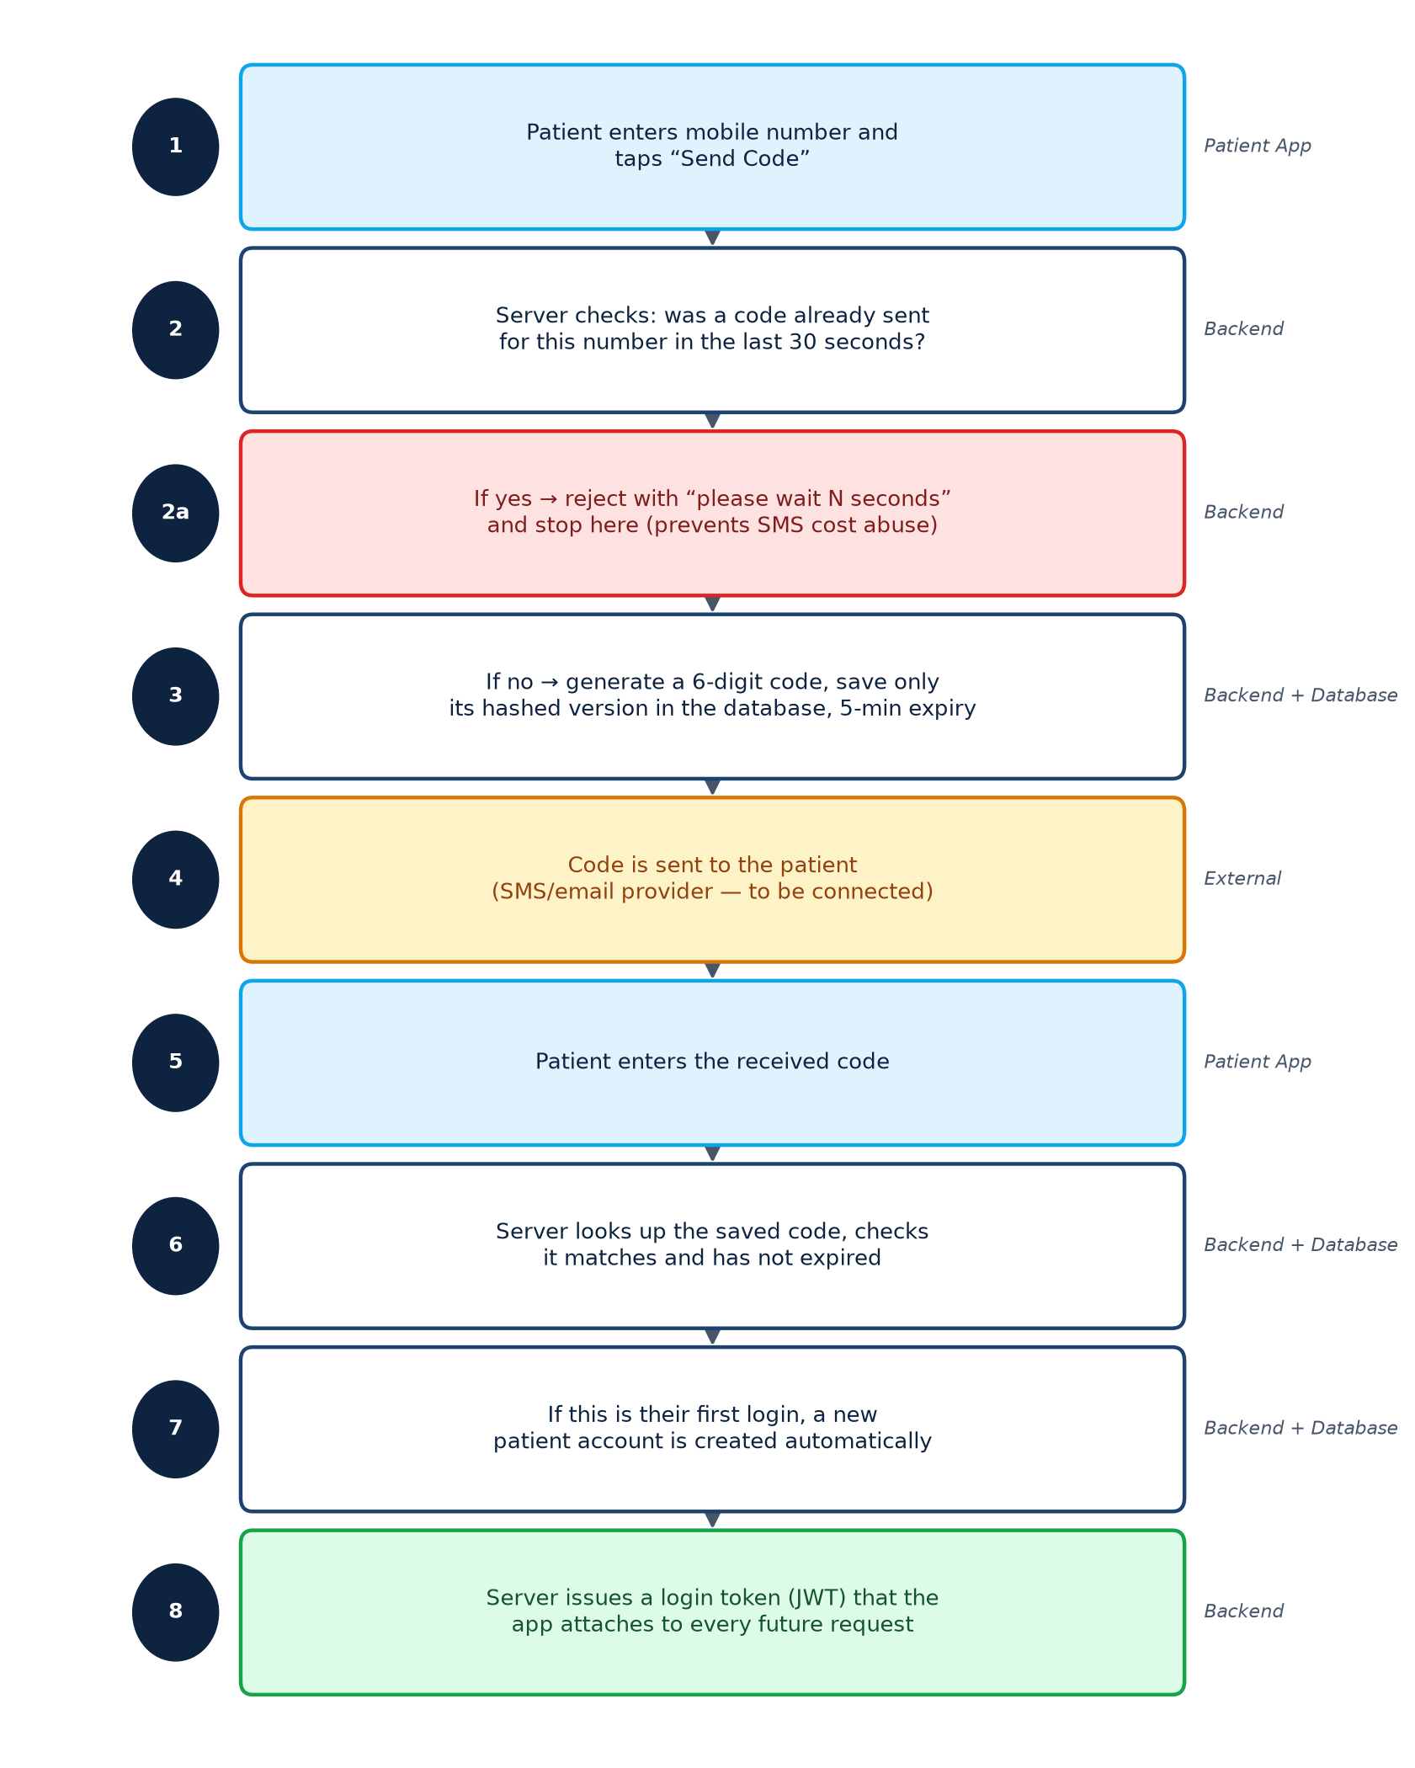
Patient login flow — the vendor flow follows the same pattern, with an email/password check added at step 1.

Endpoints available today
Endpoint | Who calls it | What it does
POST /auth/otp/request | Patient app | Requests a login code by mobile number (30s cooldown applied).
POST /auth/otp/verify | Patient app | Submits the code; creates the account on first login; returns tokens.
POST /auth/vendor/login | Vendor portal | Checks email + password, then sends an OTP (30s cooldown applied).
POST /auth/vendor/otp/verify | Vendor portal | Submits the code; returns login tokens.

How vendor accounts get created today
There is no public vendor sign-up page — vendors are business partners onboarded by HumanCare's own operations team. Right now, a small script creates a vendor account directly in the database for testing. Later, this becomes a proper “Add Vendor” screen inside an internal admin tool (not built yet).

7. What's Next
- Service Request module — lets a logged-in patient submit a request (matching the “Request a Service” screens already approved in the app prototype), save it with a tracking reference number, and track its status. Bitrix24 CRM sync will initially be stubbed (logged, not actually sent) until Bitrix24 API credentials are available.
- Vendor-facing case list and status-update endpoints.
- Mobile app (Expo / React Native) — not started yet.
The full original build plan and phase sequencing is kept in ROADMAP.md in the project folder.

