# Bug 0

Describe the bug

Entering a birth year of ‘1942’ returns a full retirement age of 65, when the minimum full retirement age according to ssa.gov is 66.

Program

CSC256PublicChangeDoc 10/3/21 6:00 PM

Component

full_retirement_age_calculator_app.py

Error Type

Design Error

Severity

Minor

Priority

TBD

## State

Open

To Reproduce

Steps to reproduce the behavior:

1. Enter 1942 when prompted for birth year, and any number 0-12 for birth month
2. Receive incorrect full retirement age

Expected behavior

full_retirement_age() should return 66, instead returns 65 and some months

Screenshots

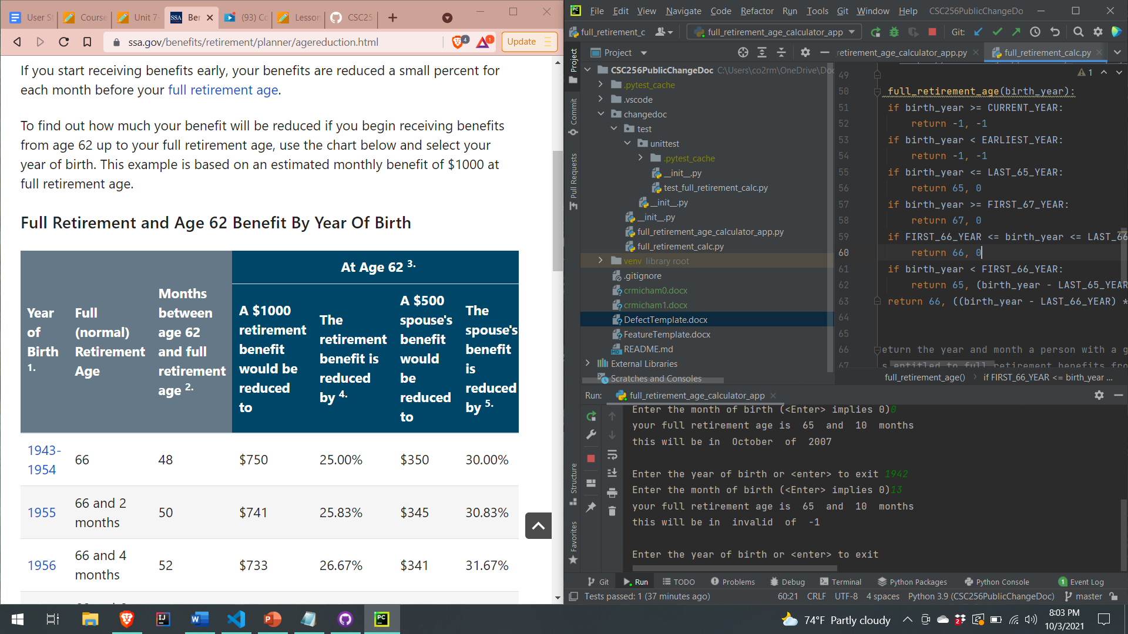

Desktop

Please complete the following information:

* OS: Windows
* Browser: Brave
* Version: 1.29.81

Additional context

Assigned

unassigned