# Feature request 0

A Feature is a request for new function, and not related to something that must be "fixed."

Is your feature request related to a problem?

When the program receives invalid inputs, instead of displaying an error message to the user and then prompting them to re enter the correct info, the program displays the FRA as -1.

Program

CSC256PublicChangeDoc 10/3/21 6:00 PM

Component

full_retirement_age_calculator_app.py

Describe the solution you'd like

Display an error message to the user telling them which input was invalid, then re-prompt them for the correct inputs.

Describe alternatives you've considered

A clear and concise description of any alternative solutions or features you've considered.

Additional context

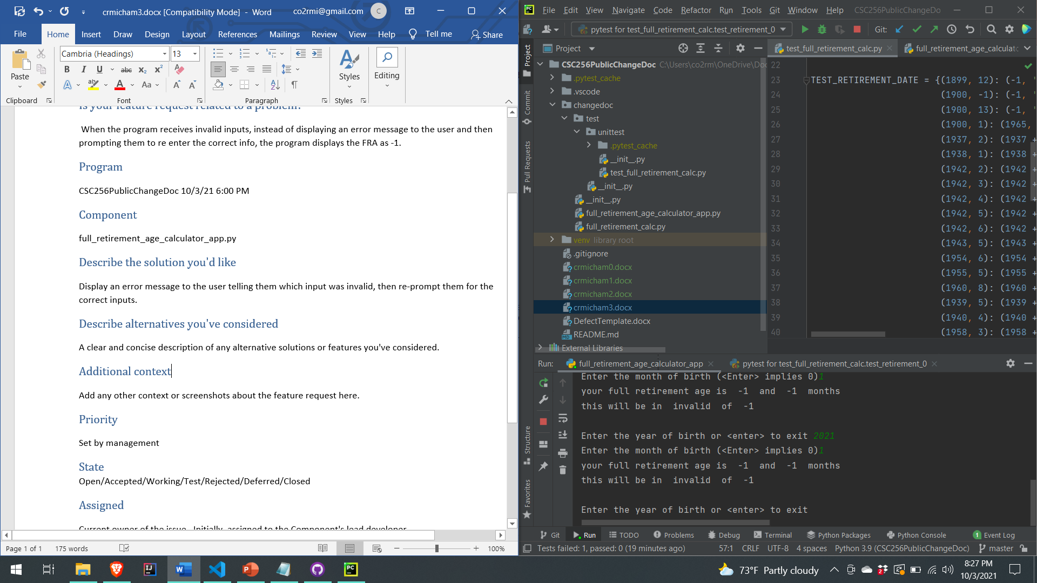Priority

TBD

## State

Open

Assigned

unassigned

Cost

TBD