# Feature request 1

A Feature is a request for new function, and not related to something that must be "fixed."

Is your feature request related to a problem?

When prompted for the user’s birth month, the program currently is supposed to automatically convert a blank input into 0, and then an input of 0 into 1, which is then given to the retirement age calculator. Instead of this implicit conversion taking place, the program should just specify 0 as an invalid input, and convert a blank input to 1.

Program

CSC256PublicChangeDoc 10/3/21 6:00 PM

Component

full_retirement_calc.py

Describe the solution you'd like

Modify full_retirement_calc.py to convert a blank input to 1 and specify 0 as an invalid input. Upon receiving 0 the program should display an error message to the user and re-prompt them for the correct input.

Describe alternatives you've considered

Keep the current conversion of a blank input but still provide an error message, rendering the user unable to input a blank input.

Additional context

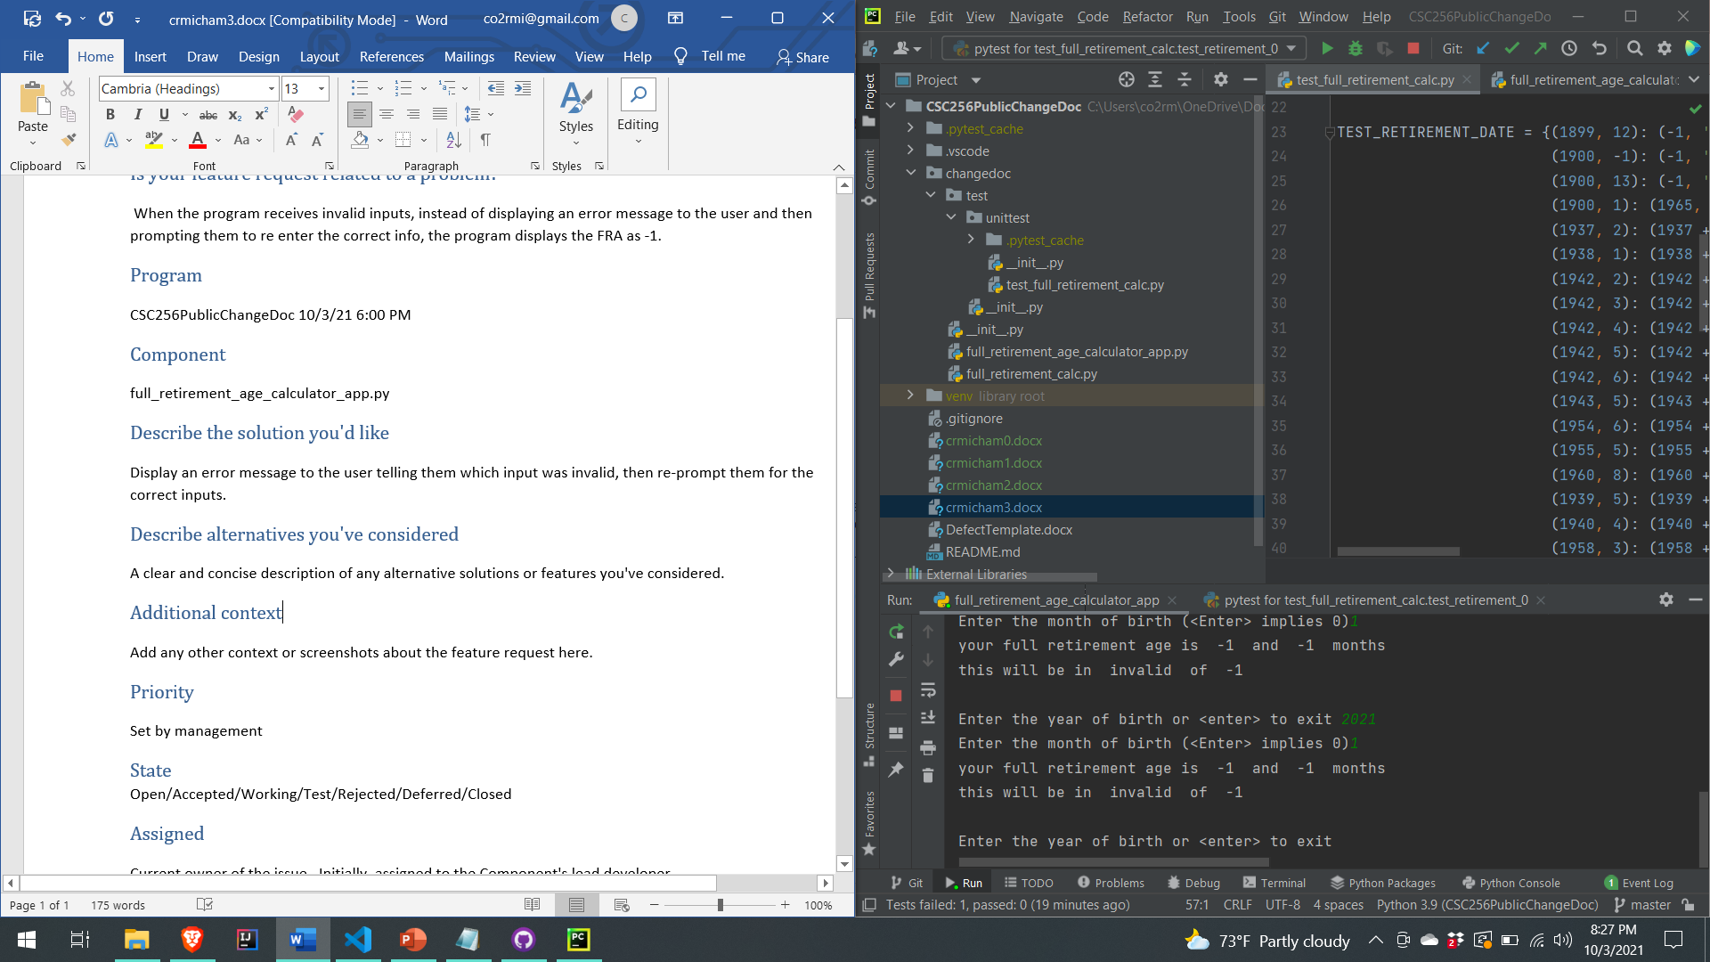

Priority

TBD

## State

Open

Assigned

unassigned

Cost

TBD