Cody Minns

Brittney Hill

5/10/23

**Studying Inflation Using Power BI**

**Motivation**

With both US and global inflation rates on the rise, inflation is an interesting and potentially informative area of study. In particular, exploring historical inflation rate trends may help us to understand patterns in how the inflation rate is changing now and how it might change in the future. Looking at relationships between inflation rate and other economic indicators may help develop these patterns further. Our goal in this project is to look at inflation rate and other economic data to see if we can find any patterns that may help forecast future change in inflation rate.

**Dataset Selection**

Several different potential datasets come to mind when thinking about how to analyze inflation. To compare inflation to other economic measures, we obtained historical inflation rate data from the federal reserve (Reserve, 2017). This dataset also included several other measures, like unemployment rate and GDP. We also wanted to start by comparing inflation to a general economic measure, so we decided to get data on the United States CPI (Verma, 2021). After looking at these data, we decided to look both for more data on inflation and more data on other economic measures. The distributions of these datasets over time are shown in the graphs below. A picture containing text, line, handwriting, font

To get a better idea about inflation on a global scale, we obtained data on historical global inflation rates (HossainDS, 2023). This turned out to be an overwhelming amount of data which made it difficult to use for inference. We also gathered historical data on US housing prices by region and on 30-year conventional mortage rates (US Census Bureau, 2011) in the US from the federal reserve (Reserve, 2019). The distributions of these datasets (or some part of the dataset) are shown in the graphs on the next page. Tabular summaries of all datasets selected for use in our model are found in the Appendix.

**Data Processing and Modeling**

After we extracted the data we wanted to use, we had to transform and load the data into Power BI. Each dataset went through several standard transformations, like converting the first row into column headers, merging related columns (like date information) into single columns, and removing large portions of data with null values. Several of the data tables required more consideration before being loaded into Power BI. For example, the median and average housing value columns from the housing data by region table were merged into single columns for each region before the table was unpivoted and cleaned a bit more to get the final data table used in the model. In addition, the data for global inflation required transposition and unpivoting before being used in the model.

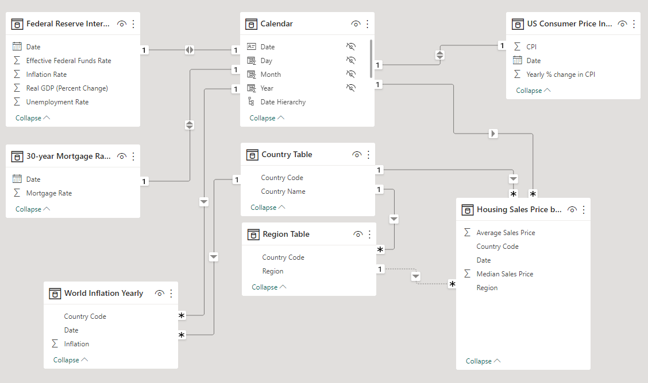The model we used in Power BI is shown below. In addition to the data tables described above, tables to group data by country and by region were created from the world inflation data and the regional housing price data, respectively. A calendar table was also created to connect the date columns of all data tables in the model. A screenshot of a computer

**Initial Analysis**

We began our analysis by reviewing the stand-alone datasets to determine if there were any observations we could make prior to analyzing multiple datasets together. An observation that jumped out initially was in the CPI dataset. We could clearly see there was a high point in the consumer price index in 2008, followed by a low point in 2009, which coincided with the financial crisis occurring at that same time.

This dataset also shows volatility in this metric that at first glance, we are not easily able to explain without including additional context from other datasets.

Next, we started to analysis datasets as they compared to each other over the same period of time. We chose to analysis inflation and unemployment. At first glance, it appears there is an inverse relationship between the two datasets – as inflation decreases (a slow down of the overall economy perhaps), the unemployment rate increases. We see a dramatic increase in the unemployment rate over the 2008-2010 time frame, and we an follow it as the shock of the financial crises slowly recovers and unemployment trends downward.

Lastly, we wanted to view our US data from a more granular perspective, looking closer at trends across regions. We chose to analyze median household sales prices by region over time. From this visualization, we could easily start to see which regions had more volatility over time and which ones did not and which regions were on average higher or lower than their US counterparts. According to the data, the NE, although more volatile, has consistently higher median sales prices than all other regions, while the South and the Midwest are comparatively the same and on average, lower.

We took the analysis of this data one step further, and compared median home sales prices against mortgage rates and as one would expect, as rates increased, the purchasing power of the consumer decreased, and shoppers couldn’t purchase as high of homes. This has a clear, inverse relationship, as rates rise, home prices decline.

The information we were able to review and analyze was interesting as we started to see the relationship between the datasets, but understanding the macro-economic pressures and events that impact these datapoints would help us even further understand the data and if one potentially impacts the other or their relationships are more coincidental or both relying on an additional outside force.

**Interpretation**

Looking at these graphs, we can see many places where the phenomena we observe can be related back to historical events. For example, when looking at the graph of US inflation rate over time (shown in the Dataset Selection section), we can clearly see that the federal reserve’s efforts to control inflation finally started to take effect around 1985. After this year, we see a much more stable graph, where before this year the graph was much more turbulent.

Another example can be found by looking at the graph of unemployment and inflation shown below. We can see that the unemployment rate in the US started increasing in the early 1980s as a result of the efforts to fight inflation. This relationship suggests that there may be some advantage to using inflation rate to predict the unemployment rates in subsequent years.

We can also look to more recent years for some examples of how the data connects to real-world events. The graph below shows the inflation rate before, during, and after the financial crisis of 2007-2008. We can clearly see that rising inflation rates were a precursor to the financial crisis and that the inflation rates fell again toward the end of the crisis. The inflation data alone can be used to tell many more stories like these.

**Conclusion**

After looking at a variety of datasets in Power BI, it is more clear than ever that inflation is a complicated thing to predict or to use to make predictions. While it is possible to find many apparent correlations between inflation and other economic indicators, their relationships are far too complex to be modeled with the limited number of variables considered in this report. Furthermore, while historical inflation data may be used to predict other variables (like unemployment rate), there are also likely many additional factors that are affecting these other variables. Despite these limitations, we still did find several apparent correlations between inflation and various other measures, and these correlations could be used to drive future study.

**Appendix**

Appendix Figure 1: This figure shows data from all data tables used in this project.

**Data References**

HossainDS, B. (2023, February 21). *Global inflation dataset - (1970~2022)*. Kaggle. https://www.kaggle.com/datasets/belayethossainds/global-inflation-dataset-212-country-19702022

Reserve, F. (2017, March 16). *Federal Reserve interest rates, 1954-present*. Kaggle. https://www.kaggle.com/datasets/federalreserve/interest-rates

Reserve, F. (2019, December 24). *30-year conventional mortgage rate*. Kaggle. https://www.kaggle.com/datasets/federalreserve/30-year-conventional-mortgage-rate

US Census Bureau (MCD): Cheryl Cornish, S. C. (2011, August 23). *New residential sales*. United States Census Bureau. https://www.census.gov/construction/nrs/historical_data/index.html

Verma, A. (2021, September 10). *U.S. inflation data*. Kaggle. https://www.kaggle.com/datasets/varpit94/us-inflation-data-updated-till-may-2021