INVOICE | فاتورة

Client Name: | {{client_name}} | Quotation No: | {{quote_no}}
Project Location: | {{client_location}} | Prepared By: | {{prepared_by}}
Contact Number: | {{client_phone}} | Approved By: | {{approved_by}}

Item No. | Product / Device | Description | Qty | Unit Price (AED) | Line Total (AED) | Warranty (Years)
 |  |  | {{QTY}} | TOTAL(AED) | {{total1}} AED
 | ACCOUNT DETAILS |  |  | Price (AED) | {{Price}} AED
 | BANK NAME | Al Maryah Community Bank LLC |  | Installation & Operation Devices (AED) | {{installation_cost}} AED
 | ACCOUNT NO | 3003140080000000 |  | TOTAL AMOUNT (AED) | {{Total}} AED
 | IBAN | AE830973003140080000001
 | COMPANY NAME | NEWTON SMART HOME

1. General Terms
- These Terms and Conditions govern the sale, installation, and servicing of smart home automation products by NEWTEN Smart Home.
- By engaging in a transaction with NEWTEN Smart Home, the client agrees to these terms.

2. Warranty & Liability
- Warranty is provided for manufacturing defects. This does not cover:
  - Wear and tear, misuse, or improper maintenance.
  - External damages or influences beyond our control.
  - Any third-party modifications to hardware or software.
- Warranty claims must be submitted within two months of defect detection.
- Clients are responsible for shipping costs AED 100.00 related to warranty claims.
- No cash refunds are provided under any circumstances.

3. Payment Terms
- 70% (24,367.00) payment upon order confirmation.
- 30% (10,443.00) payment upon testing and commissioning.
- All payments are non-refundable.

4. Delivery & Installation
- Estimated delivery time: 7- 45 days upon receipt of third payment.
- Installation includes testing and programming but excludes:
  - Power supply sources (TAQA) and related failures.
  - Any structural modifications needed for installation.

5. Product Use & Maintenance
- Customers are responsible for ensuring proper use and maintenance of installed systems.
- Any misuse or mishandling voids the warranty.

6. Project Modifications & Delays
- Any request to modify project timelines (expedited services, handover date changes, etc.) may result in additional fees.
- NEWTEN Smart Home reserves the right to adjust pricing due to market fluctuations, supplier changes, or product discontinuation.

7. Intellectual Property & Media Usage
- NEWTEN Smart Home reserves the right to capture and use photos/videos of projects for promotional purposes unless explicitly prohibited by the client.
- Clients may not modify or reproduce any proprietary software or system components without permission.

8. Force Majeure
- NEWTEN Smart Home is not liable for delays or failures caused by external factors beyond its control (natural disasters, supplier disruptions, regulatory changes, etc.).

9. Dispute Resolution
- Any disputes will be resolved amicably; otherwise, they will be handled under the applicable laws of the United Arab Emirates.

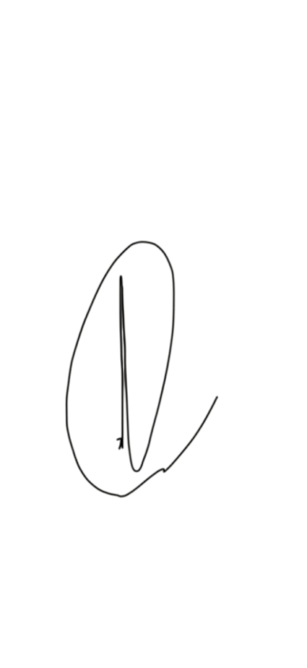
Newton Smart Home | Customer Signature


