

Patrick Sperl  
Drink-O-Matic  
Capstone 2016

Contents

1. Project Justification 2
2. Scope Description 3
3. Acceptance Criteria 3
4. Deliverables/Objectives 3
5. Constraints 4
6. Assumptions 4
7. Requirements 5
8. Entity Relationship Diagram 6
9. Data Flow 7
10. Gantt chart 7

# Project Justification

In every bar, saloon, restaurant that serves drinks and or college Greek house there is a need for drinks. As much as we may praise the person making the drinks we want, they do not know every drink out there. This is including that one drink you had over in Hawaii with a pineapple slice that was muddled exactly 4 times then put in the Collins glass. With this software the patron of whatever location you are can be told what it had in it and how it might have been made and you can search all the popular drinks. If, by chance, this fantastic experience of a drink is not in the list because Mike’s cousin Vinny made it up while in Cabo, you can just add in what they can remember then try to guess what else goes into it so they can send more people up to get that great drink you just made even if you are not there. Consistency is the key with this. Everyone knows what goes into a Mai Tai or a Long Island Iced Tea, but not everyone knows what goes into a Dirty Bronx or a Mystic River Dance or even Uncle Jim’s Midnight Special.

While using “Drink-O-Matic” you are able to get more people to return and get their drinks any day of the week and any time of the day. It no longer matters who is mixing up the drinks. As long as they can read and follow directions they can do some near perfect rendition of the drink. One of the major keys of this besides consistency is familiarity. This of how Cheers worked. Everyone knew Norm’s name when he walked in. This is the same idea but in reverse. You want everyone to know how to make your drink how you like it, even if you can’t remember what it is even called.

# Scope Description

While you using this application you will search and produce key results that fall into the parameters of the query that were inputted in the first place. These results will contain key ingredients, category, name, or one of the other options that can be searched for. Included into this will be any user inputted recipe/ drink/ concoction that the user chooses to enter in.

# Acceptance Criteria

To fully claim this as a successful application and project this must meet the standards of what I call the senior mix. This is the idea walk through as well as the physical testing of user that are, shall we say, less then technological savvy. While keeping in mind that the designer and coders of this application understand what the goal is and how it works, some of the end users may not grasp it as a whole unless it is set up for them to use at their skill level.

# Deliverables/Objectives

As this is geared to the professional level of users, this is setup to allow more establishments to maintain the level of satisfaction of the cliental that they achieve once the clients know that their drinks are saved and easily obtainable by anyone with access to that computer. Soon a mobile version will be available.

# Constraints

As of now this will be a local based system. This means that if a drink is saved at Moe’s tavern it cannot be searched for at Applebee’s unless that same drink is entered manually on location. Down the line a service that will connect all systems together will be implemented in order to allow no privatized drinks to be shared across the board. The drinks that are saved as public will be available to surrounding locations if that option is selected at the time of input.

# Assumptions

Planning ahead on paper and in discussion the design of this application is designed to be used with a mouse, as well as fingertips on touch screen devices. To fully succeed the system must be user friendly, easy to navigate, as well as visually appealing. With the spread of use of the Drink-o-Matic application will make use of custom colors, fonts, logos as well as language, all will be available through updates and new installs to though who wish to customize the experience.

# Requirements

**OS**

* Windows 7 Professional and Ultimate (32 bit)
* Windows 7 Professional and Ultimate (64 bit)
* Windows 8.1 and 8.1 Pro (32 bit)
* Windows 8.1 and 8.1 Pro (64 bit)
* Windows 10 Professional and Ultimate (32 bit)
* Windows 10 Professional and Ultimate (64 bit)

**RAM**

* 32 bit OS: 1 GB
* 64 bit OS: 2 GB

**Screen**

* Resolution: 1024 x 768 or higher

This software, dubbed “Drink-O-Matic”, needs to be developed in the most simplistic fashion in order for all users to be able to use this application. No matter what the capabilities of the user is. The overall design must reach those with the lowest of skills or even the most savvy computer user. This personal or business application will allow users to search for any drink or build on the wide range of standard drinks just by using a mouse or touch screen. Using the UI that could only rival an AOL Chat room any user, patron, customer, single mom or even an otter could search for their favorite OTP. FYI OTP stands for One-True-Pairing. I know I had to look it up too. Knowing that you have what you need or at least the ability to pretend you remember makes it so much easier.  
  
Software Test Plan(s)  
  
[See attached packet in back]

Entity Relationship Diagram 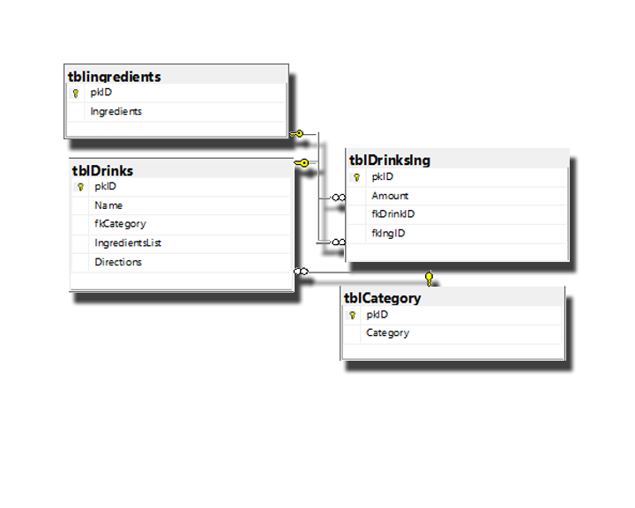

# Data Flow

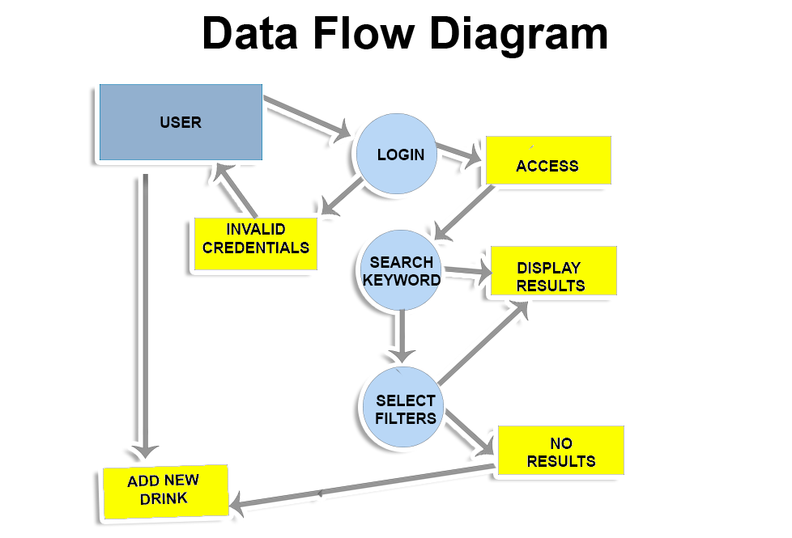

Gantt chart