Salesforce API Integration Scoping Overview
Sales-Portal sandbox baseline and integration blueprint for external system connectivity
Field | Value
Document purpose | Scope Salesforce integration approach via APIs for downstream systems
Source org alias | xeretec-sandfull01
Source org id | 00DAe000009POI7MAO
Source instance URL | https://xeretecprod--sandfull01.sandbox.my.salesforce.com
Salesforce API version | 66.0
Metadata snapshot timestamp | 2026-03-02T12:29:48.9546818Z
Document generated | 2026-03-02 13:35:42 UTC

1. Executive Summary
This document provides a technical scoping baseline for integrating Salesforce with external systems through API-based patterns. It combines org metadata inventory, object relationship mapping, and focused business-flow diagrams generated from the current sandbox snapshot.
- Org baseline includes 3914 objects (2913 standard, 1001 custom).
- Relationship map includes 7653 lookup-style links across 963 source objects.
- Commercial object chain and finance integration paths are mapped and included as ERD diagrams.
- Recommended primary integration posture is API-first with OAuth 2.0 server-to-server authentication.
- A phased implementation plan is included for delivery, governance, and operational readiness.

2. Environment and Metadata Baseline
The following baseline is derived from files generated under config/ in this repository.
Metric | Value
Total objects discovered | 3914
Standard objects | 2913
Custom objects | 1001
Custom metadata types (__mdt) | 45
Custom platform events (__e) | 16
Relationship rows discovered | 7653
Objects with outbound relationships | 963
Unique relationship targets | 427
Lookup relationships | 7602
RecordType relationships | 51
Target resolution from ReferenceTo | 6713
Target resolution from DataType parsing | 940
Top custom package/object namespaces in this org:
Namespace prefix | Object count
c2g__ | 324
SCMC__ | 170
fferpcore__ | 104
ffr__ | 73
ffct__ | 35
ffbc__ | 33
sf_devops__ | 30
FAM__ | 25
APXTConga4__ | 24
ffirule__ | 22
ffbf__ | 19
CS_APP__ | 14

3. Integration-Relevant Data Model Highlights
This org has a dense managed-package footprint. Integration design should treat Salesforce as a hub with multiple domain-specific bounded contexts, especially SCMC and c2g finance objects.
Highest edge density in focused map (source objects):
- c2g__codaCreditNote__c: 7 focused target links
- c2g__codaInvoice__c: 7 focused target links
- Commission_Payment__c: 7 focused target links
- c2g__codaJournalLineItem__c: 6 focused target links
- c2g__codaTransaction__c: 6 focused target links
- SCMC__Invoicing__c: 6 focused target links
- SCMC__Customer_Quotation__c: 5 focused target links
- SCMC__Purchase_Order__c: 5 focused target links
Highest edge density in focused map (target objects):
- Account: 16 inbound focused links
- c2g__codaCompany__c: 10 inbound focused links
- Opportunity: 8 inbound focused links
- SCMC__Sales_Order__c: 7 inbound focused links
- Contact: 6 inbound focused links
- SCMC__Item__c: 6 inbound focused links
- c2g__codaGeneralLedgerAccount__c: 5 inbound focused links
- c2g__codaIntercompanyTransfer__c: 5 inbound focused links
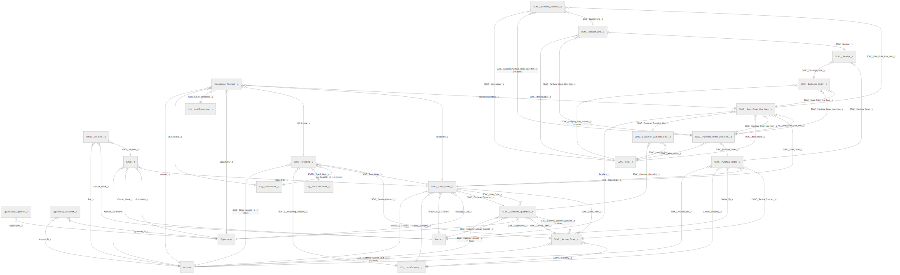
Figure 0 - Focused ERD: Commercial process landscape

4. Commercial Flow (Opportunity to Invoice)
The commercial flow connects CRM and order operations from opportunity through quotation, sales order, invoicing, and invoice-related finance references.
Source object | Target object | Link count | Primary field(s)
Commission_Payment__c | Account | 1 | Account__c
Commission_Payment__c | c2g__codaInvoice__c | 1 | Sales_Invoice__c
Commission_Payment__c | Opportunity | 1 | Opportunity__c
Commission_Payment__c | SCMC__Invoicing__c | 1 | OPI_Invoice__c
Commission_Payment__c | SCMC__Sales_Order__c | 1 | SalesOrder__c
Commission_Payment__c | SCMC__Sales_Order_Line_Item__c | 1 | SalesOrderLineItem__c
Opportunity_Approval__c | Opportunity | 1 | Opportunity__c
Opportunity_Snapshot__c | Account | 1 | Account_ID__c
Opportunity_Snapshot__c | Opportunity | 1 | Opportunity_ID__c
SCMC__Customer_Quotation__c | Account | 2 | SCMC__Customer_Account__c;SCMC__Override_Bill_to_Account__c
SCMC__Customer_Quotation__c | Contact | 1 | SCMC__Customer_Account_Contact__c
SCMC__Customer_Quotation__c | Opportunity | 1 | SCMC__Opportunity__c
SCMC__Customer_Quotation__c | SCMC__Sales_Order__c | 1 | SCMC__Sales_Order__c
SCMC__Customer_Quotation__c | SCMC__Service_Order__c | 1 | SCMC__Service_Order__c
SCMC__Customer_Quotation_Line__c | SCMC__Customer_Quotation__c | 1 | SCMC__Customer_Quotation__c
SCMC__Invoicing__c | Account | 2 | SCMC__Billing_Account__c;SCMC__Customer__c
SCMC__Invoicing__c | c2g__codaCompany__c | 1 | SCMFFA__Accounting_Company__c
SCMC__Invoicing__c | c2g__codaCreditNote__c | 1 | SCMFFA__Credit_Note__c
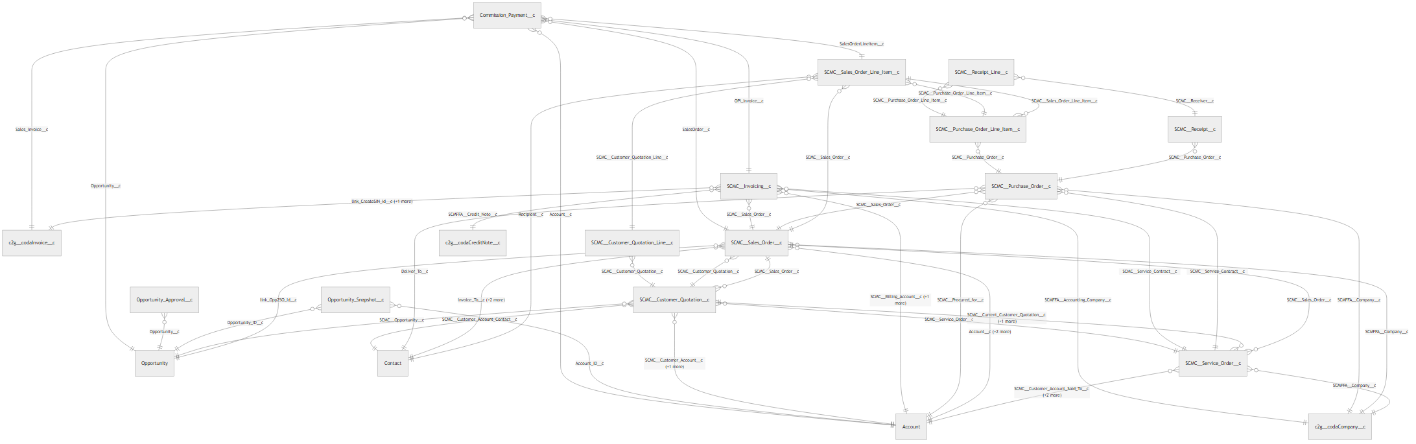
Figure 1 - Focused ERD: Opportunity to Invoicing flow

5. Finance Integration Lens (SCMC to c2g)
Finance-related links show where commercial records connect into c2g accounting entities such as sales invoice, credit note, transaction, intercompany transfer, and company/GL structures.
Source object | Target object | Link count | Primary field(s)
c2g__codaCompany__c | Account | 1 | c2g__IntercompanyAccount__c
c2g__codaCompany__c | c2g__codaGeneralLedgerAccount__c | 9 | c2g__AuxiliaryGLA__c;c2g__CustomerCurrencyWriteOff__c;c2g__CustomerCurrencyWriteOffLoss__c;c...
c2g__codaCreditNote__c | Account | 1 | c2g__Account__c
c2g__codaCreditNote__c | c2g__codaCompany__c | 1 | c2g__OwnerCompany__c
c2g__codaCreditNote__c | c2g__codaIntercompanyTransfer__c | 1 | c2g__IntercompanyTransfer__c
c2g__codaCreditNote__c | c2g__codaInvoice__c | 1 | c2g__Invoice__c
c2g__codaCreditNote__c | c2g__codaTransaction__c | 1 | c2g__Transaction__c
c2g__codaCreditNote__c | Opportunity | 1 | c2g__Opportunity__c
c2g__codaCreditNote__c | SCMC__Invoicing__c | 1 | SCMFFA__SCM_Invoice__c
c2g__codaIntercompanyTransfer__c | Account | 1 | c2g__SourceDocumentVendorAccount__c
c2g__codaIntercompanyTransfer__c | c2g__codaCompany__c | 2 | c2g__DestinationCompany__c;c2g__SourceCompany__c
c2g__codaIntercompanyTransfer__c | c2g__codaCreditNote__c | 1 | c2g__SourceSalesCreditNote__c
c2g__codaIntercompanyTransfer__c | c2g__codaInvoice__c | 1 | c2g__SourceSalesInvoice__c
c2g__codaIntercompanyTransferLineItem__c | c2g__codaGeneralLedgerAccount__c | 2 | c2g__GeneralLedgerAccount__c;c2g__LocalGLA__c
c2g__codaIntercompanyTransferLineItem__c | c2g__codaIntercompanyTransfer__c | 1 | c2g__IntercompanyTransfer__c
c2g__codaInvoice__c | Account | 2 | c2g__Account__c;Customer_Account__c
c2g__codaInvoice__c | c2g__codaCompany__c | 1 | c2g__OwnerCompany__c
c2g__codaInvoice__c | c2g__codaGeneralLedgerAccount__c | 1 | c2g__GeneralLedgerAccount__c
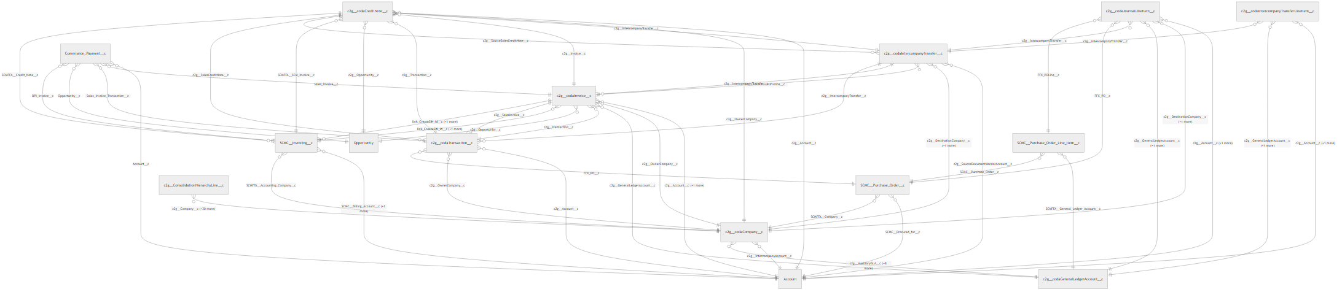
Figure 2 - Focused ERD: Finance integration flow

6. API Access Model and Recommended Patterns
Recommended default is API-first orchestration via a middleware or integration service account. Use object and relationship metadata to drive payload mapping and contract ownership.
Salesforce API | Best use | Typical volume/latency | Implementation notes
REST API | CRUD, query, orchestration | Low/medium volume, near real-time | Default for synchronous integration flows.
Composite REST | Bundled writes/reads in one call | Low/medium volume, near real-time | Reduces round-trips; useful for transactional orchestration.
Bulk API 2.0 | Large inserts/updates/extracts | High volume, async | Use for backfill, reconciliation, and nightly integration windows.
Streaming (Platform Events/CDC) | Event-driven downstream updates | Near real-time | Use where low-latency propagation is required.
Metadata + Tooling APIs | Schema and deployment automation | N/A | Use in CI/CD and schema governance, not business-transaction payloads.
Recommended authentication profile:
- Use a dedicated integration user per system or integration domain.
- Use Connected App with OAuth 2.0 JWT Bearer flow for server-to-server calls.
- Restrict scopes to least privilege and enforce IP/session policies.
- Store private keys and client credentials in a secure secret manager.
- Separate sandbox and production connected apps/credentials.
Suggested endpoint baseline:
https://xeretecprod--sandfull01.sandbox.my.salesforce.com/services/data/v66.0/

7. Integration Scoping Matrix
Use case type | Direction | Pattern | Key Salesforce objects | Design notes
Order sync to ERP | Salesforce -> ERP | Event + REST/Composite | SCMC__Sales_Order__c, SCMC__Sales_Order_Line_Item__c, SCMC__Invoicing__c | Publish order state changes and perform idempotent upserts.
Invoice/credit feedback | ERP -> Salesforce | REST + Bulk for backlog | c2g__codaInvoice__c, c2g__codaCreditNote__c, Commission_Payment__c | Use external IDs and replay-safe processing.
Master data sync | Bidirectional | REST for delta + Bulk for periodic reconciliation | Account, Contact, SCMC__Item__c, c2g__codaCompany__c | Define source-of-truth per field domain.
Analytics extraction | Salesforce -> data platform | Bulk API 2.0 | Opportunity chain + finance objects | Partition exports and enforce incremental strategy.

8. Security, Governance, and Operational Controls
- Establish data classification for all synced entities and fields.
- Implement field-level allowlists, not broad object-level extracts.
- Apply integration user profile/permission set with minimum required access.
- Use idempotency keys and external IDs to prevent duplicate writes.
- Set API monitoring with alerts for failures, retries, and limit consumption.
- Define retention and audit strategy for request/response payload logs.
- Document runbooks for incident triage, replay, and rollback.

9. Delivery Plan and Effort Bands
Phase | Duration (estimate) | Primary outputs
Phase 1 - Discovery and contracts | 1-2 weeks | Field-level mapping, ownership model, API contracts, non-functional requirements.
Phase 2 - Foundation build | 2-4 weeks | Connected App setup, auth automation, middleware scaffolding, observability baseline.
Phase 3 - Core flows | 3-6 weeks | Opportunity-to-invoice and finance feedback integrations in sandbox/UAT.
Phase 4 - Hardening and go-live | 2-3 weeks | Performance tests, failure handling, runbooks, production cutover and hypercare.

10. Immediate Next Actions
- Confirm target systems and ownership for each integration lane (ERP, data platform, service tooling, etc.).
- Approve canonical key strategy (Salesforce IDs vs external IDs) per object family.
- Create Connected App(s) and service principals for non-interactive integration access.
- Finalize object and field allowlists for Opportunity, SCMC order flow, and c2g finance entities.
- Define integration SLAs (latency, RPO/RTO, retry policy, support window).

11. Supporting Artifacts in config/
- org-info.json
- objects.csv
- object-relationships.csv
- object-link-summary.csv
- object-link-summary-focused.csv
- object-link-summary-oppty-flow.csv
- erd-focused-commercial.png/.svg/.mmd
- erd-focused-finance.png/.svg/.mmd
- erd-opportunity-flow.png/.svg/.mmd

