**Negative feedback equalizes polarity sites in a multi-budding yeast**

Alex W. Crocker, Alison C.E. Wirshig, Joanne L. Ekena, Daniel J. Lew, Timothy C. Elston, Amy S. Gladfelter

**Morphogenesis in fungi and animals is directed by polarization of small GTPases Cdc42 and Rac. In the budding yeast *Saccharomyces cerevisiae* a positive feedback loop drives competition between polarity patches, resulting in one polarized patch and the growth of a single bud. Here, we describe cell polarity in the yeast *Aureobasidium pullulans*, which can produce multiple buds during a single cell division cycle. We find that *A. pullulans* cells maintain multiple polarity sites and that these sites oscillate in intensity over time. Previous theoretical work has demonstrated that negative feedback in a polarity circuit could promote coexistence of multiple polarity sites, and time-delayed negative feedback is known to cause oscillations. We show that both these features of negative feedback depend on a protein we identified as Pak1, and that Pak1 requires Rac1 but not Cdc42 for its localization.**

**Introduction**

Cell polarization by small GTPases at the plasma membrane is an evolutionarily conserved process that directs diverse morphological changes in cells (Etienne-Manneville and HAll, 2002). In the yeast *Saccharomyces cerevisiae* polarization of the GTPase Cdc42 directs cytoskeletal rearrangements and localizes exocytosis, leading to the formation of a bud or mating projection (Chiou et al., 2017). The molecular mechanisms of cell polarization in *S. cerevisiae* are well studied, and mathematical models have been developed to rigorously describe the process. Although similar polarity machinery is able to drive processes as distinct as cell migration (Raftopoulou and Hall, 2004), phagocytosis (Mao and Finnemann, 2015), and hyphal branching (Philippsen et al. 2005), it is unknown to what extent the yeast models of cell polarity are applicable in other systems.

Initial theoretical and computational models of cell polarity relied on a positive feedback loop in which a slow-diffusing, active, GTP-bound Cdc42 or other GTPase promoted activation of fast-diffusing, inactive, GDP-bound Cdc42 (Goryachev and Pokhilko, 2008; Kozubowski et al., 2008). The reactions were defined such that recruitment of inactive Cdc42 was nonlinear with respect to the local concentrations of active and inactive Cdc42. Higher local concentrations of active Cdc42 led to increasing local activation of Cdc42 while the fast-diffusing inactive Cdc42 was depleted globally. These models always resulted in, at most, a single polarity patch as time went to infinity. More recent models, however, have included negative feedback, which became evident experimentally in certain mutant strains of *S. cerevisiae* (Howell et al., 2012; Wu and Lew, 2013; Kuo et al., 2014). In these models, negative feedback increased the robustness of the polarity circuit, allowing for polarization over a wider range of protein concentrations. It has also been shown that negative feedback in the yeast polarity circuit could theoretically equalize multiple polarity patches (Chiou et al., 2021; Goryachev and Leda, 2011; Jacobs et al., 2019), although this role for negative feedback has not been demonstrated in cells.

Here, we investigated cell polarity in the fungus *Aureobasidium pullulans*, a morphologically plastic generalist isolated from environments as varied as plant leaves, solar salterns, and arctic glaciers (Gostinčar et al. 2019). This organism exhibits a number of distinct cell morphologies, one of which is a multinucleate yeast which can grow one or many buds in a single cell division cycle. We asked whether budding growth of *A. pullulans* relies on the same molecular mechanisms that have been described in *S. cerevisiae*, and whether the differences in bud number can be accounted for by established mathematical models of cell polarity. We found similar polarity machinery, with a few significant differences. We observed that polarity site number scaled with cell size, consistent with an established positive-feedback-only polarity model, but that polarity dynamics required the incorporation of time-delayed negative feedback. Our findings suggest that a conserved negative feedback loop involving a small GTPase and PAK is important for the equalization of bud growth in this multi-budding yeast.

**RESULTS**

**Identification of cell polarity proteins in *Aureobasidium pullulans***

To understand how cell polarity is regulated in the multi-budding yeast *Aureobasidium pullulans*, we first identified homologs of the proteins that drive polarization in *Saccharomyces cerevisiae*. The core polarity circuit in *S. cerevisiae* consists of a single GTPase, Cdc42, which is activated by a GEF called Cdc24 that promotes exchange of GDP for GTP. In its active state, Cdc42 binds two p21-activated kinases (PAKs), relieving their autoinhibition and promoting their kinase activity (Lamson et al. 2002) [X]. PAKs also bind to the scaffold protein, Bem1, which also binds to the GEF, Cdc24 (Ito et al., 2001; Irazoqui et al., 2003; Kozubowski et al., 2008), completing a positive feedback loop whereby active Cdc42 localizes its own activator [X] (Fig. 1B). We identified homologs of these polarity proteins in *A. pullulans* using the Basic Local Alignment Search Tool (BLAST) with *S. cerevisiae* protein sequences as search queries (Altschul et al., 1990).

We first searched for small GTPases and identified two proteins encoded by the *A. pullulans* genome with similarly high homology to the *S. cerevisiae* Cdc42 protein sequence. One showed 98% coverage and 78% amino acid identity; the other 98% coverage and 67% identity. When used as queries for a BLAST search in *S. cerevisiae*, the best hit for each of these proteins was Cdc42. Many fungi and animals (but not *S. cerevisiae*) express Rac as well as Cdc42 proteins (Diepeveen et al., 2018; Hall, 1994). These two GTPases share similar sequences, structures, and functions; but may have specificity for certain effectors (Knaus et al., 1998, Mahlert et al., 2006). Examination of specific residues (A48 and R180) in the two *A. pullulans* homologs for Cdc42 indicate that the second putative Cdc42 homolog is in fact better described as a Rac protein (Mott et al., 1999; Morreale et al., 2000). While the structures of *Sc*Cdc42, *Ap*Cdc42 and *Ap*Rac1, are all remarkably similar to one another, *Ap*Cdc42 contains an approximately 7 amino-acid extension of an internal loop next to the α3’ loop (Fig 1C). This region of Cdc42 proteins has previously been identified as less-conserved, and has been used successfully as an insertion site for fluorescent tags. We refer to these two identified GTPases in *A. pullulans* as *Ap*Cdc42 and *Ap*Rac1.

We next searched for potential GEFs and found that the *A. pullulans* genome encodes a reciprocal best hit for *Sc*Cdc24 with 52% coverage and 27% amino acid identity. No other *A. pullulans* proteins were found to have more than 6% coverage. The Cdc24 homolog features a potentially autoinhibitory calponin homology (CD) domain (Shimada et al., 2004), a catalytic GEF or Dbl homology (DH) domain, a pleckstrin homology (PH) domain, and Phox and Bem1 (PB1) domain, important for interaction with the scaffold protein Bem1 (Ito et al., 2001). The sequence also includes a disordered region of about 250 amino acids between the PH and PB1 domains, not present in ScCdc24 (Fig. 1D). We refer to this protein as *Ap*Cdc24.

Continuing to examine components of the known polarity circuit, a reciprocal best hit in *A. pullulans* was found for *Sc*Bem1, with 70% coverage and 33% amino acid identity. The predicted protein features two SRC Homology 3 (SH3) domains, which in *S. cerevisiae* are important for interaction with the PAK Ste20 (Kozubowski et al., 2008); it features a phox homology (PX) domain, involved in membrane binding (Takahashi and Pryciak, 2007); and it features a PB1 domain, important for interaction with the GEF in *S. cerevisiae* (Fig. 1D). We refer to this protein as ApPak1.

The *S. cerevisiae* genome encodes two PAKs (*Sc*Ste20 and *Sc*Cla4) known to interact with Cdc42, however, we identified only a single PAK in *A. pullulans*. While we identified two additional proteins in A. pullulans with PAK-like kinase domains, each lacked the P21 binding domain (PDB) and Cdc42/Rac interactive binding (CRIB) motif required for interaction with Cdc42 or Rac1. We found that the *A. pullulans* PAK has greater sequence-level homology to *Sc*Ste20 than to *Sc*Cla4, but features a PH-domain which is present in *Sc*Cla4 but not *Sc*Ste20 (Takahashi and Pryciak, 2007). A PxxP motif, implicated in PAK binding to Bem1 in *S. cerevisiae*, is present in the *A. pullulans* PAK between residues 375-383. The *A. pullulans* PAK features a p21 binding domain (PDB) which includes a Cdc42/Rac interactive binding (CRIB) motif, and features a characteristic kinase domain (Fig. 1D). We refer to this protein as ApPak1.

In addition to the four classes of proteins described above, additional regulators have been shown to control aspects of polarity in *S. cerevisiae* and other organisms (Bender et al., 1996; Brown et al., 1997; Lee et al., 2015; Sawin and Nurse, 1998; Woods et al., 2016). We identified homologs to a number of additional polarity regulators including upstream polarity landmarks, GTPase activating proteins (GAPs), and a GDP-dissociation inhibitor (GDI) (Table S1).

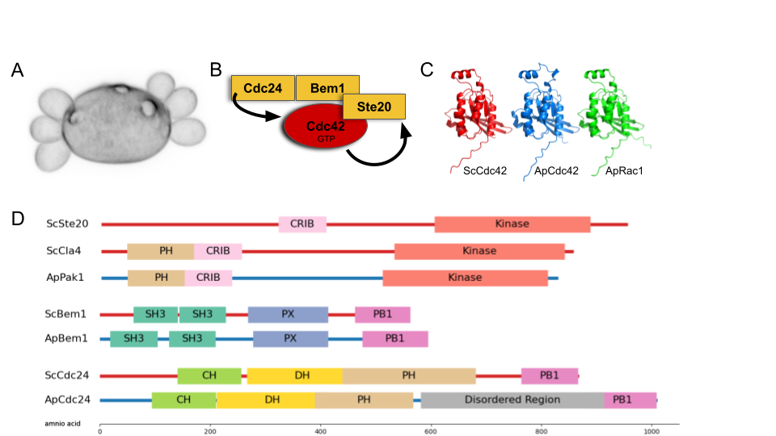

**Figure 1. Aureobasidium pullulans genome features clear homologs of core polarity proteins from Saccharomyces cerevisiae.** (A) *A. pullulans* cell stained with calcofluor white is shown producing multiple buds of the same size from one mother. Bud scars can be seen at sites of previous budding events. (B) Schematic of the core polarity network in *Saccharomyces cerevisia*e. (C) Comparison of the predicted structure of Cdc42 and Rac GTPases in *S. cerevisiae* and *A. pullulans*. (D) Comparison of the domains found in core polarity proteins of S. cerevisiae and their homologs in *A. pullulans.*

**Polarity proteins in *Aureobasidium pullulans* localize to pre-bud sites, buds, and bud-necks**

We next tagged each of these polarity proteins with genetically-encoded fluorophores to test their localization to pre-bud sites, and to measure their properties in live cells. Pak1, Bem1, and Cdc24 were each endogenously tagged at their C-termini with a version of GFP that was codon optimized for *A. pullulans* (Petrucco et al. 2024). Since tagging Cdc42 at either terminus can interfere with its function and localization, we tagged Cdc42 and Rac1 at an internal loop that has proven functional in other systems with a codon-optimized version of mCherry (Bendezú et al., 2015). The mCherry-tagged versions of Cdc42 and Rac1 were each incorporated, along with their own promoter and terminator regions, as additional copies of the genes at the URA3 locus.

All five tagged proteins were found to localize to pre-bud sites (Fig 2A), with varying levels of enrichment. Localization of the probes occurred in small and large cells, and at each pre-bud site in multi-budding cells. As in *S. cerevisiae*, these proteins also localize to growing buds and mitotic cell bud-necks (Fig 2A). Cdc24 did not localize to the nucleus at any point during the cell cycle, inconsistent with *S. cerevisiae*, but consistent with observations made in other non-*Saccharomyces* fungi (Takemoto 2011, Castillo-Lluva 2007).

**Concentrations of polarity proteins do not scale with cell size**

Yeast cells of *Aureobasidium pullulans* are multinucleate and their volume correlates well with nuclear number (Wirshig et al., 2024). Scaling gene dosage with cell size could help maintain protein concentrations despite differences in cell size, but this doesn’t have to be the case. Differences in relative protein concentrations could alter cell polarity outcomes, as overexpression of one or more polarity proteins is known to promote non-polarized or multi-polar outcomes in S. cerevisiae (Howell et al., 2010, Ziman and Johnson, 1994). To determine whether size differences are associated with differences in polarity protein concentration in *A. pullulans* we measured cell size and fluorescence intensity of tagged proteins using confocal microscopy. We converted fluorescence intensity to protein concentration using molecular brightness estimates from fluorescence correlation spectroscopy (FCS). Measurements from tens of thousands of cells are summarized in Figure 2B and a more complete description of the experiments and data are in Figure S2. These measurements showed that the average concentrations for each tagged protein varied less than two-fold across cells of different size, and variation within size groups was larger than the difference between size groups for any probes. We conclude that each of the polarity proteins we have identified and tagged increases in number with cell volume so that concentration is conserved.

In addition to measuring concentrations of polarity proteins in *A. pullulans* we measured concentrations of their homologs in *S. cerevisiae*. Some proteins were found to be at similar concentrations between *A. pullulans* and *S. cerevisiae*. The concentration of Bem1 was similar between *A. pullulans* and *S. cerevisiae*, while Pak1 in *A. pullulans* was slightly lower in concentration than Ste20 or Cla4 in *S. cerevisiae*. Other proteins were found to be expressed at dramatically different concentrations. In *A. pullulans* Cdc24 concentration was about a quarter of the concentration measured in *S. cerevisiae*. Cdc42 levels also measured far lower in *A. pullulans* than in *S. cerevisiae;* and although Rac1 levels were higher than *Ap*Cdc42, the sum of *Ap*Rac1 and *Ap*Cdc42 is still lower than the level observed for *Sc*Cdc42.

Despite some differences in protein concentration between *S. cerevisiae* and *A. pullulans*, none of our observations regarding concentration or localization of fluorescently tagged proteins provide evidence of a circuit inconsistent with established models of cell polarity. We do find that polarity protein concentrations in *A. pullulans* are independent of cell size, necessitating that a model for polarity in this fungus be able to produce a different number of polarity sites without relying on large changes to protein concentration.

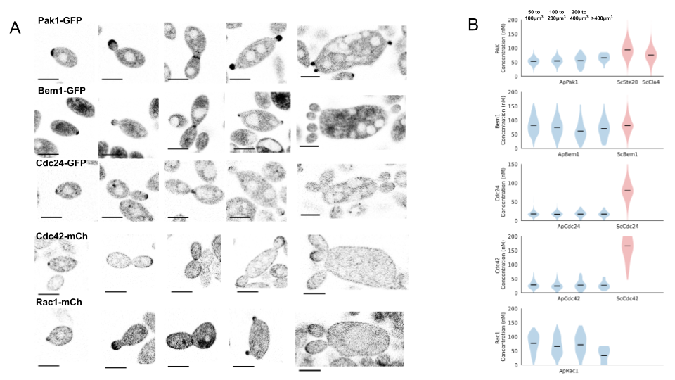

* **Figure 2. Predicted *Aureobasidium pullulans* polarity proteins were fluorescently tagged to determine localization and concentration.** (A) Confocal images show that probes localize to pre-bud sites, growing bud tips, and bud necks to varying degrees. Fluorescence intensity has been mapped to concentration by calibrating the molecular brightness of GFP using fluorescence correlation spectroscopy.(B) Probes are expressed at similar or moderately different levels compared to their *Saccharomyces cerevisiae* homologs. Average concentrations are consistent across *A. pullulans* cells with large differences in cell volume.

**Bud number scales with cell size in *Aureobasidium pullulans*, consistent with established model of cell polarity**

Given that polarity protein concentrations are independent of cell size, the total amounts of polarity proteins in the cell should scale with cell volume, but should outpace cell membrane surface area, which scales more slowly as an approximately ellipsoid cell increases in size. Established polarity models have shown that the time to reach a mono-polar outcome increases as the size of the simulated cell increases, and that incomplete competition between sites can yield multiple polarity sites (Chiou et al., 2018; Ishihara et al., 2007; Chiou et al., 2021). We next implemented a minimal model of cell polarity to explore mechanisms of multi-site polarity and ask whether the increased competition time associated with a larger domain can result in increasing numbers of polarity sites when simulation time is limited to an appropriate biological time scale.

Multiple computational models have been developed to account for cell polarity, with varying levels of complexity and resolution (Goryachev and Leda, 2017; Guan, 2023; Miller et al., 2022; Pablo, 2018; Ramirez, 2021). Here we use the simplest such model, which reduces the number of molecular species involved to two: the active and the inactive forms of the Cdc42/Rac1 GTPase (Fig 3A). This minimal model is easier to implement and optimize, but preserves the behavior of a more mechanistic polarity network (Goryachev and Pokhilko, 2008). We simulate the localization of the GTPase on square domains intended to correspond to the plasma membrane of the cell. We alter the volume that is simulated and scale the surface area with the volume as if the cell were a sphere. The concentration of GTPase in the system is kept constant, with only interconversion between active and inactive states allowed.

We found that when polarization is simulated for 30 minutes, approximately the time between a previous cell division and bud emergence, the number of patches increases in accordance with the size of the simulated cell (Fig 3B). We compared our simulation results to measurements of volume and polarity patch number from actual *A. pullulans* cells, using Pak1-GFP as a reporter (Fig 3C). Each simulation used the same set of model parameters, and the same concentration of total GTPase. We found that this minimal model of cell polarity, which relies on global depletion of inactive GTPase and local depletion of the active GTPase, was able to capture the formation of multiple polarity sites observed in cells, as well as the relationship between cell volume and polarity site number.

While the number of polarity patches is well accounted for by a minimal model of polarity, we observed that the size of polarity patches within the multi-polar simulations were variable: a phenomenon we had not noticed during imaging of polarity probes in *A. pullulans*. In trying to observe whether this was also a feature of polarization in cells, we noticed that patches fluctuated in intensity over time (Movie 1). In the minimal polarity model, patches initially increase in intensity, before competing for substrate, at which time some patches begin to shrink while others grow. Large fluctuations up and down, however, are not present in the simulations, raising the question of whether polarity dynamics in *A. pullulans* have additional features not captured with the minimal model of cell polarity.

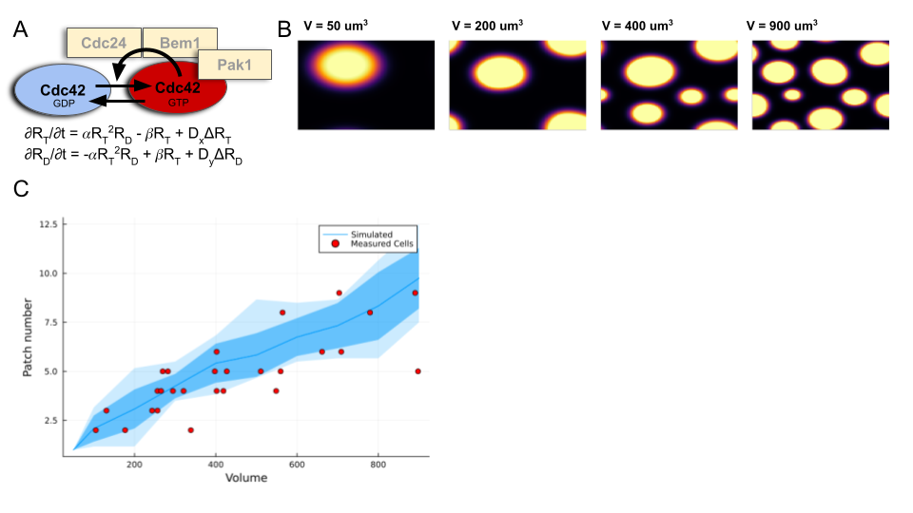

**Figure 3. Bud site number in Aureobasidium pullulans is consistent with polarity models developed for single-budding yeast when cell size and duration of competition are considered.** (A) A minimal model of cell polarity with two molecular species, active and inactive GTPase. In its active form, the GTPase is able to promote its own formation. Both forms diffuse but at different rates. Two coupled partial differential equations describe these interactions. (B) Example simulations based on cells of different sizes are shown. When a small yeast cell is simulated, a single polarity site is resolved from initial noise within 30 minutes. When the size of the domain is increased, and the total amount of protein in the system (though not the concentration) is also increased, the time required to resolve a single polarity patch becomes longer. (C) Plot showing the relationship of cell size and bud or polarity-patch number. Blue line shows results from simulations seeded with different random initial conditions. Lighter blue ribbon represents standard deviation and lightest blue ribbon represents the range of values. Red dots show measurements from cells.



**Movie 1.** Polarity patches fluctuate in intensity before bud emergence

**Dynamics of polarization indicate negative feedback in the polarity circuit**

To precisely monitor cell polarity dynamics in *A. pullulans*, we imaged Pak1-GFP cells at 5 second intervals. We observed that not only does fluorescence signal fluctuate over time (Fig 4A, Fig4D) but the signal appears to oscillate at regular intervals. To evaluate whether these fluctuations are in fact periodic, we examined the power spectrum (Fig 4B), and autocorrelation (Fig 4C) of fluorescence signals. A peak in the autocorrelation indicates a time delay at which the signal becomes self-similar again. Using the first peak in the autocorrelation function to indicate the oscillation frequency, we found that these sites generally oscillated with a period of just under two minutes, but that the period varied between cells.

Oscillatory dynamics have been described in many biochemical systems (Tyson 2002; Novak and Tyson, 2008), and in fact have been observed in the polarity signals from *rsr1* mutants in *S. cerevisiae* (Howell et al., 2012) as well as in wildtype *S. pombe* cells (Das et al., 2012). Biochemical oscillations are known to require negative feedback (Novak and Tyson, 2008), and negative feedback is known to be one way to stabilize multi-polar outcomes when incorporated into models of cell polarity (Howell et al.. 2012, XXX).

We considered two general mechanisms of negative feedback. In the first, active GTPase recruits another protein which directly inactivates the GTPase (Fig 4X). The GAP-mediated negative feedback model is an example of this mechanism, and has been described to provide equalization of polarity sites (Howell 2012, Chiou 2018, Chiou 2021). In the second mechanism we considered, negative feedback is incorporated indirectly: Active GTPase recruits another regulator, which in turn inactivates the activator of the GTPase. The GEF-phosphorylation model is an example of this mechanism; it also provides equalization of polarity sites and has been shown to exist in both *S. cerevisiae* and *S. pombe* (Howell 2012, Chiou 2021, Das 2012). We found that although either model stabilizes multiple polarity patches, only the indirect model is capable of sustaining oscillations at polarity patches (Fig 4X). This is consistent with analyses by Novak and Tyson (2008) which determined that a time delay, which can be provided by a series of intermediate reactions, is required for negative feedback to induce oscillation, at least in ODE systems.

We next asked whether oscillations in polarity patches within the same cell showed any kind of coupling, as seen in *S. pombe* (Das 2012), which could distinguish local versus global negative feedback. In order to reduce the complexity of our analysis, we examined only cells with exactly two polarity patches. We observed similar oscillation frequencies between cells with one polarity site and cell with two polarity sites, and also in cells with greater than two polarity sites indicating that the oscillation properties are not sensitive to the number of sites. To assess the relationship between oscillations in the same cell, we calculated the crosscorrelation between each set of sites. Any two oscillators with similar frequency should have peaks in their cross-correlation, whether coupled or not, but when averaging many cross-correlations from many cell measurements, peaks with time-shifts that are consistent across cells should emerge. Instead, we observed an essentially flat average cross-correlation when averaging multiple oscillator pairs. The lack of any consistent cross-correlation suggests that individual polarity sites oscillate independently and that negative feedback is operating locally, without transmitting information across the cell.

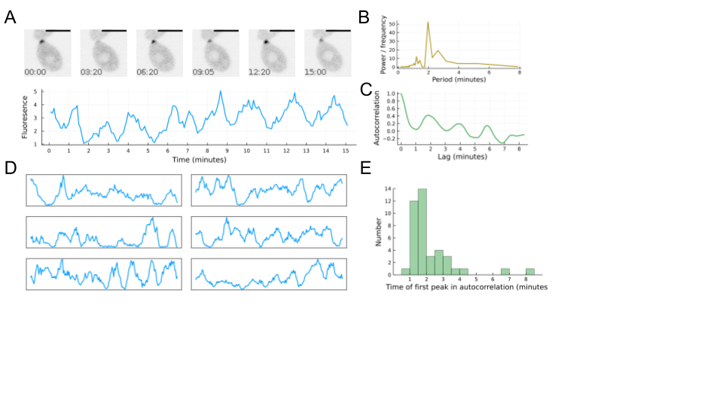d

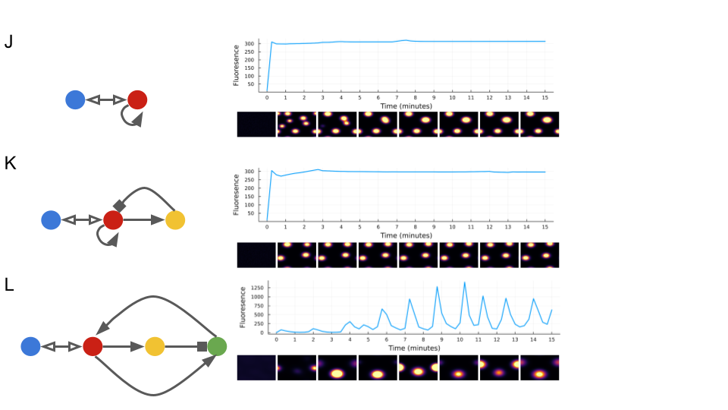

**Figure 4. Dynamics of polarization in A. pullulans suggest negative feedback in the polarity circuit.** (A) Polarity patches are observed to fluctuate in intensity. These fluctuations often appear periodic. (B) A periodogram shows a peak frequency with a period at around 2 minutes in the signal from the trace in A. The gray line shows a smaller, broader peak, also around 2 minutes, representing the average of frequencies from 41 polarity patches. (C) When a cell has more than one polarity patch, each oscillates in intensity. (D) The average cross-correlation between two sites in the same cell shows no clear peak, indicating that sites are agnostic to one another rather than in- or out-of-sync with each other. (E) Addition of time-delayed negative feedback to a minimal model of cell polarity can generate oscillations.

**Effects of gene deletions on negative feedback in the polarity circuit**

In search of the mechanisms providing negative feedback and driving the oscillation and equalization of polarity sites, we tested the effect of deleting the gene encoding Pak1. In *S. cerevisiae*, deletion of both STE20 and CLA4 genes is lethal [X]. We found that deletion of the PAK1 in *A. pulluans is* tolerated, although we observed unusual cell morphology in this pak1Δ mutant (Fig 5A). We noticed that cells frequently produced buds of unequal size in the mutant, and next sought to observe polarity patches in these cells. Since we could not use Pak1-GFP to monitor polarity in a pak1Δ, we made the deletion in the background of a strain expressing 3XGFP-Bem1. We also constructed a strain expressing both Pak1-mCherry and 3XGFP-Bem1, to ensure that both probes reported the same polarity dynamics. Indeed, the probes colocalized, and showed apparently simultaneous fluctuations (Fig 5B). The 3XGFP-Bem1 probe localized to pre-bud sites in the pak1Δ mutant, as in wildtype (Fig 4C), but showed diminished fluctuations in fluorescence intensity over time compared to wildtype, and no discernable oscillations (Fig 4D, Fig 4E). In cells that produced two buds, polarity sites in the pak1Δ sometimes accumulated the Bem1 probe to much higher levels than in wildtype cells, consistent with failure to constrain patch growth through negative feedback. We also observed that the differences in intensity between two patches from the same cell were greater in the pak1Δ mutant, indicating a failure to equalize polarity sites.

PAKs directly bind and are activated by GTPases [X]. We next asked whether either of the two GTPases, Cdc42 and Rac1, are uniquely required for Pak1 localization and activation. To this end, we constructed strains in which either CDC42 or RAC1 genes were deleted. Deletion of each GTPase yielded distinct differences. The cdc42Δ mutant showed slower growth than its parent strain (Fig SX), and had unusually shaped buds. The rac1Δ mutant showed irregular cell morphology, similar to what was observed in a pak1Δ mutant, with different sizes of bud often attached to the same mother cell (Fig 4A). Pak1-GFP localization in the cdc42Δ mutant was similar to that of wildtype cells, while the Pak1-GFP probe failed to localize to polarity sites at all in the rac1Δ mutant (Fig 4I).

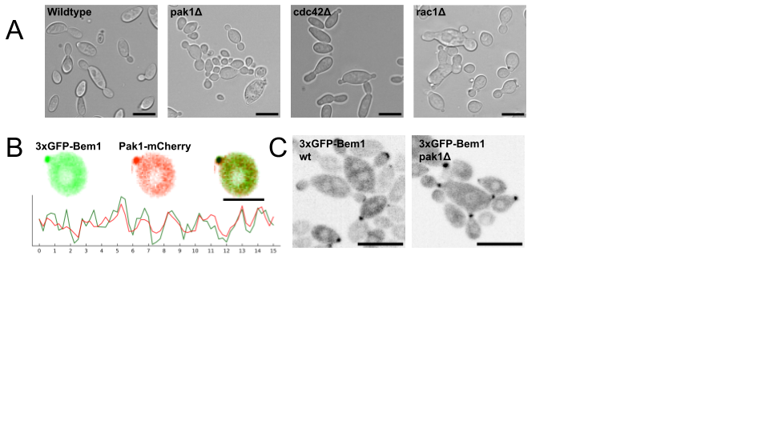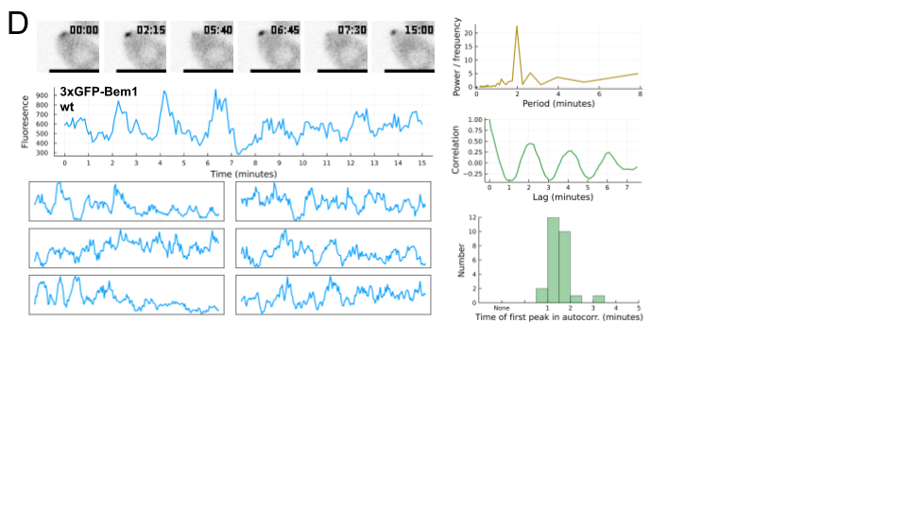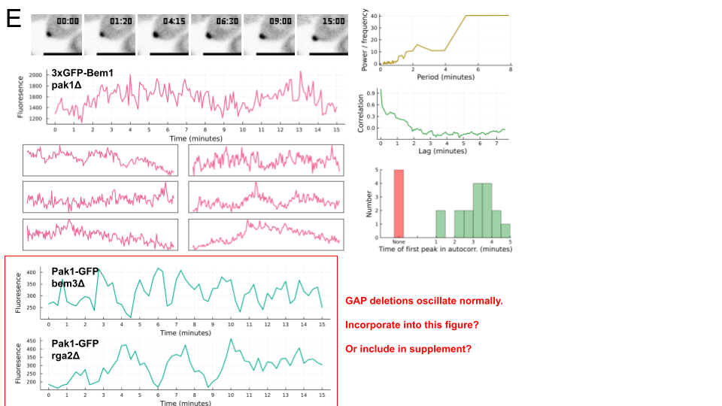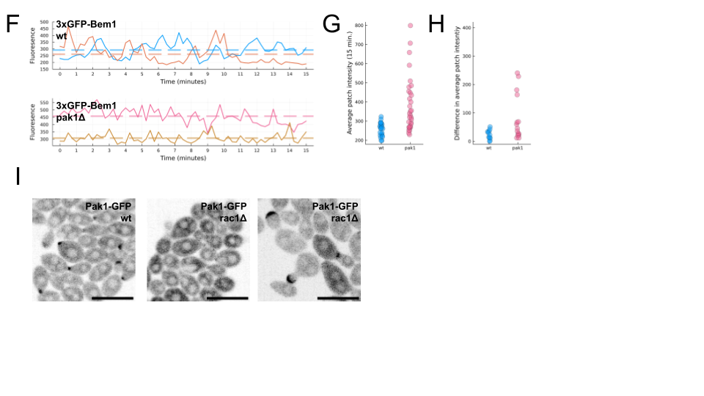

**Figure 5. Role of core polarity proteins in polarity patch equalization and oscillation.** (A) Brightfield images of Aureobasidium pullulans mutants. Scale-bar is 10 micrometers. (B) Pak1 and Bem1 colocalize and co-fluctuate over time. (D) A pak1Δ mutant polarizes a 3xBem1-GFP probe but while wildtype cells show oscillatory dynamics at the polarity patch, (E) pak1Δ mutant cells with the same probe do not. (F) In cells that make two buds, the polarity sites have (G) a larger range of intensity values in the pak1Δ mutant than in the wildtype, and (H) greater differences in intensity between polarity sites.

**DISCUSSION**

**Components of the polarity circuit**

Many proteins are known to contribute to the regulation of cell polarity [X], some of which are evolutionarily well conserved, and others of which are found only within subsets of organisms (Diepeveen 2018). We focused our attention on four types of proteins which are both highly conserved across fungi, and are known to be integral to the polarity circuit in *S. cerevisiae*. We show that each of the identified proteins contains the functional domains that were identified in *S. cerevisiae*, and that each of the proteins localizes to pre-bud sites. Even so, we acknowledge that the functions of these proteins may have changed, and that additional polarity regulators may have become more important to the core polarity circuit in this organism.

The four types of core polarity proteins we focused our attention to in this study were the small GTPases, Cdc42 and Rac1; the GEF, Cdc24; the PAK, Pak1; and the scaffold protein, Bem1. The genomes of *S. cerevisiae* and the fission yeast *Schizosaccharomyces pombe* encode only a Cdc42 protein and not a Rac homolog, while animals and filamentous fungi generally encode both Cdc42 and Rac proteins. These two GTPases have effector specificity [X], and have been shown to have distinct roles in cell morphogenesis (Kwon 2010, XXX). In *S. cerevisiae* Cdc42 binds directly to the PAKs Ste20 and Cla4, which relieves autoinhibition of their kinase domains, and serves as a link recruit to Bem1 and Cdc24 [X]. While deletion of either PAK is tolerated, deletion of both is lethal [X]. In *A. pullulans* we were able to delete Pak1, which we identified as the sole PAK. This suggests that an alternative pathway exists for the colocalization of the GTPases and their GEF(s). The GEF Cdc24 directly activates GTPases by exchanging GDP for GTP [X]. We found only a single Cdc24 homolog in *A. pullulans*, which may regulate activation of both Cdc42 and Rac1 alone, or may function alongside other GEFs which we did not identify due to lack of homology to Cdc24. In the Cdc24 protein, we noticed a disordered region between the PH and PB1 domains, which is absent in *S. cerevisiae* Cdc24. Disordered regions can contribute to phase separation, a behavior reminiscent of polarization, but generally described in thermodynamic, rather than kinetic terms [X]. We noticed frequent localization of Cdc24-GFP signal to cytosolic foci as well as polarity sites, but did not investigate further in this study. Cdc24 binds to Bem1 in *S. cerevisiae*, an interaction which promotes Cdc24 activity [X] and becomes essential for polarization in the absence of upstream polarity landmarks [X]. We do not test the function of Bem1 in this study, but do show that it co-localizes with Pak1 during polarization (Fig 5B).

**Maintaining multiple polarity sites**

*Aureobasidium pullulans* can produce a variable number of buds from a given mother cell. We anticipated that polarity proteins would localize to each of the bud and pre-bud sites in these cells, and this is in fact what we observe for each of the probes we tested. A previous study asked whether cells that generate more than one bud do so because competition is sufficiently delayed, or because of additional regulatory mechanisms [X]. Chiou et al. use a mutant of *S. cerevisiae* with a cytokinesis defect that results in large, multinucleate cells. In that system cells could produce multiple sites of polarized growth, but they found that the persistence of multiple polarity sites was consistent with a “coexistence” mechanism, in which competition through positive feedback fails to complete over the relevant time frame. We also observed in *A. pullulans* that the number of sites of polarized growth increases with cell size (Fig 3C), however we did not find evidence of slow competition, but instead dynamic sites in which the time-averaged intensity of sites was equalized.

Multiple mechanisms have been proposed for the maintenance of multiple polarity sites [Jacobs 2019, XXX]. One straightforward and robust way to stabilize multiple polarity sites is negative feedback. It has been observed in *S. cerevisiae* that a GAP, which could directly inactivate Cdc42 is enriched at polarity sites [X], and it has been shown in *S. cerevisiae* that the PAK, Ste20 can phosphorylate the GEF, Cdc24, inhibiting positive feedback [X]. With nonlinear reaction rates, either of these mechanisms could produce a system where polarity sites promote their own growth over certain ranges of concentrations, but promote their own dissolution at higher concentrations; a polarity site that grows too large may split to form two sites in these models. We examined the outcome of models in which either: competition was simply delayed, negative feedback was added directly, or negative feedback was incorporated such that a time delay was created between the accumulation of the active GTPase and the recruitment of the negative regulator. Models with negative feedback could stabilize multiple polarity patches, but only a model with a time delayed negative feedback could generate the dynamics we observed.

**Negative feedback through a PAK**

We observed that multiple polarity patches could be maintained in *A. pullulans* even as concentrations in the patches oscillated from highly enriched, to nearly cytosolic levels, and back to highly enriched. We found that deletion of the PAK1 gene resulted in a loss of oscillatory behavior, patches with higher protein levels than observed in wildtype cells, and greater differences in intensity between patches in the same mother cell. We conclude that Pak1 provides negative feedback in the polarity circuit in *A. pullulans*. We found that Rac1, and not Cdc42, is required to localize Pak1 to polarity sites, but we did identify the mechanism by which Pak1 provides negative feedback.

Mechanisms for negative feedback in the polarity circuit have been identified in *S. cerevisiae* [Gulli 2000, ]and in the bi-polar fission yeast *Schizosaccharomyces pombe* [X]. In each case, a PAK mediates negative feedback. Unlike in *A. pullulans*, deletion of all PAKs is lethal in these yeasts [XX]. In *S. cerevisiae*, oscillations at polarity sites become apparent when an upstream polarity landmark is deleted [X]. Researchers showed that the GEF Cdc24 is phosphorylated by the PAK Cla4 (Bose et al., 2001), and a strain with a non-phosphorylatable mutant allele of Cdc24 no longer shows polarity oscillations (X), suggesting that GEF inactivation is the mechanism by which negative feedback is mediated. In *S. pombe*, oscillations at polarity sites were sometimes apparent in wildtype cells [X], and were found to be sensitive to the activity or dosage of PAK and GEF. With our observations in *A. pullulans*, Pak-mediated negative feedback in the polarity circuit has now been reported in three distinct clades of fungi. It stands to reason that this represents an ancestral mechanism for the control of polarized growth in fungi, and potentially even more broadly.

**METHODS**

**Yeast strains**

Mutant strains of *Aureobasidium pullulans* were constructed in the EXF-150 genetic background. Gene deletions and fluorescent protein fusions were generated using homologous recombination by means of chemical transformation (Wirshig 2024). The GFP and mCherry tags were designed such that each amino acid was encoded with its most frequently used codon, based on all predicted coding sequences from the EXF-150 reference genome, as described previously (Petrucco 2024). Either hygromycin- or nourseothricin-resistance genes were incorporated into the DNA constructs for endogenous fluorescent tags and gene deletions. For fluorescently tagged proteins expressed as additional copies, probes were integrated at the URA3 locus along with the URA3, in a strain background lacking the URA3 gene. A list of strains used in this study can be found in supplemental table 1.

**Cell growth and imaging conditions**

Cells were grown in yeast peptone dextrose (YPD) medium at 25°C overnight before imaging. We applied 4 μL of the YPD culture to an Ibidi 8 well glass bottom μ-Slide and placed a pad of complete synthetic medium (CSM) with 2% agarose on top. Pads were punched from plates of agarose using a 1 mL pipette tip. We performed all imaging at room temperature.

**FCS and still imaging**

FCS measurements and images in which protein concentrations are quantified, were performed on a Zeiss 980 confocal microscope. For FCS calibration, one chamber of an Ibidi 8 well glass bottom μ-Slide was blocked with BSA, washed twice with water, and filled with dye. FCS calibration for green fluorophores was performed with Atto488. Initially, a dilution series of 16 μM, 8 μM, 4 μM, and 2 μM Atto488 was used to estimate focal volume and aberration in Z (FV = 0.42 cubic microns; k = 4.2). Subsequently, 2 μM Atto488 was used for calibration. Calibration for red fluorophores was performed with 2 μM Atto594 (FV = 0.43 cubic microns; k = 5.83). FCS measurements in cells were taken for 5 seconds, with one measurement per cell, and autocorrelations from a minimum of 10 cells were averaged for each probe.

Confocal images were taken using a 40X water objective using scan speed X and pixel dwell time X. A single position in Z was used, making each pixel in the resulting image the integrated fluorescence of a consistent volume.

**Cell segmentation determination of protein concentration from fluorescence brightness**

From still images of *A. pullulans* cells in a single Z plane, we generated masks around individual cells using the Cyto3 segmentation model in Cellpose3 [X]. Masks and images were imported into python, where tools from scikit-image [X] were used to extract features from masked individual cell images. The long and short axes were extracted as features and used to estimate cell volumes as the product of the long axis and the square of the short axis. The median pixel value was extracted and used as an estimate of the cytosolic concentration within the cell. Median was chosen over mean because of the presence of both enriched regions, due to polarization, and deficient regions, due to exclusion from vacuoles, lipid droplets, and nuclei. To convert pixel intensity to concentration, we used molecular brightness estimates obtained by FCS of Pak1-GFP, for green probes, or Rac1-mCherry, for red probes.

**Imaging for polarity movies**

Live cell time-lapse imaging was performed on a Nikon spinning disk confocal microscope with a 40X silicon-immersion objective. When using Pak1-GFP expressing strains to monitor polarity patch dynamics in cells with only one patch, we took images every 5 seconds in a single Z position. In order to capture polarity dynamics at multiple sites in the same cell it was necessary to use multiple Z positions and analyze the maximum intensity projections. To monitor polarity dynamics of Pak1-GFP expressing cells which produced exactly two patches, we used some time-lapses with 5 second intervals from single Z positions, and some time lapses with 15 second intervals with the maximum intensity projection images obtained from 7 to 11 Z positions. Oscillatory behavior was indistinguishable when using single Z positions or projections from Z stacks. To monitor polarity dynamics using 3XBem1-GFP in wild type and mutant strains, Z stacks were taken at 15 second intervals.

**Analysis of polarity patch dynamics**

To analyze the dynamics of polarity patches, we cropped time-lapse images around individual cells before loading and processing the cropped movies using custom scripts written in the Julia programming language (Bezanson 2012, X). In short, projections were made from each image such that each pixel represented the standard deviation of the fluorescence at that position with respect to time. We found that this method gave much stronger separation of cytoplasmic signal and polarized signal than did a more intuitive maximum project image, and produced high signal at the entire area traversed by the polarity patch, making thresholding robust to small amounts of cell movement during the time-lapses. From the projections, we thresholded at half of the maximum signal to find the polarity sites. For each polarity site, we then took the maximum intensity of the site at each time point in the time-lapse movie. The movies were 30 minutes, but the signals were then cropped to 15 minutes, beginning at the time at which the signal first reached half its maximum. These time-cropped signals, as well as the autocorrelations and the periodograms of these signals are shown in Figures 4 and 5. The code used to generate these figures can be found at the GitHub page associated with this article.

**Polarity models**

* Equations for each model.

**Numerical simulation**

Models for cell polarity were based on equations described by X, and expanded to include direct and indirect local negative feedback. Exact parameterizations of the models were manually selected and are available at [X github page X]. PDEs were solved numerically using a finite difference method in the Julia programming language (Bezanson 2012, Rackauckas 2017). Spatial domains were discretized as 100x100 square grids with periodic boundary conditions; timesteps were automatically determined per-simulation by the adaptive-time solver, CVODE, which performed time integration steps using the generalized minimal residual method (GMRES) (Hindmarsh 2005, Gardner 2022).

**SUPPLEMENTAL INFORMATION**

Table X. Strains used in this study

Table X. Identification of protein homologs

Code: <https://github.com/crockeraw/PolarityProject>

**CITATIONS**

1. Bender L, Lo HS, Lee H, Kokojan V, Peterson V, Bender A. Associations among PH and SH3 domain-containing proteins and Rho-type GTPases in Yeast. J Cell Biol. 1996 May;133(4):879-94. doi: 10.1083/jcb.133.4.879. PMID: 8666672; PMCID: PMC2120828.
2. Bezanson J, Karpinski S, Shah VB, Edelman A. Julia: A fast dynamic language for technical computing. arXiv 2012 preprint arXiv:12095145
3. Bose I, Irazoqui JE, Moskow JJ, Bardes ES, Zyla TR, Lew DJ. Assembly of scaffold-mediated complexes containing Cdc42p, the exchange factor Cdc24p, and the effector Cla4p required for cell cycle-regulated phosphorylation of Cdc24p. J Biol Chem. 2001 Mar 9;276(10):7176-86. doi: 10.1074/jbc.M010546200. Epub 2000 Dec 11. PMID: 11113154.
4. Brown JL, Jaquenoud M, Gulli MP, Chant J, Peter M. Novel Cdc42-binding proteins Gic1 and Gic2 control cell polarity in yeast. Genes Dev. 1997 Nov 15;11(22):2972-82. doi: 10.1101/gad.11.22.2972. PMID: 9367980; PMCID: PMC316694.
5. Castillo-Lluva S, Alvarez-Tabarés I, Weber I, Steinberg G, Pérez-Martín J. Sustained cell polarity and virulence in the phytopathogenic fungus Ustilago maydis depends on an essential cyclin-dependent kinase from the Cdk5/Pho85 family. J Cell Sci. 2007 May 1;120(Pt 9):1584-95. doi: 10.1242/jcs.005314. Epub 2007 Apr 3. PMID: 17405809.
6. Chiou JG, Balasubramanian MK, Lew DJ. Cell Polarity in Yeast. Annu Rev Cell Dev Biol. 2017 Oct 6;33:77-101. doi: 10.1146/annurev-cellbio-100616-060856. Epub 2017 Aug 7. PMID: 28783960; PMCID: PMC5944360.
7. Chiou JG, Moran KD, Lew DJ. How cells determine the number of polarity sites. Elife. 2021 Apr 26;10:e58768. doi: 10.7554/eLife.58768. PMID: 33899733; PMCID: PMC8116050.
8. Das M, Drake T, Wiley DJ, Buchwald P, Vavylonis D, Verde F. Oscillatory dynamics of Cdc42 GTPase in the control of polarized growth. Science. 2012 Jul 13;337(6091):239-43. doi: 10.1126/science.1218377. Epub 2012 May 17. PMID: 22604726; PMCID: PMC3681419.
9. Diepeveen ET, Gehrmann T, Pourquié V, Abeel T, Laan L. Patterns of Conservation and Diversification in the Fungal Polarization Network. Genome Biol Evol. 2018 Jul 1;10(7):1765-1782. doi: 10.1093/gbe/evy121. PMID: 29931311; PMCID: PMC6054225.
10. Etienne-Manneville S, Hall A. Rho GTPases in cell biology. Nature. 2002 Dec 12;420(6916):629-35.
11. Gardner DJ, Reynolds DR, Woodward CS, Balos CJ. Enabling new flexibility in the SUNDIALS suite of nonlinear and differential/algebraic equation solvers. ACM Transactions on Mathematical Software (TOMS). 2022 Sep 10;48(3):1-24.
12. Goryachev, Andrew B. and Pokhilko, Alexandra V.(2008), Dynamics of Cdc42 network embodies a Turing-type mechanism of yeast cell polarity, FEBS Letters, 582, doi: 10.1016/j.febslet.2008.03.029
13. Gostinčar C, Turk M, Zajc J, Gunde-Cimerman N. Fifty Aureobasidium pullulans genomes reveal a recombining polyextremotolerant generalist. Environ Microbiol. 2019 Oct;21(10):3638-3652. doi: 10.1111/1462-2920.14693. Epub 2019 Jun 18. PMID: 31112354; PMCID: PMC6852026.
14. Gulli MP, Jaquenoud M, Shimada Y, Niederhäuser G, Wiget P, Peter M. Phosphorylation of the Cdc42 exchange factor Cdc24 by the PAK-like kinase Cla4 may regulate polarized growth in yeast. Mol Cell. 2000 Nov;6(5):1155-67. doi: 10.1016/s1097-2765(00)00113-1. PMID: 11106754.
15. Hall A. Small GTP-binding proteins and the regulation of the actin cytoskeleton. Annu Rev Cell Biol. 1994;10:31-54. doi: 10.1146/annurev.cb.10.110194.000335. PMID: 7888179.
16. Harrell MA, Liu Z, Campbell BF, Chinsen O, Hong T, Das M. Arp2/3-dependent endocytosis ensures Cdc42 oscillations by removing Pak1-mediated negative feedback. J Cell Biol. 2024 Sep 2;223(10):e202311139. doi: 10.1083/jcb.202311139. Epub 2024 Jul 16. PMID: 39012625; PMCID: PMC11259211.
17. Herron JC, Hu S, Liu B, Watanabe T, Hahn KM, Elston TC. Spatial models of pattern formation during phagocytosis. PLoS Comput Biol. 2022 Oct 3;18(10):e1010092. doi: 10.1371/journal.pcbi.1010092. PMID: 36190993; PMCID: PMC9560619.
18. Hindmarsh, A.C., Brown, P.N., Grant, K.E., Lee, S.L., Serban, R., Shumaker, D.E., & Woodward, C.S. (2005). SUNDIALS: Suite of nonlinear and differential/algebraic equation solvers. ACM Trans. Math. Softw., 31, 363-396.
19. Howell AS, Lew DJ. Morphogenesis and the cell cycle. Genetics. 2012;190(1):51-77. doi:10.1534/genetics.111.128314
20. Irazoqui JE, Gladfelter AS, Lew DJ. Scaffold-mediated symmetry breaking by Cdc42p. Nat Cell Biol. 2003 Dec;5(12):1062-70. doi: 10.1038/ncb1068. Epub 2003 Nov 16. PMID: 14625559.
21. Ito T, Matsui Y, Ago T, Ota K, Sumimoto H. Novel modular domain PB1 recognizes PC motif to mediate functional protein-protein interactions. EMBO J. 2001 Aug 1;20(15):3938-46. doi: 10.1093/emboj/20.15.3938. PMID: 11483497; PMCID: PMC149144.
22. Ivorra-Molla E, Ivorra-Molla E, Akhuli D, et al. A monomeric StayGold fluorescent protein. Research Square; 2023. DOI: 10.21203/rs.3.rs-2684100/v1.
23. Jacobs B, Molenaar J, Deinum EE. Small GTPase patterning: How to stabilize cluster coexistence. PLoS One. 2019;14(3):e0213188. Published 2019 Mar 7. doi:10.1371/journal.pone.0213188
24. Knaus UG, Wang Y, Reilly AM, Warnock D, Jackson JH. Structural requirements for PAK activation by Rac GTPases. J Biol Chem. 1998 Aug 21;273(34):21512-8. doi: 10.1074/jbc.273.34.21512. PMID: 9705280.
25. Kozubowski L, Saito K, Johnson JM, Howell AS, Zyla TR, Lew DJ. Symmetry-breaking polarization driven by a Cdc42p GEF-PAK complex. Curr Biol. 2008 Nov 25;18(22):1719-26. doi: 10.1016/j.cub.2008.09.060. Epub 2008 Nov 13. PMID: 19013066; PMCID: PMC2803100.
26. Kuo CC, Savage NS, Chen H, Wu CF, Zyla TR, Lew DJ. Inhibitory GEF phosphorylation provides negative feedback in the yeast polarity circuit. Curr Biol. 2014 Mar 31;24(7):753-9. doi: 10.1016/j.cub.2014.02.024. Epub 2014 Mar 13. PMID: 24631237; PMCID: PMC4018745.
27. Kwon MJ, Arentshorst M, Roos ED, van den Hondel CA, Meyer V, Ram AF. Functional characterization of Rho GTPases in Aspergillus niger uncovers conserved and diverged roles of Rho proteins within filamentous fungi. Mol Microbiol. 2011;79(5):1151-1167. doi:10.1111/j.1365-2958.2010.07524.
28. Lamson, R. E., Winters, M. J., & Pryciak, P. M. (2002). Cdc42 regulation of kinase activity and signaling by the yeast p21-activated kinase Ste20. Molecular and cellular biology, 22(9), 2939–2951. <https://doi.org/10.1128/MCB.22.9.2939-2951.2002>
29. Lee ME, Lo WC, Miller KE, Chou CS, Park HO. Regulation of Cdc42 polarization by the Rsr1 GTPase and Rga1, a Cdc42 GTPase-activating protein, in budding yeast. J Cell Sci. 2015 Jun 1;128(11):2106-17. doi: 10.1242/jcs.166538. Epub 2015 Apr 23. PMID: 25908844; PMCID: PMC4457026.
30. Miller PW, Fortunato D, Muratov C, Greengard L, Shvartsman S. Forced and spontaneous symmetry breaking in cell polarization. Nat Comput Sci. 2022 Aug;2(8):504-511. doi: 10.1038/s43588-022-00295-0. Epub 2022 Aug 22. Erratum in: Nat Comput Sci. 2022 Nov;2(11):771. doi: 10.1038/s43588-022-00345-7. PMID: 37309402; PMCID: PMC10260237.
31. Magliozzi JO, Sears J, Cressey L, Brady M, Opalko HE, Kettenbach AN, Moseley JB. Fission yeast Pak1 phosphorylates anillin-like Mid1 for spatial control of cytokinesis. J Cell Biol. 2020 Aug 3;219(8):e201908017. doi: 10.1083/jcb.201908017. PMID: 32421151; PMCID: PMC7401808.
32. Mahlert M, Leveleki L, Hlubek A, Sandrock B, Bölker M. Rac1 and Cdc42 regulate hyphal growth and cytokinesis in the dimorphic fungus Ustilago maydis. Mol Microbiol. 2006 Jan;59(2):567-78. doi: 10.1111/j.1365-2958.2005.04952.x. PMID: 16390450.
33. Mao Y, Finnemann SC. Regulation of phagocytosis by Rho GTPases. Small GTPases. 2015;6(2):89-99. doi: 10.4161/21541248.2014.989785. Epub 2015 May 5. PMID: 25941749; PMCID: PMC4601285.
34. Mata J, Nurse P. Tea1 and the microtubular cytoskeleton are important for generating global spatial order within the fission yeast cell. Cell. 1997 Jun 13;89(6):939-49. doi: 10.1016/s0092-8674(00)80279-2. PMID: 9200612.
35. Mitchison-Field LMY, Vargas-Muñiz JM, Stormo BM, Vogt EJD, Van Dierdonck S, Pelletier JF, Ehrlich C, Lew DJ, Field CM, Gladfelter AS. Unconventional Cell Division Cycles from Marine-Derived Yeasts. Curr Biol. 2019 Oct 21;29(20):3439-3456.e5. doi: 10.1016/j.cub.2019.08.050. Epub 2019 Oct 10. PMID: 31607535; PMCID: PMC7076734.
36. Moran KD, Kang H, Araujo AV, et al. Cell-cycle control of cell polarity in yeast. J Cell Biol. 2019;218(1):171-189. doi:10.1083/jcb.201806196
37. Morreale A, Venkatesan M, Mott HR, Owen D, Nietlispach D, Lowe PN, Laue ED. Structure of Cdc42 bound to the GTPase binding domain of PAK. Nat Struct Biol. 2000 May;7(5):384-8. doi: 10.1038/75158. PMID: 10802735.
38. Mott HR, Owen D, Nietlispach D, Lowe PN, Manser E, Lim L, Laue ED. Structure of the small G protein Cdc42 bound to the GTPase-binding domain of ACK. Nature. 1999 May 27;399(6734):384-8. doi: 10.1038/20732. PMID: 10360579.
39. Pablo M, Ramirez SA, Elston TC. Particle-based simulations of polarity establishment reveal stochastic promotion of Turing pattern formation. PLoS Comput Biol. 2018 Mar 12;14(3):e1006016. doi: 10.1371/journal.pcbi.1006016. PMID: 29529021; PMCID: PMC5864077.
40. Petrucco CA, Crocker AW, D'Alessandro A, Medina EM, Gorman O, McNeill J, Gladfelter AS, Lew DJ. Tools for live-cell imaging of cytoskeletal and nuclear behavior in the unconventional yeast, Aureobasidium pullulans. Mol Biol Cell. 2024 Apr 1;35(4):br10. doi: 10.1091/mbc.E23-10-0388. Epub 2024 Mar 6. PMID: 38446617; PMCID: PMC11064661.
41. Philippsen P, Kaufmann A, Schmitz HP. Homologues of yeast polarity genes control the development of multinucleated hyphae in Ashbya gossypii. Current opinion in microbiology. 2005 Aug 1;8(4):370-7.
42. Rackauckas C, Nie Q. DifferentialEquations.jl – A Performant and Feature-Rich Ecosystem for Solving Differential Equations in Julia. Journal of Open Research Software. 2017;5(1):15. DOI: <https://doi.org/10.5334/jors.151>
43. Raftopoulou M, Hall A. Cell migration: Rho GTPases lead the way. Dev Biol. 2004 Jan 1;265(1):23-32. doi: 10.1016/j.ydbio.2003.06.003. PMID: 14697350.
44. Ramirez SA, Pablo M, Burk S, Lew DJ, Elston TC. A novel stochastic simulation approach enables exploration of mechanisms for regulating polarity site movement. PLoS Comput Biol. 2021 Jul 15;17(7):e1008525. doi: 10.1371/journal.pcbi.1008525. PMID: 34264926; PMCID: PMC8315557.
45. Saad, Y, & Schultz, MH. GMRES: a generalized minimal residual algorithm for solving nonsymmetric linear systems. 1986. Siam Journal on Scientific and Statistical Computing, 7, 856-869.
46. Savage NS, Layton AT, Lew DJ. Mechanistic mathematical model of polarity in yeast. Mol Biol Cell. 2012 May;23(10):1998-2013. doi: 10.1091/mbc.E11-10-0837. Epub 2012 Mar 21. PMID: 22438587; PMCID: PMC3350562.
47. Sawin KE, Nurse P. Regulation of cell polarity by microtubules in fission yeast. J Cell Biol. 1998 Jul 27;142(2):457-71. doi: 10.1083/jcb.142.2.457. PMID: 9679144; PMCID: PMC2133047.
48. Shimada Y, Wiget P, Gulli MP, Bi E, Peter M. The nucleotide exchange factor Cdc24p may be regulated by auto-inhibition. EMBO J. 2004;23(5):1051-1062.
49. Takahashi S, Pryciak PM. Identification of novel membrane-binding domains in multiple yeast Cdc42 effectors. Mol Biol Cell. 2007 Dec;18(12):4945-56. doi: 10.1091/mbc.e07-07-0676. Epub 2007 Oct 3. PMID: 17914055; PMCID: PMC2096579.
50. Takemoto D, Kamakura S, Saikia S, Becker Y, Wrenn R, Tanaka A, Sumimoto H, Scott B. Polarity proteins Bem1 and Cdc24 are components of the filamentous fungal NADPH oxidase complex. Proc Natl Acad Sci U S A. 2011 Feb 15;108(7):2861-6. doi: 10.1073/pnas.1017309108. Epub 2011 Jan 31. PMID: 21282602; PMCID: PMC3041104.
51. Tay YD, Leda M, Goryachev AB, Sawin KE. Local and global Cdc42 guanine nucleotide exchange factors for fission yeast cell polarity are coordinated by microtubules and the Tea1-Tea4-Pom1 axis. J Cell Sci. 2018 Jul 19;131(14):jcs216580. doi: 10.1242/jcs.216580. PMID: 29930085; PMCID: PMC6080602.
52. Turner JJ, Ewald JC, Skotheim JM. Cell size control in yeast. Curr Biol. 2012 May 8;22(9):R350-9. doi: 10.1016/j.cub.2012.02.041. Epub 2012 May 7. PMID: 22575477; PMCID: PMC3350643.
53. Tyson JJ. Biochemical oscillations. InComputational cell biology 2002 (pp. 230-260). New York, NY: Springer New York.
54. Wirshing ACE, Petrucco CA, Lew DJ. Chemical transformation of the multibudding yeast, Aureobasidium pullulans. J Cell Biol. 2024 Oct 7;223(10):e202402114. doi: 10.1083/jcb.202402114. Epub 2024 Jun 27. PMID: 38935076; PMCID: PMC11211067.
55. Wu CF, Chiou JG, Minakova M, Woods B, Tsygankov D, Zyla TR, Savage NS, Elston TC, Lew DJ. Role of competition between polarity sites in establishing a unique front. Elife. 2015 Nov 2;4:e11611. doi: 10.7554/eLife.11611. PMID: 26523396; PMCID: PMC4728132.
56. Ziman M, Johnson DI. Genetic evidence for a functional interaction between Saccharomyces cerevisiae CDC24 and CDC42. Yeast. 1994;10(4):463-474.