Mobility areas

Methodology
Mobility areas are drawn up on the basis of data on flows between origins and destinations. These data can come, for example, from home-work or home-study data from the population census, household travel surveys or other data sources such as mobile trace data (FCD, FMD)
For a rendering through a cartographic visualization, an animation or videos, it is necessary to have a layer of geographical objects corresponding to the zones (origins and destinations of flows) and to have a common zone/origin/destination identifier in the two data sources.
The strongest link in % of flows between two zones is recursively taken from the set of flows. The area of origin is aggregated with the pole area and forms a pool. Migration between zones or areas is then updated and the process is repeated until only one area remains.
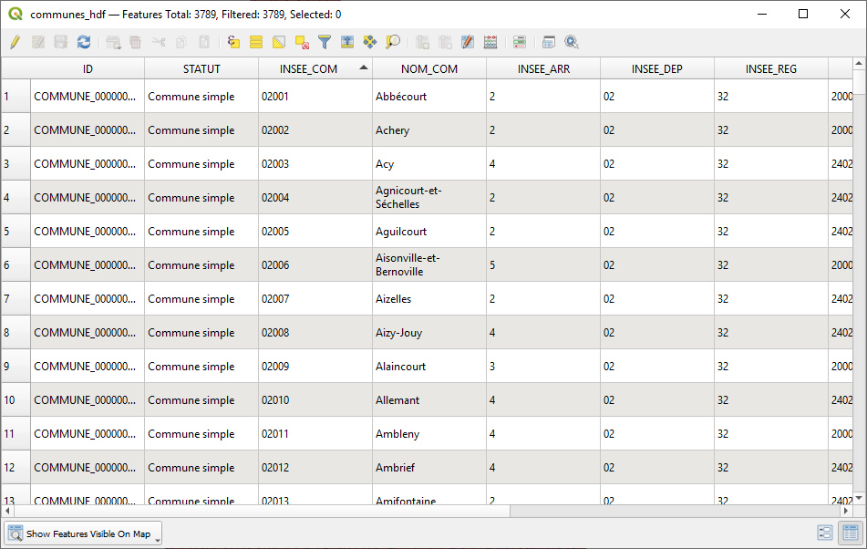
INSEE_COM : zone Id
NOM_COM : zone label
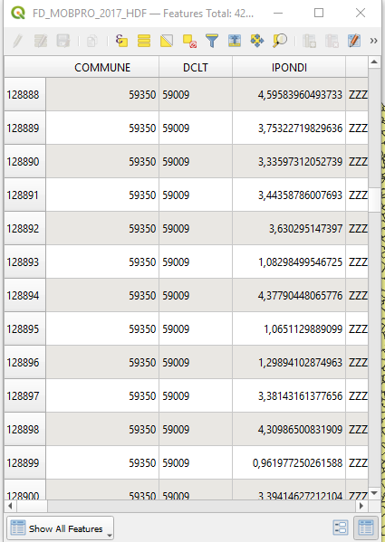
COMMUNE : origin
DCLT : destination
IPONDI : value (number of trips)

The zone identifier in the zone table (Communes HDF) corresponds to the zone identifiers of the origins and destinations in the flows table (FD_MOBPRO_2017_HDF)

Calculation of mobility areas
Once the Qgis plugin is installed, it appears in the processing box as below


With the above data the setting is for example
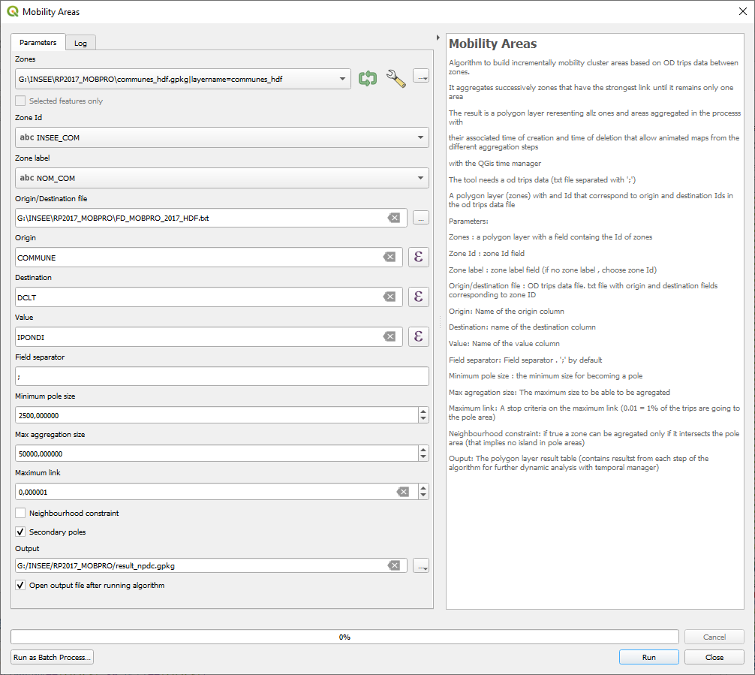To be a cluster, an area must have more than 2,500 trips or migrations and if the cluster is greater than 50,000 it cannot be aggregated with another cluster in subsequent stages.

When the neighbourhood constraint is checked, in order to be aggregated, zones must intersects geographically the pole area.

Activating secondary poles enables to let appearing smaller poles that could be masked by the main attracting poles for a second level analysis.
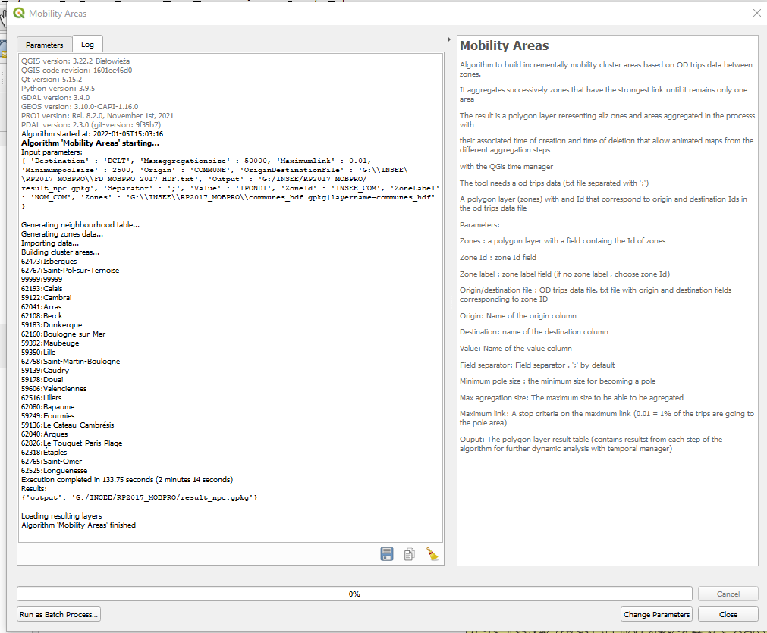
The algorithm lists the poles that have successively appeared and loads the result table
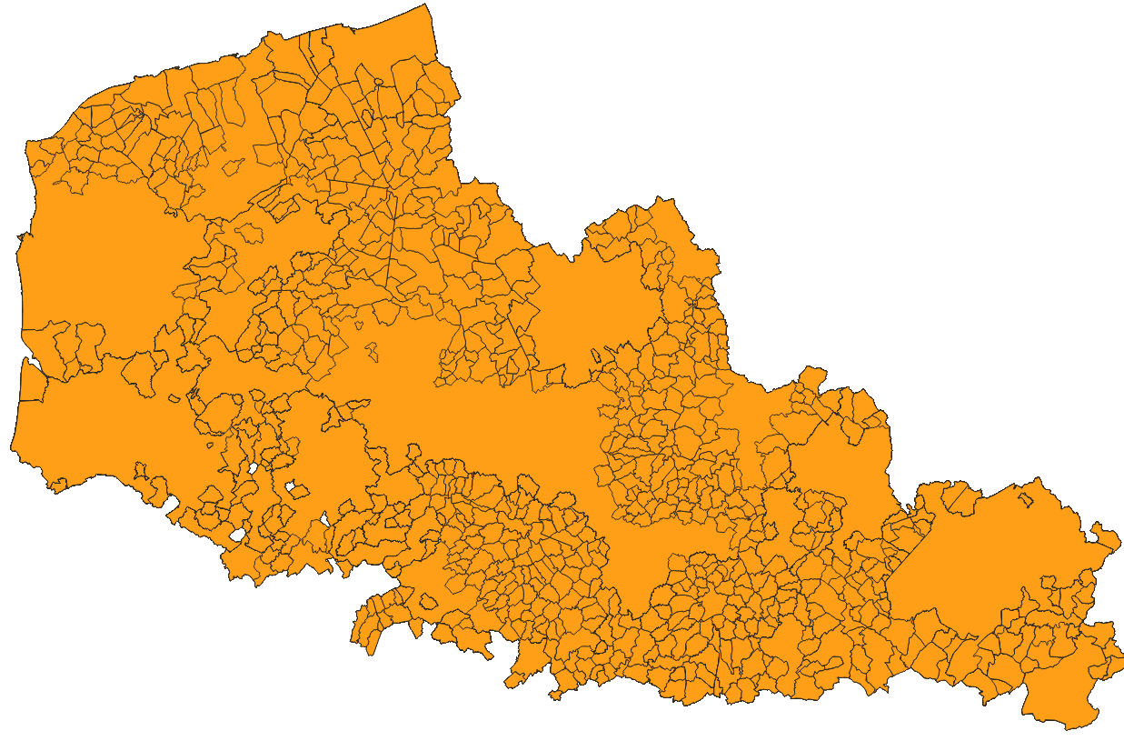

Making the animated map
The result layer must first be set up: :
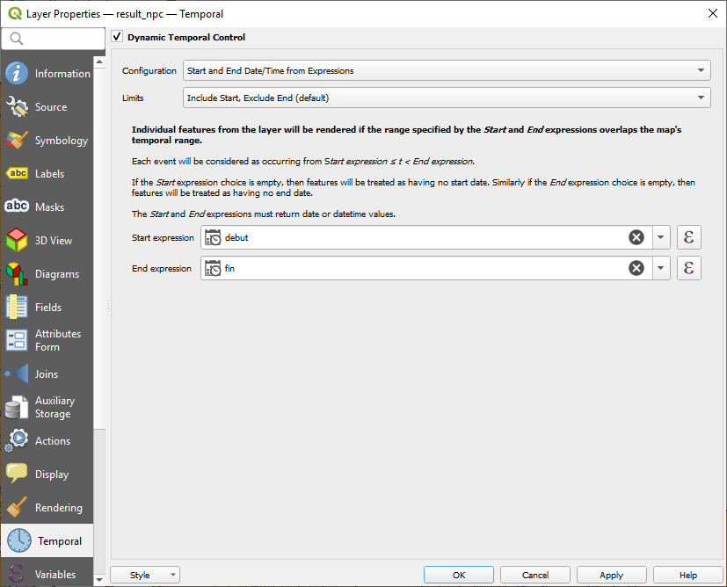
Then set the time controller with a step of 1s on the result layer
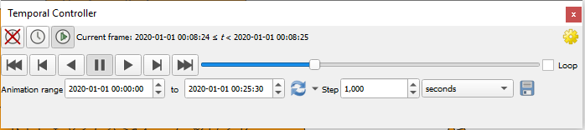

You can then perform a categorized thematic analysis on the column "city_name" and deactivate the values without labels
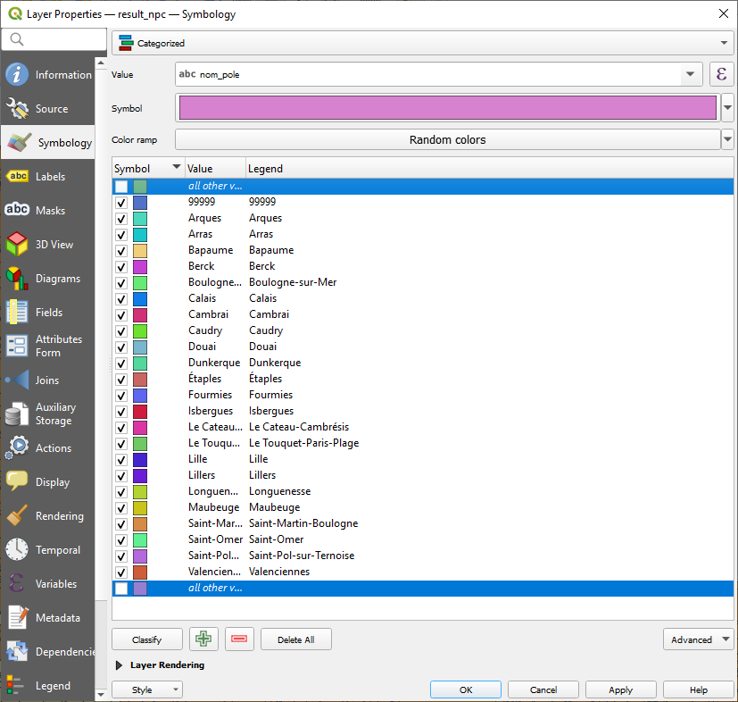
With the time controller, we can see the generation of mobility pools as a function of steps (seconds in the time controller)
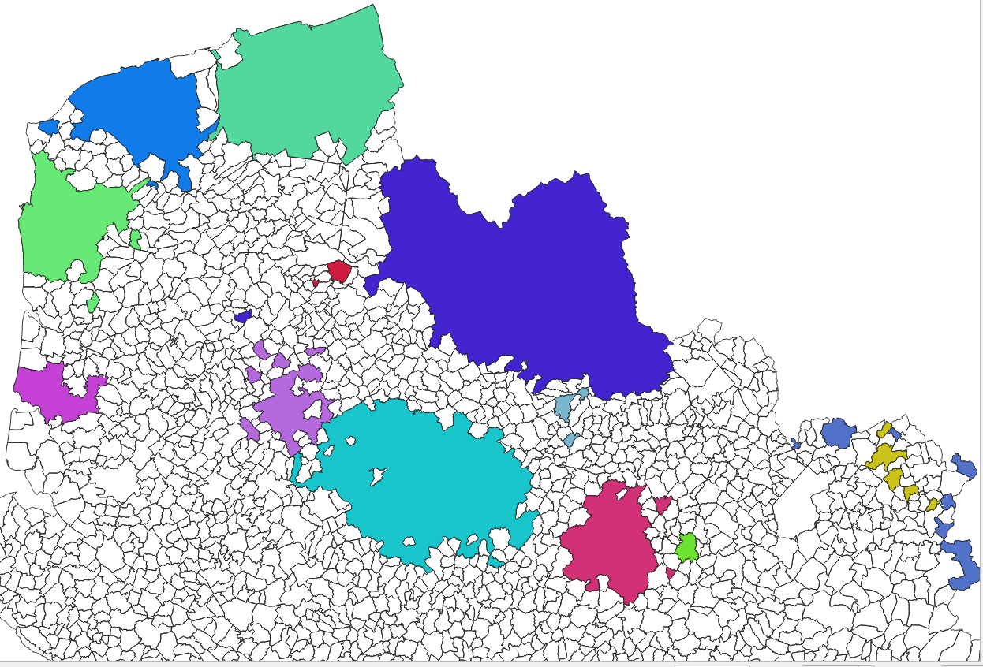
The labels can then be set up to display the names of the pools and the percentage of autonomy, for example, by defining labels based on rules
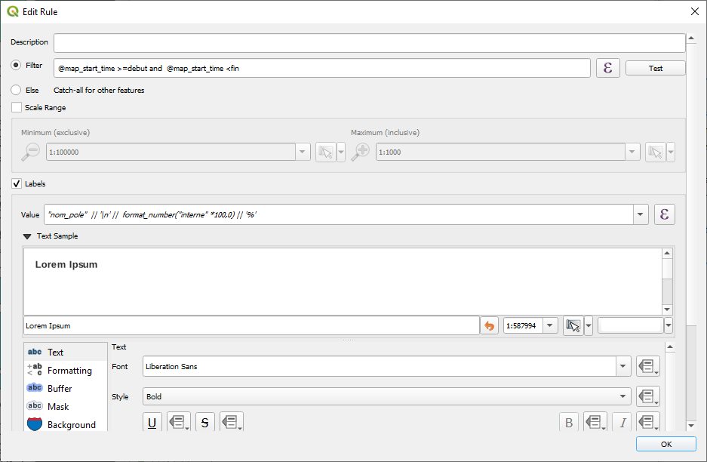
And the result below in animated map
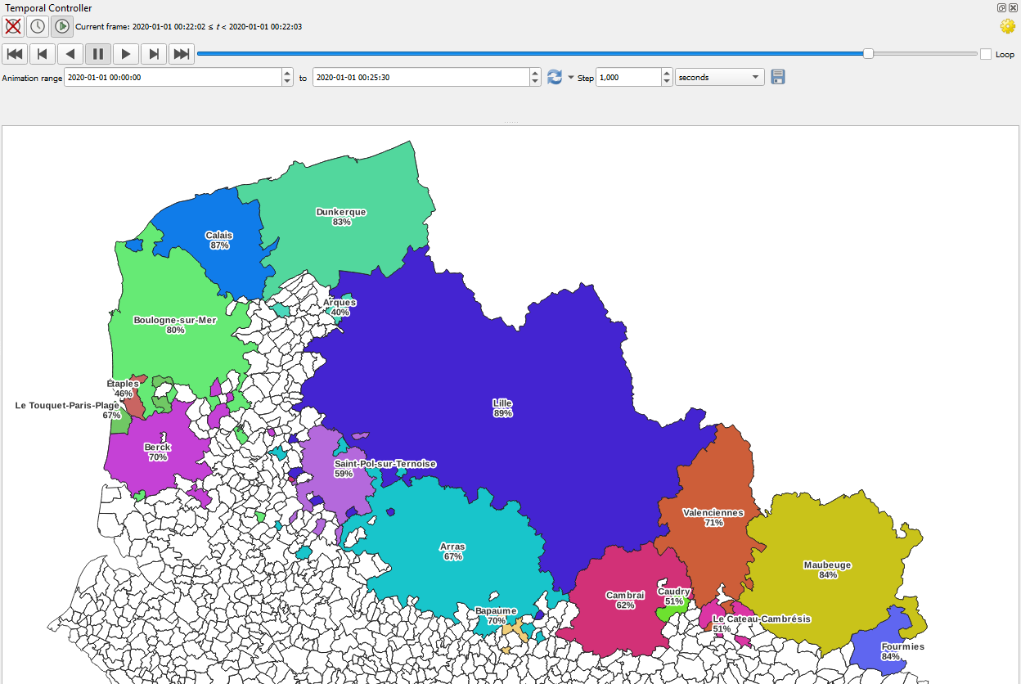

Generating a video
To generate a video there are several solutions.
The principle is to export a frame of each step from the time controller and then from an external tool to assemble each frame to make a video, for example with the open source tool ffmpeg

To do this, you just need to use the export of the animation from the time controller. The images will be called commuters_0001.png, commuters_0002.png, ...
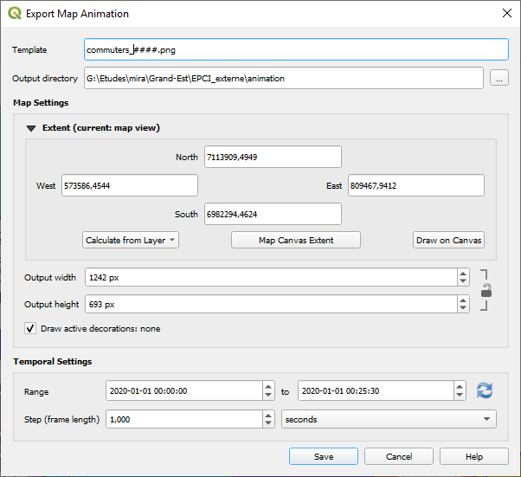

Example of a command with ffmeg to combine the images into a video "mobility_areas.mp4
ffmpeg -r 1 -i b commuters_%04d.png -vcodec mpeg4 -y mobility_areas_hdf.mp4

