Solution.

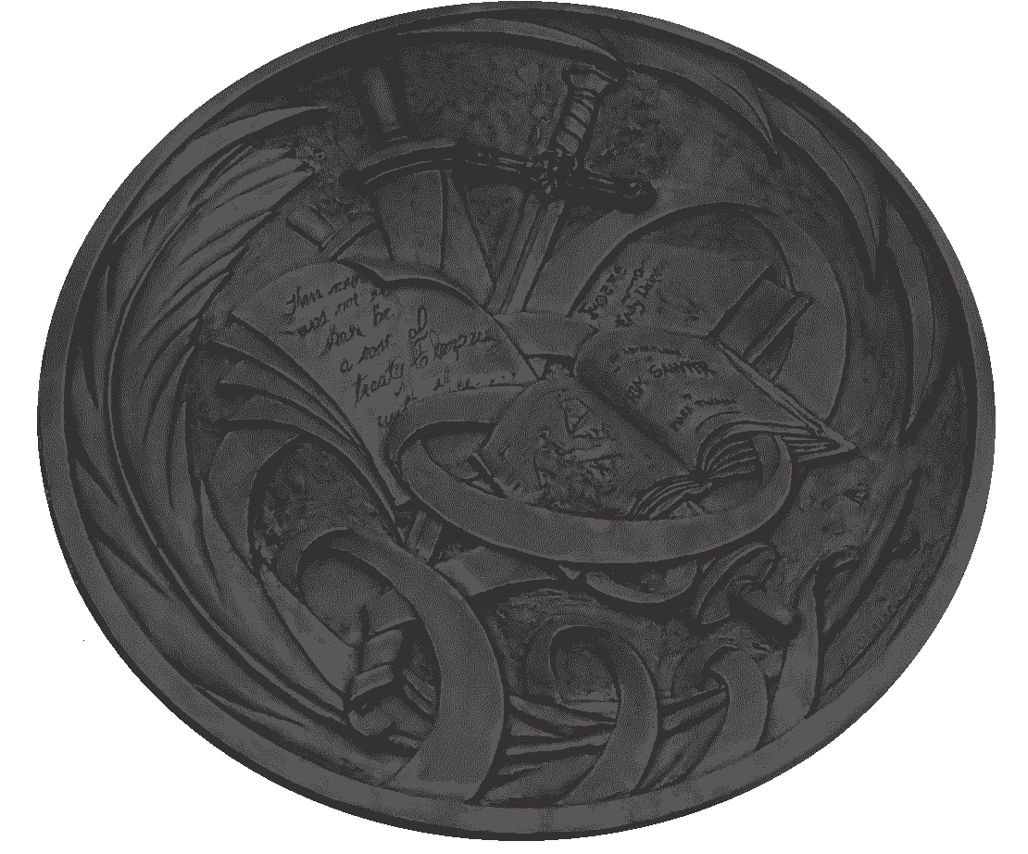

|  |
| --- |
| Capacitor>>>hertz^Tube1_Tube2  1MAXh≈1000>2MAXh<901>>ijk  i(ST)/j-INTERSEX:iffinit><>>\  S∙>D(T4trait)k=tat(e) |

|  |
| --- |
| } |

|  |
| --- |
| { |