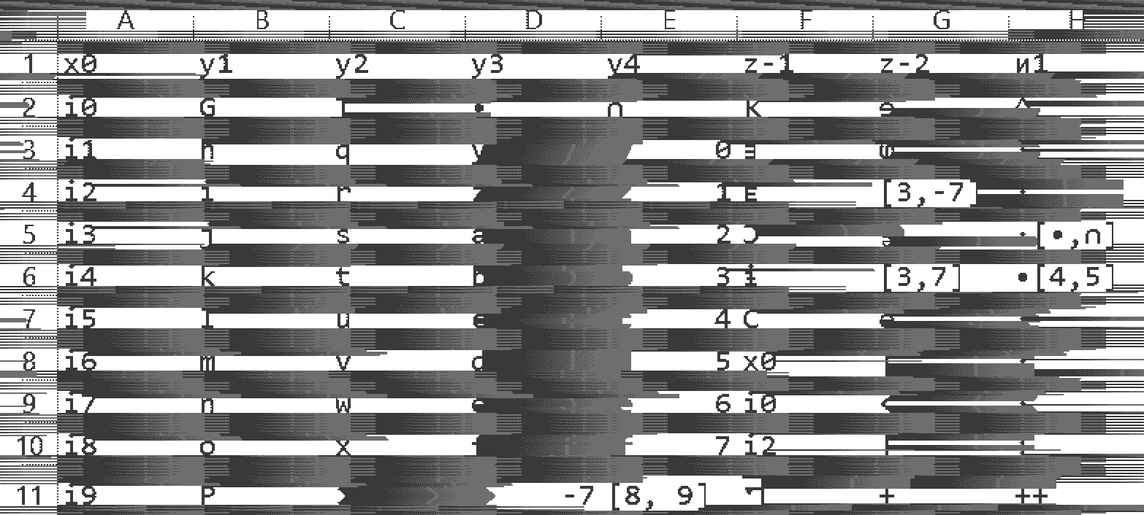

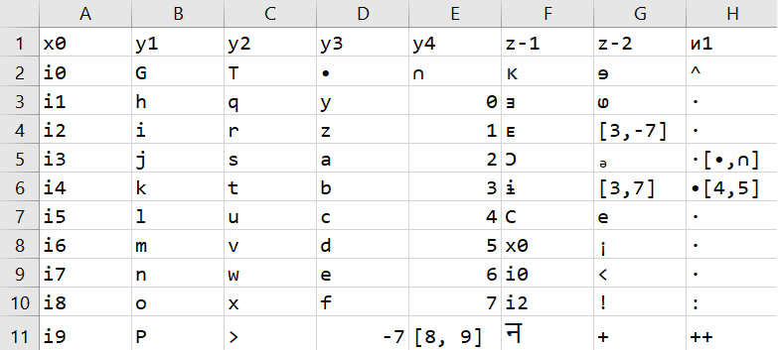

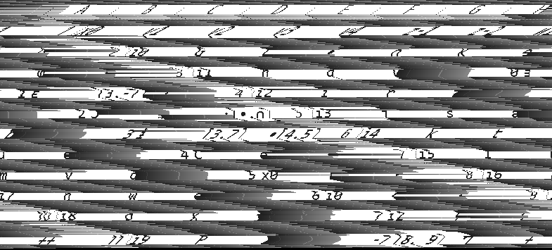

P5

# Created by IrfanView

783 353

255

!"#$%&'()*+,-.?0123456789:;<=>?@ABCDEFGHIJKLMNOPQRSTUVWXYZ[|}^_`abcdefghijklmnopqrstuvwxyz{|}~€‚ƒ„…†!"#$%&'()*+,-.?0123456789:;<=>?@ABCDEFGHIJKLMNOPQRSTUVWXYZ[|}^_`abcdefghijklmnopqrstuvwxyz{|}~€‚ƒ„…†!"#$%&'()*+,-.?0123456789:;<=>?@ABCDEFGHIJKLMNOPQRSTUVWXYZ[|}^_`abcdefghijklmnopqrstuvwxyz{|}~€‚ƒ„…†!"#$%&'()*+,-.?0123456789:;<=>?

x0,y1,y2,y3,y4,z-1,z-2,?1

i0,G,T,•,?,?,?,^

i1,h,q,y,0,?,?,·

i2,i,r,z,1,?,"[3,-7]",·

i3,j,s,a,2,?,?,"·[•,?]"

i4,k,t,b,3,?,"[3,7]","•[4,5]"

i5,l,u,c,4,C,e,·

i6,m,v,d,5,x0,¡,·

i7,n,w,e,6,i0,<,·

i8,o,x,f,7,i2,!,:

i9,P,>,-7,"[8, 9]",?,+,++

,,,,,,,

P5

# Created by IrfanView

785 355

255

!"#$%&'()*+,-.?0123456789:;<=>?@ABCDEFGHIJKLMNOPQRSTUVWXYZ[|}^_`abcdefghijklmnopqrstuvwxyz{|}~€‚ƒ„…†‡!"#$%&'()*+,-.?0123456789:;<=>?@ABCDEFGHIJKLMNOPQRSTUVWXYZ[|}^_`abcdefghijklmnopqrstuvwxyz{|}~€‚ƒ„…†‡!"#$%&'()*+,-.?0123456789:;<=>?@ABCDEFGHIJKLMNOPQRSTUVWXYZ[|}^_`abcdefghijklmnopqrstuvwxyz{|}~€‚ƒ„…†‡!"#$%&'()*+,-.?0123456789:;<=>?