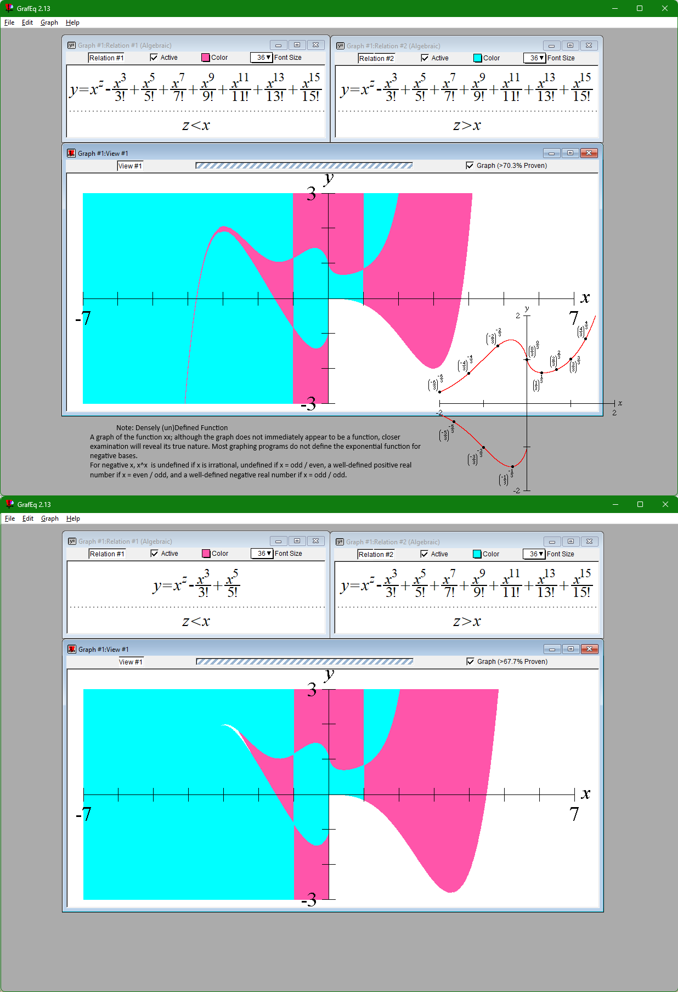

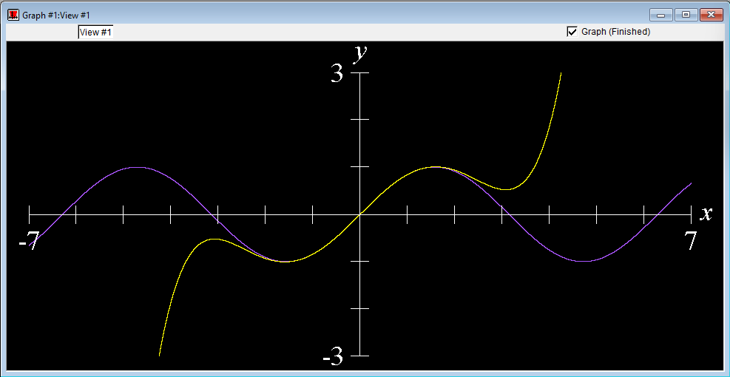

(Approximation of Mclauren Polynomial over sine graph, GraphEQ)

**“An Enrichment Exercise”**

“In this exercise, we will examine the approximation of the sine function with the McLaurin polynomial. In particular, we will discuss the following question:

* How many terms of the McLaurin series are required to provide an approximation for the sine function?  
  (The McLaurin series for the sine function is *x*-*x*3/3!+*x*5/5!-*x*7/7!+*x*9/9!-*x*11/11!+....)

From the form of the McLaurin series, we can deduce that, ultimately, each successive term of the series brings us closer to the limiting value, on alternate sides. We will take a finite prefix of the McLaurin series as an approximation to the sine function: the more terms we take, the closer the approximation. Our question is: How many terms would be required?” –Jeffrey Allen Tupper GraphEQ manual

To the left is a graphic demonstration of the variable accuracy when approximating the Mclauren polynomial using GrafEQ by using the “densely (un)defined function” within graphEQ. This approach doesn’t define the error bounds, but proves existentially that z<e<x where e is the range of the error of approximation.  
  
Within the (-x,y) quadrant the white color denotes the error variance.