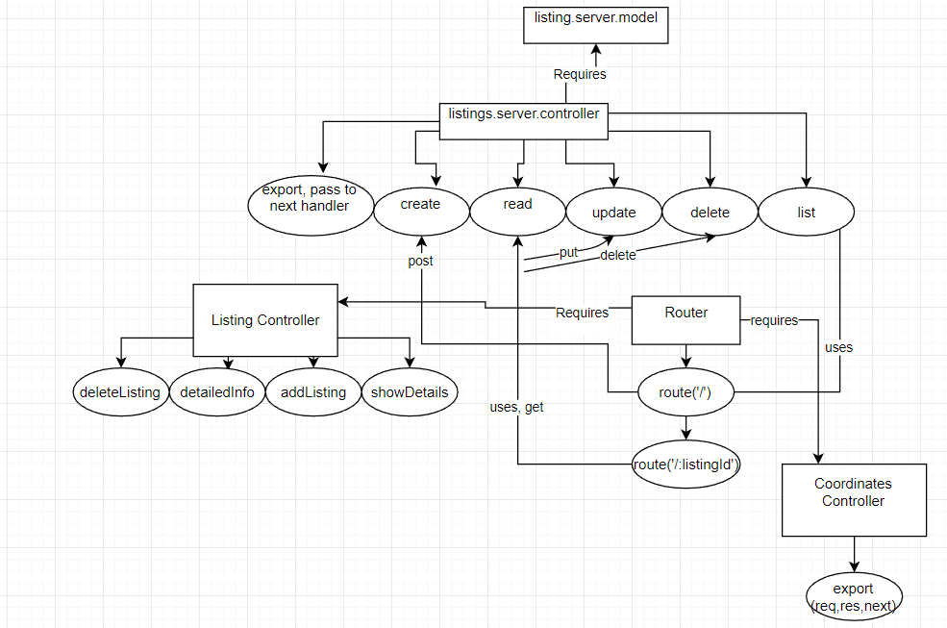

In the server, the listing.server.controller handles the create, read, update, delete, and list requests. The router uses these functions in various routes, through get, put, post, and delete requests, based on the path (‘/’ or ‘.listingId’). The router requires both the listing controller and the coordinates controller, which allow it to properly use the functions to display data to the page, and manage the coordinates variable. By using these middleware routes, we’re able to have a module for each route that only uses certain functions. The fact that all of these functions are now .export functions allow them to send their data as a request/response to modularize code.