Contents

1 Introduction 3
1.1 Purpose 3
1.2 Scope 3
1.3 Definitions, Acronyms and Abbreviations 3
1.4 References 4
1.5 Overview 4
2 Overall Description 5
2.1 Product Perspective 5
2.2 Product Functions 5
2.3 User Characteristics 5
2.4 Constraints 6
2.5 Assumptions and dependencies 6
3 Specific Requirements 7
3.1 External Interfaces 7
3.2 Functional Requirements. 7
3.3 Performance Requirements 11
3.4 Maintainability 12
3.5 Design Constraints 12
3.5.1 Placement and overall Design 12
3.5.2 Form of the Functions 12
3.5.3 Programming Languages 12
3.5.4 Errors 12
3.5.5 Complexity 13
4 Supporting Information 14

Revision History

Date | Version | Description | Author(s)
03.10.2017 | 1.1 | First discussion, allocation of tasks. | Jurilj, Huber, Fuchs
06.10.2017 | 1.2 | Creation of scaffolding. | Jurilj, Huber, Fuchs
07.10.2017 | 1.3 | Extension in many chapters. | Jurilj, Huber, Fuchs
10.10.2017 | 1.4 | Revision and formatting. | Jurilj, Huber, Fuchs
14.10.2017 | 1.5 | Minor revisions and creation of final version 1.5. | Jurilj, Huber, Fuchs

Introduction

Purpose
This document represents the Software Requirements Specifications for the HTML Generator Library for the Eiffel programming language. It is written and designed for the stake holders, such as the teaching assistants and the professor, as well as fellow students, lastly it is for the developers involved in the project (namely Dominik Jurilj, Ramon Huber, Basil Fuchs). Its purpose is to describe the scope of both functional and non-functional requirements for the software. Lastly it describes the design constraints of the HTML Generator Library.

Scope
The goal of this project is to develop an extensible library for the programming language Eiffel, its purpose is to simplify the task of presenting output i.e. testing statistics or simulation results. We set our main focus on HTML, but tried to leave it open to add other similar languages as Markdown or LaTex. The library shall be easily usable for individuals acquainted with Eiffel without the need for them to have knowledge of the output language. The library will include being able to create a string of the wanted (HTML) output and to generate a new (.html) file. In its base version it will include various functions to display (HTML-)forms such as plain text, titles, images, bullet lists, tables, etc.

Definitions, Acronyms and Abbreviations
Bullet lists: Tool for listing elements, every new element starts on a new line and with a bullet (circle) in front (as first character).
Browser: Program to illustrate Websites and Documents (e.g. HTML Files). Well-known examples: Firefox, Chrome, Internet Explorer, Edge, Safari.
CSS: Cascading Style Sheets, language used to add visualization and customization to HTML code.
Eiffel: Object-oriented programming language used in this project.
Forms: The most used HTML elements are called forms and include things like images, text, titles etc.
(HTML-)ID/Name: HTML-forms use IDs to differentiate them while using complementary languages like JavaScript or CSS.
initiate-string: String created by the initiate function and filled by other functions.
Injections: Unwanted additions of code, mostly in form of strings.
JavaScript: High-level, object-oriented programming language used together with HTML (and CSS) on almost all webpages.
LaTex: Document preparation System, that will generate a PDF, as an opposite to most writing programs nowadays, with LaTex you have to compile first to see the output properly.
Markup: Language to format text and similar data. Closely related to HTML.
PHP: Server-side scripting language.
Regarding the requirements in 3.2:
ID: Unique identifier for the requirements.
Priority: The priority of the requirements, which ones are the most essential for the project, ranging from one to three (one being the highest priority)

References
IEEE 830-1998 (IEEE Standards Organization, https://standards.ieee.org/findstds/standard/830-1998.html)
Eiffel Programming Language (https://www.eiffel.org/)
Lecture Slides “Software Construction” (Bertrand Meyer, Universität Zürich, 2017)
Examples for SRS provided by the Teaching Assistants.
EiffelStudio System Requirements (from: Eiffel Software, https://www.eiffel.com/eiffelstudio/system-requirements/, (13.10.2017))

Overview
The next points, mainly in the second chapter, in this SRS are dedicated to show what the base library contains, what its flaws and constraints are, what it can be used for and how. We will also discuss who will be the typical user of our library.
In the third chapter we present the specific requirements, which show the software requirements in detail in order to give the programmers a good understanding of what they have to implement. This is divided into the subsections of Functional Requirements, Performance Requirements and Maintainability Requirements.
Chapter four provides supporting information.

Overall Description

Product Perspective
Our Product is intended to be used as a library inside the programming language Eiffel. All functions of the mainly HTML focused generator can be imported into the programming language and therefore any Eiffel system. Our Product is very dependant on the programming language and it’s version, it can only be used with an Eiffel Compiler, as seen in Figure 1, and cannot run on its own. An interface for our product would be EiffelStudio for example.
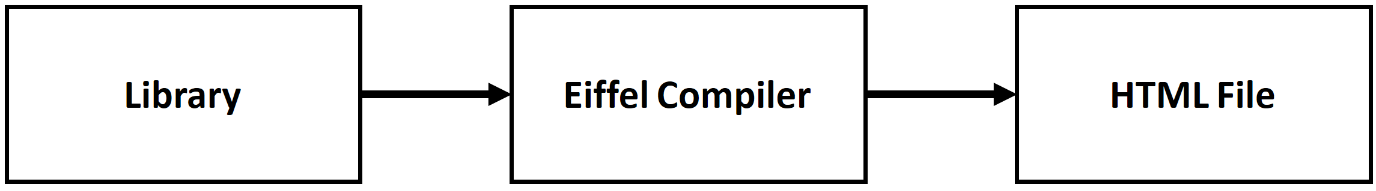
Figure 1: Shows the flow from the user input, using the library, to creating a HTML file

Product Functions
The functions presented are implementations of basic HTML code to easen the creation of a HTML file. The most important duo consists of initiate() and generate() which are respectively used to start filling the output-string and to create an HTML file with said string as input. What follows is a list of functionalities used in the base library of this product.
- Initiate and create a HTML string or file, that will store the code created with our library.
- Insert text into the html file that is either in normal, bold or italic print. Additionally, there’s the option to input a title which is in bigger print.
- Insert a link to a webpage or another file through a linked text or a actionbutton.
- Insert an image.
- Create an ordered or unordered list.
- Create a table.
- Insert an already existing HTML snippet into the HTML file.
In section 3.2 follows a more detailed description of the functions.
Features that are explicitly not supported in the base form of the library are all features that would require the use of CSS or JavaScript.

User Characteristics
This library is mostly aimed at users who want to create a simple HTML file or who just want to create a few basic forms, in form of a string, without much hassle.
The extensibility of the library adds possibilities for users who are more experienced with HTML to add functions of their own to counter the later mentioned constraints of the base library.
It is however not recommended to be used by people well acquainted with HTML, especially if they need complementary languages like JavaScript, PHP and CSS.

Constraints
Since the library is aimed at creating a .html file and/or filling an empty string with the data, it does not contain the means to delete functions or files, or to edit them in any way. Once the string generated by initiate is no longer empty, the user has to start over again. If they intend to add something in-between or to delete a form which means that once a function is used it is irreversible with the base library.
In its base form, the library does not contain any form of CSS, JavaScript or PHP, which are vital for visualization and for calculations and communications on bigger websites. While it is still possible to add those, this project concentrates on the purpose of creating a simple one-page HTML site or only the string for it.
More about constraints in chapter 3.5 Constraints.

Assumptions and dependencies
The user must be acquainted with the Eiffel programming language, to be able to use the library, and has to have a basic understanding of variables and features (functions).

Specific Requirements

External Interfaces
The Eiffel Programming environment (which comes from another source) will be the main interface for our library. The environment we will be working with during this project is EiffelStudio.

Functional Requirements
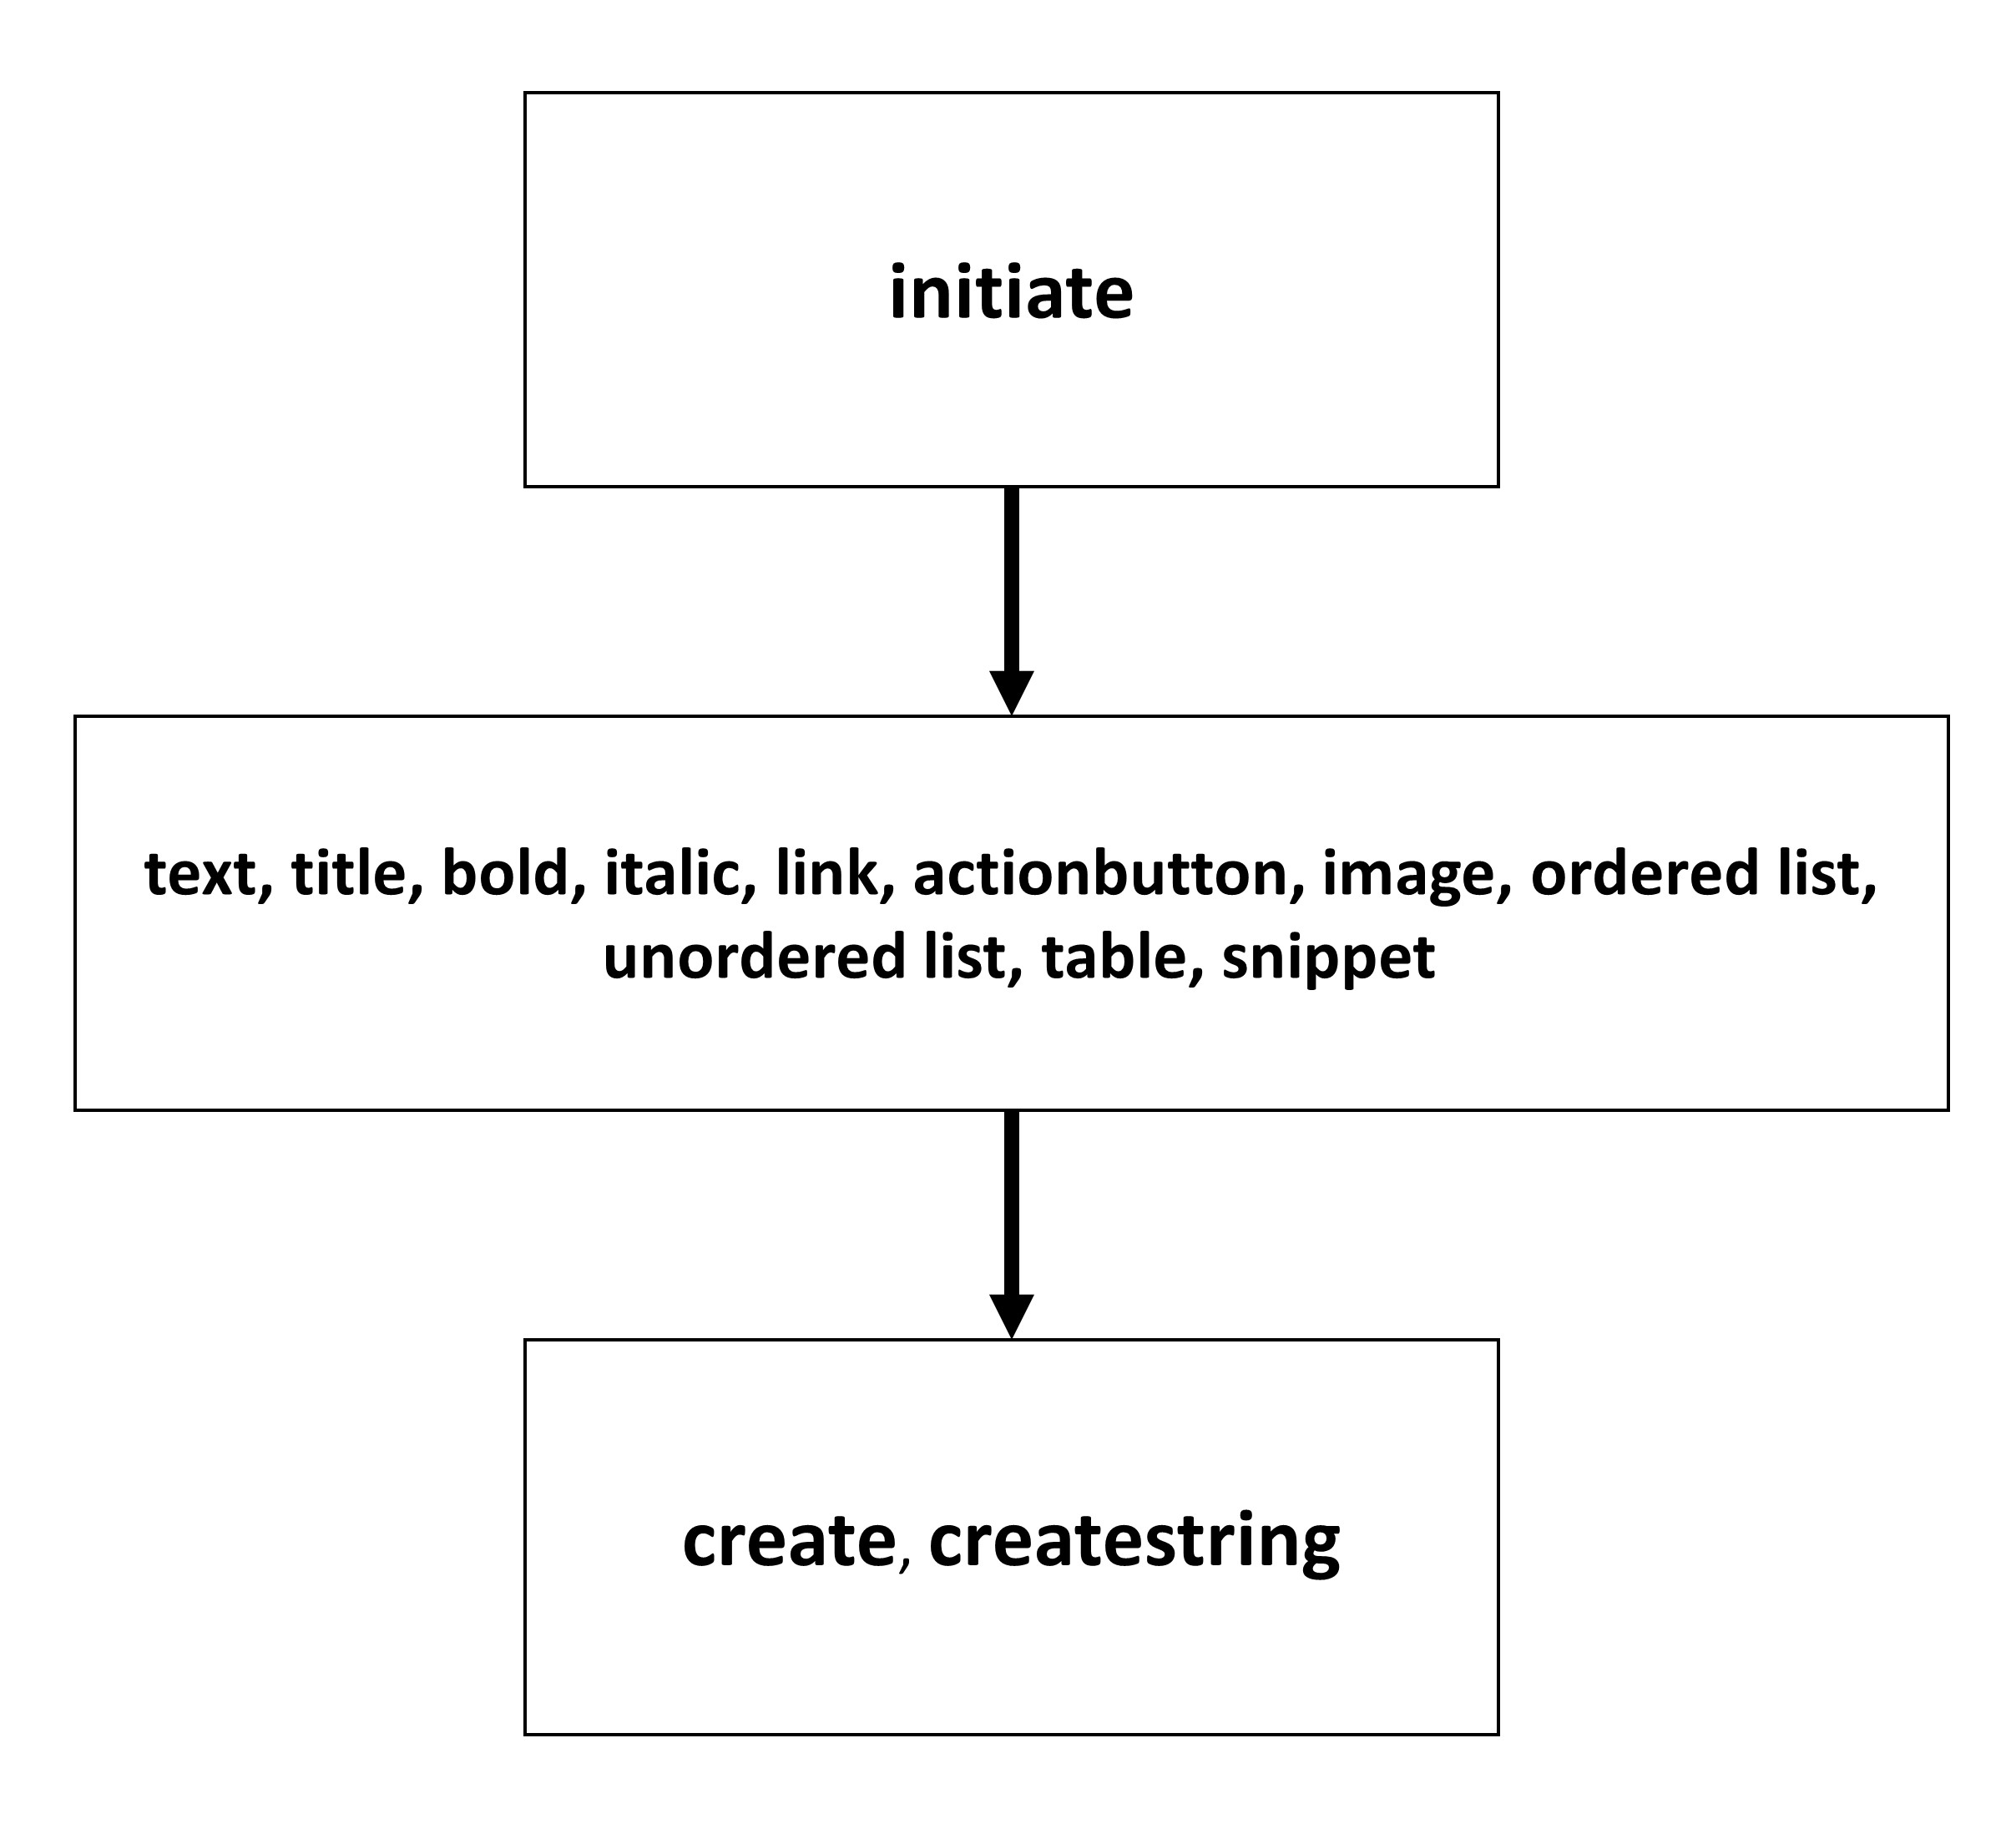
ID  Name  Description  Priority  References | R1.1  initiate  Everytime a user wants to generate a new string or file including HTML code, they need to initiate it with this function. It creates an empty string and adds information based on the order of function uses besides initiate and create.  1  create, createstring
ID  Name  Description  Priority  References | R2.1  text  Adds the possibility to write plain text into the output string.  2  title
ID  Name  Description  Priority  References | R2.2  title  Lets the user choose a number from one to five and makes an according title from the HTML presets.  2  text
ID  Name  Description  Priority  References | R2.3  bold  Takes the input and adds the necessary indications to make the text bold, when using HTML.  3  text, italic
ID  Name  Description  Priority  References | R2.4  italic  Same as bold, but changes the text to italic.  3  text, bold
ID  Name  Description  Priority  References | R2.5  link  Adds a linked text. Links may contain third party links such as websites, and file paths.  2  actionbutton
ID  Name  Description  Priority  References | R2.6  actionbutton  Create a clickable button which may be linked similar to the function link.  2  link
ID  Name  Description  Priority  References | R2.7  image  Shows an image through a link.  2  None
ID  Name  Description  Priority  References | R2.8  ordered list  Takes an array and turns it into an ordered list.  2  unordered list
ID  Name  Description  Priority  References | R2.9  unordered list  Takes an array and turns it into an unordered list (bullet list).  2  ordered list
ID  Name  Description  Priority  References | R2.10  table  Creates a simple table. The input consists of one-dimensional arrays which all represent a row of data to be put into the table.  2  None
ID  Name  Description  Priority  References | R2.11  snippet  Adds an existing HTML snippet.  2  All the other forms
ID  Name  Description  Priority  References | R1.2  create  Concludes the initiate function by creating an HTML file with choosable filename. It also checks if the chosen name already exists.  1  initiate, createstring
ID  Name  Description  Priority  References | R1.3  createstring  Shows the initiate-string with the HTML code, the string is only available during runtime.  1  initiate, create

All R2.X requirements (X stands for any number) create HTML code that can later be stored in a file or a string, through the functions create or createstring.

Performance Requirements
Most of the computational power will be needed to run EiffelStudio since the functions itselves are not of a high complexity.
See chapter 4. Supporting Information for the system requirements of EiffelStudio.

Maintainability
The nature of the library makes it easily maintainable and extensible if using the Eiffel programming language. If a user wants to add more complex elements like CSS or wants to have functions to delete/edit an already existing string or file, they additionally need to know to code HTML. In order to simplify maintainability the programmers should write in a way that their code is easy to read and simple to understand.

Design Constraints
The usage of simple forms like text-forms or adding images are easy enough to efficiently implement with Eiffel. The addition of more complex possibilities like editing existing pages however need too big of an effort for it to be worth.

Placement and overall Design
The functions are designed to add a single form into the string/file after calling it. Without extending the library or modifying the functions, it is impossible to swap places of previously added forms or change its styles with CSS.

Form of the Functions
The main functions used for generating the string and new file, initiate and create are vital in the way the library works. If one does not follow the design pattern of adding to the initiate-string at the end of each function, the output will not be changed.

Programming Languages
Creating a new .html file by using the base library only demands knowledge about Eiffel, while adding new functions automatically assumes familiarity with HTML or more.

Errors
In its base form, none of the functions are able to detect or remove errors or injections done by the user. It is possible by extending the library with checking for regular expressions.

Complexity
This chapter concludes the previously mentioned chapters (3.5.1, 3.5.2, 3.5.3, 3.5.4).
Most elements in the base library are easily comprehensible even for a new user of HTML. Changing an existing file in a desired way or adding communication in form of PHP and JavaScript add a lot of complexity to functions and makes room for more errors and bugs.
Let us take a look at the text function:
The only input needed is a string to be added in the initiate string respectively added as an HTML-form in the file.
If one were to add the possibility to give the text-form an ID and make it another class to be separately modified through CSS, the function would need two more arguments in the best case. Furthermore, the function automatically needs more lines of code to use those values and add them to the initiate string. The option to add a CSS file would still be missing which means that either the text function permanently needs to use a certain CSS template (saved in the function), you need one more argument for the function, or the initiate-function needs to be adapted to usage of CSS.
If we now additionally want to use JavaScript or PHP it quickly leads to exceptionally complicated functions.

Supporting Information
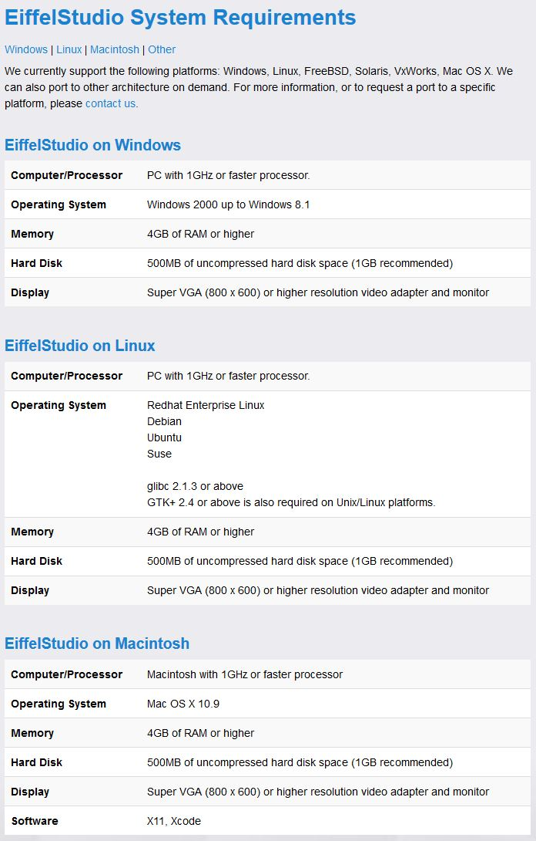
(See References for source declaration)

