**Juan I Castaneda**

**Homework Assignment #1 Excel**

**1/24/2021**

**what are three conclusions we can draw about Kickstarter campaigns?**

Based on pivot tables and charts generated from the data we can draw the next conclusions:

1. **Category Analysis:**
   1. 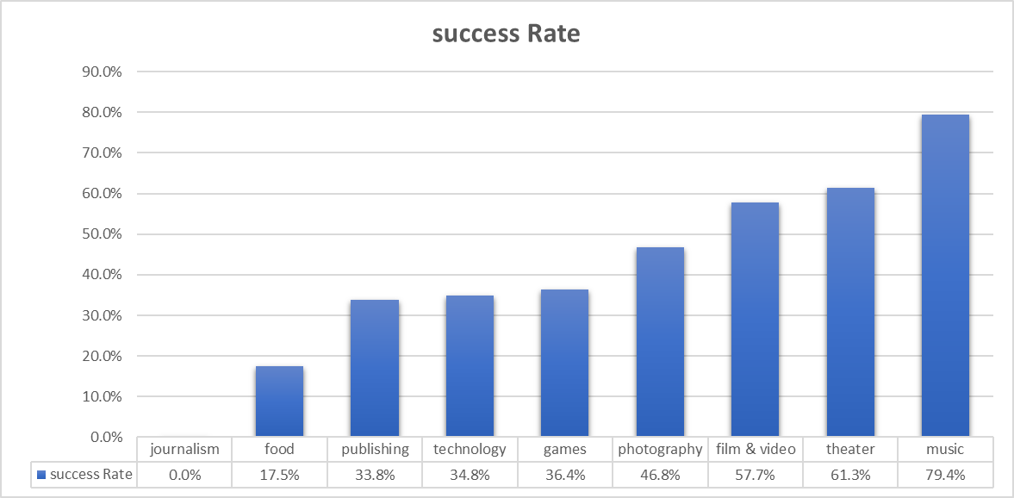Considering only the successful, failed and canceled Kickstarter (excluding the live ones) we can determine that the category where the projects have a higher success rate is music, with a 79.4% of success rate; at first sight theater might seem the one with the highest success rate due to the grand total in that category. On the other hand, Journalism is the category with the lowest success rate. We can also see that Journalism is the category with a 100% cancelation rate followed by technology with a 29.67%. KickStater campaigns in the Games and Photography were not cancelled.

Sorted data generated from pivot table 1 in Excel File

* 1. We can see that the number of Kickstarter campaigns that succeeded is higher than the ones who failed (53% were successful).

1. **Sub-Category Analysis:**
2. Following a similar logic used to analyze the categories we can determine that the next Kickstarter Campaigns had a 100% success rate were classical music, documentary, electronic music, hardware, metal, non-fiction, pop, radio & podcasts, rock, shorts, small batch, tabletop games & television
3. Kickstarter Campaigns with the lowest success rate (0%) were: animation, art books, audio, children's books, drama, faith, fiction, food trucks, gadgets, jazz, mobile games, nature, people, places, restaurants, science fiction, translations, video games, web & world music.

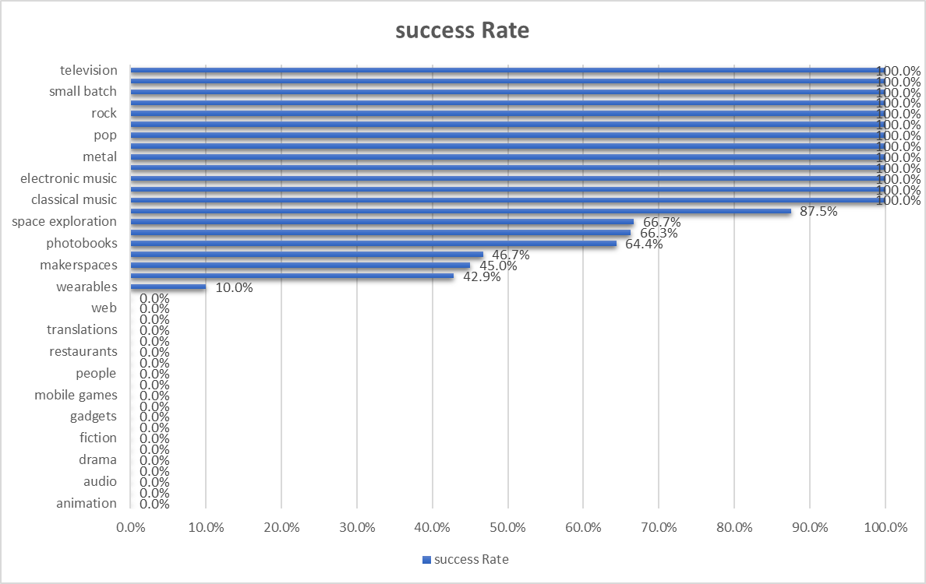

Sorted data generated from pivot table 2 in Excel File

1. The theater’s sub-category “plays” represents the most popular sub-category among all of the sub-categories with a 21.95% of the grand total of sub-categories.
2. **Analysis by Season:**
3. The sorted data shows that the highest success rate occurs in May at 60.62% and the lowest success rate occur in December at around 44%, this could be due to the holidays (specifically Christmas) when people have spent more money in presents.

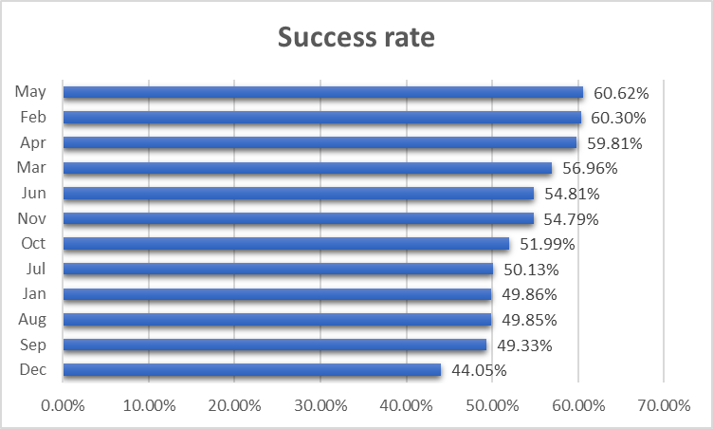

Sorted data generated from pivot table 3 in Excel File

1. It’s important to highlight the fact that in December the number of failed Campaigns surpasses the number of succeeded campaigns.

**What are some limitations of this dataset?**

1. The qualitative aspects of the campaign: There’s no information about the finalized product (in the case it made to that stage), some of these could be: Quality of the product, campaign organizer’s experience, Founder Appearance, money use, the project structure, marketing, etc.
2. The size of the dataset could be a factor that limits the certainty and/or accuracy of the analysis.
3. The backer’s acceptance of the result, is not present in this data set, that is very important qualifier to provide insight about their acceptance.
4. The target audience. This data is not provided and it could be a factor that contributes in a great magnitude to analysis insight.

**What are some other possible tables and/or graphs that we could create?**

1. Success rate comparison
2. The analysis by geographical area (not just the country but the state, etc.).
3. A chart that shows the relationship between the duration of the funding period and the outcome of the campaign. (How longer periods would affect the final result). Similarly, a chart that shows the relation between the funding goal and the outcome of that campaign.
4. A chart that represents donations (average donation, minimum, mean, maximum), a good example would be box plot to show. This would help us visualize how certain types of campaign receive different amounts based on diverse factor such a category, period of time, goals, etc.