**Juan I Castaneda**

**Homework Assignment #4 Pandas**

**2/15/2021**

**Three observable trends based on the data**

**Gender demographics analysis:**

* 1. Based on the data provided we determined the gender demographics. There are 576 players in total; we can clearly see that the predominant gender among the players is “Male”, which represents the 84% of the players who made a purchased in-game.
  2. ” Other / Non-Disclosed” category is by far the category with the lowest presence in the game (1.91%); this might be because the person doesn’t identify with either “Male” or “Female” gender, or because they made a mistake while selecting the category. A further analysis would be necessary if we want to know more about this category.

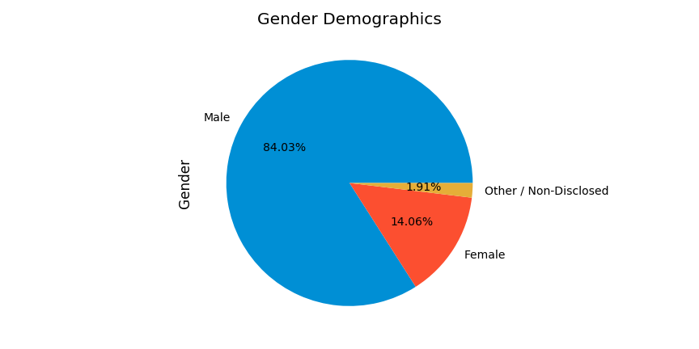

Data Obtained from purchase_data.csv utilizing pandas

**Purchasing analysis(gender):**

1. There were 780 registered purchases in total.
2. Kickstarter Campaigns with the lowest success rate (0%) were: animation, art books, audio, children's books, drama, faith, fiction, food trucks, gadgets, jazz, mobile games, nature, people, places, restaurants, science fiction, translations, video games, web & world music.