1. **What wallets allow buying tokens?**

The tokens can be bought from the wallets which support the standard ERC20. Here are the most widespread wallets -

1. MyEtherWallet
2. Ethereum Wallet / Mist
3. Parity

Never buy the tokens directly from token exchanges or marketplaces.

1. **Establishing the wallet**

Participation in the sales requires an Ether wallet, which supports ERC20. In case if you still don’t have it, we recommend to use <https://www.myetherwallet.com/>.

* 1. Enter <https://www.myetherwallet.com/>

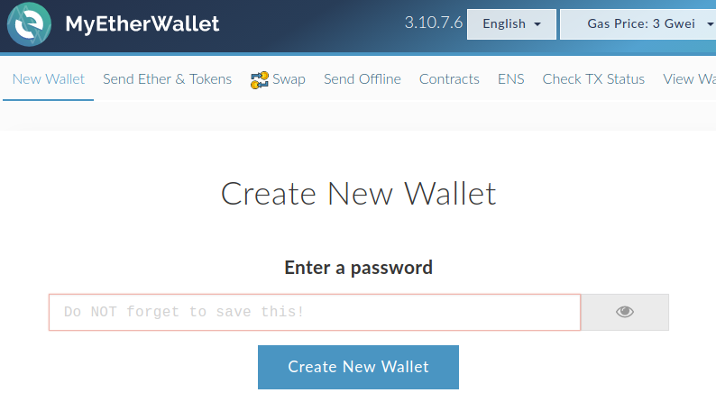

* 1. Enter a safe password, press on “create a wallet”.

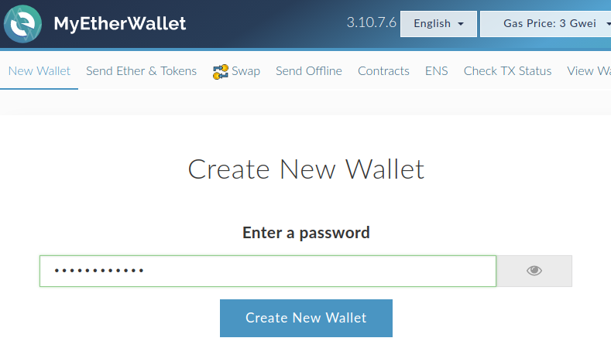

* 1. Download the wallet file Keystore by pressing on the blue button. Then press on the red button.

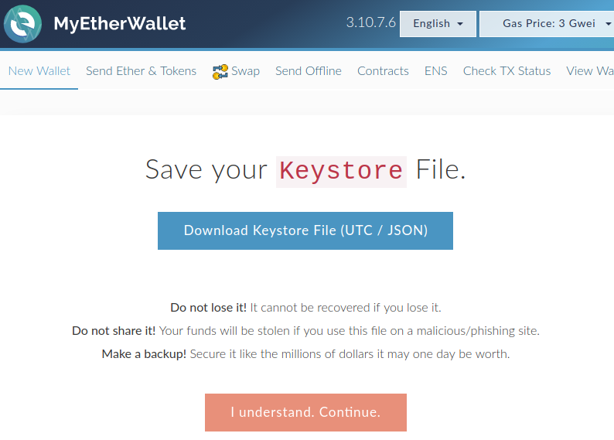

* 1. Store your Key-file in a safe location and press on “Save your address”.

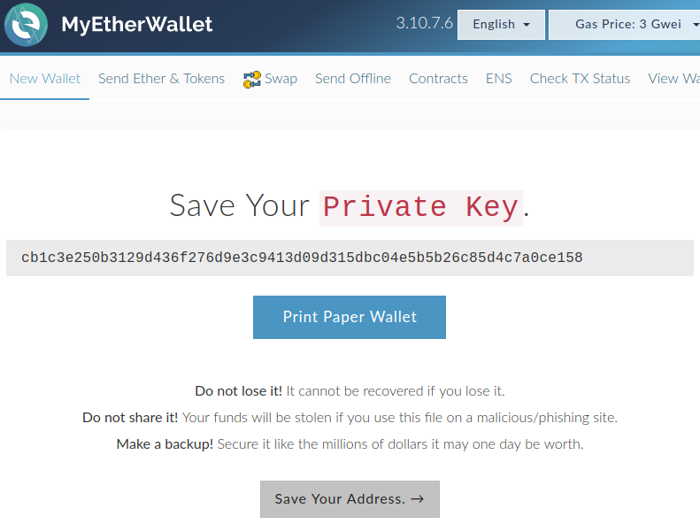

* 1. Now press on “The wallet info” to check the data of your wallet and your address.
  2. 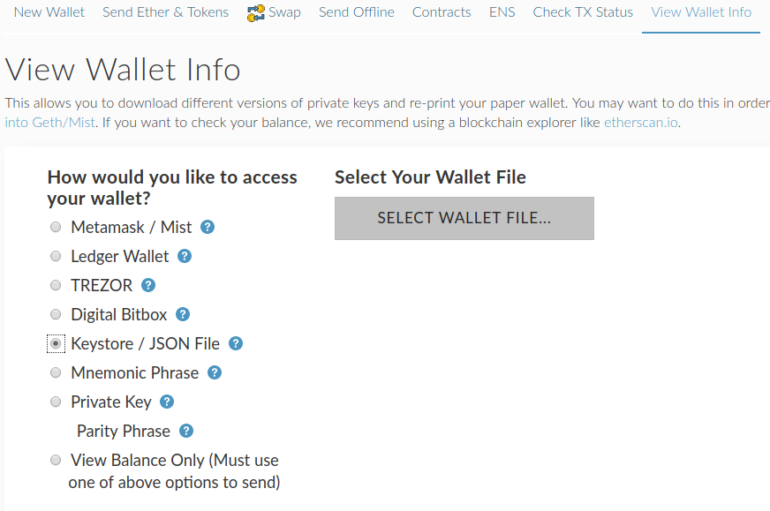Select a previously downloaded file with a wallet by pressing on “select a file with a wallet” and enter the password. Now press on “unlock”.

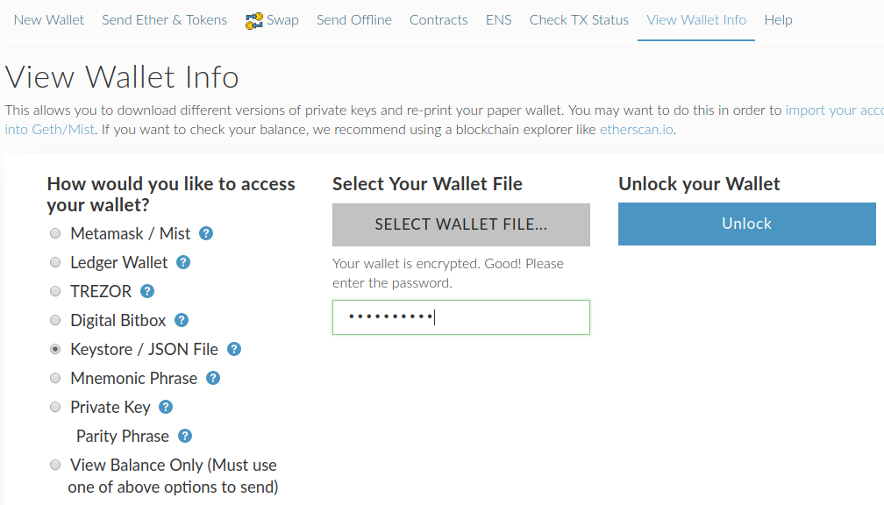

* 1. The field “Your address” will contain the address of your wallet.

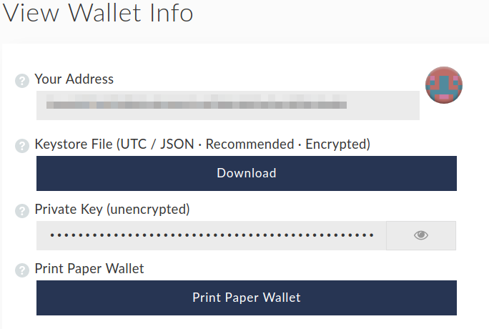**3. Purchasing Ether**

You need Ether (ETH) to participate in the sales. You can purchase ETH by the means of bank cards Visa or MasterCard on the following services-

* Changelly: https://changelly.com/
* Cex.io: https://cex.io/
* Coinbase <https://www.coinbase.com/>

By purchasing Ether you will need address, created in the item (1).

All services have different commission and different exchange rate, that is why by purchasing you must make sure that the rate matches you.

1. **Purchasing tokens**

You must send at least 40 Ethers to the wallet **0x28eEC9C792B7c68d225f2E8C12bA3C3D0183B368** in order to buy the tokens(during Presale)

Before sending make sure of the following-

* 1. You send at least 40 ETH.
  2. The gas amount is at least 200 000
  3. The price of gas is at least 21 Gwei. Transactions with the lower gas amount shall be handled slower.

In case if you use the wallet MyEtherWallet, you must perform the following activities-

* + 1. Enter <https://www.myetherwallet.com/>



* + 1. Select „ transfer Ether”

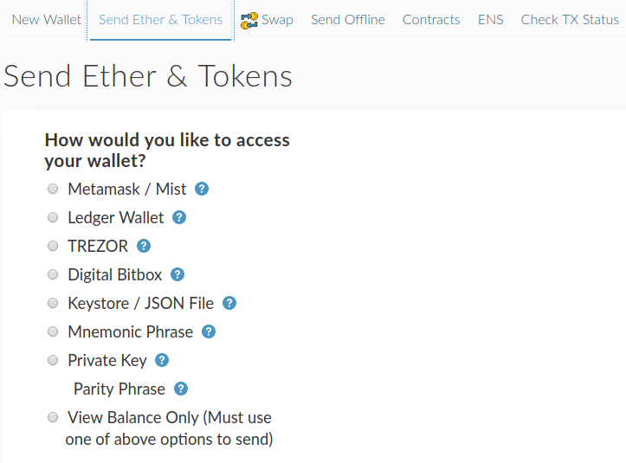

* + 1. Then select the„ Keystore file“, press on “select the file with a wallet”, enter the password and press on “unlock”.

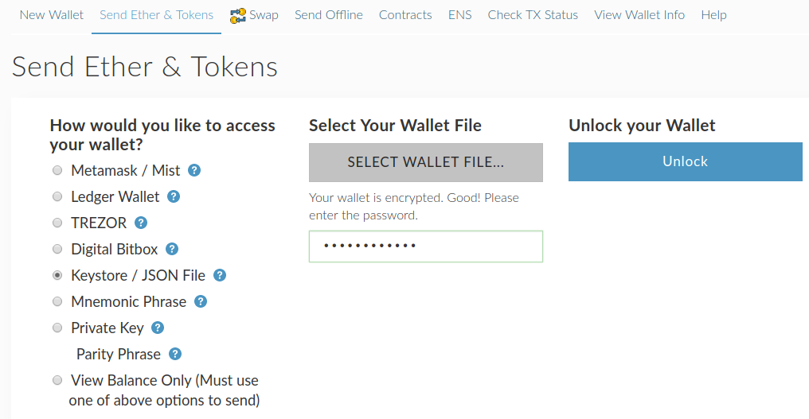

* + 1. Now enter in the address field **0x28eEC9C792B7c68d225f2E8C12bA3C3D0183B368**

Enter the sum which you want to spend for buying the tokens.

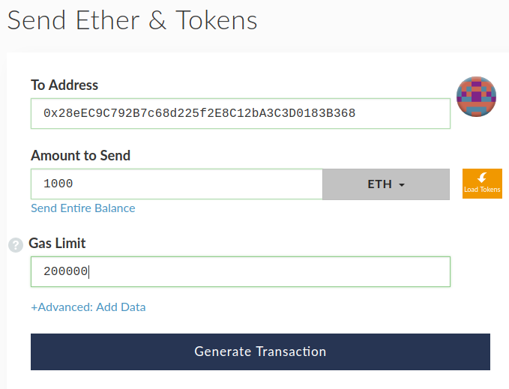

1. Press on “generate transaction” and then on “send transaction”.

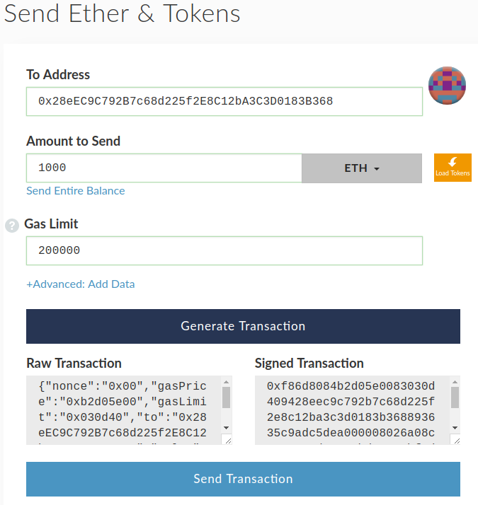

1. In emerged window press on “Yes, I’m sure! Send the transaction.”

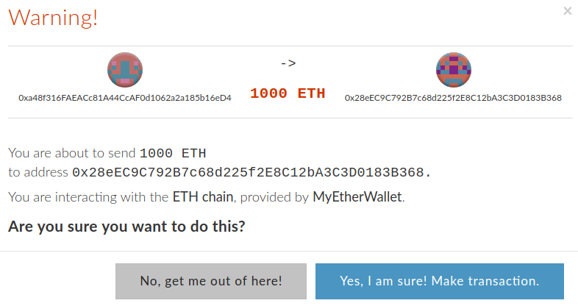**5. Adding or checking the tokens in the wallet**

Adding the tokens requires the following data

* Token address - 0xE17276888D1b3c0EAC64309c15f5d4195D24C695
* Token symbol — GEN
* Number of symbols after comma (decimal symbols) - 18

In case if you have a wallet MyEtherWallet, perform the following actions-

* 1. Enter <https://www.myetherwallet.com/>



* 1. Select „The wallet data“, select “Keystore file”, download the file by pressing on “select the file with a wallet”, enter the password and press on “unlock”.



* 1. In the right part you will see the panel “Token balance”. Press there on “Add my token”.

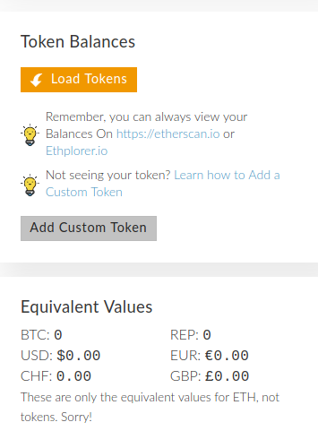

* 1. Enter address 0xE17276888D1b3c0EAC64309c15f5d4195D24C695, the symbol GEN, the fraction 18 and press on «save»

