. What crypto wallets might be used in the purchase of tokens

The tokens can be bought using the wallets based on a ERC20 standard. We recommend:
- MyEtherWallet
- Ethereum Wallet / Mist
- Parity
Do not buy tokens directly from Crypto Exchanges or Crypto currency exchange offices.

. Wallet opening

You would need a purse maintaining the ERC20 standard to take part in the trading. If you still do not have a wallet we would recommend to use a link https://www.myetherwallet.com/.
- Open https://www.myetherwallet.com/
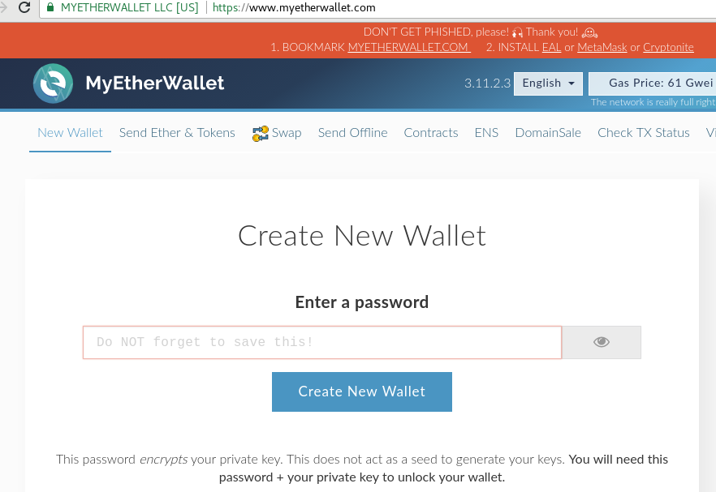

- Enter a strong password and click “create wallet”.
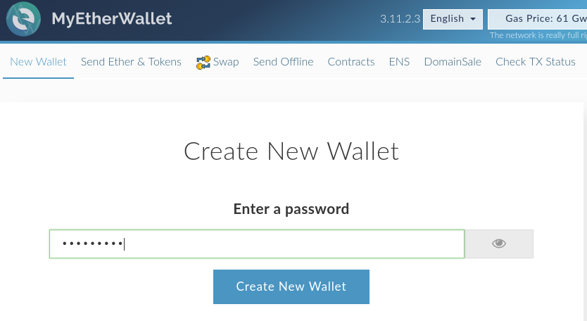
- Download the wallet’s file Keystore by clicking a blue button “ Download Keystore (UTC / JSON)” and then click the red button “I understand. Continue”.
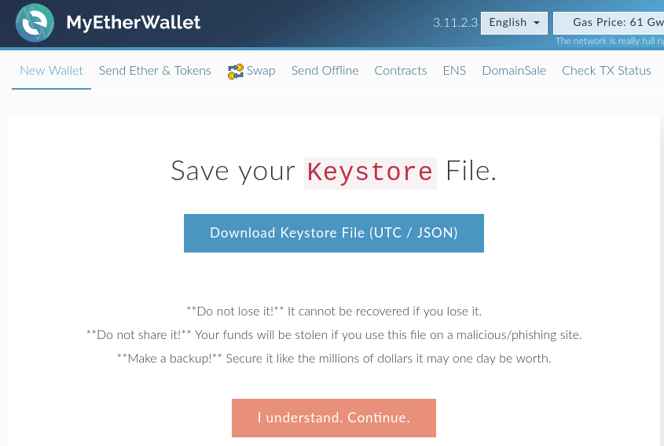

- Save your Keystore file in a safe place. Click the button “Save your address”
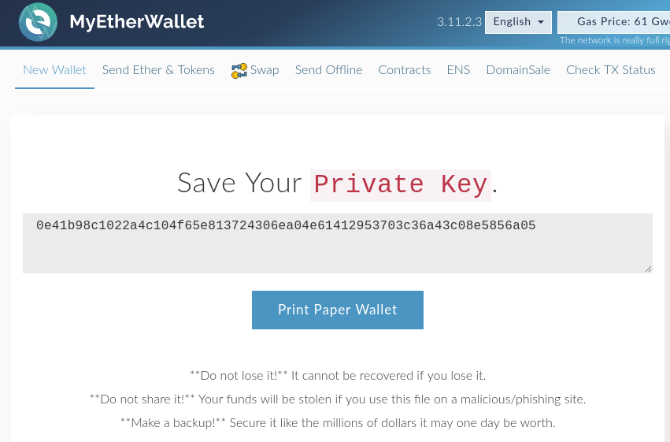
- Now to see the information about your wallet and the address click “Wallet info”
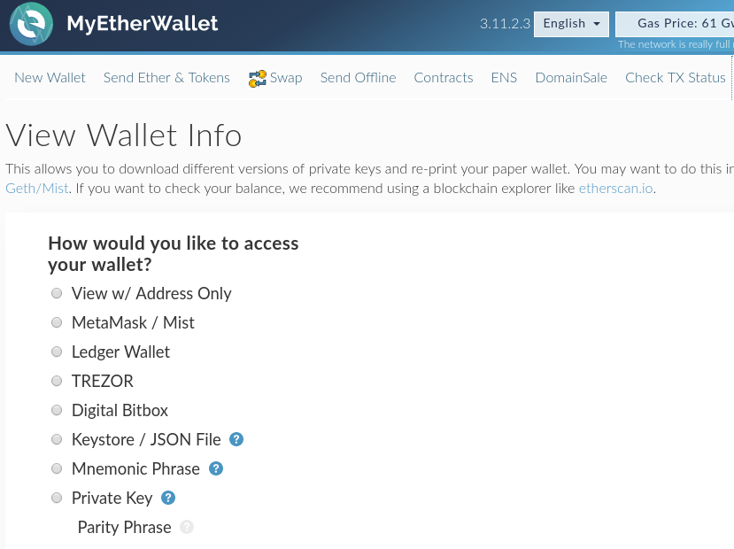
- Choose the wallet’s file downloaded in the beginning clicking “select wallet file” and enter the password. And then click “unlock”.
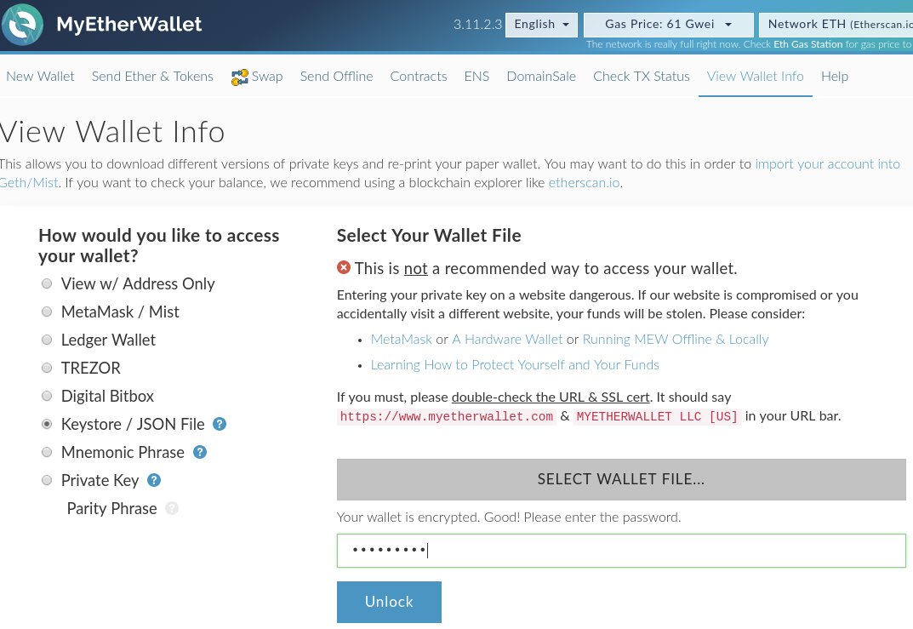
- Your wallet’s address will be given in the field “Your address”.
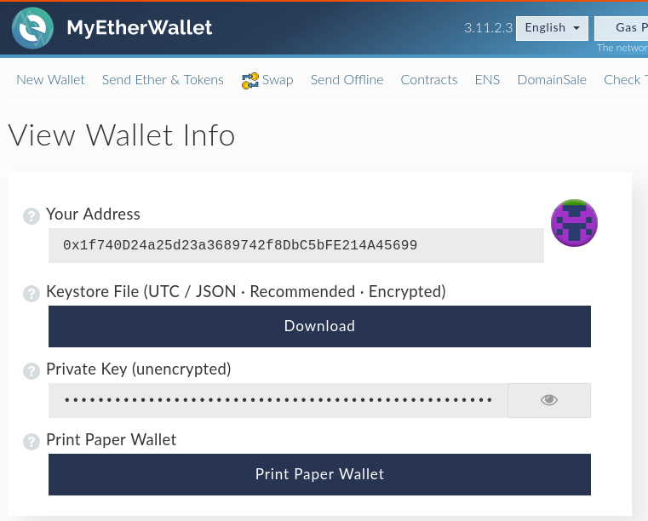

. ETH purchase

To take part in trading you would need Ether (ETH). You may buy ETH with your Visa or MasterCard plastic cards using:
- Changelly: https://changelly.com/
- Cex.io: https://cex.io/
- Coinbase https://www.coinbase.com/
When buying ETH you would also need the address we created in the beginning.
Various services have various fees and rates. Therefore make sure that the rate suits you while buying the ether.

. Token purchase

To buy tokens you need to transfer no less than of 0.1 ether to your wallet 0x90374eBF6a15e4fdf99d00E9e783cb6183b44272
Before transferring the ether please be sure that:
- You send no less than 0.1 ETH.
- The gas limit is no less than 250 000
- Gas price — no lower than 40 Gwei. The transactions with lower gas quantity are used to be processed longer. If you use a wallet type MyEtherWallet you need to do the following:
- Open https://www.myetherwallet.com/

- Choose “transfer ether and ether”.
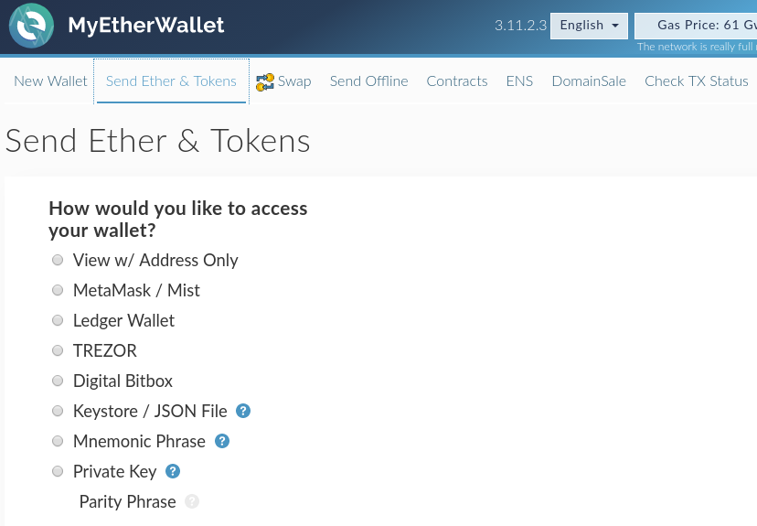
- Then choose “Keystore file/JSON File”, click “select wallet file”, enter the password and click “unlock”.
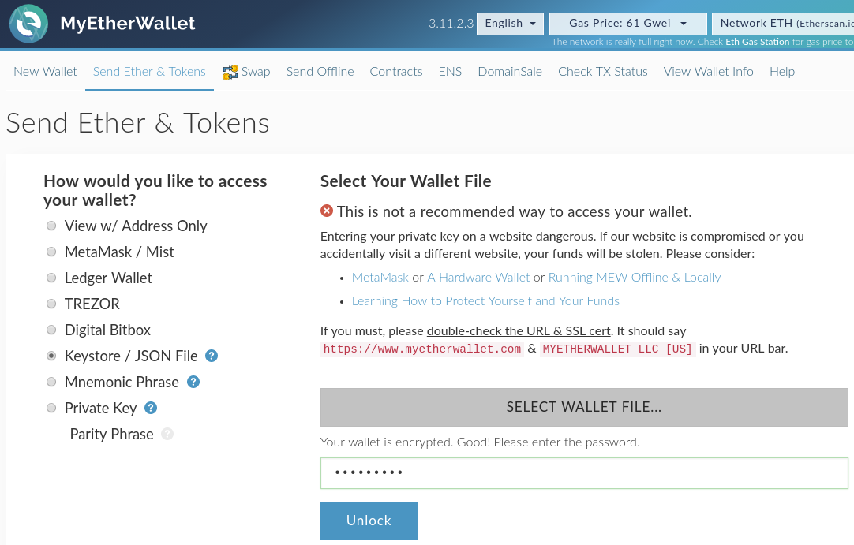

- After that enter the following data into your address line — 0x90374eBF6a15e4fdf99d00E9e783cb6183b44272. Enter the sum you want to spend to buy tokens.
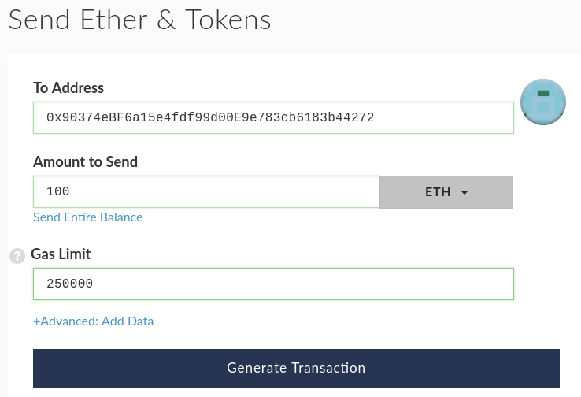

- Click “Generate transaction” and then “Send transaction”.
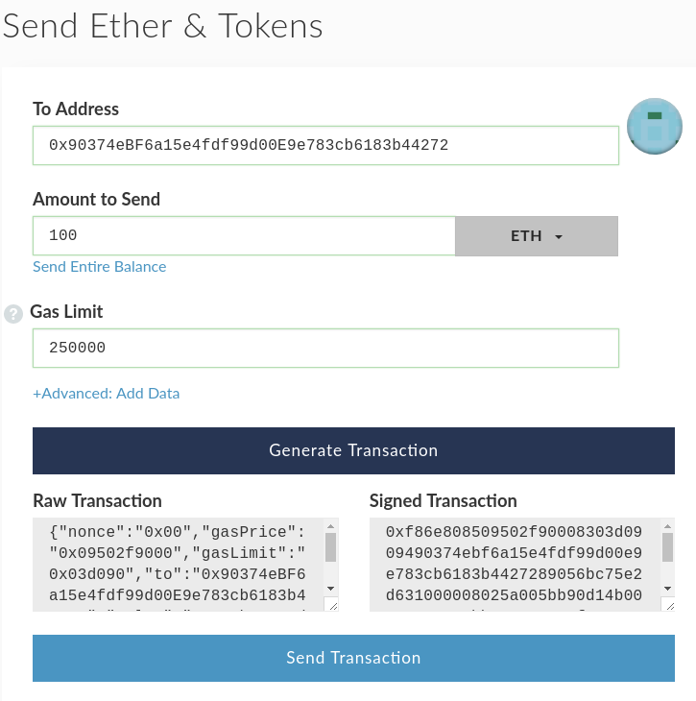

- In the popup click blue button “Yes, I am sure! Make transaction”.
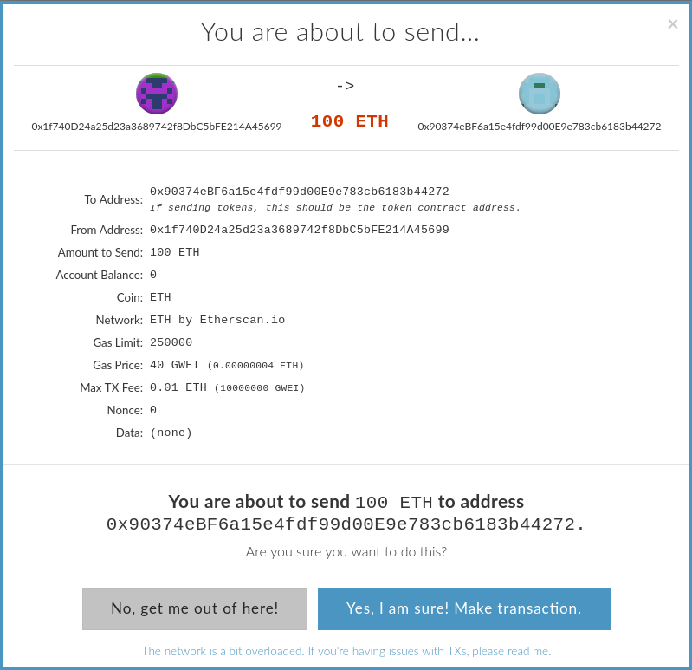

. How to add tokens to the wallet or to see.

To add a token you need the following:
- Token address - 0x849de371420b4e1002418b93d7dca95472Ba04B6
- Token symbol — GO
- Decimals — 18
If you have MyEtherWallet you need to do the following:
- Open https://www.myetherwallet.com/

- Choose “View wallet info”, choose “Keystore file”, download the file clicking “select wallet file”, enter the password and click “unlock|”.
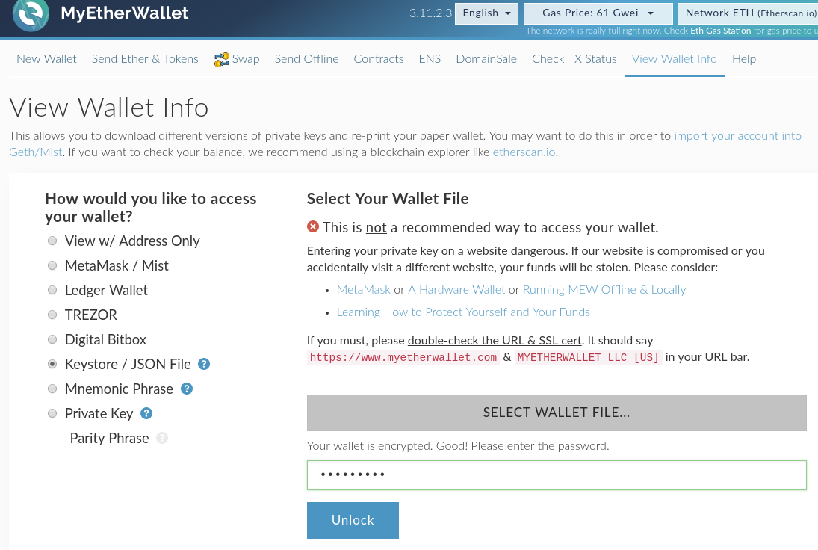
- There will be a panel on the right “Token balance”. Click there “Add custom token”.
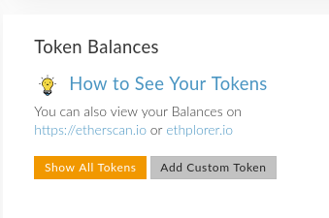

- Enter the address 0x849de371420b4e1002418b93d7dca95472Ba04B6, symbol GO, and 18 decimals and click “save’.
