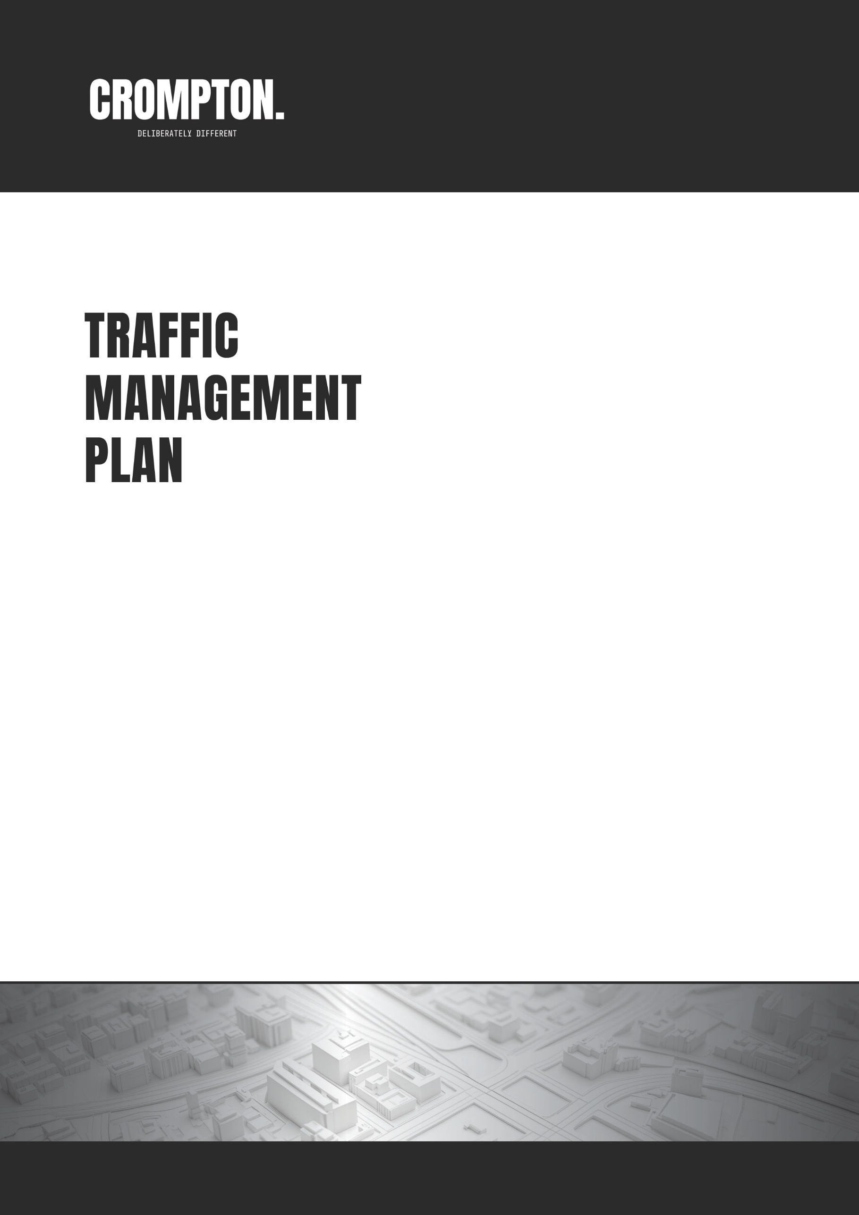



<<cc#>>-TMP - Rev 0
PROJECT: <<project name>>
SCOPE OF WORKS: <<scope of works>>
<<project location>>

PREPARED FOR

DATE: <<date>>
AUTHOR: <<author name>>
REVISION: 00
TMR CERT82: 684

DATE: 11.04.2018
AUTHOR: Andrew Bryers
REVISION: 0
TMR CERT: 684
Contents
1. Approval, Revision and Distribution 3
1.1 Approvals 3
1.2 Revision 3
1.3 Distribution 4
1.4 Change Log 4
2. <<Scope of Work>> 52. {{ scope_of_work }} 5
2.1 Introduction 5
2.2 Traffic Management Methodology and Scope of Works 5
Appendix A Traffic Guidance Scheme (TGS) 9
Appendix B Desktop Risk Assessment 75

Figures
No table of figures entries found.

Tables
Table 1: Document Preparation 3
Table 2: Document Revision History 3
Table 3: Document Distribution 4
Table 4: Change Log 4
Table 22: Construction Activity Log - <<Enter Construction Stage>> 5Table 22: Construction Activity Log - {{ enter_construction_stage }} 5
Table 23: Impacts and Constraints - <<Enter Construction Stage>> 6Table 23: Impacts and Constraints - {{ enter_construction_stage }} 6
Table 24: Options Analysis (<<enter construction stage>>) - Vehicular Traffic and Cyclists on Road 7Table 24: Options Analysis ({{ enter_construction_stage }}) - Vehicular Traffic and Cyclists on Road 7
Table 25: Options Analysis (<<enter construction stage>>) - Pedestrians and Cyclists on Footpath 7Table 25: Options Analysis ({{ enter_construction_stage }}) - Pedestrians and Cyclists on Footpath 7

Approval, Revision and Distribution

Approvals

The Signatures below certify that this CTMP has been reviewed and accepted and demonstrates that they are all aware of all the requirements contained herein and are committed to ensuring their provision.

Table 1: Document Preparation
 | Name | Signature | Position | Date
{%tr for row in preparation_table %}
{{ row.role }} | {{ row.name }} | {{ row.signature }} | {{ row.position }} | {{ row.date }}
{%tr endfor %}
{{ delete_other_reviewers_as_required }}

Revision
Table 2: Document Revision History
Version No. | New Document | Modified | Date
{%tr for row in revision_history_table %}
{{ row.version_no }} | {{ row.new_document }} | {{ row.modified }} | {{ row.date }}
{%tr endfor %}

Distribution
Table 3: Document Distribution
Name | Company | Position | Copy No. | Date
{%tr for row in distribution_table %}
{{ row.name }} | {{ row.company }} | {{ row.position }} | {{ row.copy_no }} | {{ row.date }}
{%tr endfor %}

Change Log
Table 4: Change Log
Amendment | Section | Date
{%tr for row in change_log_table %}
{{ row.amendment }} | {{ row.section }} | {{ row.date }}
{%tr endfor %}

{{ enter_construction_stage }}

Introduction
This TMP specifies the traffic control measures and devices to be used to warn, instruct and guide road users in the safe negotiation past the work site on roads around the work site including footpaths, shared paths and bicycle paths adjacent to the site. The traffic guidance schemes required for {{ enter_construction_stage }} which cause interference or obstruction to the normal use of a road by any road user are presented in Appendix AAppendix A

Traffic Management Methodology and Scope of Works
{{ enter_construction_methodology_for_the_stage }} (replicate this whole section for each construction stage – e.g.,
Site Establishment (Service investigation – potholing, Site clearing, Minor excavation, Piling, Shoring, Site sheds)
Demolition / Excavation (Foundations, footings, basement levels, Ramp removal, Dewatering (quantity, position, duration))
Superstructure (Gantries (dates, dimensions, drawings), Raft pours (details, AGI/pump positioning, OOH), General Concrete pours (details, OOH), Concrete panel lifts (top tailing, double height))
Crane Activities (Mobile crane (frequency, size, outrigger span), Tower crane install/dismantle (duration, OOH, crane specs))
Deliveries (Large and general deliveries (methods, frequency, positioning)
Civil Works (External Road Widening/Improvements, Sewer/water/stormwater, VXO installation, Energex coordination)
Finishing Works (Footpath rectification, Landscaping))
Table 5: Construction Activity Log - {{ enter_construction_stage }}
Activity | {{ enter_activity_details }}
Start Date | {{ date }} |  | Duration | {{ duration }} | Frequency | {{ frequency }}
Expected No. of Construction Vehicles per Shift |  |  | {{ enter_number_details }} |  | Type of Vehicles | {{ enter_type_details }}
Control Method | Site Active | Traffic: {{ enter_proposed_control_method }} {{ enter_figure_reference }} |  |  | TGS # | {{ tgs_reference }}
 |  | Pedestrians: {{ enter_proposed_control_method }} {{ enter_figure_reference }}
 | Site Inactive | Traffic: {{ enter_proposed_control_method }} {{ enter_figure_reference }} |  |  | TGS # | {{ tgs_reference }}
 |  | Pedestrians: {{ enter_proposed_control_method }} {{ enter_figure_reference }}

Table 6: Impacts and Constraints - {{ enter_construction_stage }}
Impact Type | Present at Site | Details / Reasoning / Constraints
End-of-Queue Collisions Management | {{ yes_no }} | TTM: {{ enter_details }}  Reasoning: {{ enter_reasoning }}  Constraints: {{ enter_constraints }}
Detouring on Major Roads | {{ yes_no }} | TTM: {{ enter_details }}  Reasoning: {{ enter_reasoning }}  Constraints: {{ enter_constraints }}
Detouring on Local Roads | {{ yes_no }} | TTM: {{ enter_details }}  Reasoning: {{ enter_reasoning }}  Constraints: {{ enter_constraints }}
Lane Availability and Closures | {{ yes_no }} | TTM: {{ enter_details }}  Reasoning: {{ enter_reasoning }}  Constraints: {{ enter_constraints }}
Length of Closures | {{ yes_no }} | TTM: {{ enter_details }}  Reasoning: {{ enter_reasoning }}  Constraints: {{ enter_constraints }}
Interference with Permanent Signals | {{ yes_no }} | TTM: {{ enter_details }}  Reasoning: {{ enter_reasoning }}  Constraints: {{ enter_constraints }}
Impacts Due to Adjoining Road Works | {{ yes_no }} | TTM: {{ enter_details }}  Reasoning: {{ enter_reasoning }}  Constraints: {{ enter_constraints }}
Bus Stop Impacts / Bus Route Impacts | {{ yes_no }} | TTM: {{ enter_details }}  Reasoning: {{ enter_reasoning }}  Constraints: {{ enter_constraints }}
Working Near Railway Crossing | {{ yes_no }} | TTM: {{ enter_details }}  Reasoning: {{ enter_reasoning }}  Constraints: {{ enter_constraints }}
Working Near Tram Line | {{ yes_no }} | TTM: {{ enter_details }}  Reasoning: {{ enter_reasoning }}  Constraints: {{ enter_constraints }}
Property Access | {{ yes_no }} | TTM: {{ enter_details }}  Reasoning: {{ enter_reasoning }}  Constraints: {{ enter_constraints }}
Other adjacent/concurrent developments | {{ yes_no }} | Details: {{ enter_details }}  Reasoning: {{ enter_reasoning }}  Constraints: {{ enter_constraints }}

Table 7: Options Analysis ({{ enter_construction_stage }}) - Vehicular Traffic and Cyclists on Road
Option | Sub-Option | Details/Reasoning | Selected
Around | Detour | {{ enter_details_reasoning }} | {{ adopted_not_adopted }}
 | Sidetrack | {{ enter_details_reasoning }} | {{ adopted_not_adopted }}
 | Contra-Flow | {{ enter_details_reasoning }} | {{ adopted_not_adopted }}
Through | Hold & Release | {{ enter_details_reasoning }} | {{ adopted_not_adopted }}
 | Local Access Management | {{ enter_details_reasoning }} | {{ adopted_not_adopted }}
Past | Lateral Shift/Partial Lane/Shoulder/Parking Lane Closure | {{ enter_details_reasoning }} | {{ adopted_not_adopted }}
 | Single Lane Reversible Flow | {{ enter_details_reasoning }} | {{ adopted_not_adopted }}
 | Lane Closure | {{ enter_details_reasoning }} | {{ adopted_not_adopted }}
Short Term |  | {{ enter_details_reasoning }} | {{ adopted_not_adopted }}

Table 8: Options Analysis ({{ enter_construction_stage }}) - Pedestrians and Cyclists on Footpath
Option | Sub-Option |  | Details/Reasoning | Selected
Around | Detour | At existing crossings | {{ enter_details_reasoning }} | {{ adopted_not_adopted }}
 |  | Mid-block crossing | {{ enter_details_reasoning }} | {{ adopted_not_adopted }}
 | Sidetrack |  | {{ enter_details_reasoning }} | {{ adopted_not_adopted }}
Through | Hold & Release |  | {{ enter_details_reasoning }} | {{ adopted_not_adopted }}
Past | Maintaining 1.8 m minimum path along the verge/footpath on the same side road |  | {{ enter_details_reasoning }} | {{ adopted_not_adopted }}
 | Maintaining 1.8 m minimum path on the road |  | {{ enter_details_reasoning }} | {{ adopted_not_adopted }}

{{ construction_activity }} works are scheduled to commence on {{ start_date }}.
To facilitate these works, {{ enter_control_measure }} has been selected as the most appropriate temporary traffic management (TTM) solution, based on traffic analysis and site constraints during site active hours. This approach allows for construction activity to occur with minimal disruption to the road network.
Pedestrian Access will be managed via a {{ enter_control_measure }}.
During site inactive periods, {{ enter_traffic_control_measure }} and {{ enter_footpath_control_measure }}.
Refer to TGS #{{ tgs_number }} for the site active setup and TGS #{{ tgs_number }} for the site inactive setup in Appendix A.
The figures below illustrate the proposed temporary traffic management arrangements in relation to site activity and road user safety.
{{ insert_figure }}: TTM {{ construction_activity }} – Site Active {{ insert_caption_to_figure_by_right_clicking_the_image }}
{{ insert_figure }}: TTM {{ construction_activity }} – Site Inactive {{ insert_caption_to_figure_by_right_clicking_the_image }}

Traffic Guidance Scheme (TGS)

(Please Turn Over)

Desktop Risk Assessment

(Please Turn Over)

