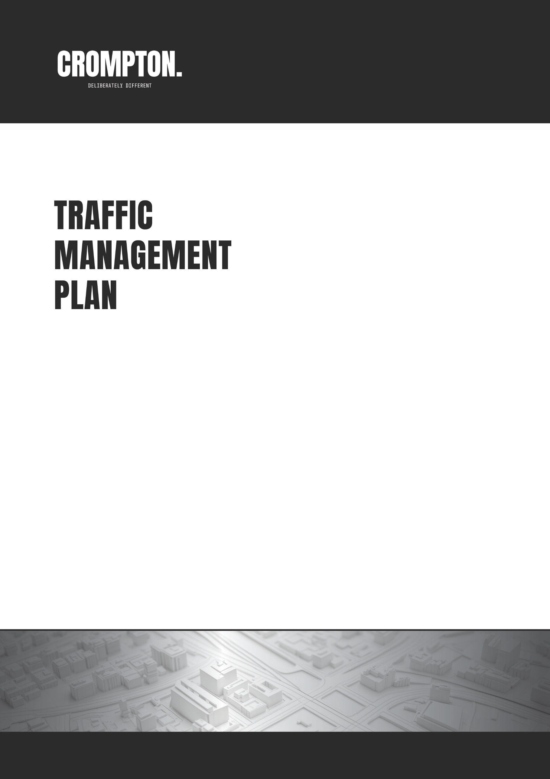



<<cc#>>-TMP - Rev 0
PROJECT: <<project name>>
SCOPE OF WORKS: <<scope of works>>
<<project location>>

PREPARED FOR

DATE: <<date>>
AUTHOR: <<author name>>
REVISION: 00
TMR CERT82: 684

DATE: 11.04.2018
AUTHOR: Andrew Bryers
REVISION: 0
TMR CERT: 684
Contents
1. Approval, Revision and Distribution 3
1.1 Approvals 3
1.2 Revision 3
1.3 Distribution 4
1.4 Change Log 4
2. <<Scope of Work>> 5
2.1 Introduction 5
2.2 Traffic Management Methodology and Scope of Works 5
Appendix A Traffic Guidance Scheme (TGS) 9
Appendix B Desktop Risk Assessment 75

Figures
No table of figures entries found.

Tables
Table 1: Document Preparation 3
Table 2: Document Revision History 3
Table 3: Document Distribution 4
Table 4: Change Log 4
Table 22: Construction Activity Log - <<Enter Construction Stage>> 5
Table 23: Impacts and Constraints - <<Enter Construction Stage>> 6
Table 24: Options Analysis (<<enter construction stage>>) - Vehicular Traffic and Cyclists on Road 7
Table 25: Options Analysis (<<enter construction stage>>) - Pedestrians and Cyclists on Footpath 7

Approval, Revision and Distribution

Approvals

The Signatures below certify that this CTMP has been reviewed and accepted and demonstrates that they are all aware of all the requirements contained herein and are committed to ensuring their provision.

Table 1: Document Preparation
 | Name | Signature | Position | Date
Prepared By | <<author name>> | <<author signature>> | Traffic Technician | DD/MM/YY
Reviewed By | Aaron Anthony | A. Anthony | Traffic Management Designer (OP611) | DD/MM/YY
Reviewed By | Andrew Bryers | A. Bryers | Director/ Traffic Management Designer (OP684) | DD/MM/YY
Reviewed By | Mark Bryers | M. Bryers | Director/ Traffic Management Designer (OP449) | DD/MM/YY
Reviewed By | Kelly Govind | K. Govind | Traffic Management Designer (OP442) | DD/MM/YY
<<delete other reviewers as required>>

Revision
Table 2: Document Revision History
Version No. | New Document | Modified | Date
0 | <<cc#>>-CTMP | - | <<release date>>

Distribution
Table 3: Document Distribution
Name | Company | Position | Copy No. | Date
<<client contact>> | <<client company>> | <<client position>> | 1 | DD/MM/YY

Change Log
Table 4: Change Log
Amendment | Section | Date

<< Enter Construction Stage>>

Introduction
This TMP specifies the traffic control measures and devices to be used to warn, instruct and guide road users in the safe negotiation past the work site on roads around the work site including footpaths, shared paths and bicycle paths adjacent to the site. The traffic guidance schemes required for <<Enter Construction Stage>> which cause interference or obstruction to the normal use of a road by any road user are presented in Appendix A

Traffic Management Methodology and Scope of Works
<<Enter construction methodology for the stage>> (replicate this whole section for each construction stage – e.g.,
Site Establishment (Service investigation – potholing, Site clearing, Minor excavation, Piling, Shoring, Site sheds)
Demolition / Excavation (Foundations, footings, basement levels, Ramp removal, Dewatering (quantity, position, duration))
Superstructure (Gantries (dates, dimensions, drawings), Raft pours (details, AGI/pump positioning, OOH), General Concrete pours (details, OOH), Concrete panel lifts (top tailing, double height))
Crane Activities (Mobile crane (frequency, size, outrigger span), Tower crane install/dismantle (duration, OOH, crane specs))
Deliveries (Large and general deliveries (methods, frequency, positioning)
Civil Works (External Road Widening/Improvements, Sewer/water/stormwater, VXO installation, Energex coordination)
Finishing Works (Footpath rectification, Landscaping))
Table 5: Construction Activity Log - <<Enter Construction Stage>>
Activity | <<enter activity details >>
Start Date | <<date >> |  | Duration | <<duration>> | Frequency | <<frequency>>
Expected No. of Construction Vehicles per Shift |  |  | <<enter number details >> |  | Type of Vehicles | <<enter type details >>
Control Method | Site Active | Traffic: <<enter proposed control method>> <<enter figure reference>> |  |  | TGS # | <<TGS reference #>>
 |  | Pedestrians: <<enter proposed control method>> <<enter figure reference>>
 | Site Inactive | Traffic: <<enter proposed control method>> <<enter figure reference>> |  |  | TGS # | <<TGS reference #>>
 |  | Pedestrians: <<enter proposed control method>> <<enter figure reference>>

Table 6: Impacts and Constraints - <<Enter Construction Stage>>
Impact Type | Present at Site | Details / Reasoning / Constraints
End-of-Queue Collisions Management | <<Yes/No>> | TTM: <<enter details >>  Reasoning: <<enter reasoning>>  Constraints: <<enter constraints>>
Detouring on Major Roads | <<Yes/No>> | TTM: <<enter details >>  Reasoning: <<enter reasoning>>  Constraints: <<enter constraints>>
Detouring on Local Roads | <<Yes/No>> | TTM: <<enter details >>  Reasoning: <<enter reasoning>>  Constraints: <<enter constraints>>
Lane Availability and Closures | <<Yes/No>> | TTM: <<enter details >>  Reasoning: <<enter reasoning>>  Constraints: <<enter constraints>>
Length of Closures | <<Yes/No>> | TTM: <<enter details >>  Reasoning: <<enter reasoning>>  Constraints: <<enter constraints>>
Interference with Permanent Signals | <<Yes/No>> | TTM: <<enter details >>  Reasoning: <<enter reasoning>>  Constraints: <<enter constraints>>
Impacts Due to Adjoining Road Works | <<Yes/No>> | TTM: <<enter details >>  Reasoning: <<enter reasoning>>  Constraints: <<enter constraints>>
Bus Stop Impacts / Bus Route Impacts | <<Yes/No>> | TTM: <<enter details >>  Reasoning: <<enter reasoning>>  Constraints: <<enter constraints>>
Working Near Railway Crossing | <<Yes/No>> | TTM: <<enter details >>  Reasoning: <<enter reasoning>>  Constraints: <<enter constraints>>
Working Near Tram Line | <<Yes/No>> | TTM: <<enter details >>  Reasoning: <<enter reasoning>>  Constraints: <<enter constraints>>
Property Access | <<Yes/No>> | TTM: <<enter details >>  Reasoning: <<enter reasoning>>  Constraints: <<enter constraints>>
Other adjacent/concurrent developments | <<Yes/No>> | Details: <<enter details >>  Reasoning: <<enter reasoning>>  Constraints: <<enter constraints>>

Table 7: Options Analysis (<<enter construction stage>>) - Vehicular Traffic and Cyclists on Road
Option | Sub-Option | Details/Reasoning | Selected
Around | Detour | <<enter details/reasoning >> | <<Adopted/Not Adopted>>
 | Sidetrack | <<enter details/reasoning >> | <<Adopted/Not Adopted>>
 | Contra-Flow | <<enter details/reasoning >> | <<Adopted/Not Adopted>>
Through | Hold & Release | <<enter details/reasoning >> | <<Adopted/Not Adopted>>
 | Local Access Management | <<enter details/reasoning >> | <<Adopted/Not Adopted>>
Past | Lateral Shift/Partial Lane/Shoulder/Parking Lane Closure | <<enter details/reasoning >> | <<Adopted/Not Adopted>>
 | Single Lane Reversible Flow | <<enter details/reasoning >> | <<Adopted/Not Adopted>>
 | Lane Closure | <<enter details/reasoning >> | <<Adopted/Not Adopted>>
Short Term |  | <<enter details/reasoning >> | <<Adopted/Not Adopted>>

Table 8: Options Analysis (<<enter construction stage>>) - Pedestrians and Cyclists on Footpath
Option | Sub-Option |  | Details/Reasoning | Selected
Around | Detour | At existing crossings | <<enter details/reasoning >> | <<Adopted/Not Adopted>>
 |  | Mid-block crossing | <<enter details/reasoning >> | <<Adopted/Not Adopted>>
 | Sidetrack |  | <<enter details/reasoning >> | <<Adopted/Not Adopted>>
Through | Hold & Release |  | <<enter details/reasoning >> | <<Adopted/Not Adopted>>
Past | Maintaining 1.8 m minimum path along the verge/footpath on the same side road |  | <<enter details/reasoning >> | <<Adopted/Not Adopted>>
 | Maintaining 1.8 m minimum path on the road |  | <<enter details/reasoning >> | <<Adopted/Not Adopted>>

<<Construction activity>> works are scheduled to commence on <<Start Date>>.
To facilitate these works, <<enter control measure>> has been selected as the most appropriate temporary traffic management (TTM) solution, based on traffic analysis and site constraints during site active hours. This approach allows for construction activity to occur with minimal disruption to the road network.
Pedestrian Access will be managed via a <<enter control measure>>.
During site inactive periods, <<enter traffic control measure>> and <<enter footpath control measure>>.
Refer to TGS #<<TGS number>> for the site active setup and TGS #<<TGS number>> for the site inactive setup in Appendix A.
The figures below illustrate the proposed temporary traffic management arrangements in relation to site activity and road user safety.
<<Insert Figure>>: TTM <<Construction Activity>> – Site Active <<Insert Caption to figure by right clicking the image>>
<<Insert Figure>>: TTM <<Construction Activity>> – Site Inactive <<Insert Caption to figure by right clicking the image>>

Traffic Guidance Scheme (TGS)

(Please Turn Over)

Desktop Risk Assessment

(Please Turn Over)

