**Bake Sale**

Sunday, April 14, 2013  
12pm-3pm

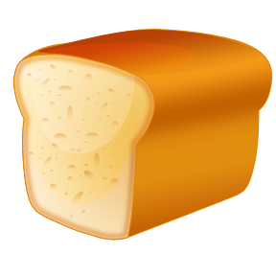

North Street Church  
123 North Street

*Cookies, cakes, breads, and more!*

|  |  |
| --- | --- |
| *Cookies* | *$6/dozen* |
| *Cakes* | *$12 each* |
| *Breads* | *$5/loaf* |