Robotic Arm
Introduction
The aim of this project is to construct a robotic arm with five degrees of freedom (DOF). This robotic arm is designed lift loads of up to 100 grams at a maximum distance of 45 centimeters. It uses seven servo motors for making up the entire arm. It also has an IR sensor to detect objects when placed in between the gripper. The physical body is made up of acrylic sheets cut according to measured shapes and dimensions. The robotic arm can be pre-programmed to automatically pick and place objects to pre calculated positions. Optionally a keypad can be connected to the PIC microcontroller to manually control the arm’s motion.
Basic servo operation and principle
A servo motor internally has a closed loop feedback system which enables precise control of the position of the shaft of the motor. It also has a gear mechanism to generate a good amount of torque. Servos usually have limited rotation (0 to 180 degrees). Six servos used in this project have a stall torque rating of 6Kg-cm at 6Volts and consumes approximately 750mA. This means that the servo can lift a 6Kg load at a distance of 1 Cm from the centre of its shaft when supplied with 6Volts and 750mA. The servo used for the gripper has a lower rating of 1.5Kg-cm at 6V.
To control the position of the servo motor a PWM signal has to be supplied to it. The signal requirements may vary according to the servo but usually the most servos require the following kind of PWM signal. Varying the pulse width from 0.8 ms to 2.2 ms changes the servo shaft position 0 to 180 degrees.
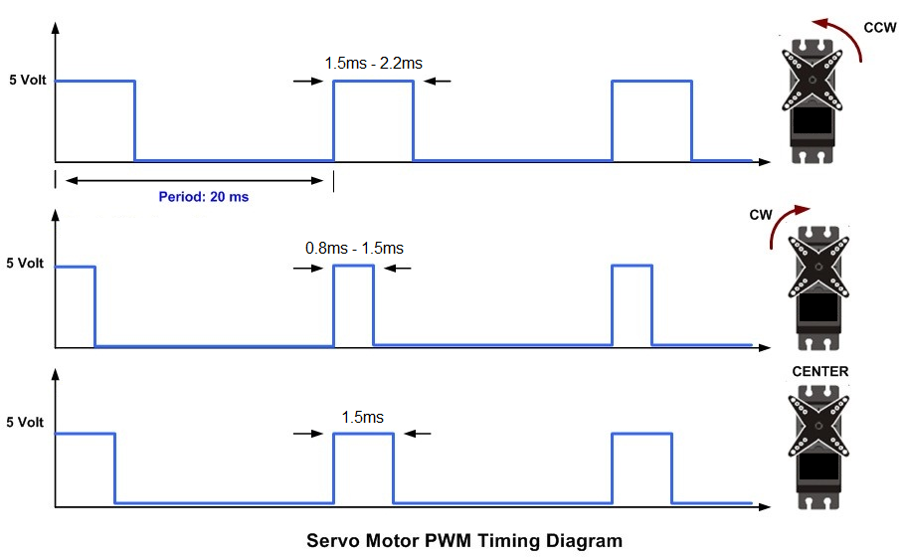
Figure 1: Servo motor PWM timing signals
Mechanical construction
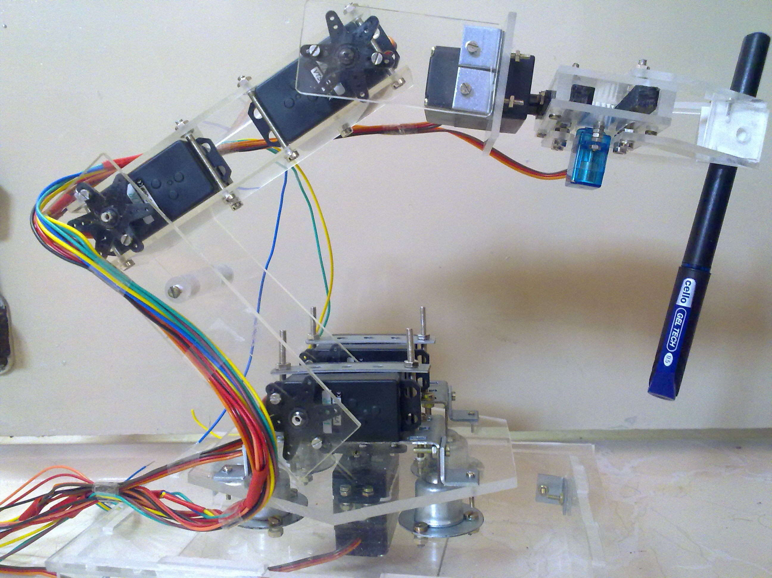
Figure 2: Side view of the robotic arm holding an object
The arm has a rectangular base which can be modified if required to a mobile platform. On top of this platform rests a rotating plate. The plate is balanced on four castor balls. The plate rotates with the help of one servo fixed to the rectangular base.
The shoulder joint is mounted on the plate. This joint is made of two servos to handle a combine torque of up to 12Kg-cm to lift the entire arm. The elbow servo is joined to the shoulder followed by the wrist servo. To attain the ability to rotate an object another servo is attached at wrist perpendicular to the wrist joint. Finally the gripper mechanism is attached to the rotating wrist servo.
The gripper mechanism is constructed around a smaller servo such that both the gripper fingers are controlled by the single servo. An IR LED and IR receiver is attached respectively to each gripper finger such a way that it is able to detect an object when gets in between the fingers.
The lengths of the acrylic links are critical to the mechanical design. If the links are too long the servo motors won’t have enough torque to lift any load at all. If the links are too short the will reduce the total reach of the arm and the motors might not be able to move freely without hitting each other. A basic understanding of the torque equation and the motor rating is required to decide the lengths of the links for optimum length and final torque. A simple rule is higher motor torque can lead to longer arms.
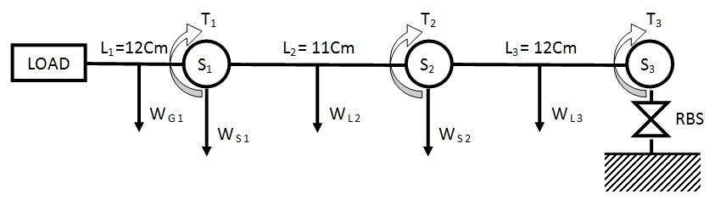
Figure 3: Stick diagram representing the robotic arm
The torque T₁ acting on the gripper servo’s shaft is due to the combined weight (W_{G1}) of the gripper mechanism and the rotating gripper servo. The weight is distributed along the entire length L₁ but the weight of the load W_{Load} is acting at length L₁ so T₁ is calculated by the following equation.
T₁ = W_{G1} * L1/2 + W_{Load} * L₁
The weights of the acrylic sheet links are negligible hence W_{L2} and W_{L3} can be ignored. Considering the weights of the servo S₁ and S₂ as WS₁ and WS₂ the following equations are obtained for T₂ and T₃.
T₂ = W_{S1} * L₂ + W_{G1} * (L₁/2 + L₂) + W_{Load} * (L₁ + L₂)
T₃ = W_{S2} * L₃ + W_{S1} * (L₂ + L₃) + W_{G1} * (L₁/2 + L₂ + L₃) + W_{Load} * (L₁ + L₂ + L₃)
The lengths of links L₁, L₂ and L₃ need to satisfy the above equations such that the resulting torque value does not exceed the stall torque rating of the corresponding servo motor. The above equations are for the worst case scenario when the arm is fully stretched. If the torque requirement is satisfied for this condition normal functioning of the arm will be well within the limits of the servo’s torque rating.

Circuit description
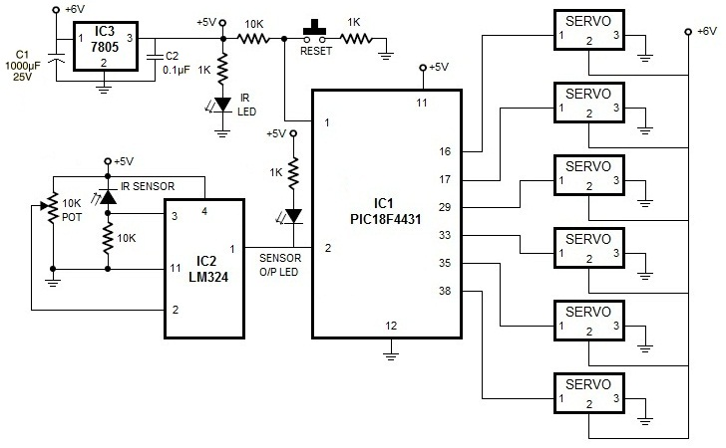
Figure 4: Circuit schematic of the robotic arm
A PIC18F4431 microcontroller is used at the heart of the controlling circuit. This specific controller has the ability to generate up to 6 independent PWM signals one for each servo. One exception is the shoulder joint, where the two servos are controlled by the same signal. The microcontroller has a basic reset circuit and is powered from a properly regulated 5V power source. The servo motors are powered directly from a 6V, 4.5Ah lead acid battery. It is preferable to properly isolate the microcontroller supply from the servo power source to avoid resetting of the controller due to sudden power surges.
The IR sensor circuit is built around the LM324 Op-Amp IC. The IR sensor is connected in the reverse bias mode with a 10K resistor in series. The voltage at the non-inverting pin of the op-Amp is low when there is no IR light. In the presence of IR rays the diode starts conducting and the voltage at the non-inverting pin increases. A potentiometer’s output is connected to the inverting input of the Op-Amp. This allows the fine tuning of the comparator’s output. A simple LED at the Op-Amp’s output pin helps when tuning the sensor circuit.
The microcontroller’s six PWM output pins are connected to the six servos. The servos and the control circuitry share a common ground but the servos are driven directly from the 6V 4.5Ah lead acid battery as they draw 2 to 3 amps on full load. Optionally high current voltage regulators may be used.
Code description
The code running on the controller was written in C language and was compiled using the Hi-Tech C compiler for 18F MCUs (Evaluation mode) on MPLAB. The PIC18F4431 has two modules to different modules generating PWM signals. One is the standard Capture/Compare/PWM module (CCP) (generates 2 PWM signals) and the other is the Power Control PWM module (generates 4 PWM signals). The timers related to each PWM module are configured to generate the 20ms time period and the PWM module registers are configured to generate independent PWM signals. Since the PWM generation takes place in the peripheral modules the main controller is free to load angles dynamically to control the servo joints.
There is a global variable for each joint which holds the angle which the servo should achieve. This variable is updated as the source and destination co-ordinates change as the controller executes the code. A look up table holds the pre-calculated values to be loaded into the PWM module duty cycle registers. The pre-calculated lookup table holds values that tell the PWM modules the pulse width (duty cycle) of the PWM signal to be generated for the corresponding angle.
Operation
In the automatic pick and place mode the controller will load the servo angles in a particular order (Rotating base, elbow, shoulder, wrist, rotating wrist and gripper). After the arm moves to the picking position it waits for the IR sensor to detect an object being placed in between the gripper. Once it detects the object the gripper closes to hold the object and the controller loads the servo angles for the default position before loading the placing position co-ordinates. The order in which the joint are activated is important for the arm to move smoothly without hitting the floor or hitting into other objects. The arm can be programmed to run infinitely or to pick and place objects in particular order and location autonomously. Since an IR sensor is present it can wait till and object is placed in its grasp.

