Cloud Service Authenticates Via Delegation - SAML

George Dobbs

# Abstract

This is one of a set of articles that illustrate a set of abstract components that may be implemented in a particular architecture. These articles describe how the abstract components defined in the reference architecture [IDPro ref-arch] interact to perform a single use-case . This particular article describes a common use-case which allows a service (the relying party) to use the authentication capability of an identity provider, using the mature security assertion markup language (SAML) standard. This article focuses on a specific method of web-based signal sign-on.

# Introduction

This popular use-case relies on trust between the identity provider and the relying party. There are various ways of doing this; this article assumes that the trust is based on the use of public key cryptography, which involves exchanging certificates.

The SAML specification defines three different kinds of assertion statements; this article is about the Authentication assertion only.

The SAML specification supports mapping of identities between different names, or federated identity. This article is restricted to a single domain, such as an organization which is providing access for its employees to web-based services provided by third-party vendors. In other words, a single domain of administration allows for the user identifiers to be shared.

Even a cursory review of the OASIS SAML standards documents [OASIS SAML Front], [SAML Technical Overview] will reveal an extremely rich and flexible structure. This article represents a very thin slice of its possiblities focusing on the run-time aspect of authentication using the web (HTTPS) messaging protocol. Technically, we are discussing what OASIS calls the Web Browser SSO profile, using the POST binding.

This synopsis stresses the importance of the Trust Root. The messaging between the IDP and RP passes through the User Agent. The User Agent must be considered untrusted. This means that a corrupted agent could potentially modify the messages. To protect against this the messages are protected by a digital signature, which must be validated. It is the common certificate authority that acts as the Trust Root to support these signatures.

The topic of signatures becomes quite deep quickly and is not covered in detail here. The SAML specification relies on the W3C Recommendation XML Signature Syntax and Processing [W3C xml-sig], which may be of interest.

# Terminology

Please see also the terminology in the reference architecture article [IDPro ref-arch].

|  |  |
| --- | --- |
| **Item** | **Definition** |
| User Agent | The user is not shown here, although he or she is operating the browser, which is called the user -agent. |

# Use Case

## Summary

The web user seeks resources at the relying party, which causes the user to authenticate to the identity provider, which then produces an authentication assertion. Subsequently the relying party consumes the assertion to establish a security context for the web user.

## Architecture Types

Of the types defined in [IDPro Introduction to IAM Architecture] this method applies to Cloud Environments.

## Actors

The user is the only actor. The user acts through the User Agent (the browser). The other participants in the use-case are systems “actors”, which we show as components.

## Components

The following components are defined in [IDPro ref-arch]

* Audit Repository
* AuthN / Assertion (part of IDP)
* Identity Register
* Relying Party (RP)
* Trust Anchor

## Assumptions

The user wishes to access a protected resource and has requested that access via a web browser, the User Agent.

The relying party has a single identity provider. It is possible that the relying party supports several service providers so a method to determine which one to use would be needed in that case.

## Preconditions

There must be an established trust between the RP (Service Provider) and the IdP (Identity Provider) before SAML can be used for authentication. “The primary mechanism is for the relying party and asserting party to have a pre-existing trust relationship which typically relies on a Public Key Infrastructure (PKI). While use of a PKI is not mandated by SAML, it is recommended.” [OASIS SAML Technical Overview]

The identity provider and the relying party are using the same user identifiers. The SAML specification establishes ways to map these, but we don’t discuss this subject here.

## Postconditions

User is logged into the relying party’s site.

## Basic Course of Events

The following shows the “happy path”, without errors. See also the sequence diagram, below. See Alternative Paths for some variations.

1. User selects the login function on the RP’s site. Possibly this is automatic when user attempts to access the protected resource.
2. RP determines that the user is not logged in.
3. The RP prepares an Authentication Request message, which the RP may sign. It is delivered to the user agent as a form targeted at the identity provider, which is known since there is a single configured IDP. The user agent (automatically via a client side script) sends the request to the IDP.
4. The IDP ensures the signing certificate from the RP is still valid, by checking for revocation.
5. The IDP validates the request and interprets its contents. The signature is checked and some field values are checked (such as Issuer, AuthnContextClassRef, etc..)
6. The IDP interacts with the user-agent to gather the user’s identifier and credentials. For example this could ask for a user name and password, but it could be something else.
7. The IDP uses its Identity Register to validate the credentials.
8. The IDP prepares a Response message, which the IDP signs.
9. The response is then sent back to the user-agent with instructions to use an HTTP POST to forward it to the RP. (The target RP URL is typically known to the IDP through initial configuration).
10. The RP and ensures the signing certificate from the IDP is still valid, by checking for revocation.
11. The RP validates the Response and interprets its contents. The signature **must** be checked. The RP checks it against the already active assertions to prevent replay, and makes other checks. The RP then determines whether the authentication was successful.
12. Not shown in the chart is the audit records being written. These should be written by the various components.

## Alternative Paths

Step 3 may be replaced with an HTTP redirect. This is an allowed composition of the POST binding and the Redirect binding [OASIS SAML bindings]

There are also alternatives to the post method in step 5. [OASIS SAML binding]

This is the service provider (the relying party) initiated variant. There is an also an IDP initiated alternative.

The messages may be encrypted. For instance in step 8 the IDP may encrypt, and in step 10 the RP would need to decrypt the response.

## Exception Paths

Failure to autheniticate at the IDP does not return an assertion.

Failure to validate the signature indicates that the assertion should not be honored.

Various error conditions such as the validity period expiring are described in the standard.

## Sequence Diagram

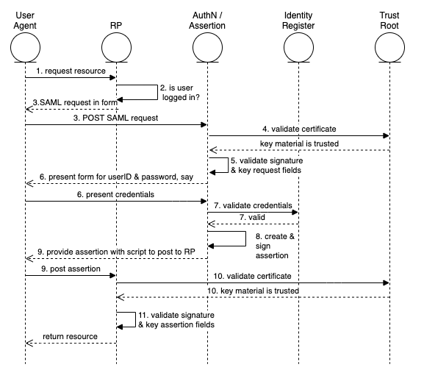

The “happy path” of the Web Browser SSO Profile

# Author Bio

George Dobbs manages architects at a major insurance company. He is also the chairman of the IDPro Body of Knowledge Committee. One of his interests is modernizing the use of Identity and Access Management techniques used by the firm. He is particularly interested in the area of customer-facing applications including approaches to fraud prevention in call center and digital contexts. Related to this, he is interested in the evolution of distributed session management – notably distributed session termination. He is a founding member of IDPro and represented his firm in the Identity Ecosystem Steering Group (IDESG). Prior to his current position, he lead the development of customer facing identity for web sites at three other insurers. He has led a local identity and access management user group since 2004. Prior to that he was the chairman of the Network Applications Consortium.

# Acknowlegements

The author would like to express gratitude to Chris Olsen and Bernard Carlier for their review and suggestions for improvement of this text.

# References

[IDPro Introduction to IAM Architecture] <https://bok.idpro.org/article/id/38/>

[IDPRo ref-arch] to be published concurrently in idpro bok*

[OASIS SAML binding] http://docs.oasis-open.org/security/saml/v2.0/saml-bindings-2.0-os.pdf

[OASIS SAML core] https://docs.oasis-open.org/security/saml/v2.0/saml-core-2.0-os.pdf

[OASIS SAML Front] <https://wiki.oasis-open.org/security/FrontPage#SAML_V2.0_Standard>

[OASIS SAML profiles] http://docs.oasis-open.org/security/saml/v2.0/saml-profiles-2.0-os.pdf

[OASIS SAML Technical Overview] <https://www.oasis-open.org/committees/download.php/27819/sstc-saml-tech-overview-2.0-cd-02.pdf> This points to more detailed documents such as the core, profiles and bindings.

[W3C xml-sig] https://www.w3.org/TR/xmldsig-core/#sec-CoreValidation