## Passwords

This section is about passwords.

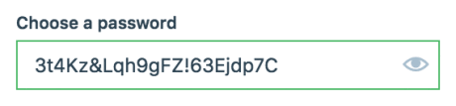

The length of the password helps the security but makes it hard to remember.