RAGF TECHNICAL SERIES | OPEN SOURCE
How Neo4j Became the Semantic Brain of RAGF
Graph Databases vs. Relational Stores for Regulatory Ontologies — A Real Benchmark

Yamil Rodríguez Montaña | Reflexio Studio | yrm@reflexio.es
Abstract
The RAGF (Reflexio Agentic Governance Framework) uses Neo4j as its Semantic Authority Layer — the component responsible for encoding regulatory ontologies and validating AI agent actions before execution. This article explains why a property graph database is architecturally correct for this problem, presents real benchmark results comparing Neo4j against PostgreSQL 16 over a PSD2 ontology (17 verbs, 500-verb scale), and invites the open-source community to contribute domain ontologies for fintech, healthcare, and critical infrastructure. All code is available under Apache 2.0.

1. The Problem: LLMs Don’t Know What They’re Not Allowed to Do
Large Language Models generate plausible actions. In regulated environments — banking, aviation, healthcare — plausible is not sufficient. Actions must be legal, authorized, and traceable to specific regulatory requirements.

Operator intent | “Reduce operating costs for Flight IB3202”
LLM proposal | “Reroute via shorter path, extend crew duty time” — violates FAA 14 CFR §91.1057
RAGF verdict | DENY | Verb ‘extend_crew_duty’ violates FAA-14-CFR-91.1057 | Semantic coverage: 0.0

Core Principle
Certify the governance harness that mediates execution — not the probabilistic model. RAGF embeds this principle as architecture: the Validation Gate is deterministic, independent of the LLM, and backed by a formal ontology stored in Neo4j.

2. Why Neo4j? The Architecture of Regulatory Meaning
Regulatory knowledge is a graph. Verbs belong to domains, domains are governed by regulations, regulations have jurisdictional scope, and agents have maturity levels that gate authorization. Before settling on Neo4j, we evaluated three alternatives:

Approach | Limitation for RAGF
Relational DB (PostgreSQL) | Fixed JOINs perform well at small scale. As regulatory complexity grows (multi-jurisdiction, variable hop depth), query plans become unpredictable. A new jurisdiction means a new JOIN, not a new relationship.
Vector DB (Pinecone, Weaviate) | Similarity search returns probabilistic nearest neighbors. Governance requires exact, deterministic predicate matching — approximations are not legally defensible.
Key-Value / Document (Redis, MongoDB) | Cannot represent the relationship graph between verbs, constraints, agents, and regulations without denormalization that breaks constraint integrity.
Property Graph (Neo4j) | Native relationship traversal, Cypher pattern matching, ACID transactions. Deterministic, exact, auditable. A new jurisdiction is one CREATE relationship.

Important nuance on PostgreSQL performance
With well-defined indexes and a fixed number of JOINs, PostgreSQL handles a known query pattern efficiently — our benchmark confirms this (p50 < 0.4ms for 3-table JOINs). The limitation emerges when the regulatory graph grows in variable depth: adding a new jurisdiction or cross-regulation dependency in Neo4j is a single relationship; in PostgreSQL it requires a schema migration and a revised query plan. For compliance teams updating rules frequently, that operational difference is significant.

3. The RAGF Ontology Schema
RAGF’s Semantic Authority Layer stores domain ontologies as a property graph in Neo4j with five node types and four relationship types. All nodes use the BM_ prefix (Business Model) — the namespace for RAGF’s core ontology layer, which separates governance schema from application data within the same Neo4j instance:

Node Label | Key Properties | Description
:BM_Verb | name, min_amm_level | A formally defined action the agent may propose
:BM_Domain | name, version, jurisdiction | The regulated sector (fintech, aviation, healthcare)
:BM_Regulation | code, title, authority | A specific regulatory requirement (e.g. PSD2 Art.97)
:BM_Agent | id, amm_level, organization | The autonomous agent requesting execution
:BM_Constraint | predicate, threshold, unit | A machine-executable enforcement rule

3.1 PSD2 Fintech Ontology — Cypher Example

CREATE (d:BM_Domain {name: 'fintech', version: '1.0', jurisdiction: 'EU'})
CREATE (r:BM_Regulation {code: 'PSD2-ART97', title: 'Strong Customer Authentication', authority: 'EBA'})
CREATE (v:BM_Verb {name: 'initiate_payment', min_amm_level: 2})
CREATE (c:BM_Constraint {predicate: 'amount_eur <= 15000', unit: 'EUR'})
CREATE (v)-[:BM_BELONGS_TO]->(d)
CREATE (v)-[:BM_MUST_SATISFY]->(r)
CREATE (v)-[:BM_REQUIRES_CONSTRAINT]->(c)

4. The Validation Query
The Validation Gate executes a single Cypher query per action. It returns the authorization decision, regulations checked, constraints evaluated, and a semantic coverage score. Coverage is calculated as matched constraints divided by total applicable constraints for that verb — a score below 1.0 triggers human escalation (HITL).

MATCH (v:BM_Verb {name: $verb_name})
WHERE v.min_amm_level <= $agent_amm_level
OPTIONAL MATCH (v)-[:BM_MUST_SATISFY]->(r:BM_Regulation)
OPTIONAL MATCH (v)-[:BM_REQUIRES_CONSTRAINT]->(c:BM_Constraint)
WITH v, collect(r) AS regulations, collect(c) AS constraints
RETURN
v.name AS verb,
[r IN regulations | r.code] AS regulation_codes,
[c IN constraints | c.predicate] AS constraint_predicates,
// coverage = matched_constraints / expected_constraints for this verb
toFloat(size(constraints)) / toFloat(v.expected_constraint_count) AS coverage_score

Coverage Score Note
coverage_score = matched_constraints / expected_constraints. If a verb expects 2 regulatory constraints but the ontology query only resolves 1 (e.g. due to a missing relationship), coverage = 0.5 and the action is escalated to human review. A score of 0.0 means the verb does not exist in the ontology — the hallucination neutralization case.

5. Benchmark Results: Neo4j vs PostgreSQL
We implemented equivalent schemas in both databases — Neo4j as a property graph and PostgreSQL 16 with full indexes — and ran 1,000 iterations of each query pattern. PostgreSQL was given its best opportunity: prepared statements, optimized indexes, and connection pooling.

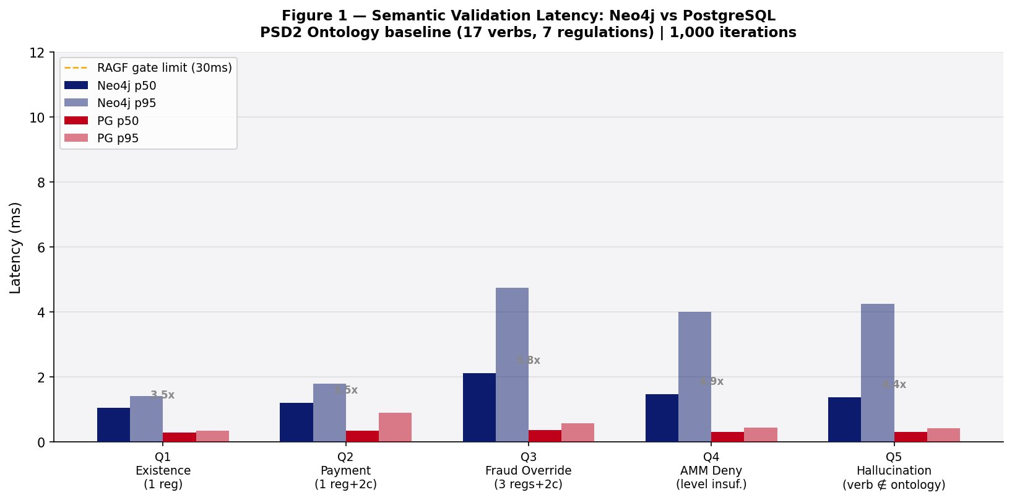
Figure 1 — Baseline latency: 17-verb PSD2 ontology, 1,000 iterations per query. Both databases well within the 30ms RAGF gate limit.

As Figure 1 shows, PostgreSQL is significantly faster in this baseline scenario — 3.5x to 5.8x lower latency across all query patterns. The result is clear and we report it without qualification. The goal of RAGF, however, is not raw speed: it is governance at scale, with a regulatory graph that evolves as jurisdictions change. That distinction shapes the architectural choice.

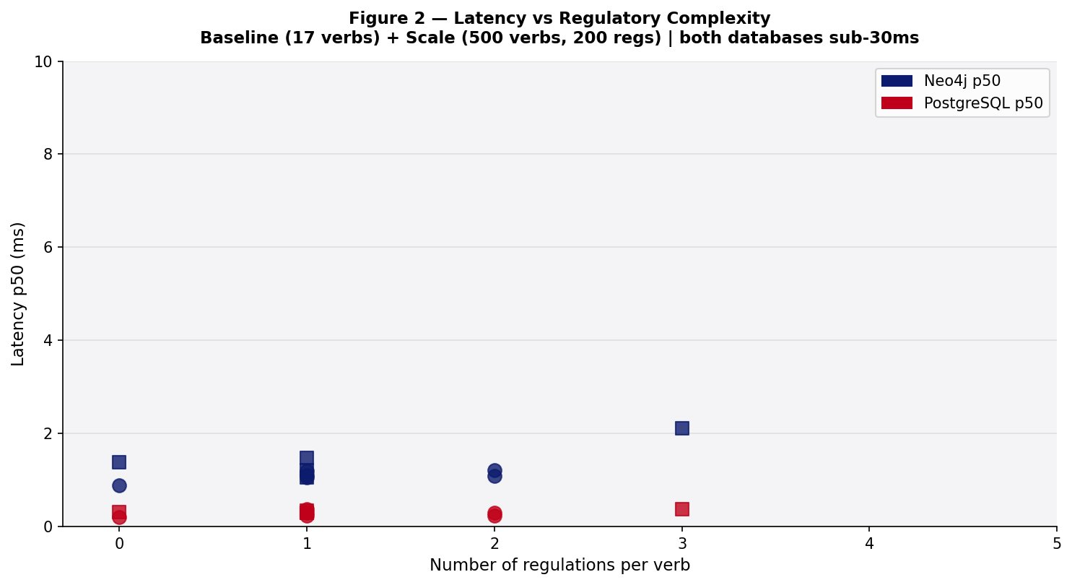
Figure 2 — Latency vs regulatory complexity (0–3 regulations per verb). Scale dataset: 500 verbs, 200 regulations. Neo4j latency grows modestly with hop depth; both remain sub-10ms.

At 500-verb scale, both databases maintain stable latency. Neo4j’s traversal cost grows proportionally to the subgraph reached from the queried verb — not the total graph size. This property becomes architecturally relevant at thousands of verbs across multiple jurisdictions.

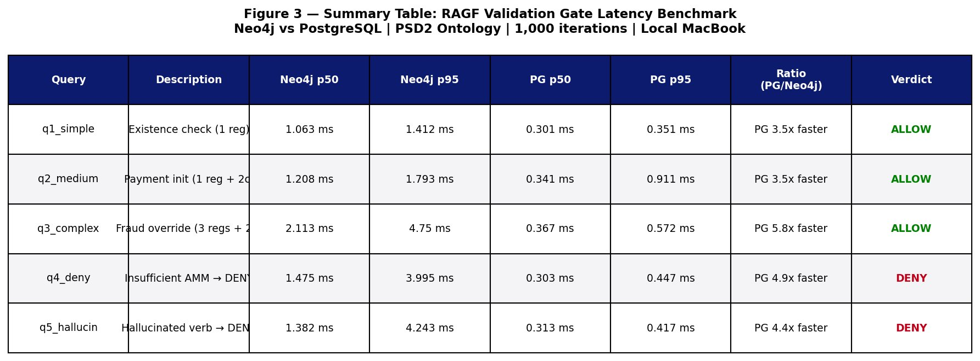
Figure 3 — Summary table. All measurements on a local MacBook. Production VPS results will be published in a follow-up benchmark.

Honest interpretation
PostgreSQL wins on raw latency at this scale. Both databases meet the RAGF sub-30ms requirement. The architectural case for Neo4j is not speed — it is schema flexibility (adding a jurisdiction is one relationship, not a migration), query expressiveness for variable-depth regulatory graphs, and native path traceability for audit trails. Choose PostgreSQL if your ontology is small and stable. Choose Neo4j if your regulatory graph will grow and evolve.

6. Contributing Domain Ontologies
RAGF ships with starter ontologies for PSD2 fintech and aviation (FAA 14 CFR). The following domains are open for community contribution:

Domain | Target Regulations | Status
Fintech / PSD2 | PSD2 Art.97, AML5, EBA Guidelines | Available — see repo
Energy / Grid | IEC 61850, IEC 61508 SIL-3 | Open for contribution
Healthcare / EHR | HIPAA, HL7 FHIR, IEC 62304 | Starter available
Autonomous Vehicles | ISO 26262 ASIL-D, UN ECE R155 | Open for contribution
Insurance | Solvency II, EIOPA Guidelines | Open for contribution
Public Sector / Gov AI | EU AI Act Art.13, NIST AI RMF | Open for contribution

6.1 How to Contribute

- Fork the repository: github.com/cronocom/rafg
- Create ontologies/<domain>/cypher/schema.cypher with node and relationship definitions
- Add ontologies/<domain>/cypher/seed_data.cypher with at least 10 verbs
- Add tests/test_ontology.py — must include a hallucination test (query for non-existent verb → DENY)
- Open a PR with tag [ontology] — reviewed within 48 hours

6.2 Quality Standards

- Every verb must link to at least one formal regulation node with a valid authority code
- Semantic coverage must be 1.0 for all defined verbs
- AMM level (1–5) required on every verb
- All constraint predicates must be machine-executable Python expressions

7. Open Question for the Community
Can a shared, community-maintained regulatory ontology library reduce the 40–60 hours of domain expert time currently required to encode a new vertical? We believe yes — and the graph database community is uniquely positioned to build it.

Join the working group
If you work in Fintech, Energy, Healthcare, or another regulated sector and want to collaborate on building the ontology for your domain, open an issue on GitHub with the label ‘ontology-contribution’ or join the discussion at github.com/cronocom/rafg/discussions. Your domain expertise is the most valuable contribution — we handle the Cypher.

8. Getting Started in 5 Minutes

git clone https://github.com/cronocom/rafg
cd rafg
docker-compose up -d neo4j timescaledb postgres
python scripts/load_ontology.py ontologies/fintech/cypher/seed_data.cypher
python examples/fintech_demo.py

# Expected output:
# Action: initiate_payment | EUR 5,000 | Agent AMM: 2
# Verdict: ALLOW | Regs: [PSD2-ART97] | Latency: 8.3ms
# Action: override_fraud_flag | Agent AMM: 2
# Verdict: DENY | AMM Level 5 required | Latency: 6.1ms

About RAGF
RAGF (Reflexio Agentic Governance Framework) is open-source governance infrastructure for agentic AI in regulated environments, published under Apache 2.0 and accepted to AIES 2026. It provides a deterministic Validation Gate that separates probabilistic LLM reasoning from regulated action execution.

GitHub: github.com/cronocom/rafg • Discussions: github.com/cronocom/rafg/discussions •

