|  |
| --- |
| MASTIV |
| Horn and Honor |
|  |
| Version #01  All work Copyright © 2020 by MASTIV.  All rights reserved. |
| **MASTIV** |
|  |

|  |
| --- |
| May 30, 2020 |

**Table of Contents**

[Your Table of Contents should go here. Make sure that your document’s sections are hyperlinked to their corresponding pages.]

**Version History**

|  |  |  |
| --- | --- | --- |
| Date | Notes | Modified by |
| May 30 2020 | Basic content | Zihan Xu |
| June 1, 2020 | Corrections | Dobrivskiy Maxim |
| June 4 2020 | Add some details of Kaben and enemies  Change the way to get soul  Add descriptions of interruptions and hit recover | Zihan Xu |
| June 9,2020 | Add animations of Kaben  Add sketch of 2 levels  Add design of dash  Add 2 kinds of map objects  Add 2 items | Zihan Xu |
|  |  |  |
|  |  |  |
|  |  |  |

1. **Game Overview**

Horn and Honor is a 2D action platform video game, featuring intense combat and challenging movement through the many platforms of the game. The player controls the hero in efforts to ward off enemies using a sword and a special power called “soul” which grants the hero the ability to shoot magical abilities.

1. **Game Play Mechanics (rules of the game)**

The hero can move left and right, and can also jump to a higher level or dodge enemies’ attack. The hero can melee attack or shoot projectiles at the enemies.

1. **Camera**

Side view, the camera follows the player.

1. **Controls**

Keyboard. Use direction keys to control player move and other key to control attack and other action.

If there’s enough time we may add gamepad support

1. **Interface Sketch (wireframe)**

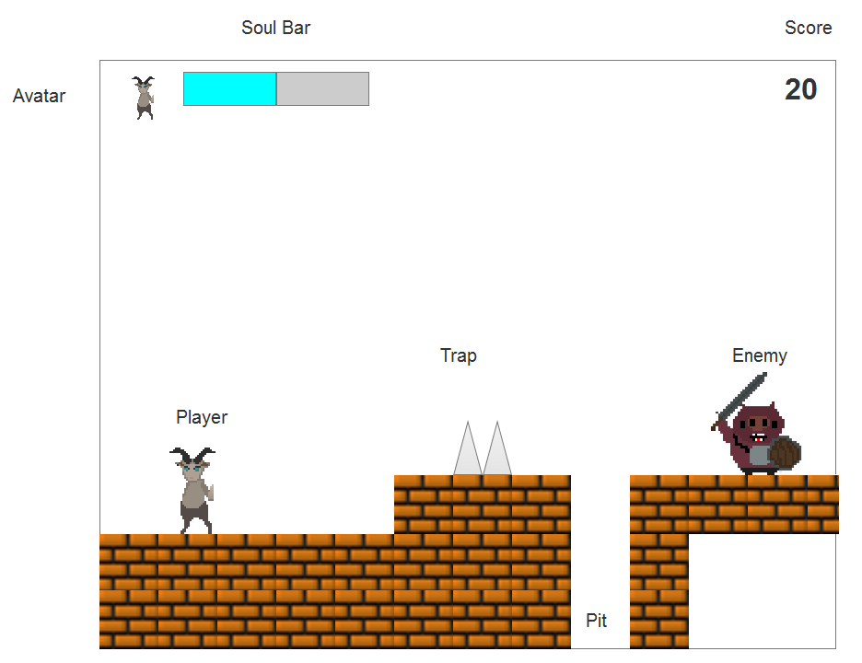

**Level Sketch**

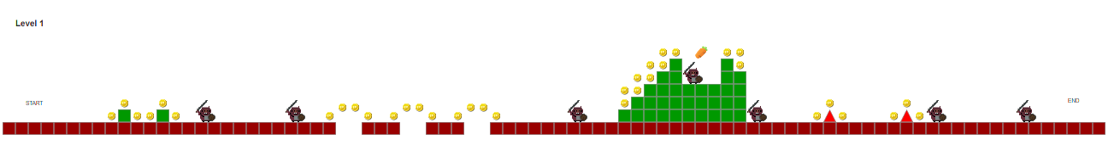



1. **Menu and Screen Descriptions**

**Menu**

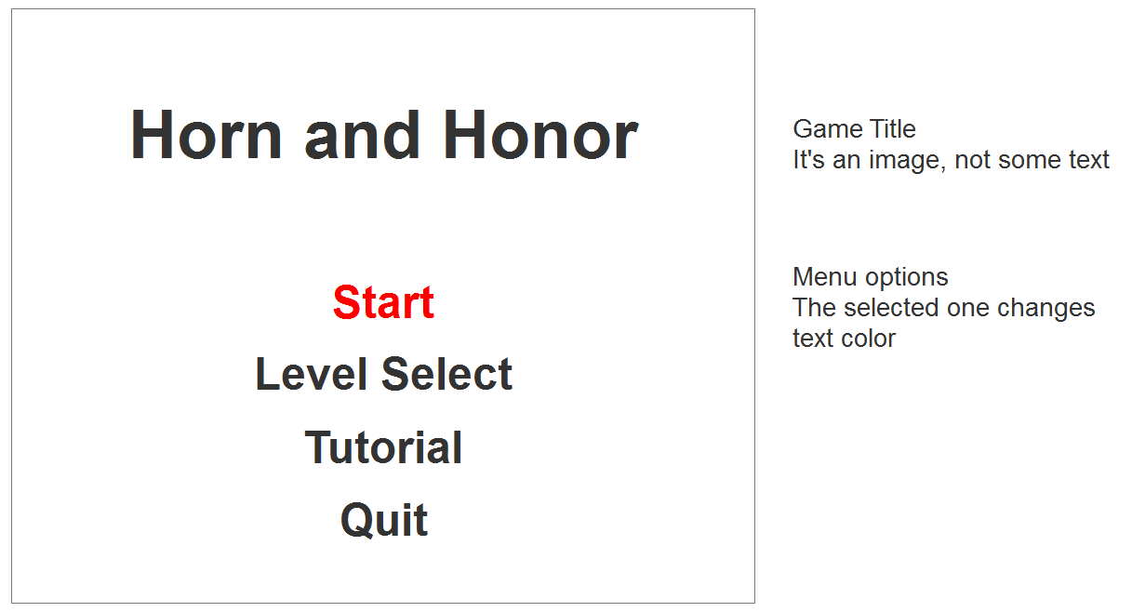

**Play Screen**



**End Screen**

Lose Screen

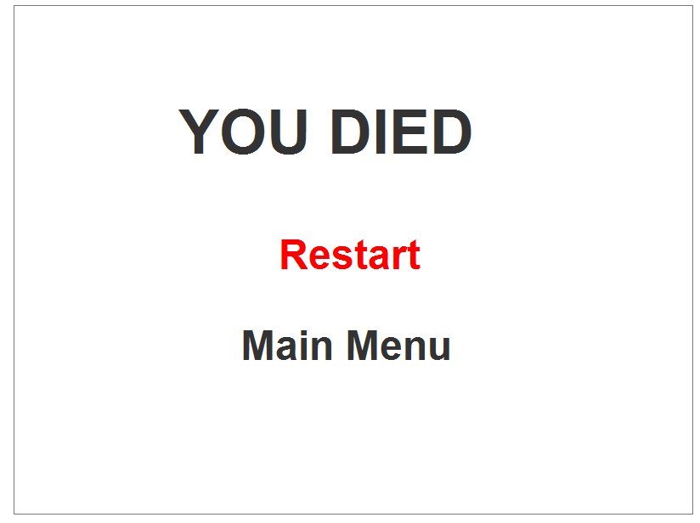

Pass Level 1 and 2

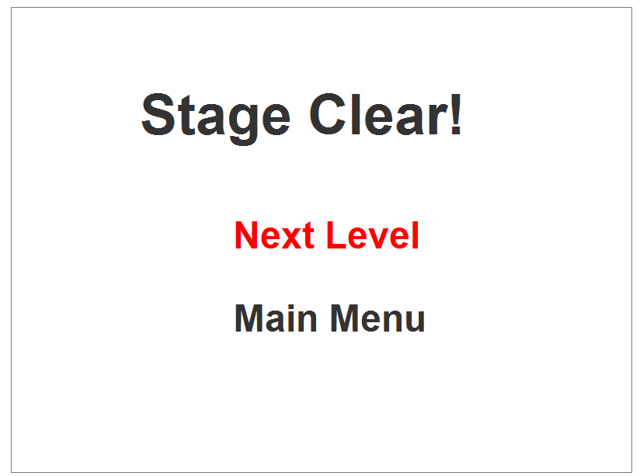

Pass Level 3



Diagrams

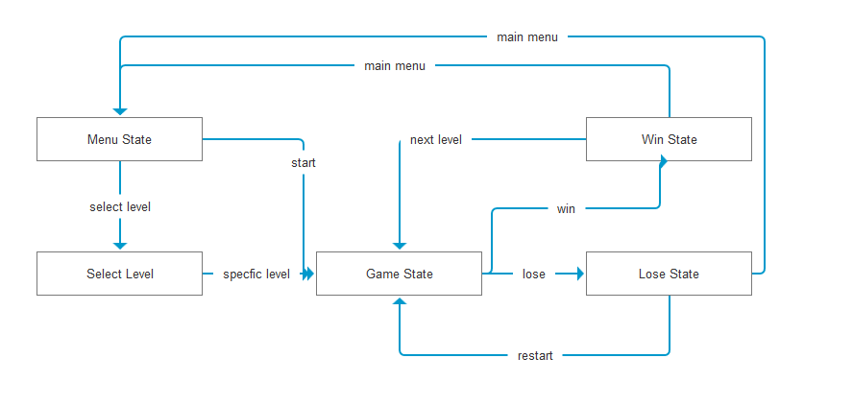

1. **Levels**

The current version of the game includes 3 levels. A level is completed upon the character reaching the end of the level.

1. **Characters**

Kaben

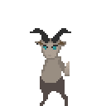

①Move

Press A and D buttons propel the character’s movement left and right. The character stops moving when the key is released.

There is inertia to the character’s movement, a transient process of changing speed at the beginning and end of a movement. The hero movement contains an acceleration and deceleration process during the initial key press and key release, his speed levels out when the key is held. Play sound when Kaben is running.

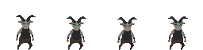

Standing

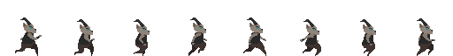

running

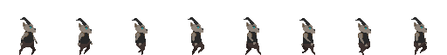

Walking

When the forward direction is blocked, the hero stops moving, but the animation keeps playing.

The hero could pass through enemies and won’t collided with them, when they overlap, the hero's image is overlaid on top of the enemy.

②Attack

Press J to melee attack (wave the sword) and K to shoot ranged magic attacks.

When the hero melee attacks, they will attack the enemies in front of them with a range of about the half length of the player model and play sound of melee. The attack will decrease enemies’ health and push them away from the character a short distance. The hero cannot attack until the end of the last attack.

When the hero shoots a fireball attack, he will consume “soul” and create a fireball in front of him and keep flying towards the direction the player faces. The fireball will be destroyed when it hits enemy, map object or flies out of the screen. The attack will decrease enemies’ health, enemies that take damage will also step back a little. There is a short cool down time between shooting fireballs.

Shooting fireballs requires certain amount of “soul”, but when the hero doesn’t have enough “soul”, they will consume all of the “soul” but have 1-point left. The animation of creating fireballs will play when the key is held, a fireball will be created in front of Kaben after the animation is over.

Kaben’s attack will interrupt enemies’ action, they can’t do anything for some time after being attacked.

The damage the hero deals is attack minus enemies’ defence. Normal attack and fireball damage need to be set separately.

The hero gets soul points when he attacks an enemy with melee. The soul decreases when the hero is hit or when the hero shoots fireballs.

Play sound when Kaben uses melee attack, play another sound if he hits enemies. Fireball creation and explosions have corresponding sound effects as well.

③Jump

Press the Spacebar to jump. The player jumps to the height of a brick. If the hero jumps as he moves, he will move at the same speed on the X-axis until he lands, which means that the player cannot change the direction when Kaben is midair. Play sound when Kaben jumps and lands.

If Kaben is attacked when he is midair, he will fall down.

④Death

When the hero's soul drops to zero or lower, play death animation, the game is over. Switch to Lose Screen after a few seconds.

⑤Be attacked

Kaben will be interrupted when attacked and can’t do anything for a while. If Kaben is creating a fireball, the fireball will not be created but soul will not be returned.

⑥Dash

Press U to dash. Kaben will interrupts what he is doing and sprint forward about two blocks in length. The gravity would be ignored during dashing.

Kaben can attack or shoot fireball during dashing without interrupting it. If Kaben is attacked when he is dashing, the dash would be interrupted.

1. **Enemies**

For now, there are 2 different type of enemies, one can melee while the other one can shoot fireballs. Friendly fire will be turned off for enemies and melee and ranged attacks by enemies will simply pass through enemy units.

① Swordman

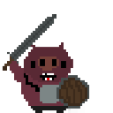

A boar that moves back and forth in an area. When the hero enters the area, Swordman will move towards the player and attack if the hero is in its attack range. Swordman’s attack range is the same as the hero’s melee attack range, which is about the half length of the body. There is cool down time between attacks.

Swordmen dies when his health drops to zero or lower, play death animation, the image becomes translucent for around 1 second and vanishes.

②Archer

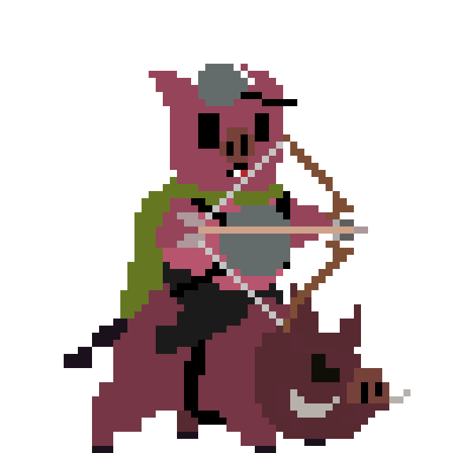

A boar who uses a bow, moves back and forth in its area. When the player enters the area, it will stop and shoot arrows towards player. There will be a cool down before the enemy can attack again.

If the hero is too close to himself, he will move away from the player unless he cannot. When the attack cool down ends, he will stop whatever he is doing and shoot a fireball at the player.

The damage enemies deal is their attack minus hero’s defence. Enemies die when their health drops to 0 or lower.

1. **Map Objects**

①Bricks



Normal bricks, the hero and enemies could stand and move on it, but they cannot go through it.

②Spine



The hero and enemies will decrease health(soul) when touching it. They cannot stand on it as well.

It can be rotated and attached to a wall.

③Pit

The hero and enemies could fall into pits, when they fall out of the screen, they die no matter how much health or soul they have.

④Flaming trap

A trap that periodically fires a fireball upward ( or other direction after being rotated).

Kaben and enemies could stand and move on it, but cannot go through it, just like bricks. Fireballs shot by it can attack Kaben only, it will never check collision with enemies.

1. **Scoring**

The player scores by killing enemies. He or she gets one score every time kill an enemy or collect a coin.

1. **Items**

①Coins

Kaben can collect coins when collided with coins and gets 1 point every time collect a coin.

②Soul enhancer

Kaben will go into a “Soul outbreak” mode after collecting a soul enhancer. That mode will last a while(set as 10s tentatively), during this time Kaben could shoot fireballs without consuming soul. Kaben sparkles when he’s in this mode(like super Saiyan).

1. **Sound Index**

*See the details in assets list*

1. **Art / Multimedia Index**

*See the details in assets list*

1. **Design Notes**

*(Include additional design notes here)*

1. **Future Features**

*More enemies like bosses.*

*More weapons like bombs.*

*More unique power of player like dash or double jump.*