Lab 2: Designing, simulating and implementing a 4-bit ALU

CSEE 4280 – ADVANCED LOGIC DESIGN
SPRING 2018

Demo Due (50 points): Jan 19 Friday 4:25 PM

Report Due (50 points): Jan 25 Thursday 5 PM

Total Points: 100

Contents

- Part 0: Building the simplified ALU component (8-bit adder/subtractor)

- Part 1: Building the logic extender component.

- Part 2: Building the arithmetic extender component.

- Part 3: Building the ALU

- Part 4: The 4-bit–to–7-segment converter

- Part 5: Everything comes together

- Part 6: Generating the UCF file

- Part 7: Programming the board

In this lab you will first design an ALU that operated on 8-bits numbers. It was rather limited, though, in that it has only capable of performing two operations: addition and subtraction.

Afterwards, you will design and implement a second 4-bit ALU that performs a total of 8 operations (4 logic operations and 4 arithmetic operations). Like the previous ALU, this one also builds upon the full-adder. An XOR gate was used to switch between addition and subtraction, and a carry-in signal was also tweaked for that purpose – in effect, this was a way to prepare the inputs of the full adder for each of the supported operations. This time, in order to perform all 8 operations you will design 2 devices that will connect to the full-adder's inputs: a logic extender and an arithmetic extender.

Then, you will put it all together, along with a binary-to-7-segment module that you will also design. The finished ALU will have two inputs, X(3:0) and Y(3:0), 2 outputs, (F3,F2,F1,F0) and the carry signal Cout, and 3 control signals, M, S0 and S1. The control signals specify the operation you would like to perform.

After simulating and making sure it all works in theory, you will synthesize your code into the Xilinx BASYS2 board to see how well it does in practice.

Part 0 - Building the simplified ALU (8-bit adder/subtractor)

- With Project Manager still open, create a New Source of type schematic. Call it fa_sch.sch. It is going to be a full adder, the basic component of our ALU.
- Draw the schematic of a full adder using the following input/output labels, you need to design what is in the dashed box:
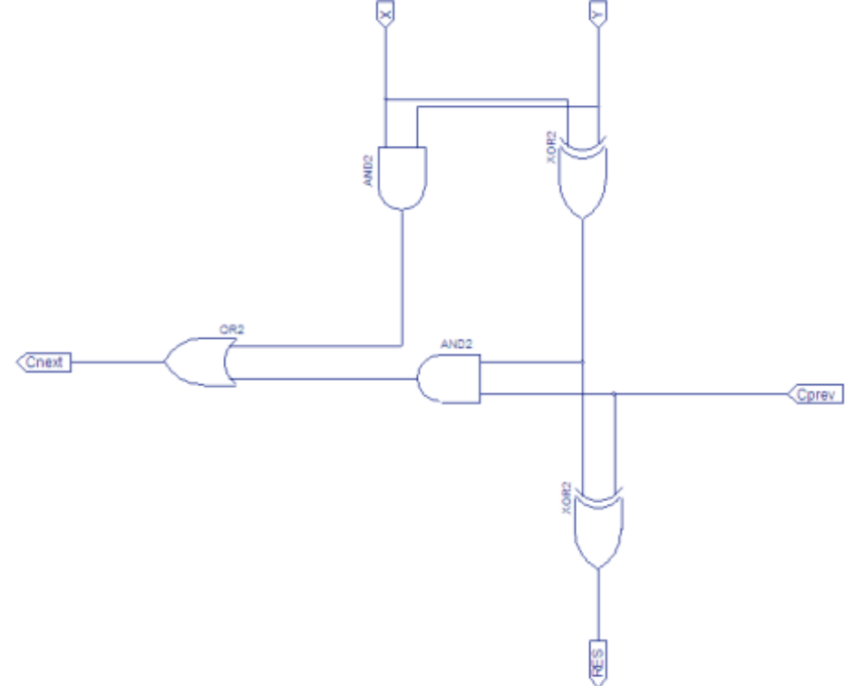
1–bit Full Adder
- Use the following test bench called fa_tb to test it.

`timescale 1ns/1ps

module fa_tbw_tb_0;
reg Cprev = 1'b0;
reg X = 1'b0;
reg Y = 1'b0;
wire Cnext;
wire RES;

WRITE YOUR OWN TESTBENCH

endmodule

- Check your simulation against the following table:
X | Y | Cprev | Sum | Cnext
0 | 0 | 0 | 0 | 0
0 | 0 | 1 | 1 | 0
0 | 1 | 0 | 1 | 0
0 | 1 | 1 | 0 | 1
1 | 0 | 0 | 1 | 0
1 | 0 | 1 | 0 | 1
1 | 1 | 0 | 0 | 1
1 | 1 | 1 | 1 | 1

- Create a symbol from it using Project Manager.
Note: To create a symbol, highlight the name of the schematic file and double-click Create Schematic Symbol from the Processes for Current Source listbox
ECS : Building the ALU from the full adder.
- Add a New Source of type schematic to the project. Name it alu_sch.sch.
- Extend the schematic to include eight bits. The diagram below has been truncated to allow for display. It gives you some idea on what the schematics will look like. You will have to design it on your own. It will consist of multiple fa symbols. You may just clone the schematic and insert more fa and XOR gates in between.
Note: SEL is connected to the CARRY of the least significant bit (LSB).
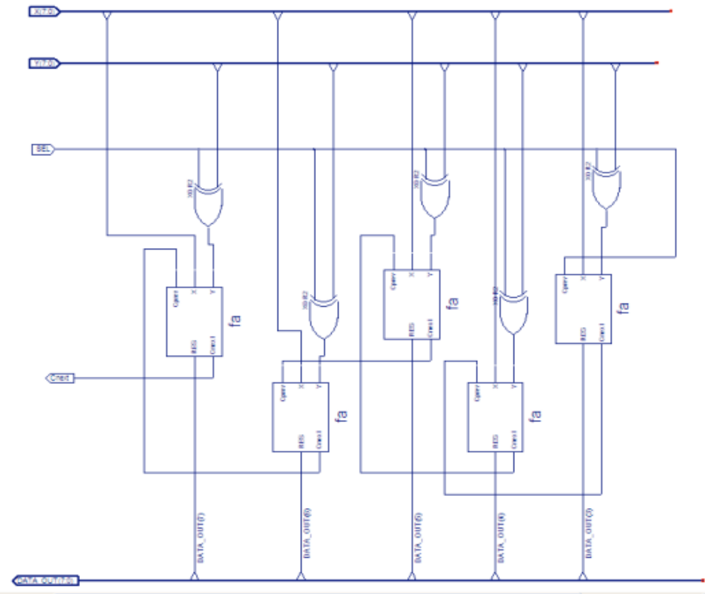

Full Adder/Subtractor (truncated 8-bit version)
- The XOR gates allow for the ability to subtract Y(7:0) from X(7:0). The test bench to test the functionality of our Addition and Subtraction ALU is shown below.
- You just build a very simple ALU. Really, it is just a 8-bit adder/subtractor. Please test bench it below. We will later build more complex ALU later in this lab.
`timescale 1ns/1ps

module alu_tbw_tb_0;
reg SEL = 1'b0;
reg [7:0] X = 8'b00000000;
reg [7:0] Y = 8'b00000000;
wire Cnext;
wire [7:0] DATA_OUT;

WRITE YOUR OWN TESTBENCH

endmodule

Part 1 - Building a Logic Extender

First, you are going to build a logic extender (LE). The LE is a device that performs a logic operation on either one or both of its inputs, and outputs the result to the full-adder (FA) from the previous assignment. The other input of the full-adder is then set to 0, so that output of the LE is in reality forwarded to the output of the FA. The LE must therefore function as described on the following table:

M | S1 | S0 | Fun. Name | F | x_{i}
0 | 0 | 0 | Complement | A’ | ?
0 | 0 | 1 | AND | A AND B | ?
0 | 1 | 0 | Identity | A | ?
0 | 1 | 1 | OR | A OR B | ?
1 | -- | -- | -- | -- | ?

As you can see, the signal M controls whether the logic extender should be utilized or bypassed. The signals S0 and S1 are used to specify the operation that should performed on a_{i} and b_{i}. For example, when S0, S1 are 0, 0, the logic extender should output the complement of a_{i} (and ignore b_{i}).

Here is how you will build it:
- Open the Xilinx ISE Project Navigator and create a New Source of type schematic. Call it logic_ext.sch.
- Draw the LE schematic, which was derived in class:
The logic extender will have inputs of a_{i}, b_{i}, M, S1, S0 and output of x_{i}.
- Create a test bench called logic_ext_tb.v (code partially given below, you need to determine the test vectors combination for each case).

//logic_ext_tb.v

`timescale 1ns/1ps

module logic_ext_tbw_tb_0;
reg ai = 1'b0;
reg bi = 1'b0;
reg M = 1'b0;
reg S0 = 1'b0;
reg S1 = 1'b0;
wire xi;

PLEASE FILL IN THE TEST VECTORS COMBINATION TO EXHAUST ALL POSSIBILITIES.

endmodule

- Simulate and make sure your component functions as specified by the table above.
- Close ISim. Then, back in the Project Navigator, create a symbol for your LE.

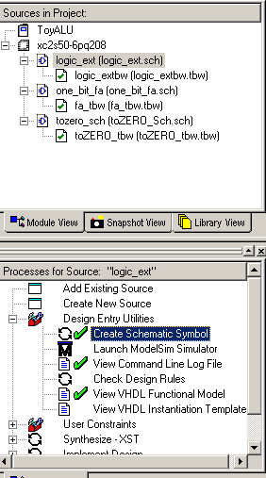
Note: To create a symbol, highlight the name of the schematic file and double-click Create Schematic Symbol from the Design Entry Utility in the Process View tab. This creates a black-box type symbol for the logic extender. The default name given to it by Project Manager is logic_ext.sym. Or you can use the Symbol Wizard under Tools in schematic view of the component.

Part 2 - Building an Arithmetic Extender

Now you are going to build the arithmetic extender (AE). The AE is a component similar to the LE, except it sets up the inputs of the full-adder for arithmetic calculations rather than logic ones. Its operation is described on the following table:

M | S1 | S0 | Fun. Name | F | y_{i} | c₀
1 | 0 | 0 | Decrement | A – 1 | ? | ?
1 | 0 | 1 | Add | A + B | ? | ?
1 | 1 | 0 | Subtract | A + B’ + 1 | ? | ?
1 | 1 | 1 | Increment | A + 1 | ? | ?
0 | -- | -- | -- | -- | ? | ?

Note that the carry-in signal (c₀) is included here only for informative purposes. It is not part of the AE, but helps you understand the operations that are taking place.

From the table it is easy to see how this works:

- To decrement X, the Y input is set to -1 (all 1s in two's complement);
- To add X and Y there is no preparation required, so X and Y are merely forwarded to the output.
- To subtract Y from X, the two's complement representation of Y is accomplished by inverting Y and setting the carry to 1.
- To increment X, the carry is set to 1 while Y is 0
Now you are ready to begin building the AE:

- With Project Manager still open, create a New Source of type schematic. Call it arith_ext.sch. It is going to be the arithmetic extender, a basic component of our ALU.
- Draw the schematic of arithmetic extender:
The arithmetic extender will have inputs of b_{i}, M, S1, S0 and output of y_{i}.
- Run “check schematic”.
- Create a test bench called arith_ext_tb.v (code partially given below, you need to determine the test vectors combination for each case).).

//arith_ext_tb.v
`timescale 1ns/1ps

module arith_ext_tbw_tb_0;
reg bi = 1'b0;
reg M = 1'b0;
reg S0 = 1'b0;
reg S1 = 1'b0;
wire yi;

PLEASE FILL IN THE TEST VECTORS COMBINATION TO EXHAUST ALL POSSIBILITIES.

endmodule

- Simulate and make sure your component functions as specified by the table above.

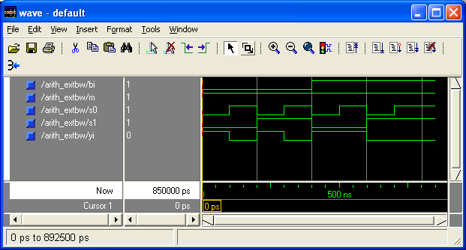
A sample simulation result

- Close ISim and create a symbol for the AE using Project Manager.

Part 3: Building the ALU (4-bit ALU)

At last, you are going to put everything together and build a 4-bit ALU. This is done by stacking the LE and AE onto the full-adder.

You should follow the same familiar steps:

- Add a New Source of type schematic to the project. Name it alu4bit_sch.sch.
- Draw the schematic of a 4-bit ALU. Your ALU should have the following inputs/outputs. Control Inputs: M, S0, S1; Data inputs: A(3:0), B(3:0); Outputs: F0, F1, F2, F3 and C_{i}Out.
- Create a test bench called alu4bit_tb.v to test the functionality of our ALU. The result you get should verify the functionalities specified on the 2 tables above (code partially shown below, fill in the rest to test all possibilities).

// alu4bit_tb.v

`timescale 1ns/1ps

module alu4bit_tbw_tb_0;
reg [3:0] A = 4'b0000;
reg [3:0] B = 4'b0000;
reg M = 1'b0;
reg S0 = 1'b0;
reg S1 = 1'b0;
wire CiOut;
wire F0;
wire F1;
wire F2;
wire F3;

PLEASE FILL IN THE TEST VECTORS COMBINATION TO EXHAUST ALL POSSIBILITIES.

endmodule

- Simulate and make sure your ALU functions work as expected. Simulate interesting cases, such as the ones where there is a long carry-signal propagation.

Make sure you understand how the ALU works, and the parts played by the AE and LE.

Part 4 – The 4-bit-to-7-segment converter
In order to interface the ALU with the 7-segment displays on the FPGA board that we will be using, we need to design a circuit that converts 4-bit binary numbers to the appropriate signals to illuminate the seven segments of the display. This is something you did before in CSEE 4270. But now we are going to do this in a schematic way instead of using Verilog entries. The 7-segment display contains 7 “lines”, one for each segment that it can display. Digits are constructed by illuminating the appropriate segments. For the number “1”, for example, we just need to illuminate the 2 rightmost lines, as shown below:
And for the number “4”, you need to turn on 4 of the seven lines as shown below:
The 7-segment display is operated by 7 inputs, each representing one of the possible “lines” of a decimal digit. They are mapped like this:
 | a
f |  | b
 | g
e |  | c
 | d
The inputs a, b, c, d, e, f, g are logic-low, that is, you illuminate them by sending a 0 and turn them off with a 1 (this is opposite to the one we did in CSEE 4270). Thus, you must make a converter that operates according to the following table:

4-Bit  Binary  Input | Digit To be Shown on  7-Seg Display | Values Needed for Segment Signals
4-Bit  Binary  Input | Digit To be Shown on  7-Seg Display | a | b | c | d | e | f | g
0000 | 0 | 0 | 0 | 0 | 0 | 0 | 0 | 1
0001 | 1 | 1 | 0 | 0 | 1 | 1 | 1 | 1
0010 | 2 | 0 | 0 | 1 | 0 | 0 | 1 | 0
0011 | 3 | 0 | 0 | 0 | 0 | 1 | 1 | 0
0100 | 4 | 1 | 0 | 0 | 1 | 1 | 0 | 0
0101 | 5 | 0 | 1 | 0 | 0 | 1 | 0 | 0
0110 | 6 | 0 | 1 | 0 | 0 | 0 | 0 | 0
0111 | 7 | 0 | 0 | 0 | 1 | 1 | 1 | 1
1000 | 8 | 0 | 0 | 0 | 0 | 0 | 0 | 0
1001 | 9 | 0 | 0 | 0 | 1 | 1 | 0 | 0
1010 | A | 0 | 0 | 0 | 1 | 0 | 0 | 0
1011 | B | 1 | 1 | 0 | 0 | 0 | 0 | 0
1100 | C | 0 | 1 | 1 | 0 | 0 | 0 | 1
1101 | D | 1 | 0 | 0 | 0 | 0 | 1 | 0
1110 | E | 0 | 1 | 1 | 0 | 0 | 0 | 0
1111 | F | 0 | 1 | 1 | 1 | 0 | 0 | 0

Build the converter schematic (you need to design this on paper first), naming it “bin_to_7seghex_sch”, then simulate it to make sure it works (use the table above to assess that). You should understand and be able to explain how the converter works. When you are done, make a symbol for the converter.

Part 5 – Everything comes together

Now it's time to put everything together, but first you should download a component that we are providing from ELC. Download the file called “seven_seg_controller.zip” and unzip its contents into your project folder. Then, open your project in the Xilinx ISE, click on the Project menu, then Add Source. Select the files that start with “mux4” and “seven_seg_control” (you can use the Ctrl key to select multiple files at once). Now press Open and then OK.
Connect all components as shown in the schematic below. Name the schematic “alu4bit_board_sch”. Then, as usual, simulate it. Given the control signals M, S0 and S1 (of the LE and AE) you should be able to execute different logic and arithmetic functions on the inputs X and Y. The output should be in the format detailed in the truth table for the 4-bit-to-7-digit-converter.
SS(6:0)
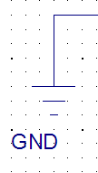
CLK
EN_L
EN_ML
EN_MR
EN_R

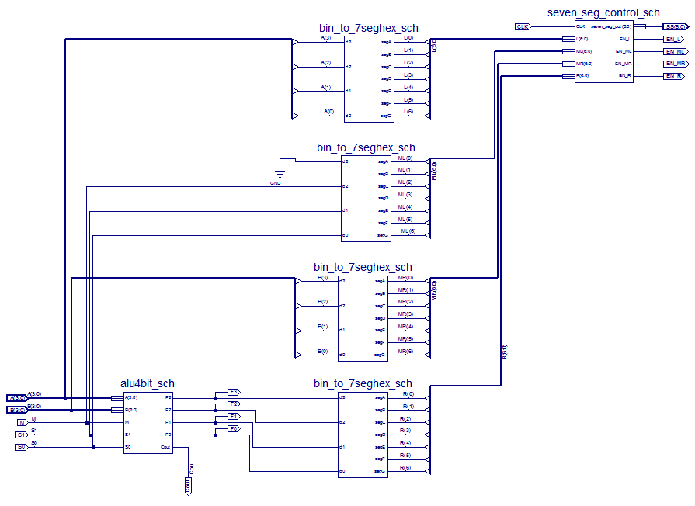
Cout
A(3:0)
B(3:0)
M
S1
S0
F3
F2
F1
F0

Notice there is an input port here that we haven’t mentioned yet: the CLK. We will connect (in Part 6) the CLK port to a clock signal that is provided by the BASYS2 board.

Also notice that there are 4 output ports, signals EN_L, EN_ML, EN_MR, and EN_R. These signals enable each of the 4 seven-segment displays of the BASYS2 board. All 4 seven-segment displays are driven by the same 7 lines SS[6:0] and these 4 signals enable in a round-robin fashion each of the displays while sending the appropriate values on the SS[6:0] bus. In other words, all 4 seven-segment displays see the values to be displayed but only one is activated. By cycling through the 4 seven-segment displays fast enough, we create the illusion that they are continuously illuminated, while in reality they are not. This is what the seven_seg_control_sch does.

Part 6 – Generating the UCF file

In the previous parts of this assignment you put together an ALU and it is now time to finally program it onto the BASYS2 FPGA board. But this ALU is now a black box with input and output ports, and before you download it to the board you must tell very precisely where these ports must be connected. This is where the UCF (User Constraints File) comes in: it tells the FPGA which pins on the chip should be connected to which inputs and outputs of your schematic.

A few things to note:

- You cannot assign one input/output port to multiple pins. To do that, you will have to duplicate the input/output signal on your schematic to go to the number of ports you want.
- Two pages below on this document you will see an Excel sheet that has UCF file. For this time, the UCF file is provided for you. In the future, you can read the datasheet of the BASYS2 board to find the pin names that you may utilize.
- On the UCF file, you may insert comments using a hash (#) in the beginning of the line.

As shown in the figure below, you should use the 8 switches for the number inputs. Number A(3:0) will be specified via switches sw7—sw4. B(3:0) will be specified via switches sw3—sw0. The ALU operation will be specified by connecting Signals (M, S1, S0) to Push Buttons (BTN3, BTN2, and BTN1), respectively. A(3:0) should be displayed in hexadecimal format at the left 7–segment display, the ALU operation should be displayed in the middle left 7–segment display (it’s a 3-bit entity, so we will connect the most significant bit to the GND), B(3:0) should be displayed at the middle right 7–segment display, and the result (F3,F2,F1,F0) should be displayed at the right 7–segment display. Also, F3, F2, F1, F0 should be displayed in discrete LEDs (LD3:LD0) and the CiOut signal should be displayed at discrete LED LD7. The following figure should clarify these assignments, which will be made through writing an appropriate UCF (user configuration) file.
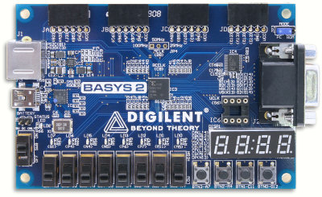

S0
CiOut
A3

A2

A1

A0
B3

B2

B1

B0
M

S1
F3F2F1F0

You should add the UCF file under the alu4bit_board_sch schematic. If you are not familiar with the procedure, please refer to the lab instructions in CSEE 4270 where we did the same thing.

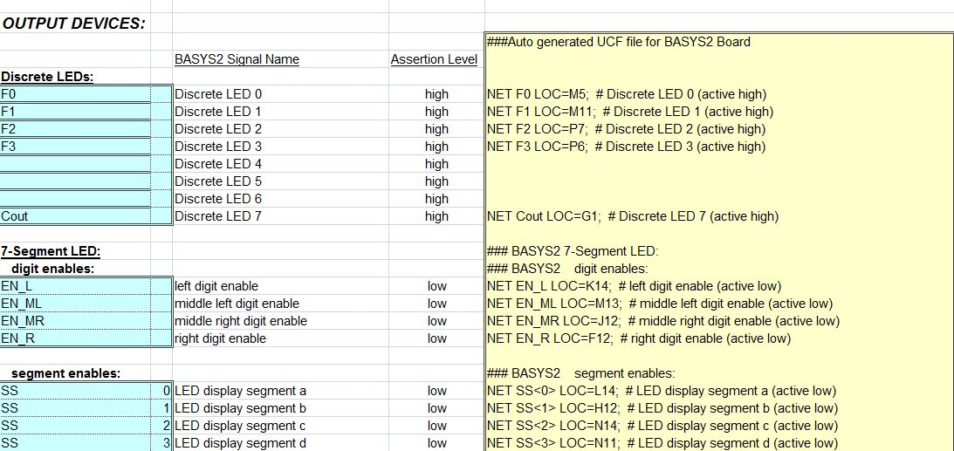
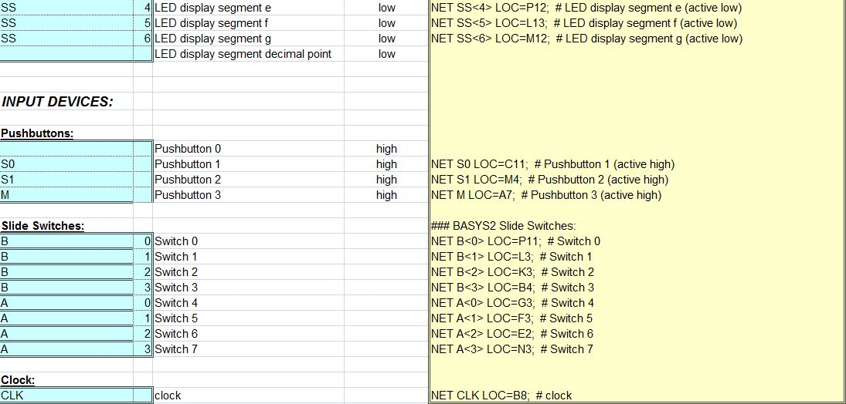

Part 7 – Programming the board

Now you are ready to program the board. Just like in CSEE 4270, you must first generate a bitstream file and then download it into the FPGA. This is how you generate the bitstream:

First of all, you must inform the Xilinx ISE that the Xilinx board that you will be programming has a SPARTAN XC3S250E FPGA. To do this, go to the Sources window, right-click on the second item (counting from top to bottom), and choose “Properties”. Make sure you project is set like this:
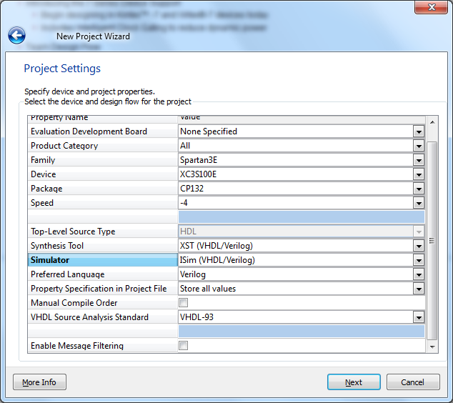
In the Device column, please choose XC3S250E !!

Now, still on the Sources window, make sure “Sources for” is set to “Synthesis/Implementation”, right click on the 4-bit ALU schematic file and choose “Set as top module”.

Now expand the “Generate Programming File” tree in the processes window and double-click on “Configure Device ”. This will take a while to complete. Check the console window in the bottom of the screen to see what is going on.

Once successful a .bit file will be generated in your program folder. You will download your bitstream to the board. Please refer to the lab instructions of CSEE 4270 on how to download the bitstream to the FPGA board.

Now play with the buttons and flip switches to make sure everything is working correctly. Demo will checked by your instructor at this point.

Lab Report/Code Requirements

Lab Report Format

Each team should submit one report using the format provided below. You should provide a detailed description/discussion for each lab report item including all schematics, codes and simulation waveforms from testbench. The lab report should be in WORD or PDF format and submitted as a single file to the dropbox in ELC. Please submit your lab reports in appropriate assignment folders on ELC before the deadline. 30% credit will be taken off if the submission is late by 0-24 hours. After 24 hours, late submission will not be accepted and zero credit will be given to the lab report.

1. Student Information (First page)

Lab Number and Title:
Names of members in the team:
E-mails:
Contributions: Please list contributions (in estimated percentages) of each member in the following categories.
- Pre-lab design and analysis
- In-lab module and testbench design
- In-lab testbench simulation and analysis
- In-lab FPGA synthesis and analysis
- Lab report writing

2. Lab Purpose (Second page)
Provide a brief summary of the lab assignment.

3. Implementation Details
Provide a detailed description of the steps you followed to implement the lab. Be sure to include all relevant information. Recommended information to be included:
- Pre-lab design and analysis
- Schematics of your design if available
- Module and testbench code

4. Experimental Results
Describe the results of the lab assignment. Be sure to include any simulation waveforms for testbench. You need to summarize the simulation results, supplemented by the evidence from Screen Captures of the waveforms. Please DO NOT just copy the waveforms as the results. You need explain why they correctly verify your design. When you attach the waveform screen captures, please crop them so that the variables names, time scale and waveforms are visible in your file.

5. Significance
What is the importance of the lab? How will you use the information you learned in this lab in the future?
In which applications you can use this information?

6. Comments/Suggestions
Please provide any comments or suggestions you may have for this lab assignment. Please indicate any areas of difficulty you encountered for this lab assignment.

7. Additional Lab Specific Information
Attach any additional information requested for this lab, including schematics, simulation waveforms, or manually performed tasks.

Grading Policy
Only one copy of the lab report from each team is needed. The grade for the report will apply to both team members, provided that each team member contributes roughly equally (50/50 – 40/60) to the lab. In the case where one team member contributes disproportionally lower to the lab, the instructor may reduce the grade of this member. Late submission after due date will receive partial credits (70% of credit for 0-24 hours late submission, no credit for more than 24 hours late submission).
Plagiarism: If plagiarism is found in reports, all of them will get ZERO points immediately, and face serious consequences.

