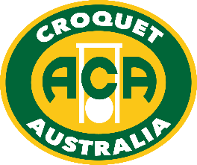

**Australian Golf Croquet Open Singles**

Do you enjoy playing Golf Croquet in State Tournaments?

Go National – Go on-line!

Each year the annual Australian Golf Croquet Open Singles attracts players from across the country. Some of the faces are familiar but new ones are always welcome. The venue is the Victorian Croquet Centre at Cairnlea; the largest croquet specific venue in the southern hemisphere, with twelve courts.

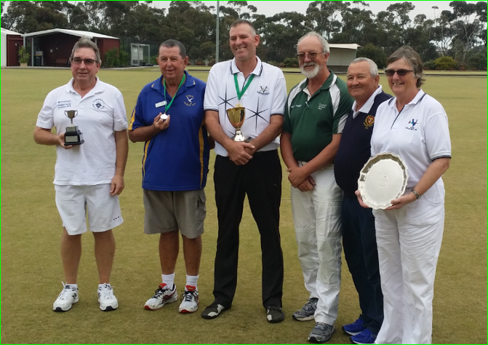

**2017 Winner Lester Hughes (centre) with (L to R) Kevin Beard (Y winner); Geoff Hull (Runner-Up);   
Peter Freer (W winner), Ron McBride (Z winner) and Patricia Watts (Plate winner).**

Play for the Tony Hall Cup commences early on Wednesday 9 May and concludes on Sunday 13 May.

If you would like to ‘have a go’ but are ‘not quite sure’ then enter the Plate – soak up the atmosphere, watch Australian’s leading players as they get to the pointy end of the competition.

Now that you have made the decision to play, it is very easy to enter just go to the Croquet Australia website, click on Tournaments and click on GC Open Singles Entry Form. Encourage other members of your club to join you and share the experience.

If you would like more information please contact Peter Freer, Chair of the Events Committee by email [events@croquet-australia.com.au](mailto:events@croquet-australia.com.au)

Please note that Atkins Quadway hoops will be used during this tournament.

[www.croquet-australia.com.au](http://www.croquet-australia.com.au)

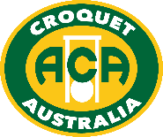

**Australian Golf Croquet – Open Singles**

**Tournament Manager:** John Grieve

**Tournament Referee:** Jim Clement

**Tournament Handicapper** Peter Freer

**ACA Events** Peter Freer

**Headquarters:** Victorian Croquet Centre

**How to Enter:** via the ACA website at:

[**http://www.croquet-australia.com.au/tournaments**](http://www.croquet-australia.com.au/tournaments)

**Closing Date for Entries:** Thursday 19 April (midnight WA time)

**Entry Fees**: $132 per player

If entering the Plate ONLY: $66 per player

Full time students (under 25) and players aged under 21 at 31 December 2018 are entitled to 50% reduction of the above fees.

**Functions:** No formal functions have been arranged but there will be a presentation at the conclusion of the final.

**Prizes:** The Winner receives $1,000, a gold medal and the Tony Hall Cup; Runner Up receives $500 and a silver medal; Third Place $300, and certificates for Fourth and Winners of W, Z, Y and Plate.

**Draw:** To be conducted by the ACA Tournament, Events and GC Selection Committees using the ACA Seeding and Draw procedures. The latest available world GC ranking list current will be used for seeding purposes

**Registration:** From 2pm Tuesday 8 May or before play on Wednesday 9 May. You could time your registration to coincide with the presentation after the Open Doubles.

**Format:** Block play with single games then 16 players into knockout, or other format, depending on entries. Finals matches will be best of 3, 13 point games, except the final which will be best of 5 if time permits. Quarter-Final losers will play-off for 5-‑8th places and Semi-Final losers will play-off for 3rd/4th place. All games will start without time-limits.

Players not making the finals proceed to the Plate which is designed to maximise the amount of play and will be conducted as large blocks or Swiss, with a single life knockout final. Players may enter direct without playing in the main event but an entry form still needs to be completed.

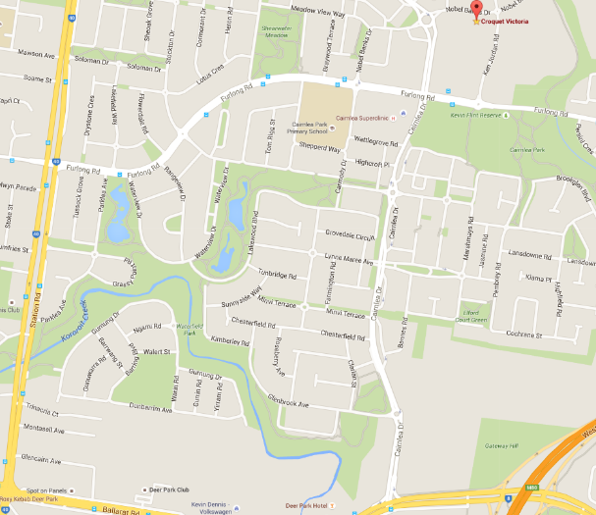**Catering:** Coffee & tea; lunch & other food available for purchase

www.croquet-australia.com.au