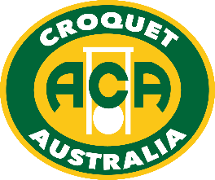

**AUSTRALIAN UNDER 21 GOLF CROQUET CHAMPIONSHIP**

**Saturday 20 to Monday 22 January, 2018**

Born after 1 January 1997 and play croquet?

Strive to become Australia’s next Under 21 Champion!

The third Australian Under 21 Golf Croquet Championship is a unique opportunity to hone skills against players of similar age and experience. The location of this event, being held at the Sandy Bay Croquet Club, in Hobart Tasmania during the summer holidays, also facilitates exploring Tasmania’s famous tourism attractions. The members of Sandy Bay are willing to billet competitors and their parents.

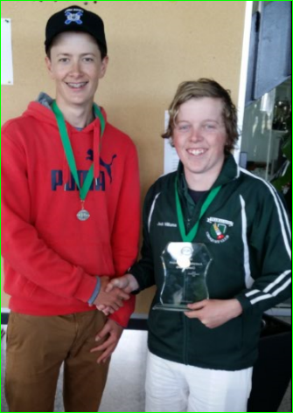

Charlie Sharpe (left) and Jack Williams (right) shake hands after the second Under 21 GC Championship in 2016.

Play will be over three days from **Saturday 20 to Monday 22 January, 2018**. The Singles format will be best of 3 game matches, as a round robin or in blocks depending on the number of entries; and Doubles will also be held if enough entries. The 2013 Rules of Golf Croquet will be used, as available on the Croquet Australia website.

The winner will be awarded the Australian Under 21 Golf Croquet Perpetual Trophy and ACA gold medal. Runner Up receives the silver medal.

If you have additional questions contact Peter Tracey at [trakka81@gmail.com](mailto:trakka81@gmail.com) ; National Co-ordinator of Under 21 Croquet, Jacky McDonald, by email [ndu21c@croquet-australia.com.au](mailto:ndu21c@croquet-australia.com.au) (or call 0409 246 294 after 30 Oct) or Peter Freer, Chair ACA Events, on [events@croquet-australia.com.au](mailto:events@croquet-australia.com.au) . Competitors under the age of 18 will need written consent - forms will be sent to you after you enter.

Entry Fee is AUD $35 for the Singles & $17 each for the Doubles.

**Closing Date is Friday 15 December, 2017** (12 midnight Western Australian time)

Competitors from New South Wales and Victoria can take advantage of their state’s Junior Scholarships to help with expenses and I am certain that the other states will assist where possible.

To enter follow the link to Croquet Australia’s website <https://croquet-australia.com.au/tournaments>.