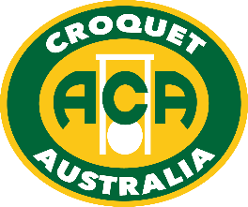

**Australian Association Croquet**

**Women’s & Men’s   
Singles Championships**

**2018**

Do you play Association Croquet?

Would you like to play in a National Tournament?

The 2018 Australian Association Croquet Men’s and Women’s Singles Championships   
are being held in Adelaide from Saturday 17 to Tuesday 20 March.

Do you have a handicap of eight or under? If so you should enter this event, which has been held for the past 48 years at various venues across six States.

Over the four day period, entrants will compete in a single-life Knock-Out playing  
best-of-3 game matches. Losing players go into a range of consolation events.

Players can register between 2-5 pm on Friday 16 March at SACA, Hutt Rd. Players may also use this time to practise on the lawns at all clubs during the afternoon, or at SACA after the conclusion of the Gold & Silver Medals, before attending the welcome BBQ at Hutt Rd.

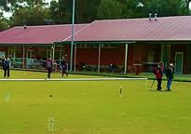

**Tournament Managers:** TBA

**Tournament Referee:** TBA

**Headquarters: South Parklands – Hutt Rd, Adelaide**

**Other Venues:** Brighton, Glenunga, Hyde Park, Millswood, North Adelaide, Norwood, South Tce

**Entries:** On-line via the ACA website, and subject to entry fees being paid by 22 Feb.

**Closing Date for Entries: Thursday 22 February 2018**

**Entry fees:** $90 per person

If ONLY entering thePlate: $45

Players under 21 or Full time students under 25 are entitled to 50% reduction of the above fees

**Functions: Welcome Barbecue** – from 5 pm Friday 16 March at Hutt Rd. $20pp  
 **Eire Cup Teams Reception** - 5:30 pm on Tuesday 20 March by invitation,   
at Government House, cnr North Tce & King William St, Adelaide.  
Hosted by His Excellency the Honourable Hieu Van Le and Mrs Le

**Eire Cup 2018 Presentation Dinner** - 6:30 pm Sunday 25 March: $60pp  
 Rydges Skyline Event Centre,1 South Tce (corner of West Tce), Adelaide

**Information:** <https://www.croquetsa.com.au/2018-eire-cup-carnival/>

**Draw:** To be conducted by the ACA Tournament, Events and AC Selection Committees using the ACA Seeding and Draw procedures. The world ranking list current at that time will be used for seeding purposes

**Registration:** At headquarters on Friday 16 March from 2 pm to 5 pm. Information will be provided at that venue. Draws will be in the Program, available on the ACA website and on croquetscores, and in hard copy at the venue.

**Players Meeting:** On-line via SurveyMonkey

**Catering:** Coffee & tea; lunch & other food available for purchase

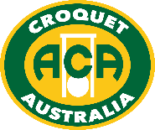

[www.croquet-australia.com.au](http://www.croquet-australia.com.au)