BAM-CASFRI Disturbance Filter

Andrew Crosby

12 March, 2018

## Filtering the BAM-CASFRI dataset by whether a disturbance occured between the photo year and the survey year

The purpose of this document is to describe the process used to identify the Boreal Avian Modelling Project (BAM; Cumming et al. 2010) point count stations that coincide with usable forest resource inventory polygons from the Common Attribute Schema Forest Resource Inventory (CASFRI; Cumming et al. 2015) dataset. Usable CASFRI polygons are ones that have sufficient forest composition and structure data and that we can determine (to the best of our ability) did not undergo disturbance between the photo year and the survey year. A lack of disturbance will be taken as evidence that the composition and structure of vegetation described in the CASFRI dataset corresponds to conditions on the ground at the time of the bird survey. The BAM points were those for which there was point count and offset data available in the most recent version of the dataset as created by Peter Sólymos.

Our first step, done in a GIS, was to do a spatial join between CASFRI polygons, BAM points, the Global Forest Change 2000-2014 (GFC; Hansen et al. 2013) dataset, and the Canada Landsat Disturbance (CanLaD; Guindon et al. 2018) dataset. The BAM points included all points (both on- and off-road) that intersected the CASFRI dataset. The GFC dataset records annual forest loss in 30m pixels between the years 2000 and 2014, and we used the portion of the dataset that records year of loss as a number between 0 and 14, where 0 indicates no forest loss reccorded and 1-14 indicate loss was recorded in that number of years after 2000. Thus, a 5 indicates that a disturbance was recorded in year 2005. The CanLaD dataset is a raster layer that records the year of distrubance throughout Canada due to fire or harvest between 1984 and 2015. Prior to the operation, all datasets were transformed into the Canada Albers Equal Area Conic corrdinate system.

### Step 1:

We queried the dataset to create a file that has the SS number (the unique identifier) of individual BAM points, the initial year the point was surveyed in (we did not include records from subsequent years), the ID of the CASFRI polygon that the point occurrs in, the year the photo was taken from which the polygon was interpreted, the difference between the photo year and the survey year, the GFC year of loss, the CanLaD disturbance year, the disturbance records (if any) from the CASFRI data, and the X-Y coordinates of the point in Canada Albers Equal Area Conic with a linear unit of meters.

# -------------------------------------------------------------------------------------------------------------------------------------------------  
# Step 1: Create the dataset with the location, distrubance records, photo year, and year of first survey at each point  
#   
# -------------------------------------------------------------------------------------------------------------------------------------------------  
  
# Query the dataset to prodcue a table with the BAM-CASFRI points, the CASFRI polygon ID, the photo year, the year of the first survey at each point, and the disturbance records from the CASFRI dataset  
years <- sqldf("select bam_casfri.SS, min(pkey.Year) as YYYY, bam_casfri.CAS_ID, bam_casfri.photo_year, bam_casfri.dist_yr_1, bam_casfri.dist_yr_2, bam_casfri.dist_yr_3  
 from bam_casfri join pkey using(SS)  
 group by bam_casfri.SS")  
  
  
# Identify points where the CASFRI data does not record a photo year and change "photo_year" to NA  
length(years$photo_year[years$photo_year== -9999 | years$photo_year== -8888 | years$photo_year== -1111 | years$photo_year== 0])

## [1] 7828

years$photo_year[years$photo_year== -9999 | years$photo_year== -8888 | years$photo_year== -1111 | years$photo_year== 0] <- NA  
  
# Creat a field of the difference between the survey year and the photo year  
years$year_dif<-years$YYYY-years$photo_year  
  
# Add the x-y data (both CAEAC and NAD 83), the gfc record, and the CanLaD records to the data  
years_dst <- sqldf("select years.*, bam_casfri_dst.POINT_X as x_caeac, bam_casfri_dst.POINT_Y as y_caeac,   
 bam_casfri_dst.CanLaD_cae as canlad_dst, bam_casfri_dst.gfc_yol_ca as gfc, ss.X, ss.Y  
 from (years join bam_casfri_dst using(SS)) join ss using(SS)")  
  
head(years_dst)

## ss YYYY  
## 1 ABCAWAWEST:100:1 2012  
## 2 ABCAWAWEST:100:10 2012  
## 3 ABCAWAWEST:100:2 2012  
## 4 ABCAWAWEST:100:3 2012  
## 5 ABCAWAWEST:100:4 2012  
## 6 ABCAWAWEST:100:5 2012  
## cas_id photo_year  
## 1 AB_0016-xxxxxxxxxCANFOR-xT083R09M6-0000001664-0000122 1994  
## 2 AB_0016-xxxxxxxxxCANFOR-xT083R09M6-0000001693-0000129 1994  
## 3 AB_0016-xxxxxxxxxCANFOR-xT083R09M6-0000001553-0000095 1994  
## 4 AB_0016-xxxxxxxxxCANFOR-xT083R09M6-0000001553-0000095 1994  
## 5 AB_0016-xxxxxxxxxCANFOR-xT083R09M6-0000001553-0000095 1994  
## 6 AB_0016-xxxxxxxxxCANFOR-xT083R09M6-0000001693-0000129 1994  
## dist_yr_1 dist_yr_2 dist_yr_3 year_dif x_caeac y_caeac canlad_dst gfc  
## 1 NA NA NA 18 -1398652 2039432 -9999 0  
## 2 NA NA NA 18 -1400285 2038829 -9999 0  
## 3 NA NA NA 18 -1399071 2039604 -9999 0  
## 4 NA NA NA 18 -1399420 2039461 -9999 0  
## 5 NA NA NA 18 -1399641 2039162 -9999 0  
## 6 NA NA NA 18 -1399902 2038856 -9999 0  
## X Y  
## 1 -119.2819 56.23876  
## 2 -119.3036 56.22879  
## 3 -119.2893 56.23893  
## 4 -119.2938 56.23668  
## 5 -119.2956 56.23352  
## 6 -119.2979 56.23018

years_dst$canlad_dst[years_dst$canlad_dst < 0] <- NA  
  
years_dst$gfc_yol <- years_dst$gfc + 2000  
years_dst$gfc_yol[years_dst$gfc_yol==2000] <- NA

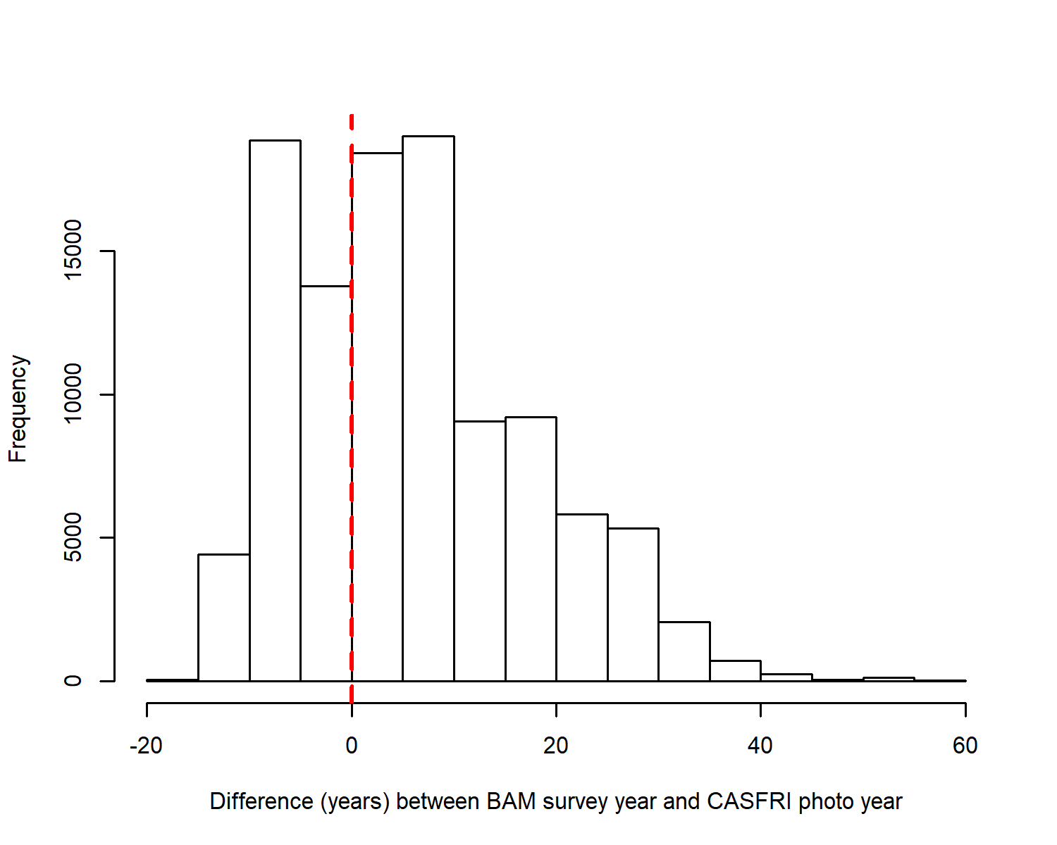

Figure 1. Histogram of the year differences between BAM survey years and CASFRI photo years.

There were 114,879 BAM points associated with CASFRI polygons. Of these, there were 7,828 that did not have a year recorded for when the photo was taken (6.81% of points). The above plot (Fig. 1) is a histogram of survey year - photo year, showing that the vast majority of points the photo was taken well before the bird survey was done. The plot in Fig. 2 (below) is the map of BAM-CASFRI points with a color ramp for year differnce. We mapped the year differences between photos and surveys to look for spatial structure.

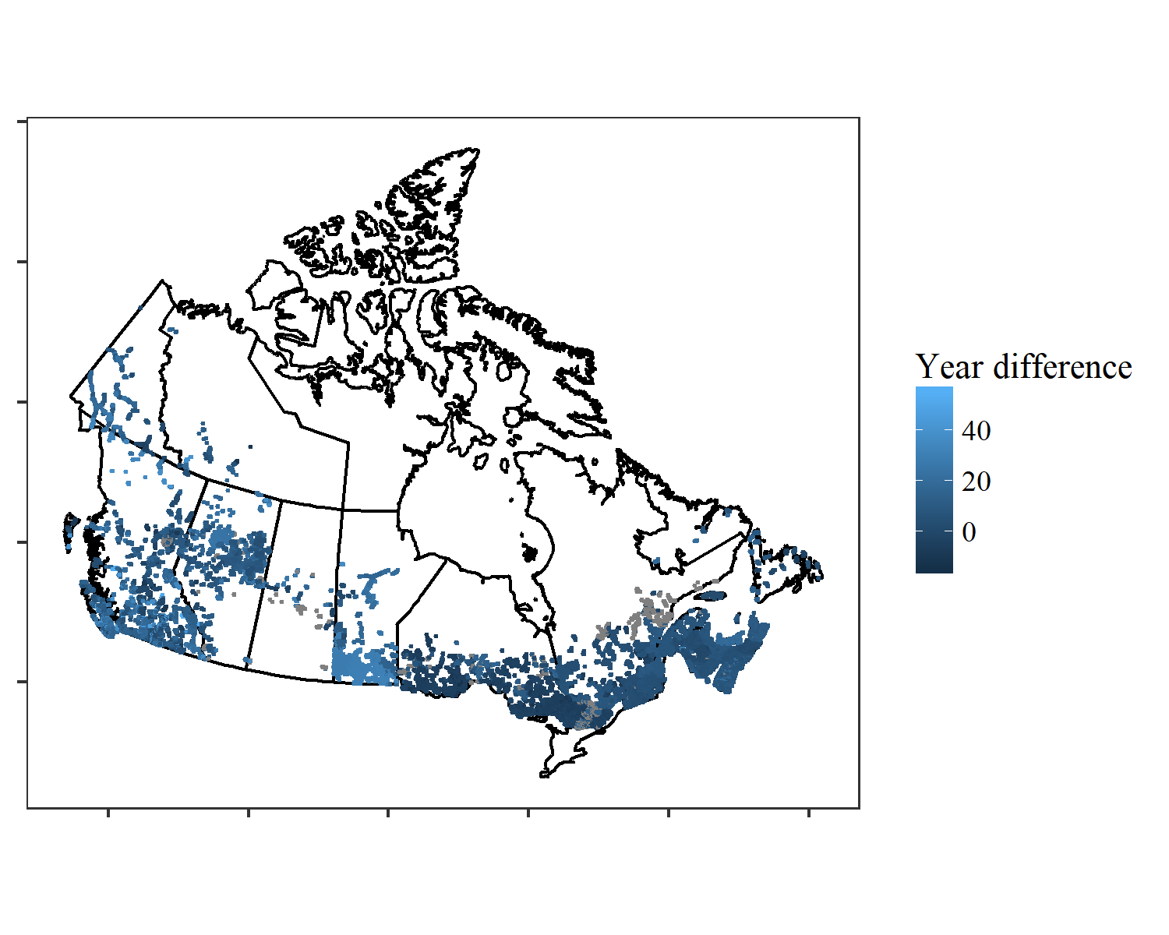

Figure 2. Map of BAM-CASFRI points showing the difference between the photo year and the survey year.

It appears that there is some spatial structure in the data, with a great deal of the older photos being in Manitoba and clustred in the western part of the study area (Alberta and British Columbia). Also, the mjority of the points with no photo year (shown in gray) are clustered in southern Ontario or scattered throughout northern Quebec.

# -------------------------------------------------------------------------------------------------------------------------------------------------  
# Step 2: Do the eliminations based on photo and disturbance  
#   
# -------------------------------------------------------------------------------------------------------------------------------------------------  
  
# The first elimination will be all sites where there is no photo year recorded  
length(which(is.na(years_dst$photo_year)))

## [1] 7828

years_dst_photo<-years_dst[-which(is.na(years_dst$photo_year)),]

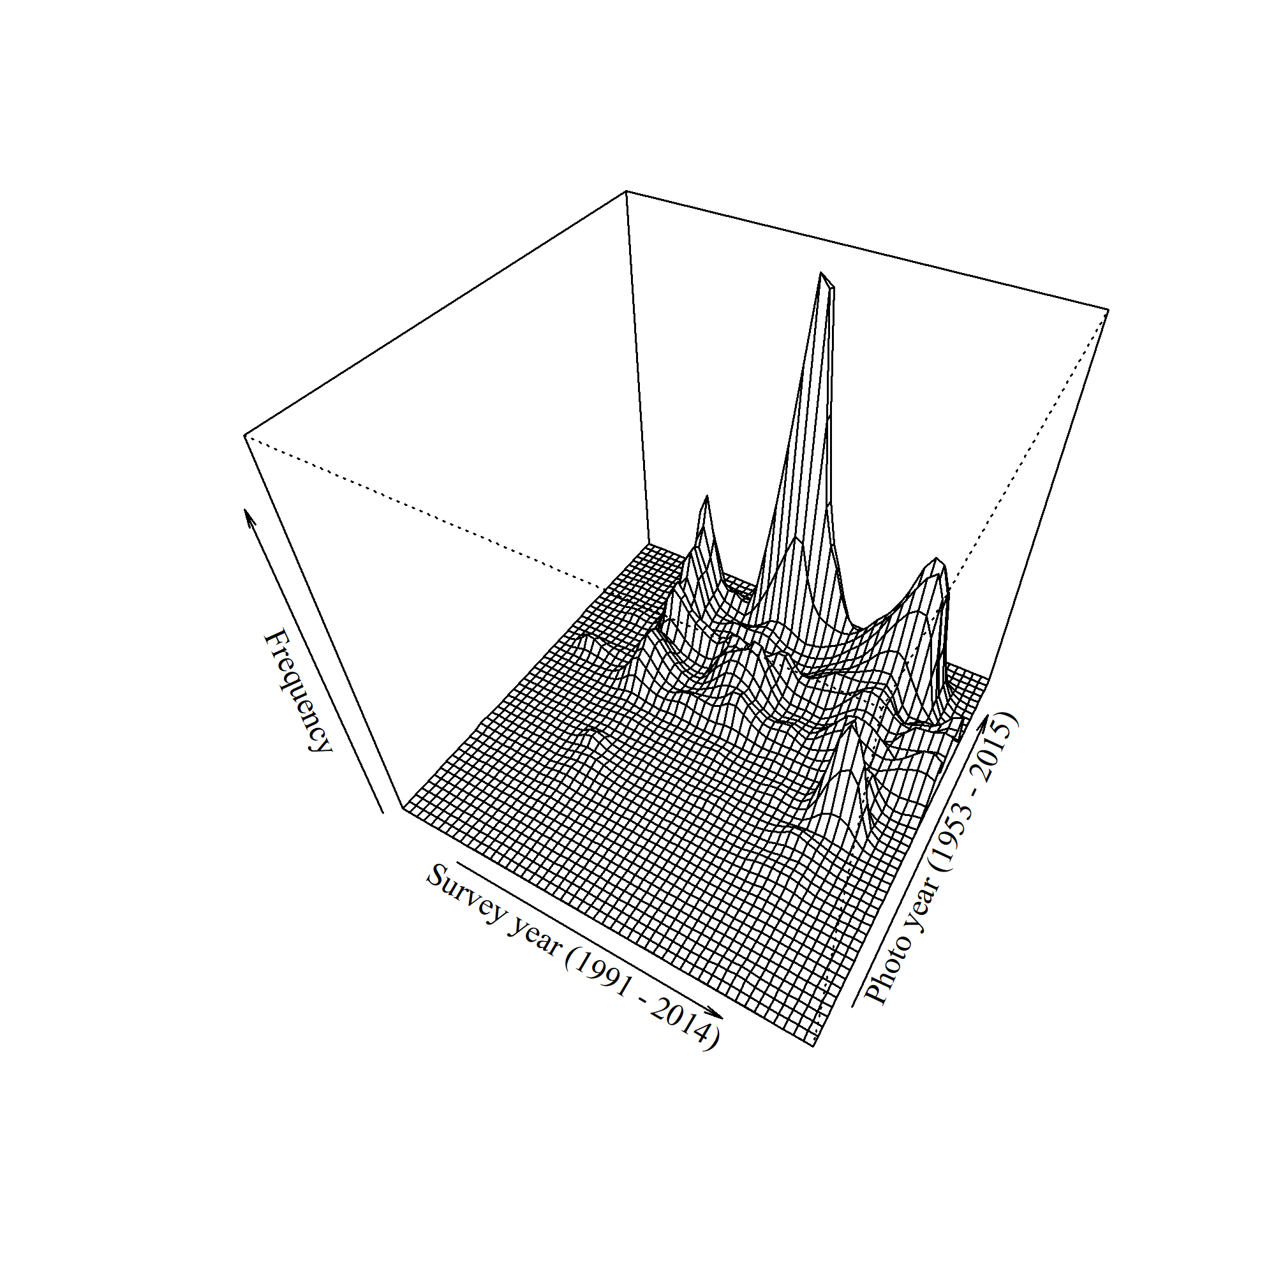

Figure 3. 3D density plot of the BAM survey years and CASFRI photo years.

We used the CASFRI disturbance data, the Global Forest Change dataset, and the CanLaD dataset to determine whether a disturbance occurred at a site and when it occurred. The CASFRI dataset records up to 3 disturbances with the year the disturbance occurred (if available). The GFC dataset begins at the year 2001 and the CanLaD dataset begins in 1985 (no points within the BAM dataset had CanLad disturbance recorded prior to 1985) and ends in 2015, so these 2 datasets cover the majority of the time period encompassed by the BAM dataset.

To determine if a disturbance had occurred between the photo year and survey year, we looked across disturbance records from each dataset (CASFRI, GFC, CanLaD) and determined if any recorded disturbances occurred betwen the photo year and the survey year.

# Now we simply check to see if a disturbance was recorded by any of the datasets (except BEAD) betwen the photo year and the survey year. If there is a disturbance  
# record in the BEAD datset but no evidence for a disturbance between the photo year and the survey year, we assume the BEAD disturbance occurred outside of that time period  
for(i in 1:nrow(years_dst_photo)){  
 d <- c(years_dst_photo$canlad_dst[i], years_dst_photo$gfc_yol[i], years_dst_photo$dist_yr_1[i], years_dst_photo$dist_yr_2[i], years_dst_photo$dist_yr_3[i])  
 years_dst_photo$i.dst[i] <- ifelse(any(d >= min(years_dst_photo$photo_year[i], years_dst_photo$YYYY[i]) & d <= max(years_dst_photo$photo_year[i], years_dst_photo$YYYY[i]), na.rm = TRUE), 1, 0)  
}  
  
t <- which(years_dst_photo$i.dst==1)  
  
y2.dst <- years_dst_photo[-t, ]

Below is a map of the points with no evidence of disturbance bewteen the photo year and the survey year, again using a color ramp for the year difference between the photo and the survey

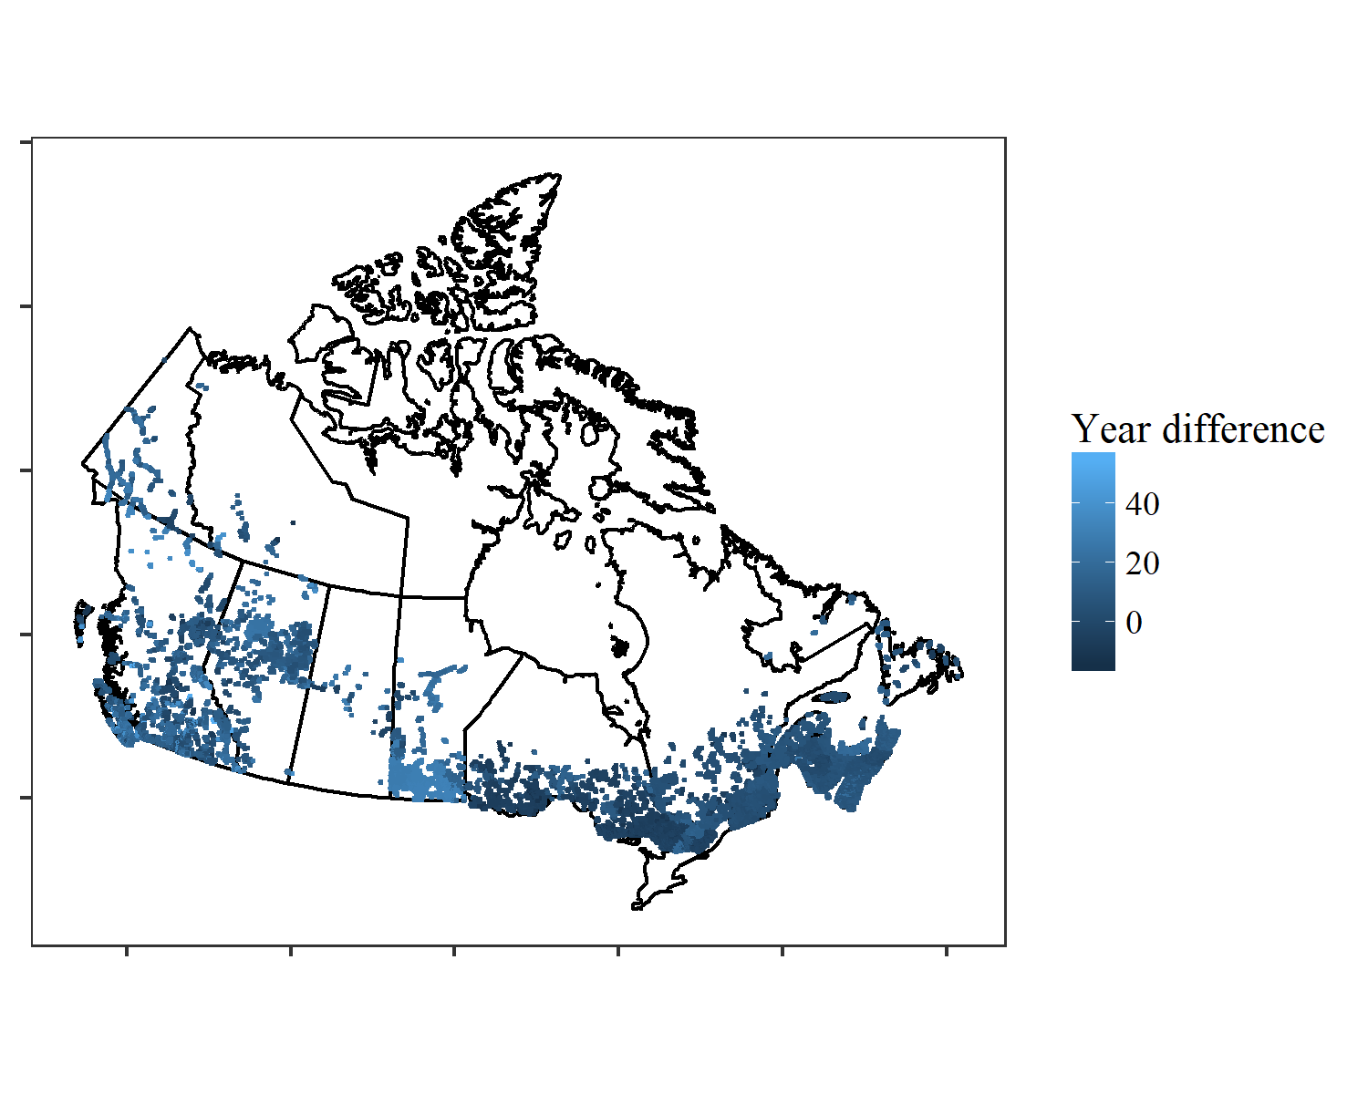

Figure 4. Map of undisturbed BAM-CASFRI points showing the difference between the survey and the photo years.

Finally, we designated each point as being either in the west or the east based on its postion relative to the 98th meridian in Manitoba, and limited the data to points where the photo and the survey were no more than 10 years apart.

# Limit the data to sites that were surveyed within 10 years of the photo year  
f<-which(y2.dst$year_dif < -10 | y2.dst$year_dif > 10)  
years_final<-y2.dst[-f, ]  
  
# Designate region as east or west of the 98th meridian in Manitoba  
years_final$west<-rep(NA, nrow(years_final))  
for(i in 1:nrow(years_final)){  
 if(years_final[i, "X"] <= -98){  
 years_final[i, "west"]<-1  
 }else{  
 years_final[i, "west"]<-0  
 }  
}  
sum(years_final$west)

## [1] 17596

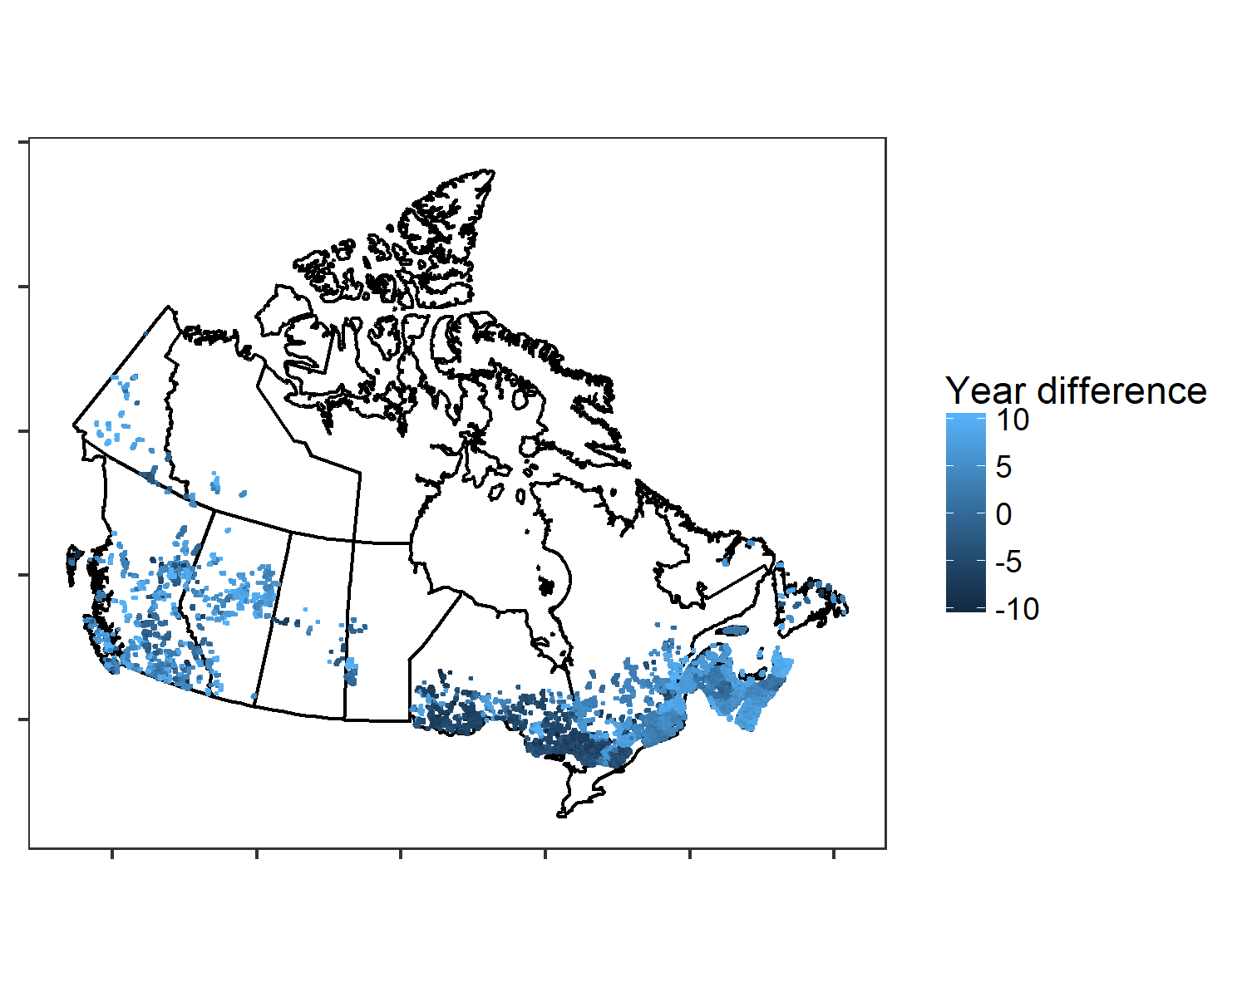

Figure 5. Map of the final points eligable to be used in analysis, using only those where the survey was done within 10 years (+ or -) of the photo.

Out of 68,680 final points, there are 51,084 points in the east and 17,596 points in the west (almost a 3:1 ratio). These points can now be matched up with forest composition and structure information from the CASFRI dataset and be used for modelling bird populations. Fig. 6 shows the denisty of survey year and photo for the final dataset, indicating the vast majority of surveys were done in the early 2000’s while the vast majority of photos were taken around 2010.

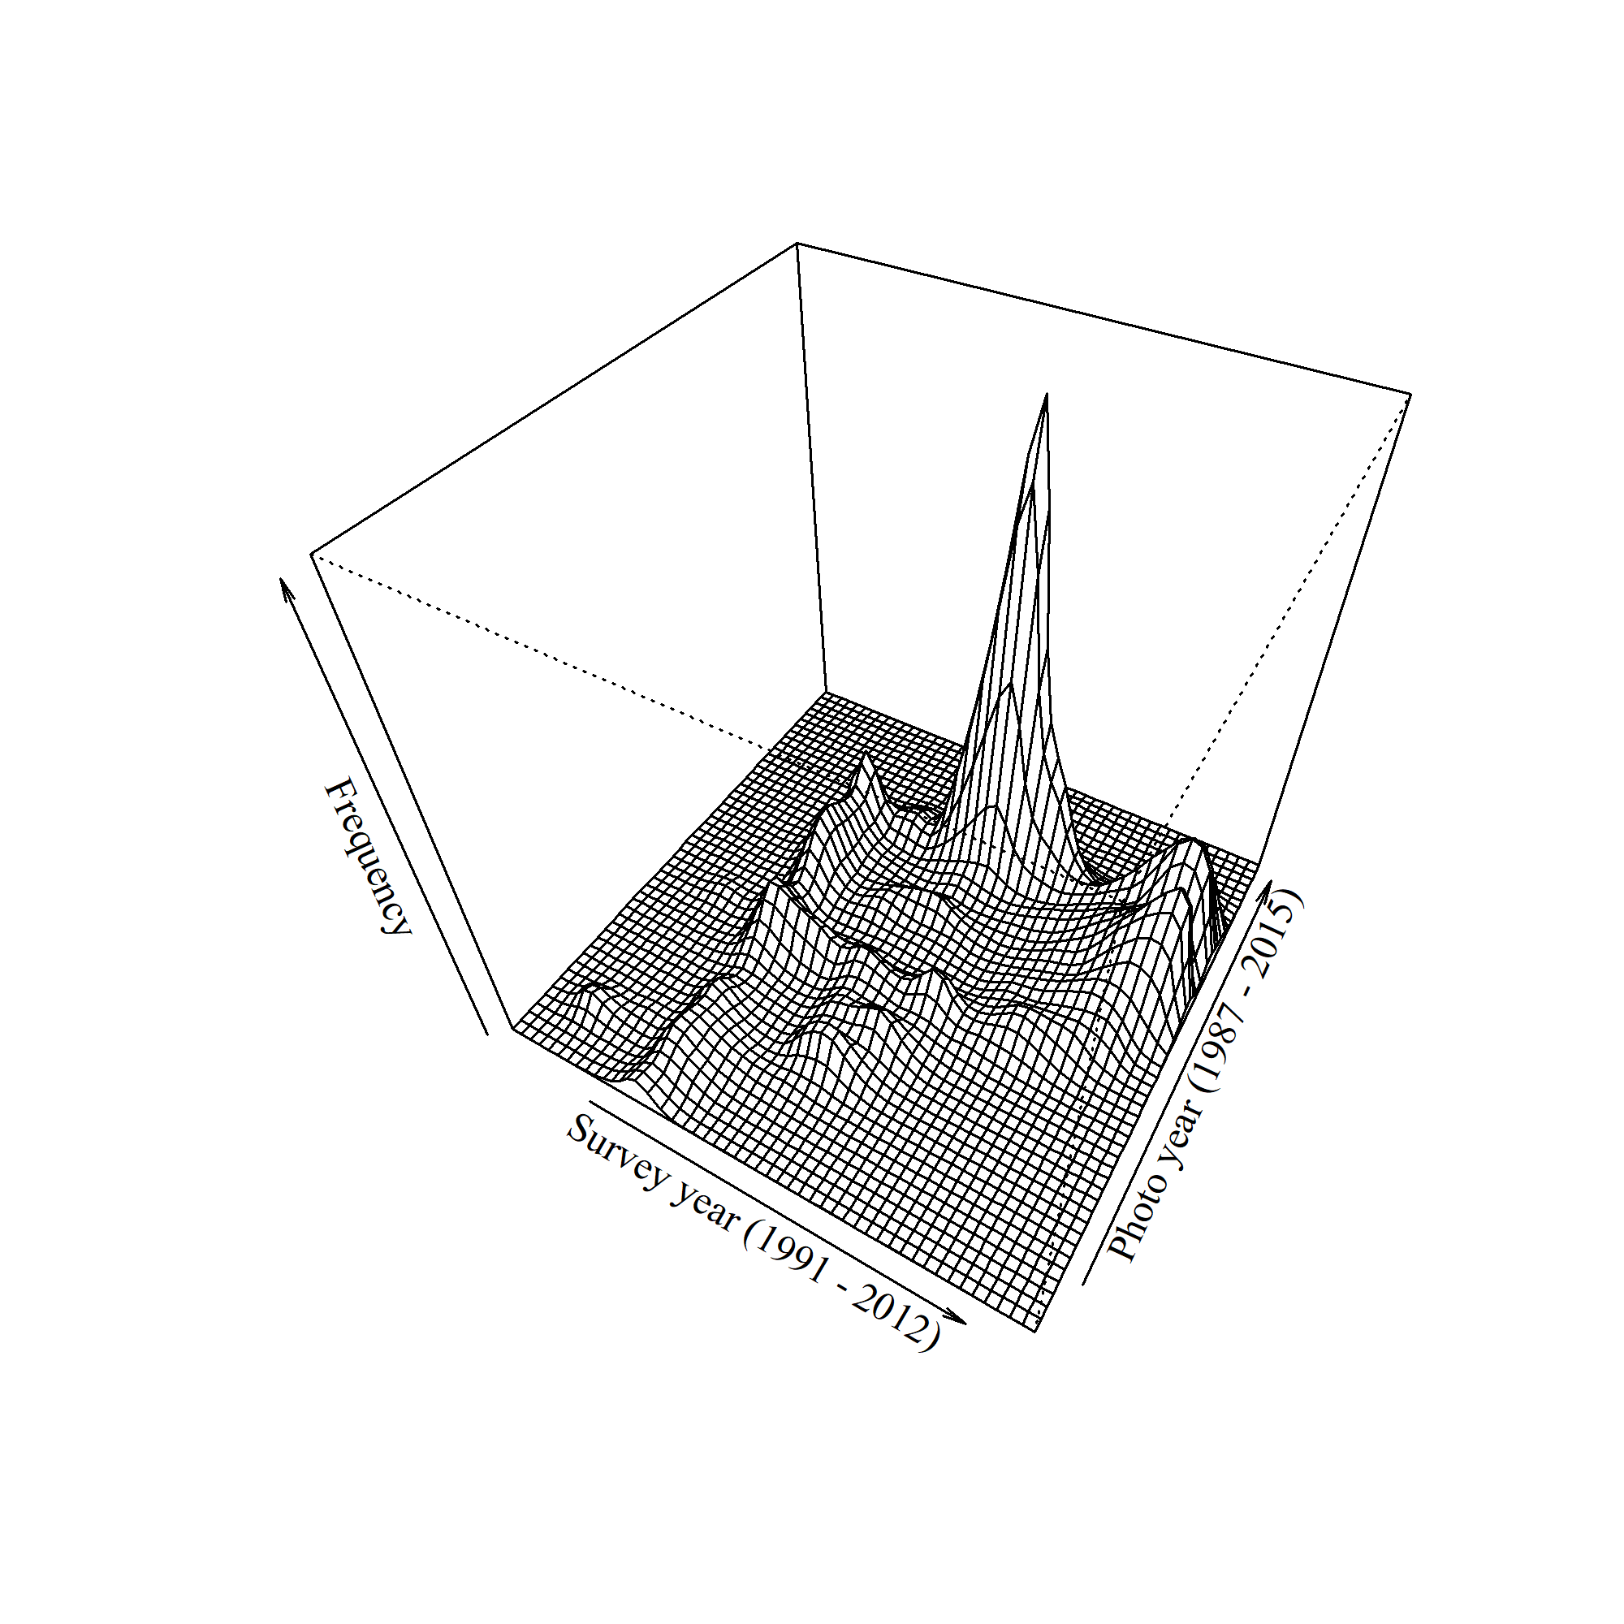

Figure 6. 3D density plot of the BAM survey years and CASFRI photo years for the final set of points.

## Literature Cited

Cumming, S. G., C. R. Drever, M. Houle, J. Cosco, P. Racine, E. M. Bayne, and F. K. A. Schmiegelow. 2015. A gap analysis of tree species representation in the protected areas of the Canadian boreal forest: applying a new assemblage of digital Forest Resource Inventory data. Canadian Journal of Forest Research 45:163–173.

Cumming, S. G., K. L. Lefevre, E. Bayne, T. Fontaine, F. K. A. Schmiegelow, and S. J. Song. 2010. Toward Conservation of Canada’s Boreal Forest Avifauna 5.

Guindon, L., P. Bernier, S. Gauthier, G. Stinson, P. Villemaire, and A. Beaudoin. 2018. Missing forest cover gains in boreal forests explained. Ecosphere 9:e02094.

Hansen, M. C., P. V. Potapov, R. Moore, M. Hancher, S. a Turubanova, A. Tyukavina, D. Thau, S. V. Stehman, S. J. Goetz, T. R. Loveland, a Kommareddy, A. Egorov, L. Chini, C. O. Justice, J. R. G. Townshend, P. Patapov, R. Moore, M. Hancher, S. a Turubanova, A. Tyukavina, D. Thau, S. V. Stehman, S. J. Goetz, T. R. Loveland, A. Kommaredy, A. Egorov, L. Chini, C. O. Justice, and J. R. G. Townshend. 2013. High-Resolution Global Maps of. Science 342:850–854.