Final BAM-CASFRI data points

Andrew Crosby

14 March, 2018

This report describes the process for adding forest structure and composition data to the usable BAM-CASFRI points (those where we could find no evidence of a disturbance between the photo year and the survey year).

The Forest Resource Inventory (FRI) variables used in these preliminary models were crown closure (the proportion of area within a stand covered by tree crowns), canopy height (meters above the ground), proportion of the canopy in conifers, the region the point occurred in (east or west of the 98th meridian in Manitoba), and the interactions of region with canopy height and proportion conifer. We filtered the forest composition and structure data to include only those stands that had records for crown closure, canopy height, and at least one tree species see Appendix 2.

points_data_final<-sqldf("select distinct years_final.ss, years_final.cas_id, years_final.x_caeac, years_final.y_caeac, lyr_totals.crown_closure, lyr_totals.canopy_height, lyr_totals.pct_con, lyr_totals.pct_pinus, lyr_totals.pinus, years_final.west, years_final.YYYY, years_final.photo_year, lyr_totals.stand_origin  
 from years_final inner join lyr_totals on years_final.cas_id = lyr_totals.cas_id")  
  
  
  
head(points_data_final)

## ss cas_id  
## 1 ABCAWAWEST:162:1 AB_0021-xxxxxxxxxxxxAVI-xT117R21M5-0000000169-0294843  
## 2 ABCAWAWEST:162:10 AB_0021-xxxxxxxxxxxxAVI-xT117R22M5-0000000102-0294432  
## 3 ABCAWAWEST:162:2 AB_0021-xxxxxxxxxxxxAVI-xT117R21M5-0000000169-0294843  
## 4 ABCAWAWEST:162:3 AB_0021-xxxxxxxxxxxxAVI-xT117R21M5-0000000169-0294843  
## 5 ABCAWAWEST:162:5 AB_0021-xxxxxxxxxxxxAVI-xT117R22M5-0000000018-0295011  
## 6 ABCAWAWEST:162:6 AB_0021-xxxxxxxxxxxxAVI-xT117R22M5-0000000021-0294616  
## x_caeac y_caeac crown_closure canopy_height pct_con pct_pinus pinus  
## 1 -1196789 2315936 60.5 3.5 0 0 0  
## 2 -1197703 2316788 18.0 16.5 0 0 0  
## 3 -1196827 2315616 60.5 3.5 0 0 0  
## 4 -1197109 2315659 60.5 3.5 0 0 0  
## 5 -1197534 2316082 40.5 17.5 0 0 0  
## 6 -1197343 2316362 40.5 17.5 0 0 0  
## west YYYY photo_year stand_origin  
## 1 1 2012 2003 1970  
## 2 1 2012 2003 1920  
## 3 1 2012 2003 1970  
## 4 1 2012 2003 1970  
## 5 1 2012 2003 1930  
## 6 1 2012 2003 1930

# Remove points where the stand origin year is greater than either the photo year or the survey year, meaning that that stand information was updated suqbsequent to the photo or the survey  
points_data_final2 <- droplevels(points_data_final[-(which(points_data_final$stand_origin>points_data_final$YYYY | points_data_final$stand_origin>points_data_final$photo_year)),])

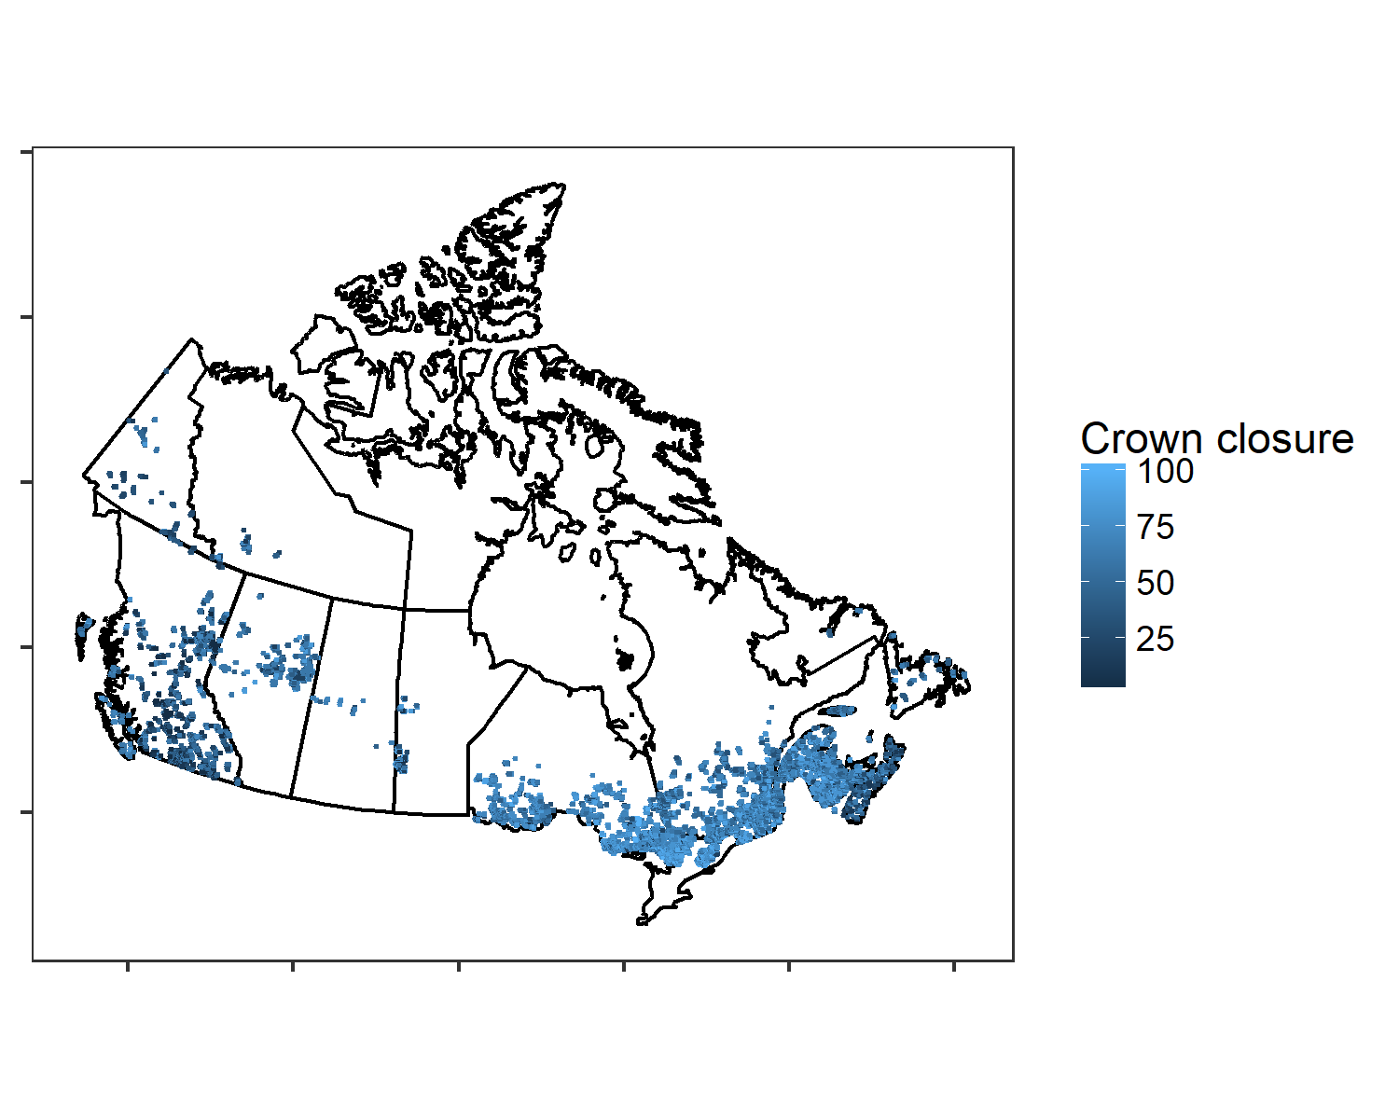

Figure 1. Map of final usable BAM-CASFRI points showing crown closure estimates in the color ramp.

The above map (Fig. 1) shows the location of usable BAM-CASFRI points that have the FRI variables necessary for our analysis. It also shows the distirbution of crown closure estimates, suggesting that there tends to be higher crown closure in the east than in the west. We removed points where the stand origin year was later than the survey year to make sure the CASFRI data had not been updated since the survey, which brought the number of usable points to 33,397.

# Load the official offsets  
load("OFF_V3_2018-02-02.Rdata")  
  
# Load the official pkey table  
pkey <- read.csv("PKEY.csv", header = TRUE)  
  
# Add the SS field to the offsets table  
OFF_SS <- data.frame(SS = pkey$SS[match(OFF$X, pkey$PKEY)], OFF)  
names(OFF_SS)[which(names(OFF_SS)=="X")] <- "PKEY"  
  
pct <- read.csv("PCTBL.csv", header=TRUE)  
  
# Select only the pct rows that correspond with rows in the BAM-CASFRI dataset  
casfri_pct <- pct[(pct$SS %in% points_data_final$ss), ]  
  
# Add the year to the spp count table   
casfri_pct$YEAR <- pkey$YEAR[match(casfri_pct$PKEY, pkey$PKEY)]  
casfri_pct[which(is.na(casfri_pct$YEAR)), ]

## X PCODE SS PKEY SPECIES ABUND  
## 1512726 1748879 CL CL:F-100-3:1-1 CL:F-100-3:1-1:12:c AMRE 1  
## 1512727 1748880 CL CL:F-100-3:1-1 CL:F-100-3:1-1:12:c BTNW 2  
## 1512728 1748881 CL CL:F-100-3:1-1 CL:F-100-3:1-1:12:c YRWA 1  
## 1512729 1748882 CL CL:F-100-3:1-1 CL:F-100-3:1-1:12:c OVEN 1  
## 1512730 1748883 CL CL:F-100-3:1-1 CL:F-100-3:1-1:12:c REVI 1  
## 1512731 1748884 CL CL:F-100-3:1-1 CL:F-100-3:1-1:12:c WTSP 1  
## 1546801 1785963 CL CL:F-100-1:4-3 CL:F-100-1:4-3:14:0650 CONW 2  
## 1546802 1785964 CL CL:F-100-1:4-3 CL:F-100-1:4-3:14:0650 OVEN 1  
## 1546803 1785965 CL CL:F-100-1:4-3 CL:F-100-1:4-3:14:0650 TEWA 1  
## 1546804 1785966 CL CL:F-100-1:4-3 CL:F-100-1:4-3:14:0650 YRWA 1  
## dur dis DISMETH DURMETH SPECIES_ALL YEAR  
## 1512726 0-5 0-50 <NA> <NA> AMRE NA  
## 1512727 0-5 0-50 <NA> <NA> BTNW NA  
## 1512728 0-5 0-50 <NA> <NA> YRWA NA  
## 1512729 0-5 50-100 <NA> <NA> OVEN NA  
## 1512730 0-5 50-100 <NA> <NA> REVI NA  
## 1512731 0-5 50-100 <NA> <NA> WTSP NA  
## 1546801 0-5 0-50 <NA> <NA> CONW NA  
## 1546802 0-5 50-100 <NA> <NA> OVEN NA  
## 1546803 0-5 50-100 <NA> <NA> TEWA NA  
## 1546804 0-5 50-100 <NA> <NA> YRWA NA

# Some don't have years, so need to derive years from the PKEY data. In this case, all of the missing years were >2000 so just need to add 2000  
casfri_pct[which(is.na(casfri_pct$YEAR)), "YEAR"] <- 2000 + as.numeric(sapply(strsplit(as.character(casfri_pct[which(is.na(casfri_pct$YEAR)), "PKEY"]), ":"), "[", 4))  
  
casfri_pct[which(casfri_pct$PKEY=="CL:F-100-1:4-3:14:0650"), ]

## X PCODE SS PKEY SPECIES ABUND  
## 1546801 1785963 CL CL:F-100-1:4-3 CL:F-100-1:4-3:14:0650 CONW 2  
## 1546802 1785964 CL CL:F-100-1:4-3 CL:F-100-1:4-3:14:0650 OVEN 1  
## 1546803 1785965 CL CL:F-100-1:4-3 CL:F-100-1:4-3:14:0650 TEWA 1  
## 1546804 1785966 CL CL:F-100-1:4-3 CL:F-100-1:4-3:14:0650 YRWA 1  
## dur dis DISMETH DURMETH SPECIES_ALL YEAR  
## 1546801 0-5 0-50 <NA> <NA> CONW 2014  
## 1546802 0-5 50-100 <NA> <NA> OVEN 2014  
## 1546803 0-5 50-100 <NA> <NA> TEWA 2014  
## 1546804 0-5 50-100 <NA> <NA> YRWA 2014

# Reformat to PKEY x SPP table  
casfri_spp_ct <- dcast(casfri_pct, SS + PKEY + YEAR ~ SPECIES, sum, value.var = "ABUND")  
  
# Finally, we made sure that all points in the final casfri data were reperesneted in the point count data  
points_data_final_pct <- points_data_final2[which(points_data_final2$ss %in% casfri_spp_ct$SS), ]

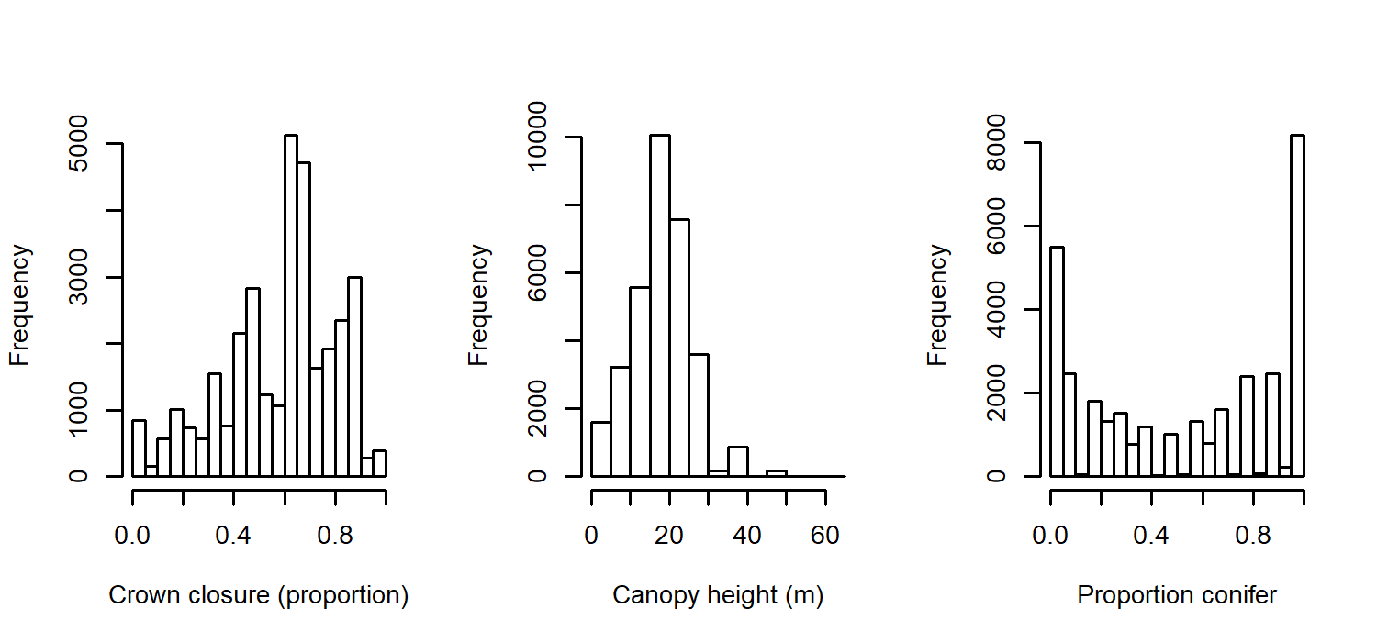

Figure 2. Frequency distirbutions of FRI variables used to model bird habitat.

The histograms in Fig. 2 (above) show the frequencies for crown closure, canopy height, and proportion conifer over the entire final dataset. The plots in Fig. 3 (below) show kernel densities of the same variables between the east (blue) and west (green). This shows that crown closure tends to be higher in the east while canoopy height tends to be higher in the west. It also appears the separation between conifer and deciduous stands is slightly stronger in the west.

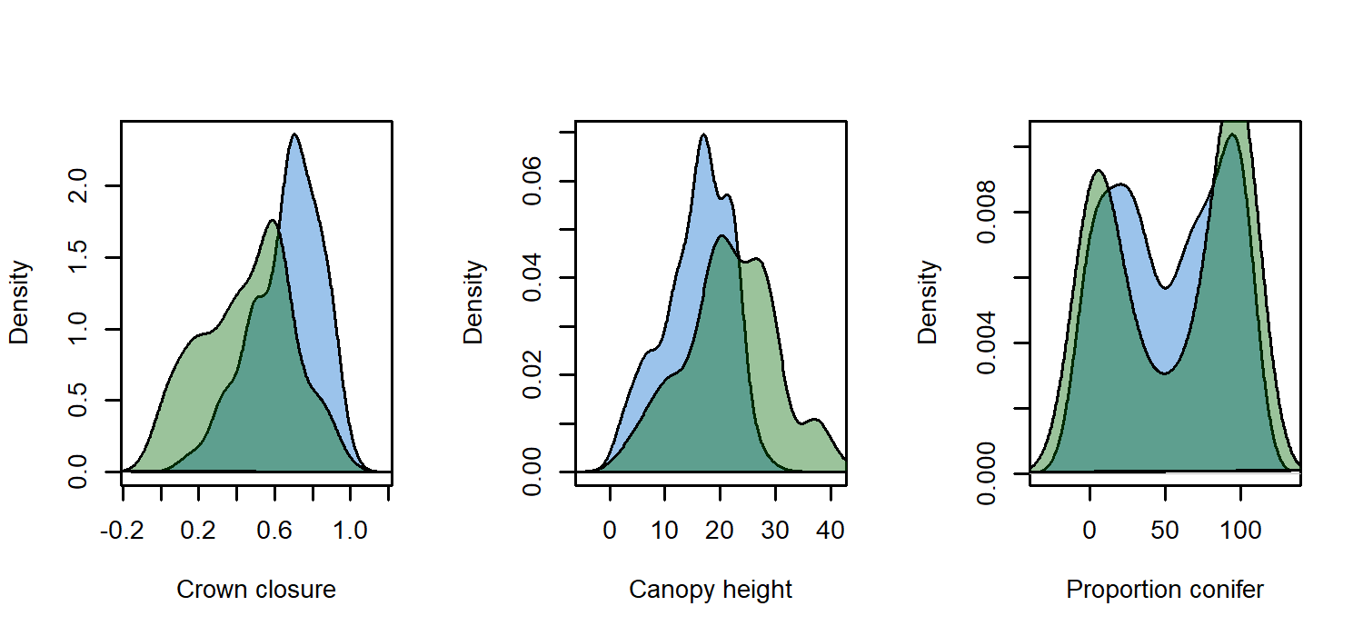

Figure 3. Kernal density plots of FRI variables used to model bird habitat separated between east (blue) and west (green).

Some sites were sampled only once in a single year, some were sampled in > 1 year or had > 1 samples in a year (or both). Therefore, to avoid bias we chose the sample that was closest in year to the photo year. If > 1 sample equalled the lowest distance betwen the sample year and the photo year we randomly chose between those sites.

# Sample from the point count data to choose the pkey that is closest to the photo year. If > 1 pkey were equally close, randomly choose between them.   
SS.rand<-rep(NA, nrow(points_data_final_pct)) # The empty dataset that will hold the row numbers of all the selected samples  
for(i in 1:nrow(points_data_final_pct)){  
 x <- as.numeric(which(casfri_spp_ct$SS == paste(points_data_final_pct$ss[i])))  
 if(length(x)==1){  
 SS.rand[i]<-x  
 }else{  
 y <- abs(casfri_spp_ct[x, "YEAR"] - points_data_final_pct[which(points_data_final_pct$ss == paste(points_data_final_pct$ss[i])), "photo_year"])  
 if(length(which(y == min(y))) == 1){  
 SS.rand[i] <- x[which(y == min(y))]  
 }else{  
 z <- sample(which(y == min(y)), 1)  
 SS.rand[i] <- x[z]  
 }  
 }  
}  
  
spp_rand<-casfri_spp_ct[SS.rand,] # The individual species counts at each selected sample

Just for fun, we ran a couple of preliminary models for 6 different species: Canada warbler, Black-throated green warbler, Brown Creeper, Connecticut warbler, Blackburnian warbler, and Cape May Warbler. We ran 2 models each: a standard Poisson glm with the variables Crown Closure, Canopy Height, Proportion Conifer, Region (East = 0, West = 1) and the interactions of region with Proportion Conifer and Canopy Height. The results will be displayed in a table showing which varaibales were significant for each species at $a = 0.05$. The full results of each model will be shown at the end in Appendix A.

points_data_final_mod <- points_data_final_pct  
points_data_final_mod$crown_closure <- points_data_final_pct$crown_closure/100  
points_data_final_mod$canopy_height <- scale(points_data_final_pct$canopy_height)  
points_data_final_mod$pct_con <- points_data_final_pct$pct_con/100  
  
head(points_data_final_mod)

## ss cas_id  
## 1 ABCAWAWEST:162:1 AB_0021-xxxxxxxxxxxxAVI-xT117R21M5-0000000169-0294843  
## 2 ABCAWAWEST:162:10 AB_0021-xxxxxxxxxxxxAVI-xT117R22M5-0000000102-0294432  
## 3 ABCAWAWEST:162:2 AB_0021-xxxxxxxxxxxxAVI-xT117R21M5-0000000169-0294843  
## 4 ABCAWAWEST:162:3 AB_0021-xxxxxxxxxxxxAVI-xT117R21M5-0000000169-0294843  
## 5 ABCAWAWEST:162:5 AB_0021-xxxxxxxxxxxxAVI-xT117R22M5-0000000018-0295011  
## 6 ABCAWAWEST:162:6 AB_0021-xxxxxxxxxxxxAVI-xT117R22M5-0000000021-0294616  
## x_caeac y_caeac crown_closure canopy_height pct_con pct_pinus pinus  
## 1 -1196789 2315936 0.605 -1.89111730 0 0 0  
## 2 -1197703 2316788 0.180 -0.18530403 0 0 0  
## 3 -1196827 2315616 0.605 -1.89111730 0 0 0  
## 4 -1197109 2315659 0.605 -1.89111730 0 0 0  
## 5 -1197534 2316082 0.405 -0.05408762 0 0 0  
## 6 -1197343 2316362 0.405 -0.05408762 0 0 0  
## west YYYY photo_year stand_origin  
## 1 1 2012 2003 1970  
## 2 1 2012 2003 1920  
## 3 1 2012 2003 1970  
## 4 1 2012 2003 1970  
## 5 1 2012 2003 1930  
## 6 1 2012 2003 1930

sum(points_data_final_mod$west)/nrow(points_data_final_mod)

## [1] 0.3532653

speclist <- c("CAWA", "BTNW", "BRCR", "CONW", "BLBW", "CMWA")  
  
for(i in 1:length(speclist)){  
 points_data_final_pct[[paste(speclist[i], "_off", sep="")]] <- OFF_SS[SS.rand, speclist[i]]  
 points_data_final_pct[[speclist[i]]] <- spp_rand[, speclist[i]]  
}  
  
for(i in 1:length(speclist)){  
 points_data_final_mod$spec <- points_data_final_pct[, speclist[i]]  
 points_data_final_mod$off <- points_data_final_pct[, paste(speclist[i], "_off", sep="")]  
 assign(paste("mod_", speclist[i], sep = ""), glm(spec ~ crown_closure + canopy_height + pct_con + west + west*pct_con +  
 west*canopy_height, data=points_data_final_mod, family=poisson("log"), offset=off))  
 assign(paste("mod1_", speclist[i], sep = ""), glmer(spec ~ crown_closure + canopy_height + pct_con + west + west*pct_con +  
 west*canopy_height + (1 | YYYY), data=points_data_final_mod, family=poisson("log"), offset=off))  
}  
  
model_table <- data.frame(matrix(NA, length(speclist), 8))  
colnames(model_table) <- c("Species", "Crown closure", "Canopy height", "% Conifer", "West (1 or 0)", "% Conifer x West", "Canopy height x West", "Delta AIC")  
for(i in 1:length(speclist)){  
 model_table[i, 1] <- paste(speclist[i])  
 coefs <- data.frame(coef(summary(get(paste("mod1_", speclist[i], sep="")))))  
 for(j in 2:7){  
 if(coefs$Pr...z..[j] <=0.05){  
 model_table[i, j] <- paste(round(coefs$Estimate[j], 3), " *", sep="")  
 }else{  
 model_table[i, j] <- paste(round(coefs$Estimate[j], 3), " ", sep="")  
 }  
 }  
 model_table[i, 8] <- round(AIC(get(paste("mod_", speclist[i], sep=""))) - AIC(get(paste("mod1_", speclist[i], sep=""))), 0)  
}

Table 1. Statistical significance of CASFRI variables (* = p < 0.05) and delta AIC between the standard linear model and the mixed affects model where the year of the survey has a random effect on the intercept.

|  |  |  |  |  |  |  |  |
| --- | --- | --- | --- | --- | --- | --- | --- |
| Species | Crown closure | Canopy height | % Conifer | West (1 or 0) | % Conifer x West | Canopy height x West | Delta AIC |
| CAWA | -0.472 * | 0.229 * | -0.376 * | 0.297 * | -1.531 * | -0.3 * | 335 |
| BTNW | 0.521 * | 0.287 * | -0.615 * | -1.052 * | -0.583 * | -0.326 * | 682 |
| BRCR | 0.819 * | 0.718 * | 1.123 * | 0.381 * | -1.068 * | -0.46 * | 388 |
| CONW | 0.249 | -0.348 * | 3.76 * | 5.855 * | -5.943 * | 0.055 | 218 |
| BLBW | 0.531 * | 0.727 * | 0.078 | -0.485 * | -0.878 * | -1.052 * | 845 |
| CMWA | 0.311 | 0.095 | 0.698 * | 1.152 * | -0.06 | 0.042 | 274 |

There are a number of different options for running these models, of which this one is the most basic. It assumes that the year effect on abundance is constant across the entire study area and has no effect on selection.

##### age break

### Appendix A: Results of linear mixed effects models with year as a random effect on the intercept for 5 species.

# Canada Warbler

## Generalized linear mixed model fit by maximum likelihood (Laplace  
## Approximation) [glmerMod]  
## Family: poisson ( log )  
## Formula: spec ~ crown_closure + canopy_height + pct_con + west + west *   
## pct_con + west * canopy_height + (1 | YYYY)  
## Data: points_data_final_mod  
## Offset: off  
##   
## AIC BIC logLik deviance df.resid   
## 11776.6 11844.0 -5880.3 11760.6 33389   
##   
## Scaled residuals:   
## Min 1Q Median 3Q Max   
## -0.6469 -0.2291 -0.1837 -0.1370 25.5136   
##   
## Random effects:  
## Groups Name Variance Std.Dev.  
## YYYY (Intercept) 0.8706 0.9331   
## Number of obs: 33397, groups: YYYY, 21  
##   
## Fixed effects:  
## Estimate Std. Error z value Pr(>|z|)   
## (Intercept) -3.00290 0.25189 -11.922 < 2e-16 ***  
## crown_closure -0.47195 0.12641 -3.734 0.000189 ***  
## canopy_height 0.22946 0.04839 4.742 2.12e-06 ***  
## pct_con -0.37627 0.10121 -3.718 0.000201 ***  
## west 0.29736 0.09175 3.241 0.001191 **   
## pct_con:west -1.53059 0.15947 -9.598 < 2e-16 ***  
## canopy_height:west -0.29999 0.06843 -4.384 1.17e-05 ***  
## ---  
## Signif. codes: 0 '***' 0.001 '**' 0.01 '*' 0.05 '.' 0.1 ' ' 1  
##   
## Correlation of Fixed Effects:  
## (Intr) crwn_c cnpy_h pct_cn west pct_c:  
## crown_closr -0.341   
## canopy_hght -0.028 -0.015   
## pct_con -0.222 0.118 0.317   
## west -0.246 0.241 0.123 0.528   
## pct_con:wst 0.096 0.030 -0.207 -0.625 -0.584   
## cnpy_hght:w 0.009 0.023 -0.718 -0.221 -0.281 0.183

##### page break

# Black_throated Green Warbler

## Generalized linear mixed model fit by maximum likelihood (Laplace  
## Approximation) [glmerMod]  
## Family: poisson ( log )  
## Formula: spec ~ crown_closure + canopy_height + pct_con + west + west *   
## pct_con + west * canopy_height + (1 | YYYY)  
## Data: points_data_final_mod  
## Offset: off  
##   
## AIC BIC logLik deviance df.resid   
## 35420.7 35488.0 -17702.4 35404.7 33389   
##   
## Scaled residuals:   
## Min 1Q Median 3Q Max   
## -1.4856 -0.4907 -0.3656 -0.2002 24.3832   
##   
## Random effects:  
## Groups Name Variance Std.Dev.  
## YYYY (Intercept) 0.2516 0.5016   
## Number of obs: 33397, groups: YYYY, 21  
##   
## Fixed effects:  
## Estimate Std. Error z value Pr(>|z|)   
## (Intercept) -1.43477 0.12732 -11.269 < 2e-16 ***  
## crown_closure 0.52080 0.06698 7.776 7.50e-15 ***  
## canopy_height 0.28746 0.01958 14.683 < 2e-16 ***  
## pct_con -0.61541 0.04030 -15.271 < 2e-16 ***  
## west -1.05247 0.05590 -18.827 < 2e-16 ***  
## pct_con:west -0.58316 0.09157 -6.368 1.91e-10 ***  
## canopy_height:west -0.32566 0.03837 -8.487 < 2e-16 ***  
## ---  
## Signif. codes: 0 '***' 0.001 '**' 0.01 '*' 0.05 '.' 0.1 ' ' 1  
##   
## Correlation of Fixed Effects:  
## (Intr) crwn_c cnpy_h pct_cn west pct_c:  
## crown_closr -0.374   
## canopy_hght -0.015 -0.038   
## pct_con -0.184 0.144 0.311   
## west -0.166 0.198 0.075 0.327   
## pct_con:wst 0.040 0.040 -0.152 -0.427 -0.602   
## cnpy_hght:w 0.006 0.018 -0.526 -0.157 -0.339 0.112

##### page break

# Brown Creeper

## Generalized linear mixed model fit by maximum likelihood (Laplace  
## Approximation) [glmerMod]  
## Family: poisson ( log )  
## Formula: spec ~ crown_closure + canopy_height + pct_con + west + west *   
## pct_con + west * canopy_height + (1 | YYYY)  
## Data: points_data_final_mod  
## Offset: off  
##   
## AIC BIC logLik deviance df.resid   
## 9272.7 9340.0 -4628.3 9256.7 33389   
##   
## Scaled residuals:   
## Min 1Q Median 3Q Max   
## -0.690 -0.206 -0.151 -0.105 39.308   
##   
## Random effects:  
## Groups Name Variance Std.Dev.  
## YYYY (Intercept) 0.645 0.8031   
## Number of obs: 33397, groups: YYYY, 21  
##   
## Fixed effects:  
## Estimate Std. Error z value Pr(>|z|)   
## (Intercept) -4.13545 0.23957 -17.262 < 2e-16 ***  
## crown_closure 0.81904 0.16540 4.952 7.35e-07 ***  
## canopy_height 0.71801 0.05201 13.806 < 2e-16 ***  
## pct_con 1.12307 0.11068 10.147 < 2e-16 ***  
## west 0.38114 0.12845 2.967 0.00301 **   
## pct_con:west -1.06832 0.17261 -6.189 6.05e-10 ***  
## canopy_height:west -0.46045 0.07488 -6.149 7.81e-10 ***  
## ---  
## Signif. codes: 0 '***' 0.001 '**' 0.01 '*' 0.05 '.' 0.1 ' ' 1  
##   
## Correlation of Fixed Effects:  
## (Intr) crwn_c cnpy_h pct_cn west pct_c:  
## crown_closr -0.504   
## canopy_hght -0.074 0.011   
## pct_con -0.361 0.177 0.249   
## west -0.324 0.233 0.155 0.542   
## pct_con:wst 0.153 0.015 -0.163 -0.620 -0.708   
## cnpy_hght:w 0.059 -0.045 -0.703 -0.179 -0.321 0.086

##### page break

# Connecticut Warbler

## Generalized linear mixed model fit by maximum likelihood (Laplace  
## Approximation) [glmerMod]  
## Family: poisson ( log )  
## Formula: spec ~ crown_closure + canopy_height + pct_con + west + west *   
## pct_con + west * canopy_height + (1 | YYYY)  
## Data: points_data_final_mod  
## Offset: off  
##   
## AIC BIC logLik deviance df.resid   
## 4827.1 4894.4 -2405.5 4811.1 33389   
##   
## Scaled residuals:   
## Min 1Q Median 3Q Max   
## -1.154 -0.118 -0.063 -0.028 107.743   
##   
## Random effects:  
## Groups Name Variance Std.Dev.  
## YYYY (Intercept) 0.8295 0.9108   
## Number of obs: 33397, groups: YYYY, 21  
##   
## Fixed effects:  
## Estimate Std. Error z value Pr(>|z|)   
## (Intercept) -9.14379 0.51405 -17.788 < 2e-16 ***  
## crown_closure 0.24913 0.19096 1.305 0.19201   
## canopy_height -0.34842 0.12169 -2.863 0.00419 **   
## pct_con 3.76047 0.50452 7.453 9.09e-14 ***  
## west 5.85484 0.44728 13.090 < 2e-16 ***  
## pct_con:west -5.94256 0.52757 -11.264 < 2e-16 ***  
## canopy_height:west 0.05502 0.13363 0.412 0.68053   
## ---  
## Signif. codes: 0 '***' 0.001 '**' 0.01 '*' 0.05 '.' 0.1 ' ' 1  
##   
## Correlation of Fixed Effects:  
## (Intr) crwn_c cnpy_h pct_cn west pct_c:  
## crown_closr -0.259   
## canopy_hght 0.010 -0.043   
## pct_con -0.832 0.043 0.206   
## west -0.864 0.061 -0.003 0.939   
## pct_con:wst 0.770 0.031 -0.200 -0.952 -0.914   
## cnpy_hght:w -0.015 0.065 -0.914 -0.187 -0.018 0.198

##### page break

# Blackburnian Warbler

## Generalized linear mixed model fit by maximum likelihood (Laplace  
## Approximation) [glmerMod]  
## Family: poisson ( log )  
## Formula: spec ~ crown_closure + canopy_height + pct_con + west + west *   
## pct_con + west * canopy_height + (1 | YYYY)  
## Data: points_data_final_mod  
## Offset: off  
##   
## AIC BIC logLik deviance df.resid   
## 20701.1 20768.5 -10342.6 20685.1 33389   
##   
## Scaled residuals:   
## Min 1Q Median 3Q Max   
## -1.3513 -0.3437 -0.2421 -0.1631 16.8611   
##   
## Random effects:  
## Groups Name Variance Std.Dev.  
## YYYY (Intercept) 0.8461 0.9199   
## Number of obs: 33397, groups: YYYY, 21  
##   
## Fixed effects:  
## Estimate Std. Error z value Pr(>|z|)   
## (Intercept) -2.50534 0.23418 -10.698 < 2e-16 ***  
## crown_closure 0.53072 0.09386 5.654 1.57e-08 ***  
## canopy_height 0.72749 0.03009 24.175 < 2e-16 ***  
## pct_con 0.07779 0.05765 1.349 0.177   
## west -0.48524 0.07655 -6.339 2.31e-10 ***  
## pct_con:west -0.87823 0.11701 -7.506 6.12e-14 ***  
## canopy_height:west -1.05228 0.05402 -19.481 < 2e-16 ***  
## ---  
## Signif. codes: 0 '***' 0.001 '**' 0.01 '*' 0.05 '.' 0.1 ' ' 1  
##   
## Correlation of Fixed Effects:  
## (Intr) crwn_c cnpy_h pct_cn west pct_c:  
## crown_closr -0.289   
## canopy_hght -0.044 0.024   
## pct_con -0.167 0.171 0.259   
## west -0.148 0.208 0.141 0.396   
## pct_con:wst 0.041 0.045 -0.134 -0.472 -0.673   
## cnpy_hght:w 0.028 -0.040 -0.568 -0.147 -0.276 0.187