## Appendix C: Point count and environmental data used for RoF analysis

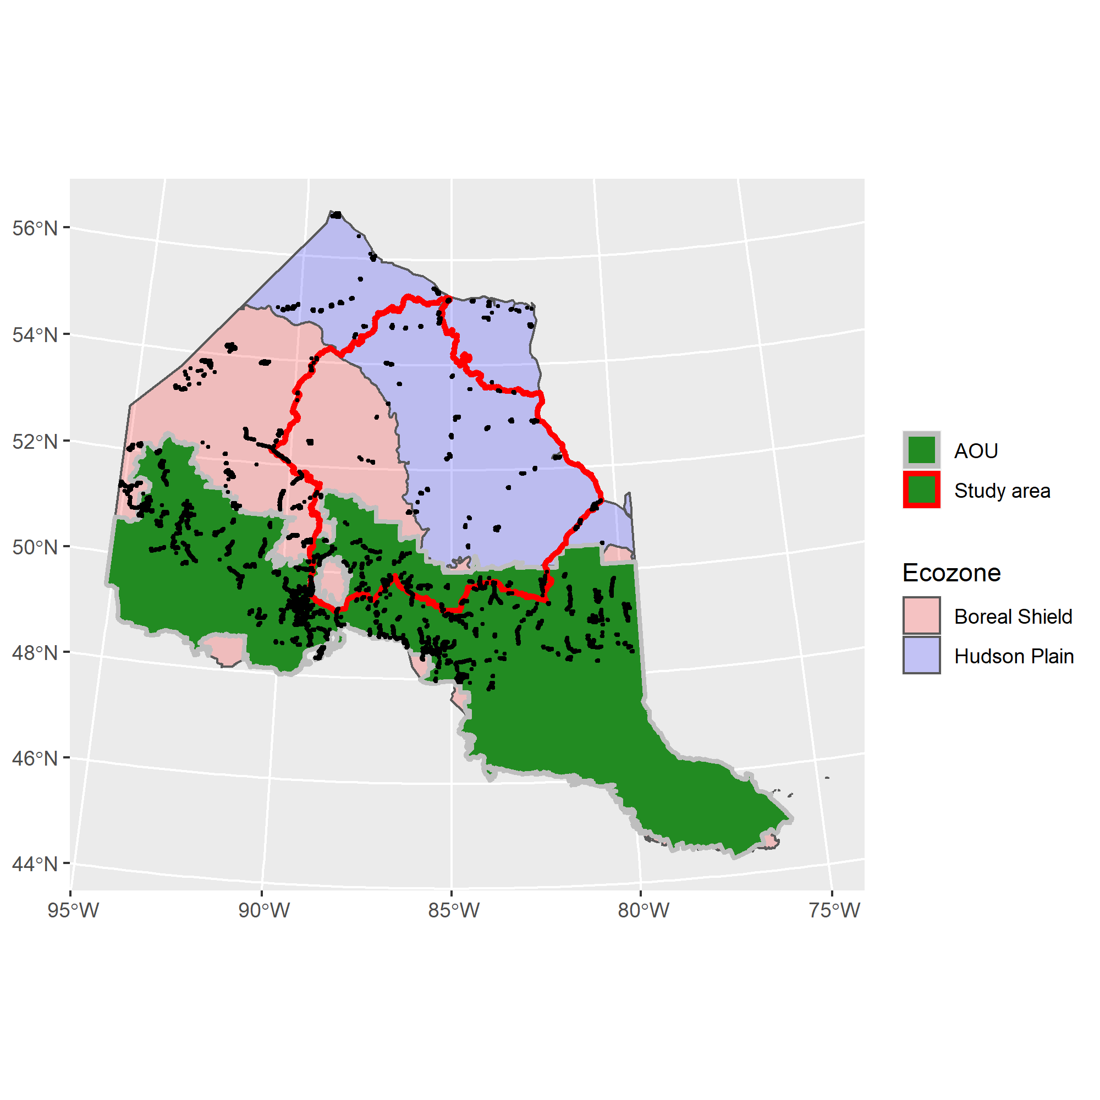

**Figure 1.** Spatial distribution of BAM point count stations (black dots) north of Bird Conservation Region 12 in Ontario.

## The breakdown of point locations is as follows:

Total: 11566  
Hudson Plain Ecozone: 1460  
Boreal Shield Ecozone: 10106

In AOU: 8487

Study Area total: 2387  
Study Area Hudson Plain: 860  
Study Area Boreal Shield: 1527  
Study Area AOU: 1309  
Study Area Far North: 1078

# Variables extracted for BAM point count stations within the larger region. This consistst of points in Ontario north of BCR 12.

All raster variables were standardized to 250m resolution raster values. If original raster was <250m resolution, the mean value among cells was used.

## Variables (and name in database)

**Elevation** (elevation): height above sea level in meters  
**Tree cover** (treecover): percentage of area covered by tree crowns  
**On road?** (road_yesno): point on road (1) or off road (0)  
**Distance from road** (road_dist_m): distance of pixel containing point from nearest road in meters  
**Adjusted distance from road** (road_dist_m.adj): distance adjusted for width of pixel  
**Distance to mine site** (mine_dist_m): distance of pixel to nearest mine site in meters  
**Slope** (slope): average slope within pixel (degrees)  
**TRI** (TRI): Topographic roughness index – The topographic ruggedness index (TRI) was developed by Riley, et al. (1999) to express the amount of elevation difference between adjacent cells of a DEM. Indicates the ruggedness of the terrain surrounding the cell. Scale-dependent.  
**TPI** (TPI): Topographic position index – Calculates whether a raster cell is on a hill, valley, or in between. Positive TPI values represent locations that are higher than the average of their surroundings, as defined by the neighborhood (ridges). Negative TPI values represent locations that are lower than their surroundings (valleys). TPI values near zero are either flat areas (where the slope is near zero) or areas of constant slope (where the slope of the point is significantly greater than zero). Scale-dependent.

### Landcover classes: These were calculated at the local level [local; pixel is in that class (1) or not (0)] and with a Gaussian filter at 250m (_G250) and 750m (_G750), where the value is the distance-weighted proportion of pixels in that land-cover class surrounding the point.

#### Far North Land-cover and Ontario Land-cover

Bedrock:  
Communities:  
Conifer Swamp:  
Conifer Treed:  
Deciduous Swamp:  
Deciduous Treed:  
Disturbed non-woody:  
Disturbed treed:  
Freshwater marsh:  
Heath:  
Intertidal marsh:  
Mixed treed:  
Mudflat:  
Open bog:  
Open fen:  
Open water:  
Sand-gravel mines:  
Sparse treed:  
Supertidal marsh:  
Thicket swamp:  
Treed bog:  
Treed fen:  
Turbid water:

#### LCC 2005

Barren:  
Cropland:  
Polar barren:  
Polar grass:  
Polar shrub:  
Taiga:  
Temperate or sub-polar broadleaf:  
Temperate or sub-polar grassland:  
Temperate or sub-polar mixed:  
Temperate or sub-polar needleleaf:  
Temperate or sub-polar shrub:  
Urban:  
Water:  
Wetland:

### Forest attributes from *k*NN MODIS imagery [the Beaudoin layer; @Beaudoin2014]. These were also extracted at the local level and with 250m and 750m Gaussian filters.

#### Species composition

Non-vegetated %: percent area in non-vegetated land-cover  
Vegetated %: percent of area in vegetated land-cover  
Treed %: percent of area in treed land-cover  
Vegetated non-treed %: percent of area in open (grass and shrub) vegetated land-cover  
Species-specific canopy cover %: pretty much every species you can think of  
Broadleaf canopy cover %:  
Needleaf canopy cover %:  
Unknown canopy cover %:

#### Structure

Total live above ground biomass (AGB): in tonnes/ha  
Total dead above ground biomass: dead standing biomass in tonnes/ha

##### As percentage of total live AGB

Branch biomass:  
Foliage biomass:  
Bark biomass:  
Wood biomass:

Age: years  
Crown closure %:  
Height: meters  
Merchantable volume: m3/ha  
Total volume: m3/ha

### Other attributes derived from new national layers. Exceedence is ian index of the ability of the area to buffer acid rain.

Fire mask: burned or not  
Fire year:  
Fire severity:  
Harvest mask: harvested or not  
Harvest year:  
Biomass in 2015:  
Volume in 2015:  
Height in 2015:  
Exceedence 05:  
Exceedence 20:

### Added esker data re-sampled to 250m (esker Y/N)