25 October, 2021

# **Title** Reproducible Methodology for Developing Species Distribution Models of Boreal Landbirds in Ontario’s Far North and Adjacent Areas

# **Authors:** Andrew D. Crosby1,2,3; Peter Sólymos1,2; Lionel Leston1,2; Erin M. Bayne1,2

# Affiliations:

# 1Boreal Avian Modelling Project, 751 General Services Building, University of Alberta, Edmonton, Alberta T6G 2H1, Canada

# 2Department of Biological Sciences, CW405 Biological Sciences Building, University of Alberta, Edmonton, Alberta T6G 2E9, Canada

# 3Corresponding author. Email: [crosby@ualberta.ca](mailto:crosby@ualberta.ca)

## Summary

The boreal region of North America represents a critical biome for sustaining continental landbird populations (Blancher and Wells 2005). Of the 190 species of landbirds that breed in the boreal, 46 breed only in the Far North, 35 are restricted to the Hudson Bay Lowlands, and nine are on the list of Species at Risk in Ontario (need citation). There are existing species distribution models developed by the Boreal Avian Modelling Project (BAM: <http://www.borealbirds.ca>) for predicting abundance and distribution of boreal bird species across all of Canada. The utility of these national-scale models for predicting bird response to cumulative effects (development, climate change) in the Ring of Fire chromium mining development area may be limited, as they do not include some key predictors available in Ontario. Therefore, it is necessary to develop localized models of breeding bird distributions and responses to disturbance.

The objective of this project is to develop regional species distribution models of breeding landbirds in Ontario’s Far North that can be integrated with outputs from landscape simulation models (e.g. SpaDES R package) to forecast the potential effects of proposed industrial development on bird populations.

The purpose of this document is to describe reproducible methods for acquiring and processing geospatial data files, and fitting species distiribution models, for boreal landbirds in Ontario’s Far North.

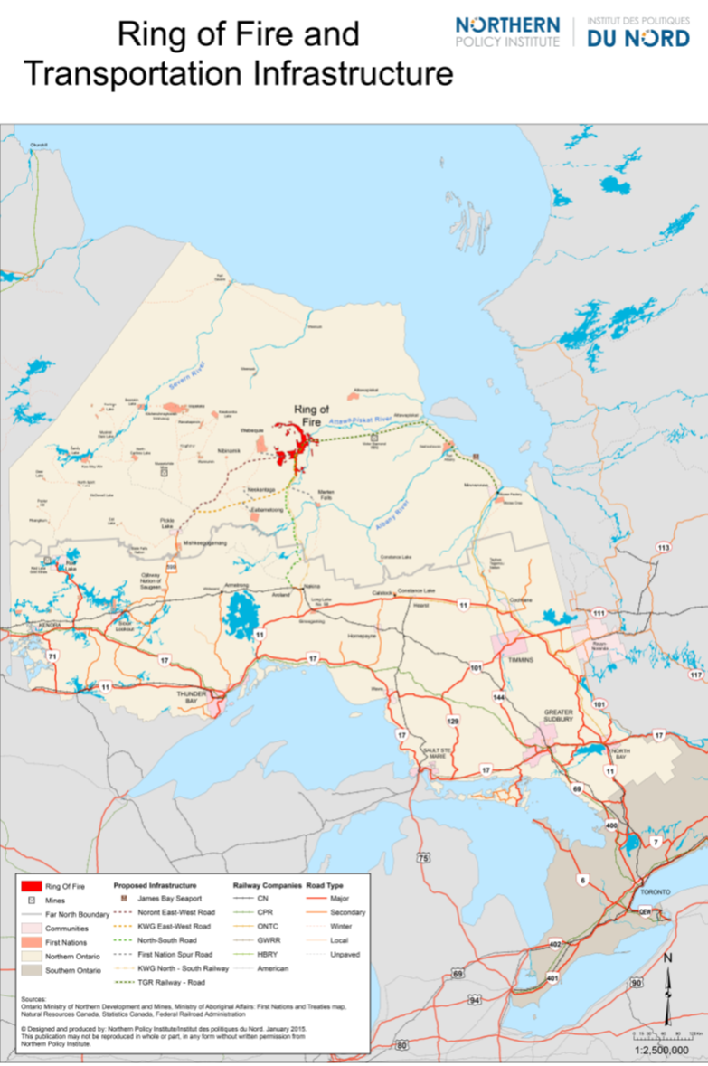

**Figure 1.** Map of Ontario, Canada showing the Far North boundary, proposed Ring of Fire development area, and current and proposed transportation infrastructure. Map provided publicly by Northern Policy Institute. Accessed online at <https://www.northernpolicy.ca/upload/documents/publications/maps/research-ring-of-fire-map-15.04.23-revis.pdf>, March 31, 2021.

# **Study Area**

Our area of interest (hereafter study area) was the area encompassed by 5 boreal caribou ranges identified as overlapping with the area of potential disturbance by industrial development for chromium mining in the Far North (Fig. 2). This area was split between the Hudson Plains and Boreal Shield ecozones. The Hudson Plains is a flat, poorly-drained area characterized by extensive wetlands intersected by numerous rivers (Ecological Stratification Working Group 1995). The Boreal Shield ecozone is a rolling landscape of glacial deposits intermixed with bedrock and many water bodies, and is much more heavily forested than the Hudson Plains (Ecological Stratification Working Group 1995). The southern portion of the Boreal Shield in our study area is within the Area of the Undertaeking (AOU) in Ontario, which is the area of commercial forest harvesting.

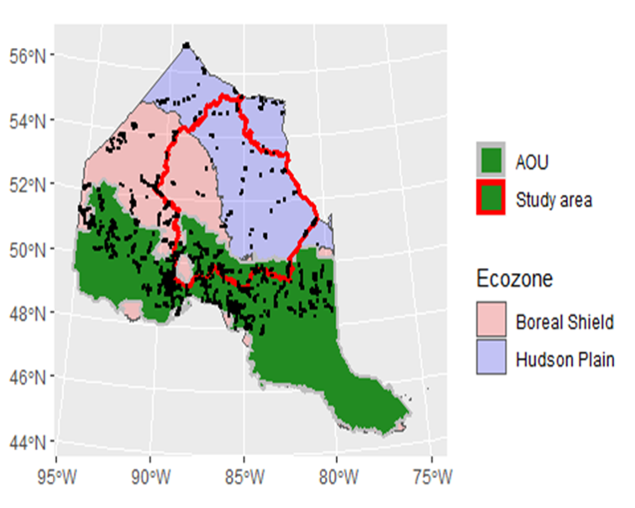

**Figure 2.** Study area within Ontario’s Far North used for assessing cumulative effects of anthropogenic disturbance on wildlife.

# **Methods**

*Avian count data*  
To estimate bird densities and habitat associations across the study area, we used data compiled by the Boreal Avian Modeling Project [BAM; Cumming et al. (2010)]. BAM is a research consortium including academic, government, and non-governmental organizations that has compiled hundreds of thousands of avian point count surveys from > 100 different research projects, provincial breeding bird atlases and North American Breeding Bird Survey sites across Canada [Barker et al. (2015). BAM has developed quantitative methods for harmonizing datasets with different survey protocols to produce standardized density estimates (Sólymos et al. 2013), thus facilitating large scale analysis of bird populations at a much higher resolution than previously possible (Crosby et al. 2019). In order to ensure the most data possible for making inference within the study area, our initial dataset consisted of all BAM points from northern Ontario north of Boreal Conservation Region 12 (Fig. 2).

*Environmental data*  
We derived habitat and other environmental covariates from regional and national scale maps of land-cover, forest attributes (Beaudoin et al. 2014), topography, and some anthropogenic features.

### [For Lionel to fill in]

*R code and narrative supplements for acquiring and processing geospatial data are found in Appendix A*

*Species distribution models*  
We used Boosted Regression Tree models (BRT, Elith et al. 2008) to model species distributions in relation to environmental covariates in the Far North region. Because point count data was not evenly distributed across the region, and most was outside the the study area, we supplemented the study area data by randomly selecting points outside the study area equal to the number of points within the study area). To build the BRT models and generate density predictions, we used the ‘dismo’ (Hijmans et al. 2020), ‘gbm’ (Greenwell et al. 2020), and ‘raster’ (Hijmans and Etten 2014) packages within program R (R Core Development Team 2017).

We fit BRT models and created density distribution maps for 61 species of breeding landbirds in Far North Ontario (Appendix B). The two most prominent predictor variables across species were Ontario Land Cover, and vegetation biomass within a 750m buffer of points. We also estimated density per habitat type and regional population size for all 61 species. Population size estimates assumed a pair adjustment of two (Sólymos et al. 2020).

*R code and narrative supplements for fitting BRT models are found in Appendix B*

##### Page break

#### Appendix A: code and narrative supplements for acquiring and processing geospatial data

This document describes the the acquisition and processing steps for geospatial data in the Ontario’s Far North for the purpose of modeling landbird distributions.

##### Page break

#### Appendix B: R code and narrative supplements for fitting BRT models

This document describes the the acquisition and processing steps for geospatial data in the Ontario’s Far North for the purpose of modeling landbird distributions.

# **References**

Barker NKS, Fontaine PC, Cumming SG, et al (2015) Ecological monitoring through harmonizing existing data: Lessons from the boreal avian modelling project. Wildlife Society Bulletin 39:480–487. <https://doi.org/10.1002/wsb.567>

Beaudoin A, Bernier PY, Guindon L, et al (2014) Mapping attributes of Canada’s forests at moderate resolution through k NN and MODIS imagery. Canadian Journal of Forest Research 44:521–532. <https://doi.org/10.1139/cjfr-2013-0401>

Crosby AD, Bayne EM, Cumming SG, et al (2019) Differential habitat selection in boreal songbirds influences estimates of population size and distribution. Diversity and Distributions 25:1941–1953. <https://doi.org/10.1111/ddi.12991>

Cumming SG, Lefevre KL, Bayne E, et al (2010) Toward Conservation of Canada’s Boreal Forest Avifauna: Design and Application of Ecological Models at Continental Extents. Avian Conservation and Ecology 5:art8. <https://doi.org/10.5751/ACE-00406-050208>

Ecological Stratification Working Group (1995) A National Ecological Framework for Canada

Elith J, Leathwick JR, Hastie T (2008) A working guide to boosted regression trees. Journal of Animal Ecology 77:802–813. <https://doi.org/10.1111/j.1365-2656.2008.01390.x>

Greenwell B, Boehmke B, Cunningham J (2020) Package ’gbm’

Hijmans RJ, Etten J van (2014) raster: Geographic data analysis and modeling

Hijmans RJ, Phillips S, Leathwick J, Elith J (2020) Package ’dismo’

R Core Development Team (2017) R: A Language and Environment for Statistical Computing. R Foundation for Statistical Computing, Vienna, Austria

Sólymos P, Matsuoka SM, Bayne EM, et al (2013) Calibrating indices of avian density from non-standardized survey data: making the most of a messy situation. Methods in Ecology and Evolution 4:1047–1058. <https://doi.org/10.1111/2041-210X.12106>

Sólymos P, Toms JD, Matsuoka SM, et al (2020) Lessons learned from comparing spatially explicit models and the Partners in Flight approach to estimate population sizes of boreal birds in Alberta, Canada. The Condor 122:1–22. <https://doi.org/10.1093/condor/duaa007>