**Design**

**Use Case Diagram**

Client/Server Communication

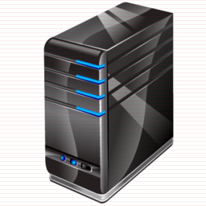

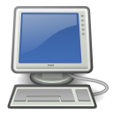

**Client Server**

Client Server Communication

**Client Server**

**Flow Chart**

Below are the flowchart of various tasks that is performed between Client and Server.

I. User Authentication

User enters username and password combination

Client system asks user for username and password

Server receives the active connection

Clients initiate a connection to the server

Client file is run by the user

Start

Server sends “Authenticated” message to Client

If Verified?

Server uses users.txt file to verify information sent by client

Client sends the user information to Server for verification

No

Yes

II. Getting Server Name and IP

Start

Server acknowledges it

Client sends the direction to Server

User enters 1 to select “Getting Server Name and IP” service

Client system displays the menu for services

Client asks user for company name and sends it to Server

Send Server Name and IP to Client

If

Found?

Server checks for the name in organizations.txt file

Client system displays the information to User

No

Yes

III. Getting Statistics (Mean, Minimum and Maximum)

Client system displays the output to Users

Server calculates mean, minimum and maximum from collected data and sends it to Client

Server uses organization.txt file to collect time data of all company

Client sends the direction to Server

User enters 2 to select “Getting Statistics” service

Start

Client system displays the menu for services

IV. Closing Client System and Connection

End

User enters 3 to close Client system and connection

Start

Client system displays the menu for services

Client system ends the connection