**Test Plan**

|  |  |
| --- | --- |
| **Test Case** | **Objectives** |
| 1 | To test whether the Server system is executed. |
| 2 | To test whether the Client system is executed. |
| 3 | To test whether Client system asks for both username and passwords. |
| 4 | To test whether Server receives username and password sent by Client. |
| 5 | To test whether Server can validate a genuine username and password. |
| 6 | To test whether Server can detect invalid username and password. |
| 7 | To test whether Client shows Welcome and Menu screen, once verified. |
| 8 | To test whether Client initiates “Get Server Name and IP” service in Server. |
| 9 | To test whether Client receives acknowledgement form Server for “Get Server Name and IP” service. |
| 10 | To test whether Client asks for Company Name to user after getting acknowledgement. |
| 11 | To test whether Client sends the Company Name to Server. |
| 12 | To test whether Server checks organizations.txt file for valid company name. |
| 13 | To test whether Server checks organizations.txt file for unknown company name. |
| 14 | To test “Menu Screen ” is showed again after completing any service. |
| 15 | To test whether Client system initiates “Get Statistics (mean, minimum and maximum)” services in Server |
| 16 | To test whether Server system calculates mean, minimum and maximum of time from organisations.txt file and sends to Client system. |
| 17 | To test whether Client system closes the connection if option 3 is selected from Menu screen. |
| 18 | To test whether Client system closes after 3 failed login attempts |

**Test Log**

|  |  |
| --- | --- |
| **Test Case 1** | |
| Objective | To test whether the Server system is executed. |
| Test Data | “Server.py” file is executed. |
| Expected Test Result | The system should run successfully, displaying “Server is ready for connection…” message. |
| Actual Test Result | The system executed successfully, displaying the message. |
| Conclusion | Successfully done |

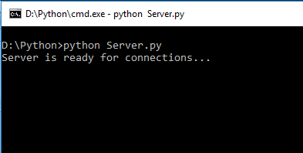

|  |  |
| --- | --- |
| **Test Case 2** | |
| Objective | To test whether the Client system is executed. |
| Test Data | “Client.py” file is executed. |
| Expected Test Result | The system should run successfully, displaying “Client is ready…” message. |
| Actual Test Result | The system executed successfully, displaying the message. |
| Conclusion | Successfully done |

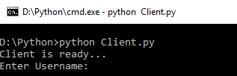

|  |  |
| --- | --- |
| **Test Case 3** | |
| Objective | To test whether Client system asks for both username and passwords. |
| Test Data | Username and passwords are entered in Client system |
| Expected Test Result | The system should provide interface to input username and password for users. |
| Actual Test Result | The system provided interface to input username and password for users. |
| Conclusion | Successfully done |

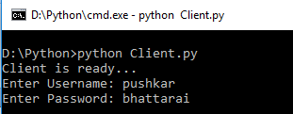

|  |  |
| --- | --- |
| **Test Case 4** | |
| Objective | To test whether Server receives username and password sent by Client. |
| Test Data | Pushkar and bhattarai is sent to Server as username and password |
| Expected Test Result | Server should get the data and starts processing displaying “Verifying username and password ” |
| Actual Test Result | Server got the data and started processing displaying “Verifying username and password ” |
| Conclusion | Successfully done |

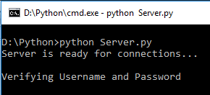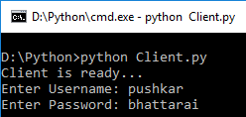

|  |  |
| --- | --- |
| **Test Case 5** | |
| Objective | To test whether Server can validate a genuine username and password. |
| Test Data | Pushkar and bhattarai is sent to Server as username and password |
| Expected Test Result | Server should process the data against users.txt file and display “Authenticated” message. Client should also get “Validation news” |
| Actual Test Result | Server processed the data against users.txt file and displayed “Authenticated” message. Client also got “Validation news” |
| Conclusion | Successfully done |

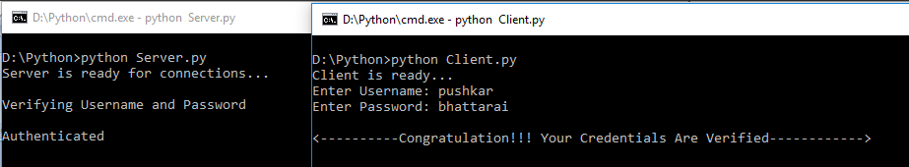

|  |  |
| --- | --- |
| **Test Case 6** | |
| Objective | To test whether Server can detect invalid username and password. |
| Test Data | apple and banana is sent to Server as username and password |
| Expected Test Result | Server should process the data against users.txt file and directs Client system to display Authentication Failed message. |
| Actual Test Result | Server processed the data against users.txt file and directed Client system to display Authentication Failed message. |
| Conclusion | Successfully done |

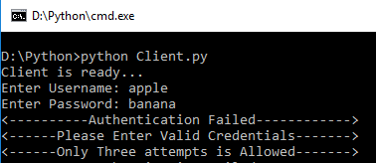

|  |  |
| --- | --- |
| **Test Case 7** | |
| Objective | To test whether Client shows Welcome and Menu screen, once verified. |
| Test Data | Valid username and password is sent |
| Expected Test Result | After user authentication client system should display the welcome and menu screen. |
| Actual Test Result | After user authentication client system displayed the welcome and menu screen. |
| Conclusion | Successfully done |

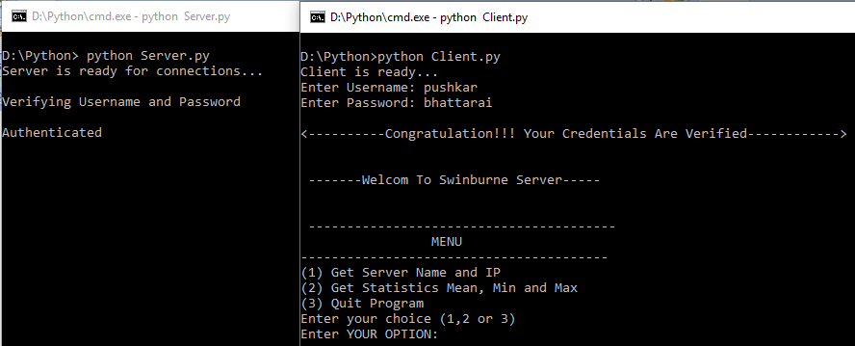

|  |  |
| --- | --- |
| **Test Case 8** | |
| Objective | To test whether Client initiates “Get Server Name and IP” service in Server. |
| Test Data | Option 1 is entered in menu screen. |
| Expected Test Result | Client system should direct the Server for the option and Server should display Acknowledgement sent message. |
| Actual Test Result | Client system directed the Server for the option and Server displayed Acknowledgement sent message. |
| Conclusion | Successfully done |

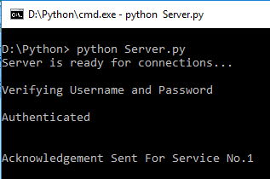

|  |  |
| --- | --- |
| **Test Case 9** | |
| Objective | To test whether Client receives acknowledgement form Server for “Get Server Name and IP” service. |
| Test Data | Option 1 is entered in menu screen. |
| Expected Test Result | Client system should display the server acknowledgement message. |
| Actual Test Result | Client system displayed the server acknowledgement message. |
| Conclusion | Successfully done |

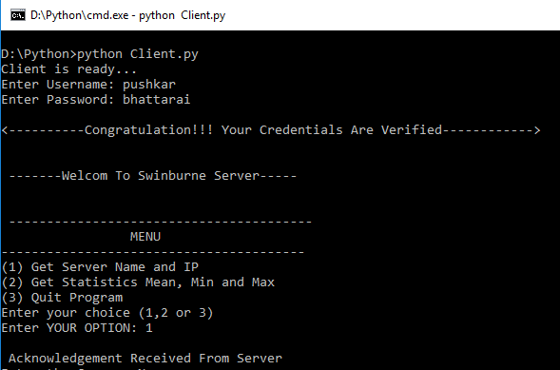

|  |  |
| --- | --- |
| **Test Case 10** | |
| Objective | To test whether Client asks for Company Name to user after getting acknowledgement. |
| Test Data | Option 1 is entered in menu screen. |
| Expected Test Result | Client system should ask company name after displaying acknowledgement message. |
| Actual Test Result | Client system asked company name after displaying acknowledgement message. |
| Conclusion | Successfully done |

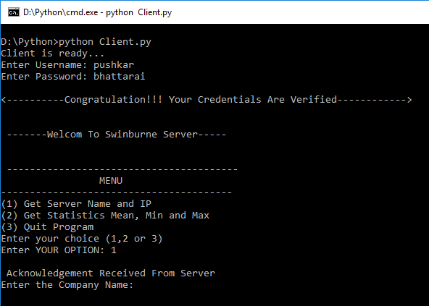

|  |  |
| --- | --- |
| **Test Case 11** | |
| Objective | To test whether Client sends the Company Name to Server. |
| Test Data | “Melbourne” as company name is entered. |
| Expected Test Result | Server should get this message and display “finding company details” message. |
| Actual Test Result | Server got this message and display “finding company details” message. |
| Conclusion | Successfully done |

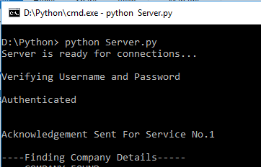

|  |  |
| --- | --- |
| **Test Case 12** | |
| Objective | To test whether Server checks organizations.txt file for valid company name. |
| Test Data | “Melbourne” as company name is entered. |
| Expected Test Result | Server should search the company against organisations.txt file and display server name and IP of that company. |
| Actual Test Result | Server searched the company against organisations.txt file and displayed server name and IP of that company. |
| Conclusion | Successfully done |

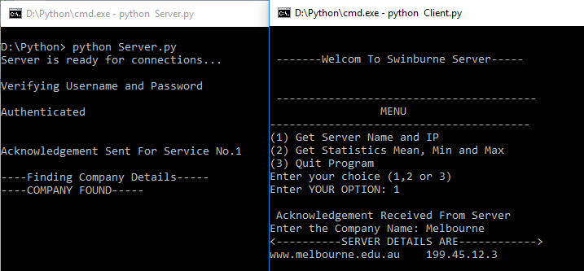

|  |  |
| --- | --- |
| **Test Case 13** | |
| Objective | To test whether Server checks organizations.txt file for unknown company name. |
| Test Data | “apple” as company name is entered. |
| Expected Test Result | Server should search the company against organisations.txt file and display Company Information Not in Database message if not found. |
| Actual Test Result | Server searched the company against organisations.txt file and displayed Company Information Not in Database message. |
| Conclusion | Successfully done |

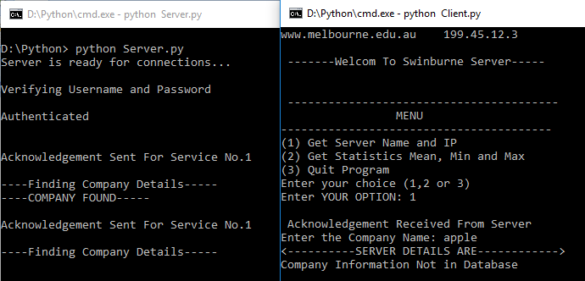

|  |  |
| --- | --- |
| **Test Case 14** | |
| Objective | To test “Menu Screen ” is showed again after completing any service. |
| Test Data | Option 1 service and operation is completed. |
| Expected Test Result | Client system should re-display the welcome and menu screen. |
| Actual Test Result | Client system should re-displayed the welcome and menu screen. |
| Conclusion | Successfully done |

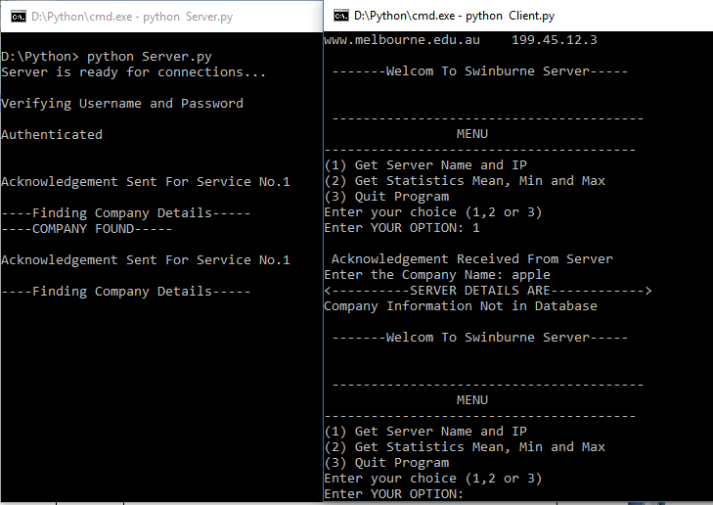

|  |  |
| --- | --- |
| **Test Case 15** | |
| Objective | To test whether Client system initiates “Get Statistics (mean, minimum and maximum)” services in Server |
| Test Data | Option 2 service is selected in welcome and menu screen.. |
| Expected Test Result | Client system should initiate Server about the service and Server should display “Calculating Please Wait…” message |
| Actual Test Result | Client system initiated Server about the service and Server displayed “Calculating Please Wait…” message |
| Conclusion | Successfully done |

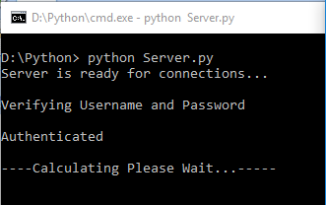

|  |  |
| --- | --- |
| **Test Case 16** | |
| Objective | To test whether Server system calculates mean, minimum and maximum of time from organisations.txt file and sends to Client system. |
| Test Data | Option 2 service is selected in welcome and menu screen.. |
| Expected Test Result | Server should use organisations.txt file to calculate mean, minimum and maximum of time and send it to Client system to display. |
| Actual Test Result | Server used organisations.txt file to calculate mean, minimum and maximum of time and send it to Client system which displayed it. |
| Conclusion | Successfully done |

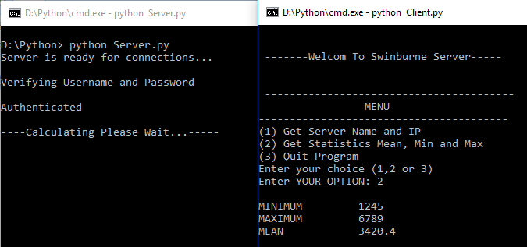

|  |  |
| --- | --- |
| **Test Case 17** | |
| Objective | To test whether Client system closes the connection if option 3 is selected from Menu screen. |
| Test Data | Option 3 service is selected in welcome and menu screen.. |
| Expected Test Result | Client system should be closed displaying Thank you message. |
| Actual Test Result | Client system closed displaying Thank you message. |
| Conclusion | Successfully done |

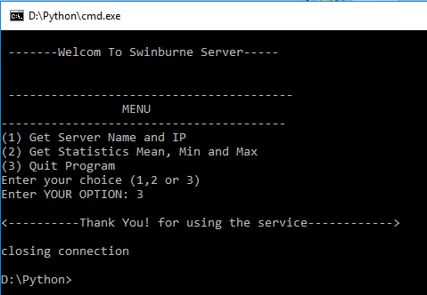

|  |  |
| --- | --- |
| **Test Case 17** | |
| Objective | To test whether Client system closes after 3 failed login attempts |
| Test Data | Wrong username and password is entered consecutively. |
| Expected Test Result | Client system should get closed after 3 failed login attempts. |
| Actual Test Result | Client system got closed after 3 failed login attempts. |
| Conclusion | Successfully done |

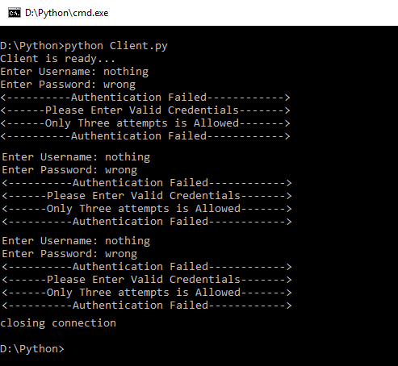

**Test Result**

|  |  |  |
| --- | --- | --- |
| **Test Case** | **Objectives** | **Status** |
| 1 | To test whether the Server system is executed. | Successful |
| 2 | To test whether the Client system is executed. | Successful |
| 3 | To test whether Client system asks for both username and passwords. | Successful |
| 4 | To test whether Server receives username and password sent by Client. | Successful |
| 5 | To test whether Server can validate a genuine username and password. | Successful |
| 6 | To test whether Server can detect invalid username and password. | Successful |
| 7 | To test whether Client shows Welcome and Menu screen, once verified. | Successful |
| 8 | To test whether Client initiates “Get Server Name and IP” service in Server. | Successful |
| 9 | To test whether Client receives acknowledgement form Server for “Get Server Name and IP” service. | Successful |
| 10 | To test whether Client asks for Company Name to user after getting acknowledgement. | Successful |
| 11 | To test whether Client sends the Company Name to Server. | Successful |
| 12 | To test whether Server checks organizations.txt file for valid company name. | Successful |
| 13 | To test whether Server checks organizations.txt file for unknown company name. | Successful |
| 14 | To test “Menu Screen ” is showed again after completing any service. | Successful |
| 15 | To test whether Client system initiates “Get Statistics (mean, minimum and maximum)” services in Server | Successful |
| 16 | To test whether Server system calculates mean, minimum and maximum of time from organisations.txt file and sends to Client system. | Successful |
| 17 | To test whether Client system closes the connection if option 3 is selected from Menu screen. | Successful |
| 18 | To test whether Client system closes after 3 failed login attempts | Successful |