Table of Contents

Project: Part 1 - Pairs 1

Project: Part 2 - Stripes 3

Project: Part 3 - Hybrid 4

Bash Scripts 5

# Project: Part 1 - Pairs

**Input**

Following image depicts the input data, where each row is the list of IDs of the product bought by a customer.

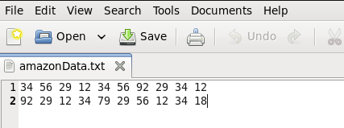

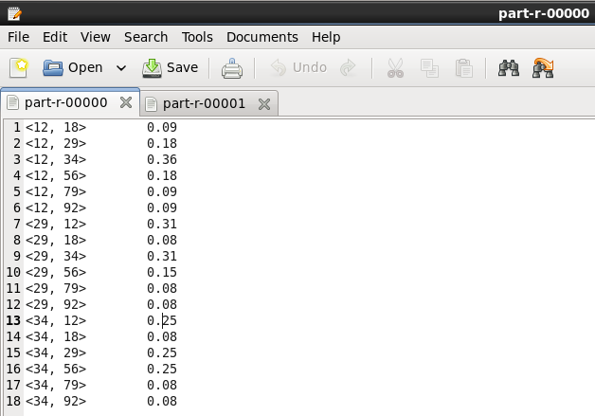**Output in Percentage**

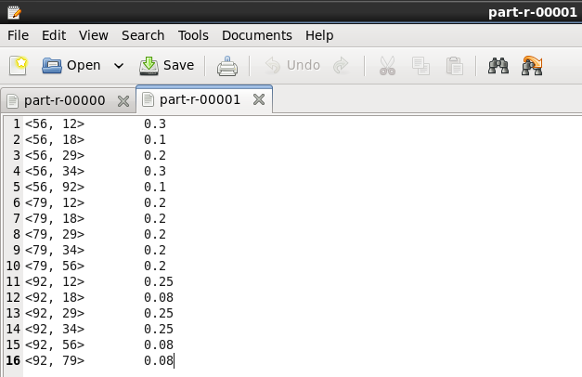

The above outputs are in percentage. We can depict from the first row data that probability of buying product 12 by customer after buying product 56 is 0.3 percent.

# Project: Part 2 - Stripes

**Input**



**Output in Percentage**

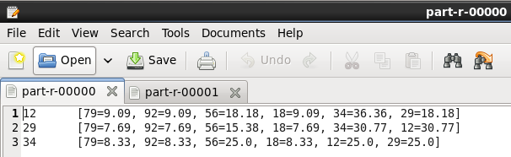

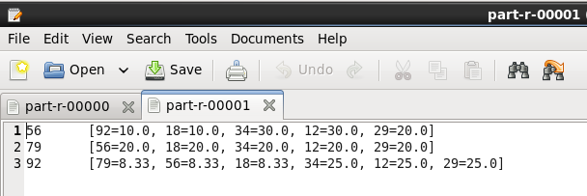

From above output, for example, row one depicts the probability of buying other products after product 12 is bought. Like, after product 12 is bought product 17 buying probability is 9.09%, product 56 is 18.18%, product 34 is 36.36%, and so forth.

# Project: Part 3 - Hybrid

**Input**



**Output in Percentage**

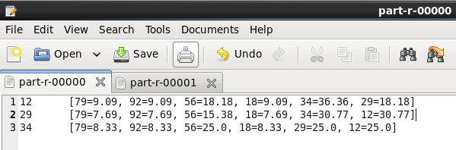

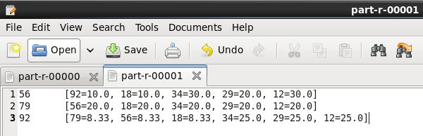

From above output, for example, row one depicts the probability of buying other products after product 12 is bought. Like, after product 12 is bought product 17 buying probability is 9.09%, product 56 is 18.18%, product 34 is 36.36%, and so forth.

# Bash Scripts

mainCrystalBall.sh

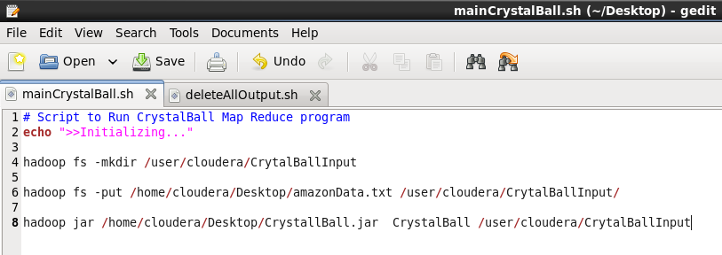

This script is used to automatically initialize the “CrystalBall” project. In order to read full step process of initializing, please go through “Read Me” file.

deleteAllOutput.sh

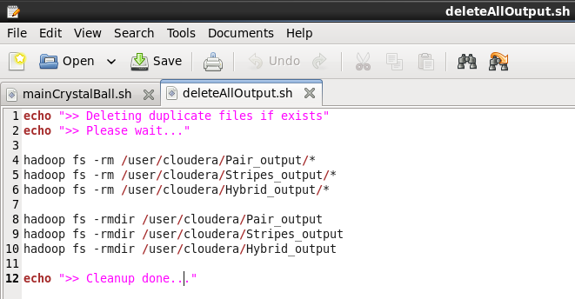

This file is used to delete output folders and its contents. It is useful when we re-execute the application so that duplicate files will be deleted automatically.