**Instructions of Setting up and Running CrystalBall Application**

**Step 1:** Unzip “Crystalball_Project.zip” file. There are four files. “CrystallBall” java project, “Jar-Batch-Txt-Files” file containing .jar, .txt. and .sh files, Documentation and Readme file.

**Step 2:** Copy all files from “**Jar-Batch-Txt-Files**” folder and paste it to Cloudera’s Desktop.

**Step 3:** Open the Shell and execute the script file named **“mainCrystalBall.sh”** by the following command:

# sh *file_name.sh*

Step 4: The script will execute following:

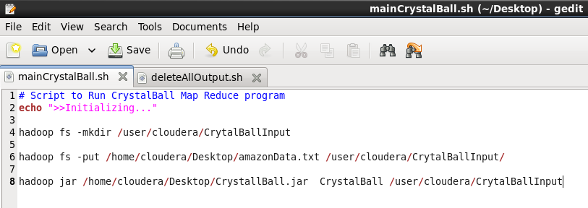

* It will create “**CrystalBallInput**” folder in path **/user/cloudera/** and copies “**amazonData.txt**” file into it.
* After above, it further executes the **CrystalBall.jar** application and you will be presented with following screen.

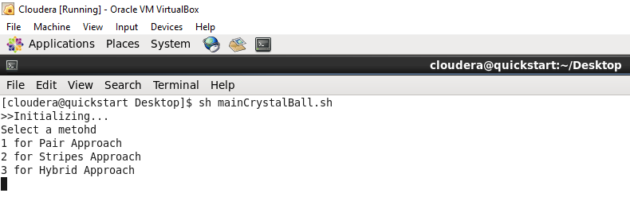

* Select desired option here. To execute Pair Approach enter 1. Likewise for Stripes and Hybrid Approach.
* After selecting any approach, you will find the respective output inside /user/cloudera/ folder.
  + For Pair Approach output folder will be: **Pair_output**
  + Likewise **Stripes_output** and **Hybrid_output** for others.
* Each above folder will contain two files **part-r-00000** and **part-r-00001** files containing data.
* Part-r-00000 contains product information of IDs below 40, while other file contains the rest.
* You can view the file in text editor after downloading.

**Note:**

* If you want re-run any of the approaches in the application, run the “**deleteAllOutput.sh”** file before re-executing the application.
  + $ sh deleteAllOutput.sh

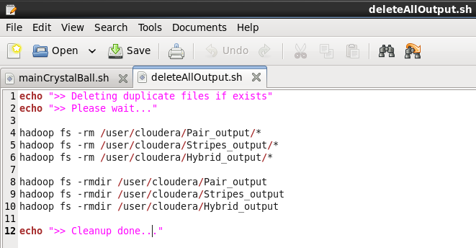

* This script deletes all the output folder and files so that application will not give “file already exists” error.