**CS372 Exam: Jan 2019 (100 points)**

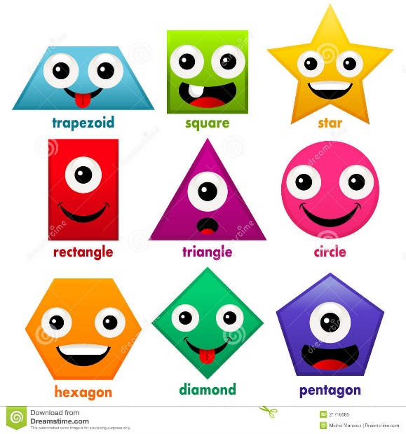Everyone loves shapes, and everyone loves geometry! And looking at shapes and understanding their properties is very important. We need a program that can show a variety of shapes to the user, and when they click on a shape, they can see the shape in some detail and see some specific properties of that shape.

So, you will be given a file (.txt, .csv, .json, .xml). That file will contain a collection of four different shapes: circle, square, rectangle, and triangle (and OK math majors, I know that a square is a rectangle, so maybe “different” was a stretch). We need you to list the objects (with their IDs) on the left-hand side of the UI. When the user clicks on a specific shape, we want you to display that shape along with specific properties, including area and perimeter. See below for a mockup:

|  |  |
| --- | --- |
| Circle (0)  Square (100)  Square (101)  Rectangle (200)  Triangle (300)  Square (102)  Triangle (301)  Circle (1)  Square (103)  Circle (2) | http://4.bp.blogspot.com/-lRwkholfrPo/UqAm23Rtq0I/AAAAAAAAAHU/vSpYYJcTf0s/s1600/1.pngRectangle (ID# 200)  Color: yellow  Length: 7  Width: 8  Area: 56  Perimeter: 30 |

You are free to use any image you wish for the images (and they obviously don’t have to match the color or properties). You will need to read the data from one of the text files into your program before you display the shapes. We may want to add more shapes at a later time, so you can’t simply hardcode each shape into your code. You can choose which file to read from – they contain the same data.

You are also expected to use the following class hierarchy, though you can add functions and variables to the classes as you see fit:

interface Shape

+String toString()

+String getKind()

+String getDetailString()

+int getID();

Circle

Triangle

Rectangle

Square

For the Shape interface:

* toString would return the kind and ID of the shape (e.g. “Circle (ID# 1)”)
* getKind would return the kind of shape (e.g. “Circle”)
* getDetailString would return the details of that shape (including kind, ID, properties, area, perimeter) – what would be displayed in the right hand side panel in the mockup above
* getID would return the ID of the shape

Below is the grading rubric I will use:

|  |  |
| --- | --- |
| Program Feature | Percentage |
| Read from the file correctly | 20% |
| Implement class hierarchy correctly | 20% |
| Populate appropriate data structures with shape data | 15% |
| Show list of shapes correctly | 15% |
| Show specific shape properties correctly | 15% |
| Well-structured, well-commented code   (JavaDoc not required) | 15% |

Save your solution to your GitHub repository.