**Project Title:** Is-it-worth-it-con

**Team Members:**   
Aaron Cross

Sean Wright

Zachary Carter

Michelle Pinsky

**Project Description:**

Developing media-rich user interface for people to research conventions and experience the magic before they buy tickets. Saving your disposable income since 2017™.

**APIs to be Used:**

Eventbrite

Instagram or Flickr

Youtube API

Google Maps API

Yelp API

**Sketch of Final Product:**

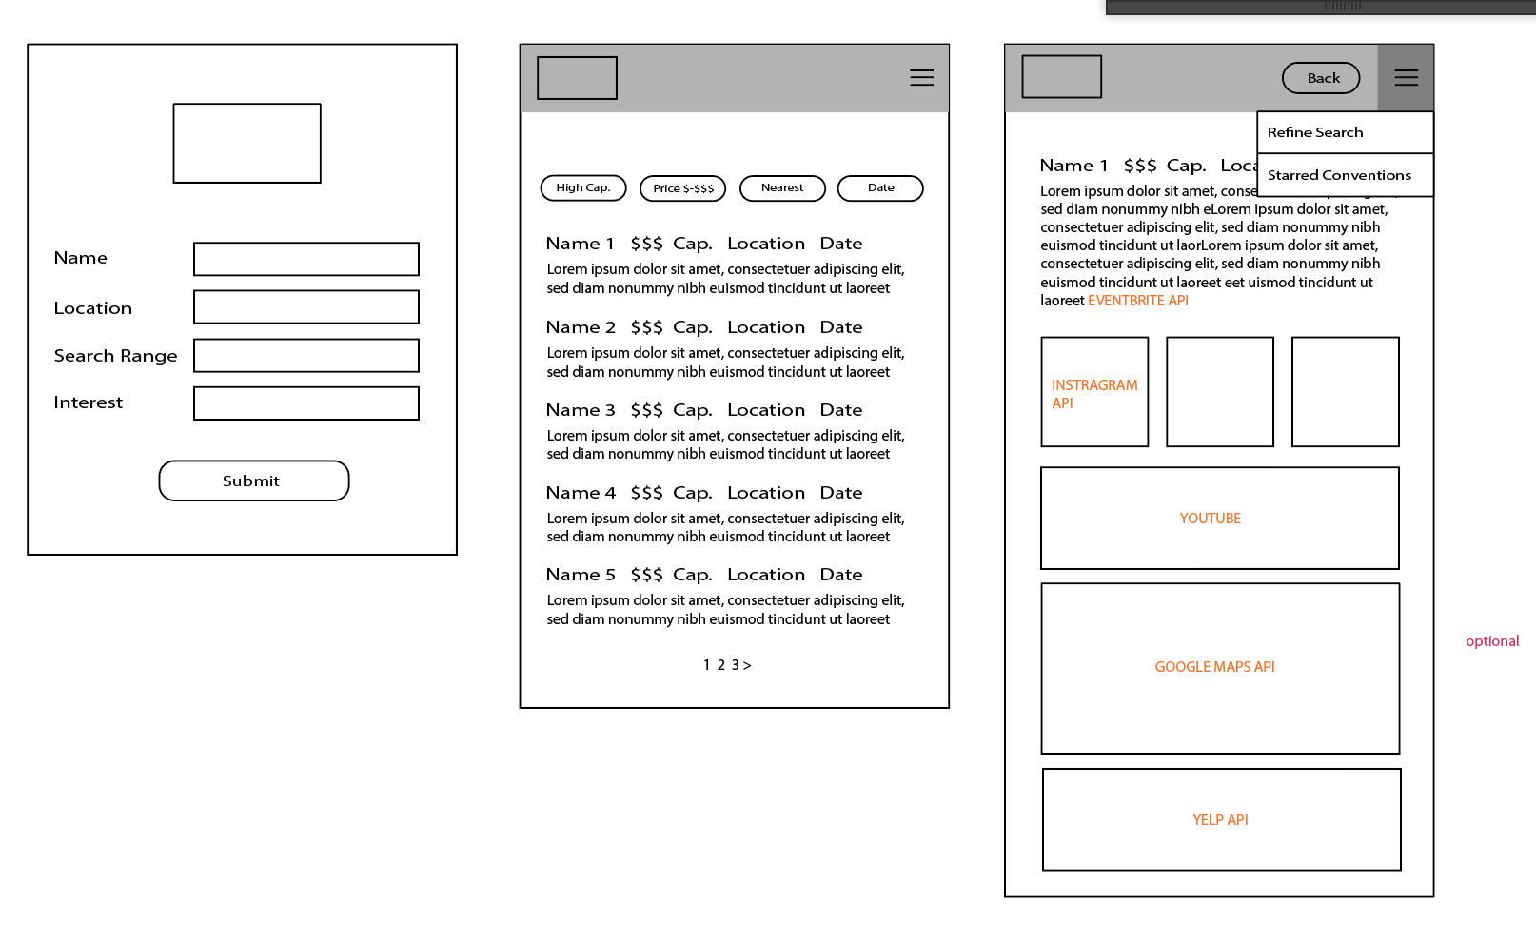

**Rough Task Breakdown:**

* Set up tasks in Asana
* Build HTML structure
  + Mobile compliant
  + Create ease-in drop-down
* Build CSS styles
* Collect User data/create database (Firebase)
* Set up and test APIs
* Create logic
  + Dynamic element creation format
  + Create event listeners
  + JSON object organization
  + *Google maps or pricing functionality