

Bizagi Widget

*DropDown Dynamic Populate*

|  |  |
| --- | --- |
| Copyright © 2015 | Bizagi | 27/08/2015 |

**ComboBoxWS:** Widget to populate combo box with business srule data

**Name: ComboBoxWS**

**BWG Name:** DropDownPopulateWS.bwg

**Group:** Bizagi Widgets

**Description:**

This Bizagi Widget allows you to populate a combo box with data obtained using a bizagi rule, which could consume an external web service.

**Type:** Forms widget

**BAS parameters:**

|  |  |  |  |
| --- | --- | --- | --- |
| Tab | Name | Data Type | Description |
| Basic | Title To Show | Text | Text to be shown in the forms modeler to identify the field |
| Basic | Data Binding | XPath | XPath of the collection: Code, Description, ColumnCode, Image, Color, Enable, Filter (Not functional) |
| Basic | IdRule | Business Rule | Business rule to execute for Widget, which return string XML with data to show, this string should have the format below (this rule maybe consume a web service to query data): <Items> <Item> <Code>1</Code> <Name>Item 1</Name> </Item> <Item> <Code>2</Code> <Name>Item 2</Name> </Item> <Item> <Code>3</Code> <Name>Item 3</Name> </Item> </Items> |
| For Data to XML | Code | Text | Field in XML to use like id/value on combo box |
| For Data to XML | Name | Test | Field in XML to use like "name/description" on combo box |

**Example**

*BAS Configuration*

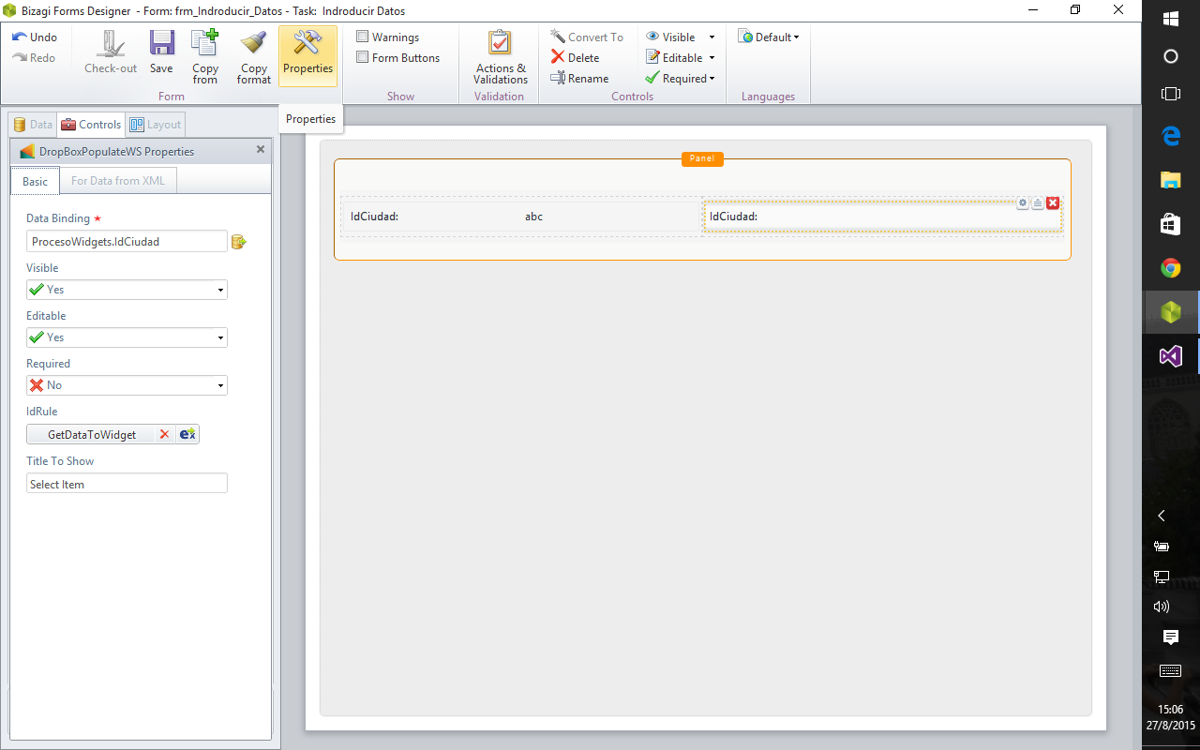

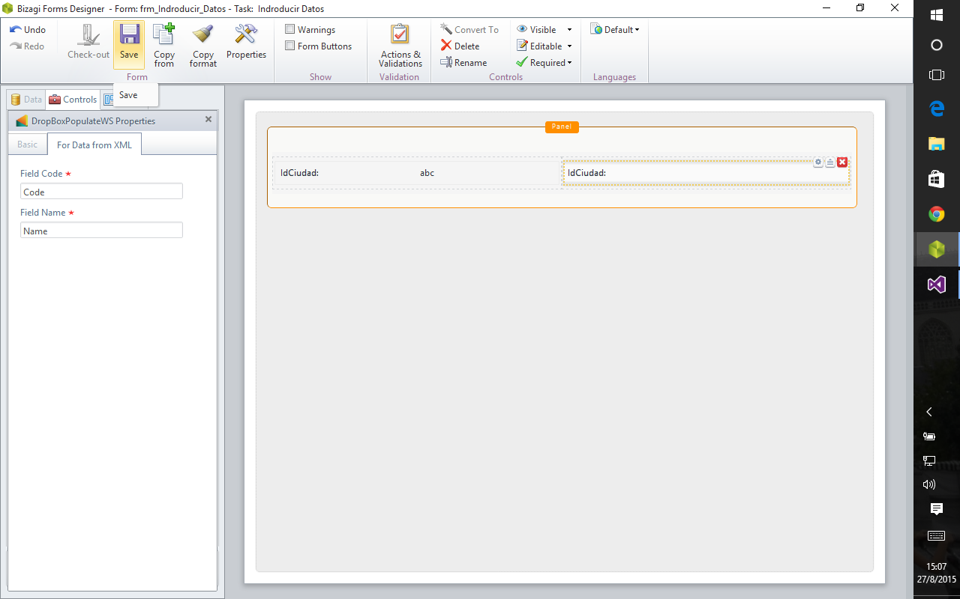

*Execution*

