CPT_S 484: Software Requirements
WRS Evolution
Requirements Elicitation

10/13/2024

Joan N.
Benjamin C.
Ivan D.
Jay-ar A.
0
Revision History 3
[1] Introduction 3
1.1. Purpose 3
1.2. Scope 3
1.3. Objectives and Success Criteria 4
1.4. Definitions, Acronyms, and Abbreviations 4
1.5. Overview 5
[2] Preliminary Definition 5
2.1. Preliminary Domain 5
2.2. Preliminary Functional Requirements 5
2.3. Preliminary Non-Functional Requirements 6
[3] Issues with the Preliminary Definition Given 7
3.1. Domain Issues 7
3.2. Functional Requirements Issues 8
3.3. Non-Functional Requirements(NFR) Issues 14
[4] WRS 20
4.1. W 20
4.1.1. Problem 20
4.1.2. Goals 21
4.1.3. Improved Understanding of Domain, Stakeholders, Functional, and Non-Functional Objectives 22
4.1.3.1. Improved Domain 22
4.1.3.2. Improved Functional Objectives 22
4.1.3.3. Improved Non-Functional Objectives 23
4.1.3.4. Stakeholders 24
4.1.3.5. Improved Functional Objectives 24
4.1.3.6. Improved Non-Functional Objectives 25
4.2. RS 26
4.2.1. Functional Requirements 26
4.2.2 Non-Functional Requirements 28
4.2.3 Specifications 31
5 Prototype Interface Mock-ups 34
1. Home Screen 34
2. Destination Input 34
3. Route Planning 34
4. Navigation Instructions 34
5. Obstacle Detection 35
6. Emergency Features 35
7. Settings 35
6 User Manual 36
7 References 36

Revision History
Date | Version | Changes | Editor
9/23/2024 | 1.0 | Initial Download | Ben Crossett
10/1/2024 | 1.1 | Transfer preliminary objectives from specifications | Ben Crossett
10/2/2024 | 1.2 | Added scope, objectives, & definitions. | Ivan D.
10/3/2024 | 1.2 | Added Purpose | Jay-Ar A.
10/3/2024 | 1.3 | Formatting Fix | Joan N.
10/4/2024 | 1.4 | Added FRIs & NFR | Entire Team
10/7/2024 | 1.5 | Worked goals/problems. | Entire Team
10/8/2024 | 1.6 | Added mock description | Ivan D.
10/12/2024 | 1.7 | Final updates/review | Ben Crossett

Introduction

Purpose
This project’s objective is to develop software that allows visually impaired individuals easier mobility in new or unfamiliar indoor spaces. Visual impairment can be the result of disease, accident, or a circumstance of birth. Unfamiliar settings can provide anyone with navigational uncertainty, but the problem is exponentially greater when one is visually impaired. To that end, our software is a tool to increase accessibility in otherwise everyday environments

Scope
This app will assist blind users in indoor navigation, such as in multi-story buildings with various rooms (classrooms, offices, bathrooms, lounges, etc.). The app will guide users through voice instructions, detect obstacles, and handle emergency situations (e.g., calling for help if the user falls). The app will make use of smartphone sensors to enhance user safety and navigation accuracy.

Objectives and Success Criteria
To be successful and fulfill project objectives, the following conditions must be met:
- Accept the user’s choice of destination.
- Devising at least one route from the current location to the destination.
- Telling the user the distance before the next turn on the chosen route.
- Telling the user when to stop for a turn.
- Telling the user when the destination has been reached.
- Detecting obstacles while in route.
- Alerting the user to detect obstacles and suggesting alternate routes.
- Automated EMS alert linked to fall detection

Definitions, Acronyms, and Abbreviations
Term | Definition
AI | Artificial Intelligence
FR | Functional Requirement
FRI | Functional Requirement Issue
IFRO | Improved Functional Requirement Objective
INFRO | Improved Non-functional Requirement Objective
NFR | Non-functional Requirement
NFRI | Non-functional Requirement Issue
PD | Preliminary Domain
PFR | Preliminary Functional Requirement
PNFR | Preliminary Non-functional Requirement
SRS | Software Requirement Specifications
THEIA | The name of the software system under development
WRS | World Requirement Specification

Overview
This project aims to create an app that helps visually impaired people navigate indoors more safely and easily. The app uses smartphone sensors to give real-time directions, detect obstacles, and provide emergency assistance if needed. It also learns user routines to offer personalized suggestions and can be customized to meet different preferences. Designed with flexibility in mind, the app can grow and adapt over time with new features and improvements to support a variety of needs.

Preliminary Definition

Preliminary Domain
PD_ID | Preliminary Domain Description
PD1 | Assist blind users in navigating indoor environments.

Preliminary Functional Requirements
P FR_ ID | Preliminary FR Description
PFR1 | The system shall accept destination input from the user. It may also suggest or confirm a possible destination based on the user’s routine or habits.
PFR2 | The system shall calculate routes to reach the selected destination and, if multiple routes are available, inform the user of the options and accept their preferred route choice.
PFR3 | The system shall provide step-by-step guidance to the user, including instructions such as walking a specific distance or number of steps (e.g., “Walk 2 minutes” or “Walk 30 steps”).
PFR4 | The system shall notify the user when to stop and turn at the appropriate place, providing clear instructions for direction changes.
PFR5 | The system shall detect obstacles in the user’s path and provide real-time instructions to help the user avoid collisions
PFR6 | The system shall have the capability to place emergency calls or send messages, possibly triggered by detecting a fall or when the system has lost its current location.
PFR7 | The system shall suggest the next action(s) based on the user’s schedule or habits and allow the user to accept or reject these suggestions.
PFR8 | The system shall be designed to accommodate additional functionalities as needed, such as support for new sensors or user interface enhancements.

Preliminary Non-Functional Requirements
PNFR_ ID | Preliminary NFR Description
PNFR1 | The system shall prioritize the user’s safety during indoor navigation, minimizing risks and ensuring a secure experience.
PNFR2 | The system shall aim to guide the user through the fastest available route to their destination, optimizing for time efficiency.
PNFR3 | The system shall offer routes that are comfortable for the user, considering factors such as familiarity, user preferences, or ease of navigation.
PNFR4 | The system shall be fully accessible and intuitive for blind users, utilizing voice commands and audio feedback for navigation.
PNFR5 | The system shall be designed to operate reliably across various indoor environments and locations, ensuring broad accessibility.
PNFR6 | The system shall allow users to customize settings, such as volume, frequency of instructions, and preferred route types, to match their individual needs and preferences.
PNFR7 | The system shall be easily extensible to support variations in user interface, language, user needs, and new technologies, such as additional sensors or hardware upgrades.

Issues with the Preliminary Definition Given

Domain Issues
Domain Issue ID | Domain Issue Description
DI1 | PD_ID | PD1. Assist blind users in navigating indoor environments.
DI1 | - Unclear or incomplete: Defining the range of indoor environments (e.g., office buildings, malls, airports) that the app will support.
DI1 | Option 1 | Consider which types of indoor spaces will be recognized as being compliant with this application by adding in specific indoor building layouts.
DI1 | Option 2
DI1 | Choice | Option 1
DI1 | Rationale | Option 1 will give the necessary details required to continue development and understand what is meant by “indoor environments”.
Revised wording

Functional Requirements Issues
FR Issue ID | Description
FRI1 | PFR_ID | PFR1. The system shall accept destination input from the user. It may also suggest or confirm a possible destination based on the user’s routine or habits.
FRI1 | Privacy concerns with data collection
FRI1 | Option 1 | Process the data on the actual device, rather than needing to send routine data to the cloud.
FRI1 | Option 2 | Allow users to opt out of routine tracking if they are uncomfortable with data collection.
FRI1 | Option 3 | Clearly communicate the data usage policies and obtain user consent before collecting routine-based data.
FRI1 | Choice | Option 3
FRI1 | Rationale | Tracking user routine to ensure correct and best routes for the user is necessary for this application. It has been decided that users will be required to acknowledge the data that will be stored and will need to digitally sign a consent form prior loading and tracking routes.
Satisfied by | FR1, FR5

FR Issue ID | Description
FRI3 | PFR_ID | PFR3. The system shall provide step-by-step guidance to the user, including instructions such as walking a specific distance or number of steps (e.g., “Walk 2 minutes” or “Walk 30 steps”).
FRI3 | Measuring distance accurately indoors can be challenging due to the lack of precise GPS signals, leading to potential errors in guiding users to walk a specified number of steps or a certain distance.
FRI3 | Option 1 | Utilize smartphone sensors, such as the accelerometer and gyroscope, to estimate steps and distance accurately.
FRI3 | Option 2 | Implement Wi-Fi and Bluetooth beacons for more precise distance measurement in specific areas where these technologies are available.
FRI3 | Option 3 | Offer users the option to calibrate their stride length to improve the accuracy of step-based guidance.
FRI3 | Choice | Option 1
FRI3 | Rationale | Using built-in smartphone sensors will require no additional infrastructure. These sensors can provide accurate distance measurements in real-time.
Satisfied by | FR1

FR Issue ID | Description
FRI4 | PFR_ID | PFR4. The system shall notify the user when to stop and turn at the appropriate place, providing clear instructions for direction changes.
FRI4 | The app may have difficulty accurately detecting when and where the user needs to turn, particularly in environments where visual landmarks are unavailable, and GPS signals are weak or unreliable.
FRI4 | Option 1 | Allow the user to confirm or adjust their position if the app detects an inaccurate turn location, especially in complex areas.
FRI4 | Option 2 | Implement Wi-Fi and Bluetooth beacons for more precise distance measurement in specific areas where these technologies are available.
FRI4 | Option 3 | Utilize smartphone sensors, such as the accelerometer and gyroscope, to estimate steps and distance accurately.
FRI4 | Choice | Option 3
FRI4 | Rationale | Utilizing sensors like the gyroscope and compass allows the app to detect changes in the user’s orientation, helping it to deliver turning instructions accurately and in real time, even in areas where GPS is unreliable.
Satisfied by | FRI1

FR Issue ID | Description
FRI5 | PFR_ID | PFR5. The system shall detect obstacles in the user’s path and provide real-time instructions to help the user avoid collisions
FRI5 | The app may struggle to differentiate between temporary and permanent obstacles, such as a table versus a person moving across the path. This may lead to incorrect guidance and confusion.
FRI5 | Option 1 | Use AI-powered object recognition algorithms that can classify obstacles as either static (like walls and furniture) or dynamic (such as people or moving carts).
FRI5 | Option 2 | Combine visual detection with motion sensors (e.g., radar or infrared) to detect the speed and direction of moving objects
FRI5 | Option 3 | Analyze the user’s route and surroundings, predicting the likelihood of encountering moving obstacles.
FRI5 | Choice | Option 1
FRI5 | Rationale | Using AI-powered object detection can help better understand the obstacles that are in the direct path of the user.
Satisfied by | FR2

FR Issue ID | Description
FRI6 | PFR_ID | PFR6. The system shall have the capability to place emergency calls or send messages, possibly triggered by detecting a fall or when the system has lost its current location.
FRI6 | The system may encounter challenges with false positives in fall detection or incorrect location loss alerts, leading to unnecessary emergency calls or messages.
FRI6 | Option 1 | Implement multi-sensor verification for fall detection.
FRI6 | Option 2 | Add a user confirmation prompt via voice command.
FRI6 | Option 3 | Use machine learning to refine detection.
FRI6 | Choice | Option 2
FRI6 | Rationale | A voice confirmation command can be used by the user to confirm that they require emergency assistance.
Satisfied by | FR3

FR Issue ID | Description
FRI7 | PFR_ID | PFR7. The system shall suggest the next action(s) based on the user’s schedule or habits and allow the user to accept or reject these suggestions.
FRI7 | The system may struggle to interpret and prioritize user’s schedule or habits, which could lead to incorrect suggestions. This could frustrate the user, causing them to ignore suggestions.
FRI7 | Option 1 | Incorporate user feedback into suggestion algorithms.
FRI7 | Option 2 | System can utilize contextual data, such as time of day, to make better informed decisions.
FRI7 | Choice | Option 1
FRI7 | Rationale | Allowing feedback from user via voice command will allow the application to understand user’s preferences over time.
Satisfied by | FR4

FR Issue ID | Description
FRI8 | PFR_ID | PFR8. The system shall be designed to accommodate additional functionalities as needed, such as support for new sensors or user interface enhancements.
FRI8 | The system may face challenges in maintaining compatibility and performance when adding new functionalities. These include support for new sensors and UI enhancements.
FRI8 | Option 1 | Utilize a modular system architecture.
FRI8 | Option 2 | Implement a plug-and-play framework for sensors.
FRI8 | Choice | Option 1
FRI8 | Rationale | A modular architecture would allow new features to be added as independent modules rather than a part of the core system. This will ensure that the app can grow and evolve w/o sacrificing performance.
Satisfied by | FR6

Non-Functional Requirements(NFR) Issues
NFR Issues ID | Description
NFRI1 | PNFR_ID | PNFR1. The system shall prioritize the user’s safety during indoor navigation, minimizing risks and ensuring a secure experience.
NFRI1 | Defining "safe navigation" can be challenging, as it may require balancing responsiveness with accuracy in complex environments.
NFRI1 | Option1 | Use AI-powered sensors for real-time obstacle detection and avoidance.
NFRI1 | Option2 | Implement a user feedback system that allows users to mark areas or routes where they felt unsafe.
NFRI1 | Option3 | Use multi-sensor verification (e.g., combining visual, auditory, and motion sensors) to detect hazards.
NFRI1 | Choice | Option 2
NFRI1 | Rationale | Collecting data on user experiences helps improve safety over time by identifying high-risk areas and refining the navigation instructions.
Satisfied by

NFR Issues ID | Description
NFRI2 | PNFR_ID | PNFR2. The system shall aim to guide the user through the fastest available route to their destination, optimizing for time efficiency.
NFRI2 | Prioritizing speed may lead to routes that are uncomfortable or unsafe for the user (e.g., involving stairs or crowded areas).
NFRI2 | Option 1 | Allow users to set their preferred balance between speed and comfort in the app settings.
NFRI2 | Option 2 | Provide multi-route suggestions, where users can choose between the fastest, most comfortable, or familiar route.
NFRI2 | Option 3 | Use feedback mechanisms that adjust route suggestions based on user ratings of previous routes.
NFRI2 | Choice | Option 3
NFRI2 | Rationale | Adapting routes over time based on user feedback helps the system align route suggestions with user preferences, enhancing satisfaction and usability.
Satisfied by

NFR Issues ID | Description
NFRI3 | PNFR_ID | PNFR3. The system shall offer routes that are comfortable for the user, considering factors such as familiarity, user preferences, or ease of navigation.
NFRI3 | Determining factors that contribute to comfort is subjective and varies from one user to another.
NFRI3 | Option1 | Include a customization option where users can set their own comfort preferences, such as avoiding stairs or high-traffic areas.
NFRI3 | Option2 | Implement machine learning to adapt to user behavior, gradually learning which routes users find comfortable.
NFRI3 | Option3 | Use predefined comfort levels (e.g., low, medium, high) that automatically adjust routes based on selected comfort levels.
NFRI3 | Choice | Option 2
NFRI3 | Rationale | Machine learning can refine route suggestions over time, offering a more personalized experience by learning from user choices.
Satisfied by

NFR Issues ID | Description
NFRI4 | PNFR_ID | PNFR4. The system shall be fully accessible and intuitive for blind users, utilizing voice commands and audio feedback for navigation.
NFRI4 | Ensuring that the system remains intuitive and accessible without overloading the user with too many options or complex settings.
NFRI4 | Option1 | Design a simplified interface with only essential options and use voice commands for navigation settings.
NFRI4 | Option2 | Include a detailed onboarding process that introduces users to each feature gradually.
NFRI4 | Option3 | Offer a "basic" and an "advanced" mode, allowing users to switch based on their level of comfort and need for customization.
NFRI4 | Choice | Option 1
NFRI4 | Rationale | Reducing complexity ensures that users are not overwhelmed, making the system easier to use and understand.
Satisfied by

NFR Issues ID | Description
NFRI5 | PNFR_ID | PNFR5. The system shall be designed to operate reliably across various indoor environments and locations, ensuring broad accessibility.
NFRI5 | Ensuring that the system operates consistently in diverse indoor environments, which may have varying connectivity and infrastructure.
NFRI5 | Option1 | Develop offline capabilities that use only the phone’s built-in sensors for navigation.
NFRI5 | Option2 | Partner with building managers to implement Bluetooth beacons or Wi-Fi enhancements in high-traffic areas.
NFRI5 | Option3 | Use adaptive routing that dynamically switches between available technologies (e.g., beacons, Wi-Fi, sensors) depending on the environment.
NFRI5 | Choice | Choice 3
NFRI5 | Rationale | Adapting based on available technologies allows for a flexible and consistent experience across different buildings.
Satisfied by

NFR Issues ID | Description
NFRI6 | PNFR_ID | PNFR6. The system shall allow users to customize settings, such as volume, frequency of instructions, and preferred route types, to match their individual needs and preferences.
NFRI6 | Managing the balance between offering enough customization to meet individual needs without complicating the user interface.
NFRI6 | Option1 | Group customization options into categories (e.g., Audio, Navigation, Notifications) and provide preset profiles (e.g., “Low Instructions,” “Detailed Guidance”).
NFRI6 | Option2 | Implement an initial setup wizard that prompts users to choose their preferences at the start.
NFRI6 | Option3 | Allow advanced users access to a separate “Advanced Settings” section for deeper customization.
NFRI6 | Choice | Option 3
NFRI6 | Rationale | This keeps the main interface simple for most users but still offers a more detailed level of control for those who need it.
Satisfied by

NFR Issues ID | Description
NFRI7 | PNFR_ID | PNFR7. The system shall be easily extensible to support variations in user interface, language, user needs, and new technologies, such as additional sensors or hardware upgrades.
NFRI7 | Maintaining system performance while integrating new features, sensors, or interfaces.
NFRI7 | Option1 | Design the system with a modular architecture, allowing new features or sensors to be added as independent modules.
NFRI7 | Option2 | Use a plug-and-play framework that automatically detects and integrates new hardware or features.
NFRI7 | Option3 | Implement a dedicated API for third-party sensors and hardware integrations.
NFRI7 | Choice | Option 1
NFRI7 | Rationale | Modular architecture enables flexibility and growth without impacting the system's core functions, preserving performance.
Satisfied by

WRS

W

Problem

Problem ID | Problem Description | Corresponding Goals
P1 | How to ensure safe and efficient navigation for blind users. | G1, G3, G4
P2 | How to incorporate user habits into route suggestions. | G2
P3 | Handling obstacles in indoor environments. | G3
P4 | Managing emergency situations effectively (e.g., falls). | G1, G3, G4
P5 | How to ensure consistent functionality across different indoor environments. | G5, G7
P6 | Ensuring user comfort during navigation. | G6
P7 | Making the system accessible and usable for blind users. | G1, G6
P8 | Adapting the system for scalability and integrating new technologies as needed. | G7

Goals

Goal ID | Goal Description | Backward Traceability | Forward Traceability
G1 | Provide safe, reliable navigation. | P1, P3, P4 | IFRO1, IFRO2, IFRO3, INFRO1
G2 | Routine and habit-based navigation | P2 | IFRO4, INFRO1, INFRO6
G3 | Effectively Handle Obstacles | P1, P3, P4 | IFR02, IFRO5, INFRO1, INFRO3
G4 | Enable emergency handling for the user's safety. | P1, P4 | IFRO3, INFRO1
G5 | Maximize user comfort during navigation. | P5 | IFRO4, INFRO2, INFRO3
G6 | Ensure accessibility and usability for blind users. | P6, P7 | IFRO1, IFRO6, INFRO4
G7 | Design to be scalable for new technologies. | P5, P8 | IFO6, INFRO5, INFRO7

Improved Understanding of Domain, Stakeholders, Functional, and Non-Functional Objectives

Improved Domain
Improved Domain ID | Improved Domain Description
ID1 | The system operates indoors across multi-story buildings with various rooms and facilities.

Improved Functional Objectives
Improved FR Objective ID | Improved Domain Description
IFRO1 | The system shall use the smartphone’s accelerometer and gyroscope to deliver accurate, real-time navigation by tracking steps and orientation.
IFRO2 | AI-powered object recognition will classify obstacles, allowing the system to provide immediate instructions for avoiding collisions.
IFRO3 | The system will trigger emergency assistance with a voice confirmation prompt to reduce false alarms and ensure user safety.
IFRO4 | It shall learn user routines, using feedback to offer personalized, location-based suggestions over time.
IFRO5 | The system will support multiple destinations in one session, enabling efficient navigation through various points.
IFRO6 | Users can customize navigation preferences like volume and route type, with a modular design for easy feature integration.

Improved Non-Functional Objectives
Improved NFR Objective ID | Improved Domain Description
INFRO1 | The system shall prioritize safety by allowing users to mark unsafe areas, helping refine the navigation for a secure experience over time.
INFRO2 | It will provide route options that balance speed and comfort, adapting over time based on user ratings of previous routes.
INFRO3 | The system shall use machine learning to learn and refine user comfort preferences, offering personalized routes accordingly.
INFRO4 | To ensure ease of use, the system will provide a simplified interface with essential options, using voice commands for navigation settings.
INFRO5 | The system will adapt to varying environments by dynamically switching between available technologies (e.g., Wi-Fi, Bluetooth, sensors) for consistent navigation.
INFRO6 | It shall offer a simplified interface for most users, while advanced users can access a separate section for detailed customization options.
INFRO7 | The system will feature a modular architecture, enabling easy integration of new features and sensors without affecting core functionality.

Stakeholders

Primary User
- Visually Impaired Users: The main users of the app, who need it to help them move around safely indoors, avoid obstacles, and call for help if needed.

Secondary Users
- Caregivers and Family Members: People who look after visually impaired users. They care about the app’s safety features and want to be notified if there’s an emergency.
- Facility Staff: Workers in buildings like schools, offices, and hospitals who may help set up the app or ensure it works well in their buildings.
- Emergency Responders: First responders who may receive alerts if the app detects an emergency, like a fall, and need accurate location information quickly.
- Building Managers: People in charge of buildings where the app is used. They might set up equipment like Wi-Fi or beacons to help the app work better indoors.

Improved Functional Objectives
Based on the above information and our goals, the functional objectives of HOPE are:
Improved FR  Objective ID | Objective Description | Alleviates Problems | Achieves Goals
IFRO1 | The system must ensure that navigation instructions (e.g., directions, steps, or turns) are accurate and delivered in real-time. This involves calculating routes promptly and giving specific, understandable commands, such as “Walk 30 steps and then turn left.” | P1 | G1
IFRO2 | The system must effectively detect obstacles in the user's path using sensors and issue real-time instructions to help the user avoid collisions. For example, "Stop, there is an obstacle ahead. Turn right." | P3 | G1, G3
IFRO3 | The system must detect emergencies, such as falls or a loss of location, and automatically trigger emergency calls or messages to designated contacts (e.g., caretakers or emergency services). It should also provide location information in these messages. | P4 | G4
IFRO4 | The system should be capable of learning from the user’s routines and habits, providing next-step suggestions (e.g., “Would you like to go to the lounge after your meeting?”). This helps streamline common tasks and provide a more personalized navigation experience. | P2 | G2
IFRO5 | The system must be able to handle multiple destination inputs from the user, allowing them to complete several tasks in one session (e.g., “First, go to Room 203, then to the lounge”). This ensures more efficient navigation when multiple locations are required. | P1 | G1, G3
IFRO6 | The system should allow users or caretakers to customize aspects of the navigation experience, such as volume levels, the frequency of voice instructions, and the user’s preferred route types (e.g., shortest vs. easiest path) | P2 | G2

Improved Non-Functional Objectives
Improved NFR  Objective ID | Objective Description | Alleviates Problem | Achieves Goal
INFRO1 | The system shall provide real-time navigation by using the smartphone's accelerometer and gyroscope to track steps and orientation accurately. | P1 | G1
INFRO2 | Adapting the system for scalability and integrating new technologies as needed. | P2 | G2
INFRO3 | The system shall use machine learning to learn and refine user comfort preferences, offering personalized routes accordingly. | P6 | G5
INFRO4 | To ensure ease of use, the system will provide a simplified interface with essential options, using voice commands for navigation settings. | P7 | G6
INFRO5 | The system will adapt to varying environments by dynamically switching between available technologies (e.g., Wi-Fi, Bluetooth, sensors) for consistent navigation. | P5 | G7
INFRO6 | It shall offer a simplified interface for most users, while advanced users can access a separate section for detailed customization options. | P6 | G5
INFRO7 | The system will feature a modular architecture, enabling easy integration of new features and sensors without affecting core functionality. | P8 | G7

RS

Functional Requirements

FR ID | Description
FR1 | The system shall provide real-time navigation instructions to assist blind users in safely and efficiently navigating indoor environments.
Satisfies Functional Requirement Issue | FRI1
Satisfies Objectives | IFRO1
Satisfied by prototype feature

FR ID | Description
FR2 | The system shall detect obstacles in the user’s path using built-in sensors and provide real-time audio instructions to help avoid collisions.
Satisfies Functional Requirement Issue | FRI5
Satisfies Objectives | IFRO2, IFRO5
Satisfied by prototype feature

FR ID | Description
FR3 | The system shall recognize emergency situations, such as a fall, and automatically trigger an emergency response with location information.
Satisfies Functional Requirement Issue | FRI6
Satisfies Objectives | IFRO3
Satisfied by prototype feature

FR ID | Description
FR4 | The system shall learn from user routines, offering personalized suggestions based on frequently visited locations or typical activities.
Satisfies Functional Requirement Issue | FRI7
Satisfies Objectives | IFRO4, IFRO6
Satisfied by prototype feature

FR ID | Description
FR5
  The system shall support the ability to input multiple destinations, allowing users to complete several tasks within one navigation session.
Satisfies Functional Requirement Issue | FRI1
Satisfies Objectives | IFRO1, IFRO5
Satisfied by prototype feature

FR ID | Description
FR6 | The system shall allow users to customize settings, including voice volume, instruction frequency, and preferred route types.
Satisfies Functional Requirement Issue | FRI8
Satisfies Objectives | IFRO6
Satisfied by prototype feature

Non-Functional Requirements

NFR ID | Nonfunctional Requirement 1
NFR1 | The system shall prioritize user safety, allowing feedback on unsafe areas to improve navigation over time.
Operationalized Functional Requirements | FR1 | Real-Time Navigation
Satisfies Nonfunctional Requirement Issue | NFRI1
Satisfies Non-functional Objective | INFRO1
Constrains | FO1
Satisfied by prototype feature

NFR ID | Nonfunctional Requirement 2
NFR2
  Provide route options that balance speed and comfort, adapting based on user ratings of prior routes.
Operationalized Functional Requirements | FR1  FR4 | Real-Time Navigation  Routine Suggestions
Satisfies Nonfunctional Requirement Issue | NFRI2
Satisfies Non-functional Objective | INFRO2
Constrains | FO2
Satisfied by prototype feature

NFR ID | Nonfunctional Requirement 3
NFR3
  Use machine learning to refine routes by learning user comfort preferences, enhancing personalized navigation experiences.
Operationalized Functional Requirements | FR4 | Routine Suggestions
Satisfies Nonfunctional Requirement Issue | NFRI3
Satisfies Non-functional Objective | INFRO3
Constrains | FO3
Satisfied by prototype feature

NFR ID | Nonfunctional Requirement 4
NFR4
  Offer a simplified interface with essential options, relying on voice commands to ensure accessibility for blind users.
Operationalized Functional Requirements | FR1  FR6 | Real-Time Navigation  Customization
Satisfies Nonfunctional Requirement Issue | NFRI4
Satisfies Non-functional Objective | INFRO4
Constrains | FO4
Satisfied by prototype feature

NFR ID | Nonfunctional Requirement 5
NFR5
  Adapt dynamically to different environments by switching technologies to maintain consistent navigation functionality.
Operationalized Functional Requirements | FR1  FR2 | Real-Time Navigation  Obstacle Detection
Satisfies Nonfunctional Requirement Issue | NFRI5
Satisfies Non-functional Objective | INFRO5
Constrains | FO5
Satisfied by prototype feature

NFR ID | Nonfunctional Requirement 6
NFR6
  Allow customization of navigation settings, with advanced options for users who need detailed control over their experience.
Operationalized Functional Requirements | FR6 | Customization
Satisfies Nonfunctional Requirement Issue | NFRI6
Satisfies Non-functional Objective | INFRO6
Constrains | FO6
Satisfied by prototype feature

NFR ID | Nonfunctional Requirement 7
NFR7
  Use a modular architecture to facilitate the integration of new features and sensors, ensuring the system can scale effectively.
Operationalized Functional Requirements | FR6 | Customization
Satisfies Nonfunctional Requirement Issue | NFRI7
Satisfies Non-functional Objective | INFRO7
Constrains | FO7
Satisfied by prototype feature

Specifications

Functional Specification ID | Functional Requirement
FS1 | The system shall provide real-time navigation instructions.
Satisfies Functional Requirement | FR1
Satisfies Objectives | IFRO1
Satisfied by prototype feature

Functional Specification ID | Functional Requirement
FS2 | The system shall detect obstacles and provide real-time guidance to avoid them.
Satisfies Functional Requirement | FRI5
Satisfies Objectives | IFRO2, IFRO5
Satisfied by prototype feature

Functional Specification ID | Functional Requirement
FS3 | The system shall trigger emergency response capabilities, like calling for help when a fall is detected.
Satisfies Functional Requirement | FRI6
Satisfies Objectives | IFRO3
Satisfied by prototype feature

Functional Specification ID | Functional Requirement
FS4 | The system shall offer personalized suggestions based on user routines.
Satisfies Functional Requirement | FRI7
Satisfies Objectives | IFRO4, IFRO6
Satisfied by prototype feature

Functional Specification ID | Functional Requirement
FS5 | The system shall support multi-destination navigation within a single session.
Satisfies Functional Requirement | FRI1
Satisfies Objectives | IFRO1, IFRO5
Satisfied by prototype feature

Functional Specification ID | Functional Requirement
FS6 | The system shall allow customization of voice settings, instruction frequency, and route type.
Satisfies Functional Requirement | FRI8
Satisfies Objectives | IFRO6
Satisfied by prototype feature

Prototype Interface Mock-ups

Detailed Theia UI buttons and mock-ups are shown below.

1. Home Screen
  - Buttons
    - "Enter Destination"
    - "Settings"
  - Additional Features:
    - Voice prompts like “Tap to enter destination.”

2. Destination Input
  - Buttons
    - "Enter Destination" (Accepts voice or typed input)
    - “Confirm Destination”

3. Route Planning
  - Buttons
    - "Choose Route" (displays route options like “Shortest” or “Usual” in a list format for easy access)
  - Feature
    - Automatically provides a voice prompt and haptic feedback based on selected route.

4. Navigation Instructions
  - On-Screen Updates
    - Large font indicators for directions (e.g., “Walk forward 20 feet”)
    - Voice and haptic cues for important actions (e.g., turning)
  - Action Button
    - “Cancel Navigation” for an emergency stop.

5. Obstacle Detection
  - Automatic Alerts
    - Large on-screen warning if an obstacle is detected, combined with voice and haptic alerts for redirection instructions.

6. Emergency Features
  - Buttons
    - "Call Emergency Contact"
    - “Send Alert” (can be triggered manually if needed)
    - Automatic Alerts: If fall is detected, automatically notifies emergency contacts.

7. Settings
  - Buttons
    - Large, labeled options for:
      - “Audio Settings” (volume, speed)
      - “Language Preferences”
      - “Haptic Feedback”

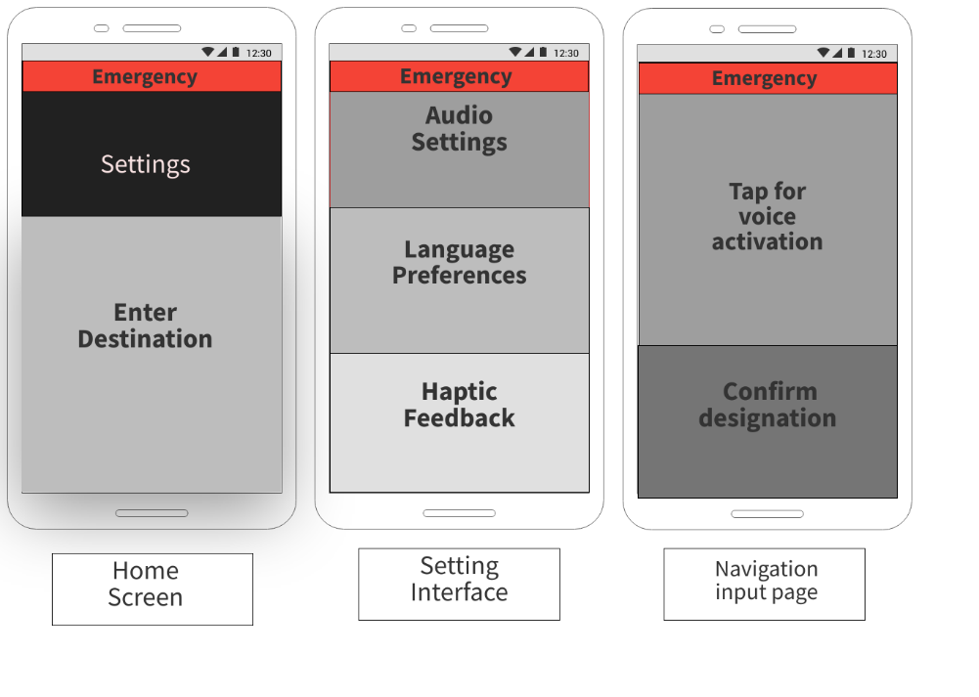
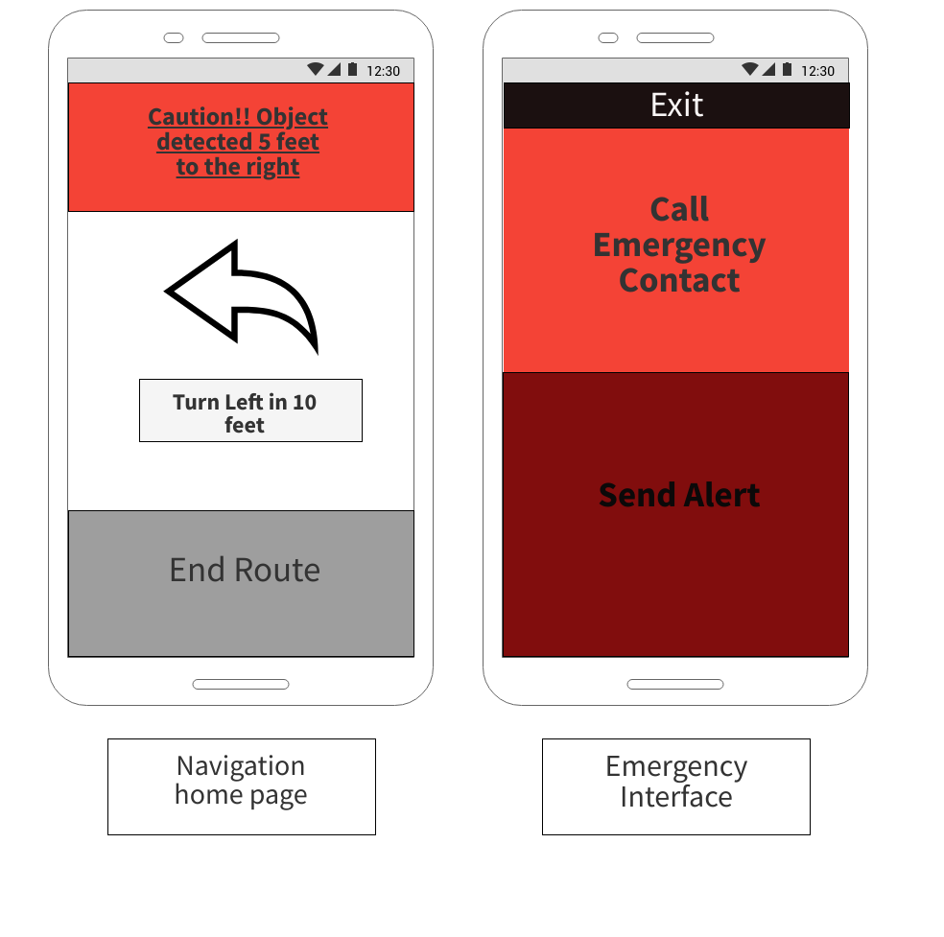

User Manual
The user manual for this project can be referenced in the included “User Manual.docx” document.

References
Writing Non-Functional Requirements in 6 steps. [Blog Post]. Modern Requirements. Retrieved from https://www.modernrequirements.com/blogs/what-are-non-functional-requirements-and-how-to-build-them/
Wiegars, K., & Beatty, J.(2013). Software requirements (3rd ed.). Microsoft Press.
The Software Development Process: A Complete Guide. [Blog Post] John McGuire. Retrieved from https://www.pulsion.co.uk/blog/the-software-development-process-a-complete-guide/

