Using the included TouchOSC interface to program your Miniak
Miniak Patch Editor users who also have an iPad and the TouchOSC app may enjoy editing parameters on the Miniak using the included TouchOSC interface. Note that this interface is not a standalone solution for programming the Miniak and must be used in conjunction with the Miniak Patch Editor desktop application.

Configuring TouchOSC
After you've added the Miniak Patch Editor.touchosc template to the TouchOSC app on your iPad (nb, this process is well-documented by hexler, the authors of TouchOSC, at their website: http://hexler.net/docs/touchosc-configuration-layout), the first step is to establish an OSC connection between TouchOSC and the Miniak Patch Editor desktop application. This connection is made via the OSC Connections page accessible from the TouchOSC home screen.

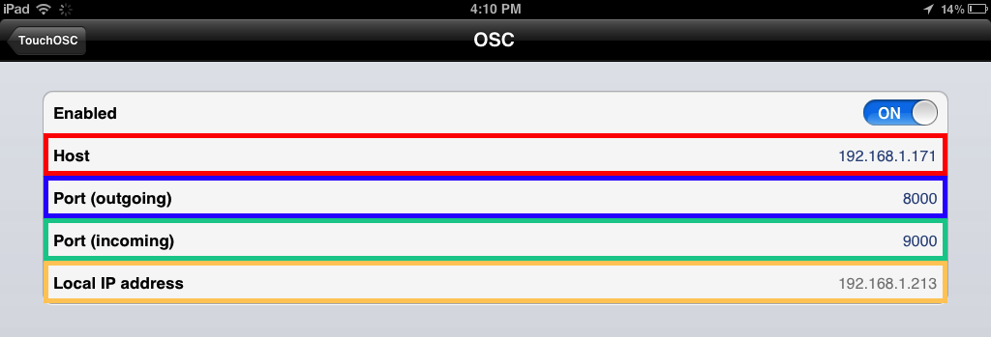
The TouchOSC “OSC Connections” page

Enabled: The Miniak Patch Editor TouchOSC template communicates with the Miniak Patch Editor desktop application via OSC. This switch should be set to “ON”.

Host: Enter the IP address of the computer running the Miniak Patch Editor desktop application in this field. Note that the IP address displayed above is for illustrative purposes only; your IP address will be different.

Port (outgoing): This number represents the communication channel across which TouchOSC will send parameter changes to the Miniak Patch Editor desktop application. The default value of 8000 will work for most users.

Port (incoming): This number represents the communication channel across which TouchOSC will receive parameter changes FROM the Miniak Patch Editor desktop application. The default value of 9000 will work for most users.

Local IP address: This field displays the IP address of your iPad. It is not editable, but make a note of this address because we will need it shortly. Here again, the IP address you see in this field will be different than the one shown above.

Configuring the Miniak Patch Editor
Launch the Miniak Patch Editor Remote Control window by clicking the “Remote Control” button in the MIDI section of the Miniak Patch Editor.
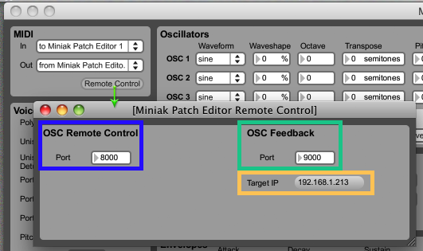
The Miniak Patch Editor “Remote Control Window”

OSC Remote Control Port: This number represents the port at which the Miniak Patch Editor will “listen” for OSC messages being sent from your iPad and TouchOSC. It should be the same as the Port (outgoing) number you just set in TouchOSC.

OSC Feedback Port: This number represents the port from which the Miniak Patch Editor will send OSC messages to TouchOSC on your iPad. It should be the same as the Port (incoming) number you just set in TouchOSC.

Target IP: Click this button to enter your iPad's IP address, as shown next to Local IP address in TouchOSC, in this field.

Programming with the TouchOSC Interface
The interface includes 16 pages of virtual faders, rotaries, and buttons for editing almost all of the Miniak's parameters. Pages 1-7 and 16 deal with the Miniak's oscillators, filters, envelopes, modulation sources, and voicing options. Pages 8-15 control 8 of the Miniak's 12 modulation routes.

Syncing TouchOSC to the Miniak Patch Editor
When you first load the interface, TouchOSC will be out of sync with the Miniak Patch Editor (and therefore your Miniak). In other words, all buttons will appear inactive and all the rotaries and faders will be set to 0 even if you have already edited values in the Miniak Patch Editor. When programming patches from an “initialized” state, it won't matter very much if the TouchOSC interface isn't perfectly in sync with the Miniak Patch Editor application because values will update on both as you make changes to either. For tweaking and inspecting existing patches, it's best to bring TouchOSC in sync with the Miniak Patch Editor before you begin.

To sync the TouchOSC interface to the Miniak Patch Editor (and your Miniak), click the “Resend” button under Patch Management in the Miniak Patch Editor. Note that Miniak programs are comprised of many different parameters and values, and TouchOSC is sometimes unable to process them all after a single click. If the TouchOSC interface doesn't update completely (or at all) after a single click of the “Resend” button, clicking it several times in rapid succession (imagine a quadruple double-click) will often do the trick.

About the Interface
Each page within the interface deals primarily with one aspect of the Miniak's synthesis engine. Interface elements have been color-coded to help you orient yourself within the interface as well as locate specific modulation sources and destinations among the many options.

In general, the interface favors the usability and precision of faders over rotaries. Each of the Miniak's core sound generating and shaping parameters is editable with faders and buttons. Where space permits, smaller rotaries controlling parameters complementary to the primary focus of a page have been included. Frequency, resonance, and level controls for Filter 1 and Filter 2 are included on the Oscillator pages for instance. These complementary controls can make programming easier by reducing the amount of page switching you have to do, but are not meant as a replacement for the more precise controls found elsewhere in the interface.
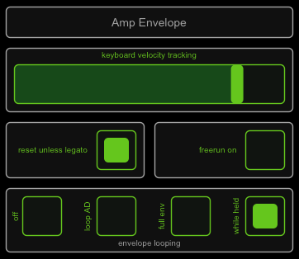
Buttons come in two varieties: radio and toggle. Radio buttons allow you to select one option from a list of many, while toggle buttons allow you to turn a single parameter on or off. In the interface, toggle buttons appear as single buttons within the white box that contains each interface element. Radio buttons, on the other hand, appear as a collection of buttons within a single white box.

Two toggle buttons and a set of radio
buttons that control the amp envelope.

Customizing the TouchOSC Template
Care has been taken in the design of the TouchOSC template to create a useful and usable programming interface for Miniak owners of all stripes. Be that as it may, it is very likely once the initial joy of having all the Miniak's parameters at your fingertips wears off, you will have ideas about how the interface could be improved to better serve your individual programming style and sound design workflow. If you find yourself in such a situation, you are encouraged to download the free TouchOSC Editor from hexler (http://hexler.net/software/touchosc) and use it to rearrange or otherwise modify our template.

If you haven't created a TouchOSC template before, the thought of modifying ours to suit your needs may seem daunting. In fact, the hard work of carefully entering many dozens of OSC addresses and value ranges is already done! By using our template as a starting point, creating one of your own is easy and rewarding. Like all software, however, the TouchOSC Editor has some quirks to be mindful of while you're creating your template.

Save a copy!
Unfortunately it's not possible to have two templates open simultaneously in the TouchOSC editor. As such, you'll be making changes to our template directly. Make sure you save a copy of the original template so you can experiment freely, confident the original template will be there for you to pull elements from again if your first interface is not perfect.

Pages are your friend
Most of the pages in our template are tightly packed with buttons and faders. Instead of trying to work within our existing pages, you may find it easier to start fresh on a new page within the template. You can then copy and paste the UI elements you want to use from the existing pages to the page you added. When you're satisfied with your new interface, you can make it wholly your own by simply deleting the pages that we created.

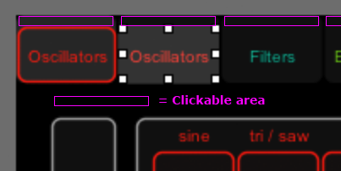
The different pages of an interface are accessed in the TouchOSC Editor by clicking the tabs at the top of the interface. And because the only way to label these tabs is with the “Label” UI object, you may find yourself selecting labels when you're trying to navigate to a different page. Take our advice and just delete these labels straightaway. They have no effect on the functionality of the tabs and although they are helpful once the interface is actually on your iPad, they mostly just get in the way when you're trying to edit ours.
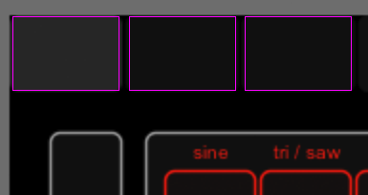
Clickable area with tab labels Clickable area without tab labels

It can be frustrating trying to click inside such tiny area when navigating between different pages of the interface in the TouchOSC editor. Delete these tab labels with abandon!

