RBII 2&4 86DataComparison 23 May 2005

We have collected 86 data sets in RBII2/3 and RBII4 double-condition.

 |  | nrCat |  | Total
 |  | 2 | 4 | Total
condition | UDII | 14 | 16 | 30
condition | CJII | 14 | 16 | 30
condition | UDCJ | 10 | 16 | 26
Total |  | 38 | 48 | 86

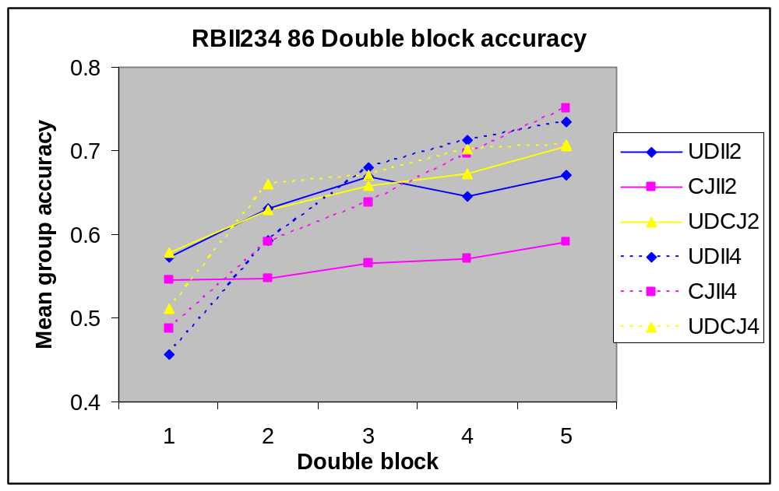
Double block means 112 stimuli
T-tests between 2cat and 4cat conditions:
UDII2>UDII4 in DB1 (trivial).
CJII2<CJII4 in DB4 and DB5 (p=.029 and p=.004).
UDCJ2=UDCJ4.

Now I look only at half of the responses (e.g. only UD part of UDII).
UDii2<UDii4 in DB4,5 marginally (p=.077, p=.063).
UDcj2=UDcj4
udII2>udII4 in DB1 (trivial)
cjII2<cjII4 in DB4,5 (p=.051, p=.012)
CJii2<CJii4 in DB3,4,5 (p=.048, p=.023, p=.004)
udCJ2=udCJ4

Here are the plots of learning curves per structure:
