RBII23_ 59Summary 14 March 2005

We have total of 59 subs in 6 conditions:

condition | db5 | N
UD | .9260 | 7
II | .8418 | 7
UDII | .6703 | 14
CJ | .8316 | 7
CJII | .5906 | 14
UDCJ | .7062 | 10
Total | .7273 | 59

Double block accuracies for each group

“db5” designates accuracy during the last double block (112 trials) for each group.
1way ANOVA is highly significant for each double block (F>8.49, p<.001)

When we separate conditions into two groups (single vs. double task):
SINGLE: 1way ANOVA significant for db2-5, post-hoc UD>>CJ=II (UD>II ns)
DOUBLE: ns (though db3 p=.087)

Reaction time is shortest for UD, longest for UDII&UDCJ

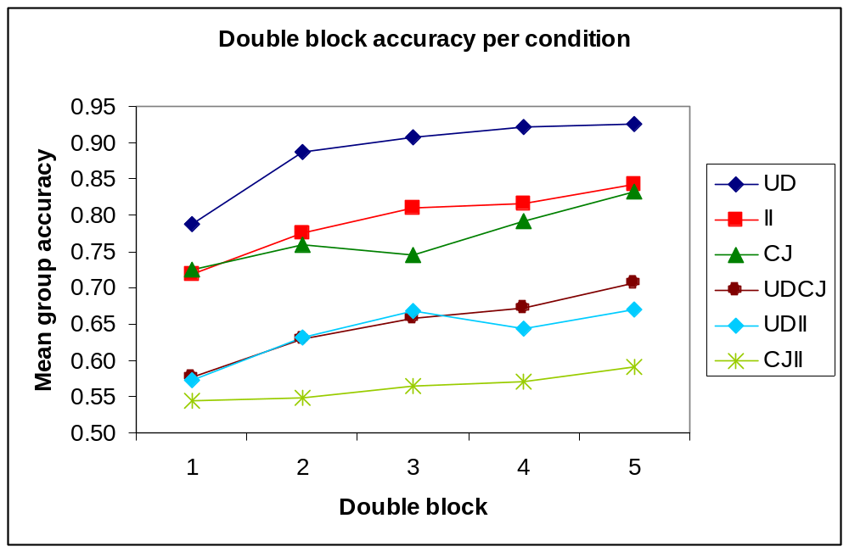

Accuracy per structure

For this analysis, I took for single task subjects accuracy in the first 5 blocks and for double task subjects accuracy achieved for a single structure (e.g. just UD part of UDII task).

