RBII4 48Summary 16 March 2005

We have collect 48 data sets, 16 in each condition.

Mean group accuracy

Overall accuracy ranged .31 to .84, with mean .63 +/- .02.
Accuracy did not differ between the groups (each double block F<1).

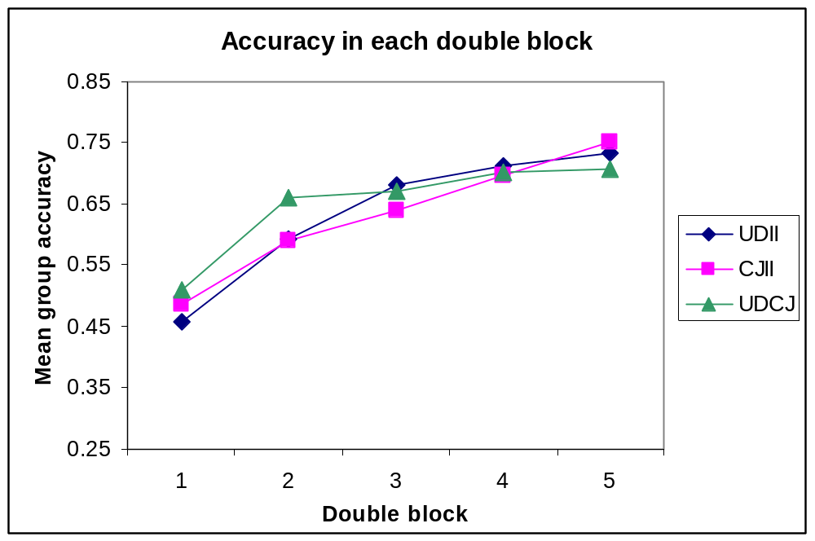

Accuracy per structure

I looked at accuracy for a given structure regardless of which other structure it was paired with. I also looked at the differences between groups depending on which structures they compared. Seems like we have slight differences between difficulties:
UD>CJ>=II
For UD structure, accuracy was no different for UDII and UDCJ groups (last block F=1.028,p=.319,II>CJ, all others F<1).
For II structure, no difference (last block F=1.1, p=.295, UD<II, all others F<1).
For CJ structure, differences suggest II>UD, last block significant F=8.2,p=.008.

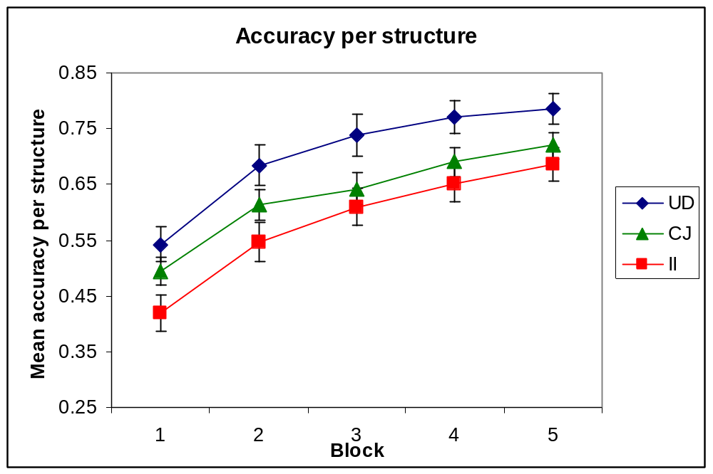

Confusion of white and black ellipses

I defined confusion as the proportion of black or white stimuli that were categorized with labels that were assigned to the other color of stimuli.

