RBII Experiment 20 February 2007

Goal

To investigate a combination of rule-based and information-integration category learning within one task. Two dimensions are used for categorizing while third indicates whether RB or II strategy should be used on the stimulus.

Description

Subjects view black and/or white ellipses. If both colors of ellipses are presented, ellipses of different colors come from different category structures.
Subjects who saw both black & white ellipses and learned two category structures were either using same response keys for both colors (2 cat conditions) or were using different keys (4 cat conditions).

Conditions for this experiment.
Two categories:
UD2 subs see only ellipses 1:56 (black) and learn UD category structure
II2 subs see only ellipses 57:112 (white) and learn II cat structure
CJ2 subs see only ellipses 1:56 (black) and learn CJ cat structure
UDII2 subs see all 112 ellipses and learn to categorize the black ones into RB category structure and the white ones into II cat structure
CJII2 subs see all 112 ellipses and learn to categorize the black ones into CJ cat str and white ones into II cat str
UDCJ2 subs see all 112 ellipses and learn to categorize the black ones into UD cat str and white ones into CJ cat str (CJ has switched cat assignment in order to minimaze overlap)
Four categories:
UDII4, CJII4, UDCJ4

Trial design is CD type:
(resp terminated) cat stimulus
response
750ms feedback ('correct' in green, 'wrong' in red)
1500ms ITI

Text file data format

Data text files contain 6 columns:
- correct category
- x-value (major axis length)
- y-value (orientation)
- z-value (binary – color of the ellipse)
- response
- reaction time
There were 560 trials organized into 5 blocks of 112 trials

Category structures

Category structures used were three:
UD Rule-based unidimensional “vertical”
CJ Rule-based conjunctive “conjunctivePos”
II Information-integration “iiNeg”

Artificial units varying between -1 and 1 on both dimensions were transferred into ellipse major axis to vary between 1.5 and 2.5 times minor axis (which was 40 pixels) and ellipse orientation to vary between pi/16 and 7*pi/16.
Unidimensional rule-based category structure
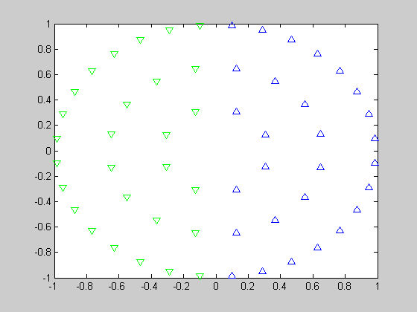

Conjunctive rule-based category structure
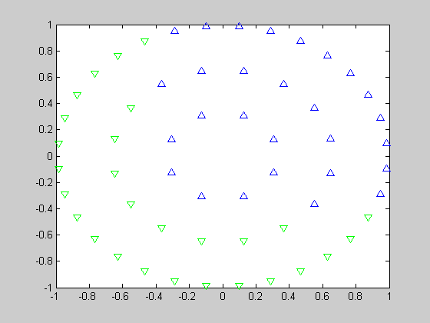

Information-integration category structure
