Replication

**Observers and Design**. In the replication, we tested two category types (rule-based/information-integration) with one type of response instructions (button switch). 45 observers were solicited from the University of California, Berkeley student population and received course credit for participation. The number of observers who participated in each experimental condition was as follows: rule-based, 22; information-integration, 24. No observer participated in more than one experimental condition. All the observers reported 20/20 vision or vision corrected to 20/20. Each observer completed one session of approximately 45-min duration. The criterion for learning was defined as 70% correct during the block preceding the change in response instructions (i.e., Block10). The data from the observers who did not meet this criterion were excluded from all the subsequent analyses. This criterion resulted in the exclusion of 1 observer each from the rule-based and information-integration category.

**Stimuli and stimulus generation**. The lines were created as outlined by Ashby, Ell, and Waldron (2003). First, the stimuli for the rule-based condition were created, and the order of the resulting 600 stimuli was then randomized separately for each observer and divided into 12 blocks of 50 trials each. The stimuli for the information-integration condition were created by rotating the rule-based categories by 45 degrees clockwise. Thus, the optimal strategy in the information-integration condition required integrating information from both the length and the orientation of the stimulus. Likewise, the order of the resulting 600 stimuli was then randomized separately for each observer and divided into 12 blocks of 50 trials each. The stimuli were computer generated and displayed on a ??-in. CRT with ?? pixel resolution in a dimly lit room. Each line was presented in white on a black. The midpoint of the line was fixed at the center of the monitor.

**Procedure.** The observers were run individually in a dimly lit testing room. They were told that there were two equally likely categories and that perfect performance was possible. There were 2 experimental conditions: rule-based or information-integration. In both the conditions, the observers depressed one of the two response keys (‘d’ or ‘k’) with their index fingers, and trial-by-trial feedback was provided. In the control condition, the observers were given 500 trials (10 blocks of 50 trials) of training, with 5sec to make their response. They were then given 100 trials (2 blocks of 50 trials), with 1.5sec to respond. If a response was not given in that time period, the observer was prompted to speed up his or her response, and that trial was discarded. A brief (1-sec) high-pitched tone (500Hz) was presented if the response was correct, and a low-pitched tone (200Hz) was presented if the response was incorrect. In addition, feedback was given at the end of each block of 50 trials regarding the participant’s accuracy during that block. The response–stimulus interval was 1sec. The buttons used to make the category response were reversed for the last 100 trials. Thus, reversing both the response location and the motor response. The observers were instructed at the beginning of the experiment that the response instructions would change following Block 10 and that they would be informed of the switch immediately before the switch occurred. The words “respond quickly and the response buttons will now be switched” were displayed on the monitor immediately prior to the change in the response instructions for both the rule-based and information-integration conditions.

## 2-back Dual Interference Experiment

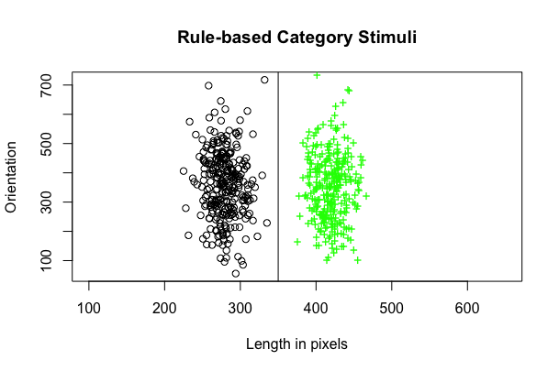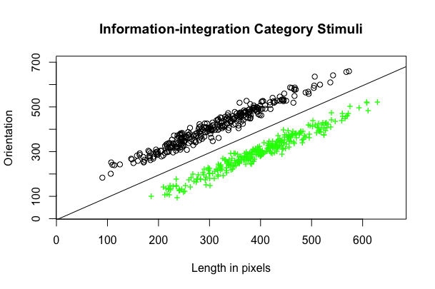

Figure 1: Category structures used in the rule-based (top) and information-integration (bottom) conditions, with circle and cross points representing separate categories.

## Methods

For the category-learning task, we used the procedure in Ashby et al. (2003), which distinguished indicators in performance between rule-based versus information-integration category learning. To generate our verbal and non-verbal interference tasks, we referenced the method used in Gilbert et al. (2006), which interleaved the interference and the main task to allow us to develop our 2-back matching interference paradigm.

**Participants** 122 participants were recruited from the University of California, Berkeley and received course credit for participation. All the participants (mean age = 20.5 years) reported 20/20 vision or vision corrected to 20/20. Each individual participated in only one of the six experiment conditions, resulting in the following breakdown: rule-based/control (no interference), rule-based/verbal, rule-based/spatial, information-integration/control (no interference), information-integration/verbal, and information-integration/spatial. (From this point forward, they will be referred to as RB-C, RB-V, RB-S, II-C, II-V, and II-S, respectively).

**Stimuli Generation** *Category-learning stimuli*: Every stimulus was a line that varied across two dimensions – length and orientation. Two sets of 600 unique lines were generated for each type of category structure using the procedure described in Ashby et al. (2003). Each point in Figure 1 indicates the length and orientation of each unique line. The rule-based category structure was unidimensional – it only required the participant to attend to line length and ignore orientation completely. Participants often described the categories as “one category was for short lines and the other was for long lines.” On the other hand, the information-integration category structure required participants to perceive both dimensions. If a rule-based rule were used, it would only result in 70% accuracy at best. Unlike the rule-based structure, the information-integration condition is difficult to describe verbally.

*Interference stimuli*: For the verbal interference task, the display presented a single word randomly selected from this set: “thin,” “thick,” “straight,” “curved,” “solid,” “narrow,” “slim,” “bent,” “wide,” “angled,” and “crooked.” These words were specifically selected due to their association in typically being used to describe types of lines. For the spatial (non-verbal) interference task, the display showed a 5cm x 5cm grid in which 12 of the squares were black and 13 were white. A set of 15 unique displays were generated and randomly selected to display.

**Procedure** The experiment was run in a designated room on a computer. Participants were given brief verbal instruction prior to the beginning of the experiment in which the general format of the experiment was explained.

The experiment duration was about 60 minutes, with 12 blocks total, each block consisting of 50 trials for a total of 600 trials. The participant would be notified of each new block with a display that stated the Block number. The category-learning stimuli and interference displays were interleaved (Figure 2). A fixation marker was shown for 1.25 s. It was then followed by either a word (verbal interference) or a grid (spatial interference) for 1.5 s. The participant would then try to recall if the interference display was the same as the interference display from two trials prior (two-back match). If it was the same, the participant would press the space bar. No key press was required for a non-matching interference.

For the interference task, the participants were urged to respond as quickly as possible. No feedback was given to the participant regarding the accuracy of their performance on the interference task. The fixation screen then reappeared for another 1.25 s, followed by one of 600 randomly selected category-learning lines. The line would be displayed until the participant pressed one of the two category-learning keys. The category-learning keys were “D” and “K” on a standard QWERTY keyboard. The keys were indicated with two different-colored squares that covered the letter. Feedback was immediately displayed, with the screen displaying either the word “Correct” or “Wrong” for 1 s. If they exceeded the 5-second response requirement, “Please respond within 5 seconds” was displayed on the screen for 1 s and the trial was discarded. Performance in the interference task was emphasized over that in the categorization task.

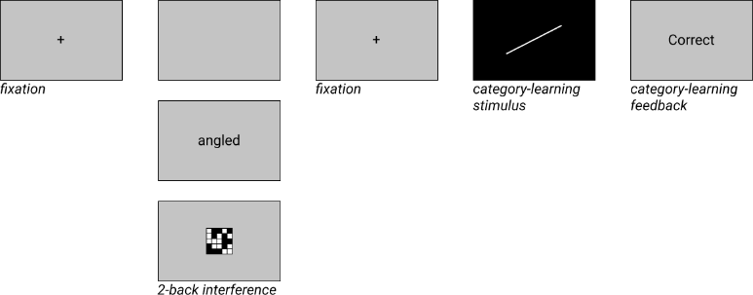

Figure 2: Example of a trial. Within a block, the category-learning task was interleaved with either no displays (no interference), displays containing a word (verbal), or displays containing a spatial grid (spatial).

Participants were also instructed that the response keys for the category-learning task would switch for the last two blocks (Blocks 11 and 12). Additionally, the response requirement for the category-learning task would decrease from 5 sec to 1.5 sec to prevent participants from inhibiting their initial response. If they exceeded the 1.5 sec response requirement, “Please respond within 1.5 seconds” was displayed on the screen for 1 s and the trial was discarded. Participants were assured that they would be informed of these changes immediately before they occurred. “Respond quickly and the response buttons will now be switched” was displayed on the monitor immediately prior to the change. The interference task remained constant throughout the entire experiment.

## Results

The learning curves for each of the three conditions are shown in Figure 3. Several important trends are evident. First, as was expected, accuracy was higher with no interference than with the other two interference conditions. Second, the learning curves of three conditions are fairly distinct, with higher accuracy in the spatial-interference condition than the verbal-interference condition. However, by Block 10, the three conditions appear to converge.

The criterion for learning was 70% accuracy for the category task, with above chance performance on the interference task for Block 10 (the block preceding the button-switch). Any participants that did not meet this threshold were excluded from data analysis.

The base question for statistical analysis is whether the type of interference caused a significant difference between the groups. So, we analyzed the effects on learning by using a mixed effects model. The subjects were specified as a random effect factor to control for correlation through Blocks, since the experiment is a learning task. Since Blocks 11-12 introduce the effects of the time-stressor and the button switch, we only analyze Blocks 1-10 using this model. The effects of no interference [p < 0.001], spatial-interference [p < 0.001], and verbal-interference [p < 0.001] were all significant. This indicates that the type of interference effects the rate of RB learning, with evidence that due to the interference on crucial verbal faculties involved in RB category-learning, the verbal-interference condition caused a detriment in learning.

Additionally, the effects of each interference type x block [p < 0.001] were also significant, which confirms the initial visual analysis that not only does learning occur over time, but the type of interference also effects the rate of accuracy between blocks.